CS 340 README

About the Project/Project Title
This is a Python module that enables CRUD functionality to a MongoDB from a client. The module simplifies database interaction and provides user access limitations.

Motivation
Austin Animal Center (AAC) needed a way for their employees to safely access their database of animals. This Python module was created for that purpose.

Getting Started
- Have a MongoDB ready
  - Set up a MongoDB
    - This was done in a linux environment, using the terminal to run MongoDB commands
  - Import your data into the database
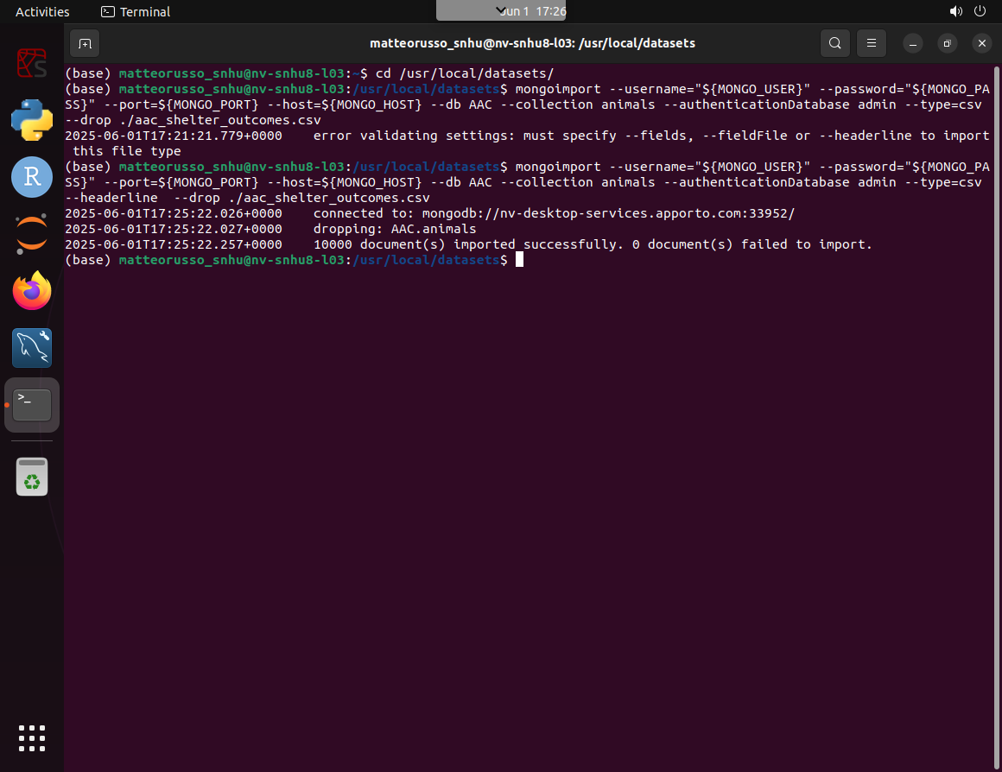
    - AAC data was imported from a CSV using mongoimport --type=csv --headline to tell mongodb the file format as well as to use the first line as the column headers.
    - Pre-established environment variables for host, port, username, and password were also used along with an --authenticationdatabase
  - Create a User with read and write permissions
    - This is done on an Admin database containing user accounts
    - Use db.createUser({ user:”name”, pwd:”password”, roles:[{role:”readWrite”, db:”aac”}] })
    - You can verify the account by reconnecting to the server using the new username and password, then run the command db.runCommand({connectionStatus:1}) to see the user info
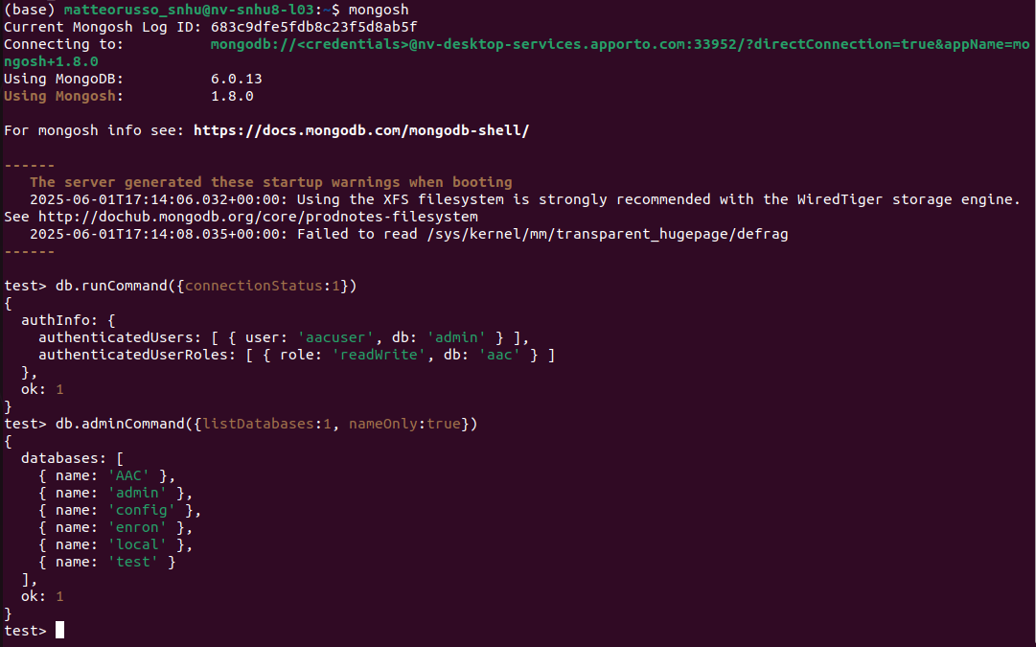
- Set up the Python module
  - Download and import the CRUD module to python
  - Use the AnimalShelter() function to automatically connect to the database
  - Use create and read to interact with the database
(Note: The module uses predefined user credentials when initializing with the AnimalShelter() function. These credentials are clearly labeled in the __init__() function within the AnimalShelter class and should be changed to match your database, collection, user, user password, and so on)
While creating the module I ran into the issue of error handling that does not crash, or fully stop, the program due to my Python error handling being rusty. I opted to use simple print statements. This gets corrected to try/except blocks. I also had to find the pymongo documentation to ensure I used functions correctly as I have not used this module in the past. Through testing with Jupyter Notebook I also ensured the code functioned correctly and gave the right outputs. A challenge with testing was also my lack of experience with Jupyter Notebook and running into an error caused by too large of output when printing read results. This was fixed by having test results only output true/false instead of the actual return for visual verification.

Installation
Python 3.9 or newer (download)
- Easy to use programming language with wide support and runs on all platforms
- Acts as a more user friendly step to use MongoDB
PyMongo (instructions)
- Allows python to interact with MongoDB
- Used for ease of access and to help prevent user error when interacting with the database
A Mongo Database with a user account set up (MongoDB, Users)
- NoSQL database management software
- Widely used and supported and well document

Usage
Add and use the module through Python command:
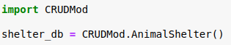
CRUDMod.AnimalShelter() will automatically connect the user to the database and log them in with predefined user credentials.

Creating database entries:
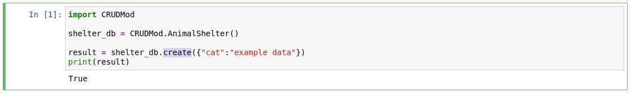
create functions as insertOne() does.
The passed in argument is tested to ensure it is a dictionary.
The function returns True or False based on if the data was added to the database.

Tests Ran:
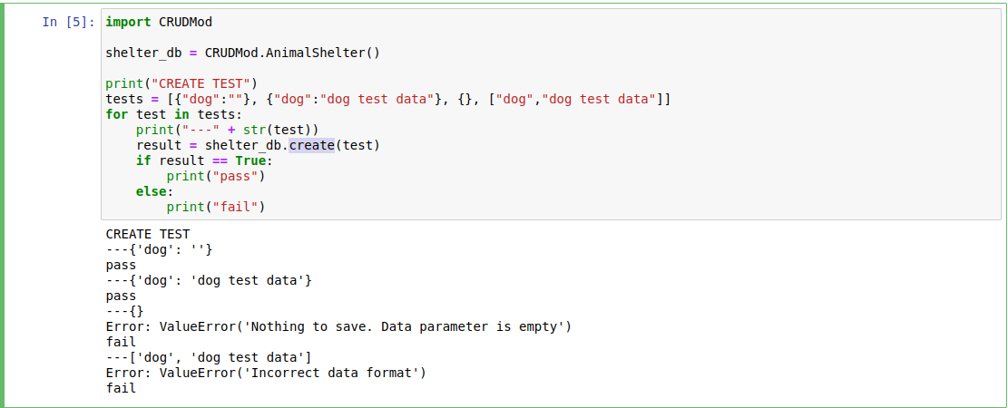

Reading from the database: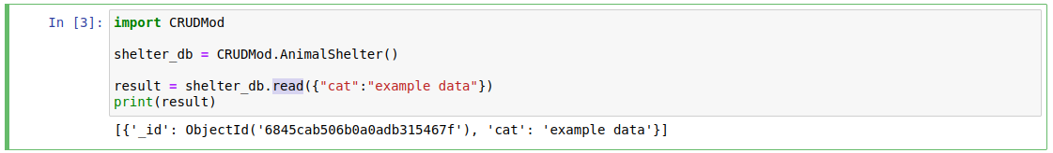
read functions similarly to find().
The passed in argument is tested to ensure it is a dictionary.
The function returns a list of the results.

Tests Ran:
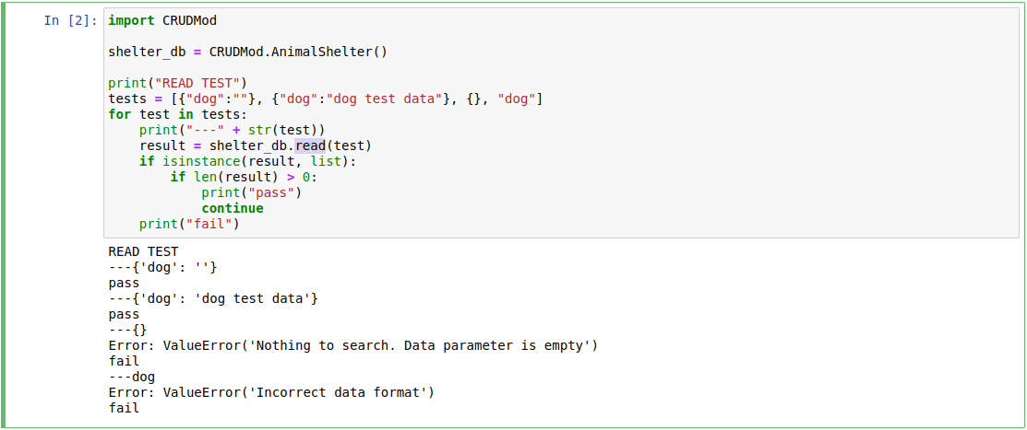

Updating the database:
shelter_db.update({“cat”:”old data”}, {“$set”: {“cat”:”new data”}})

update accepts a lookup dict and newData dict
lookup - dictionary describing the data to find
newData - dictionary describing the data to change in the results from lookup
The function returns the number of items updated.

Tests Ran:
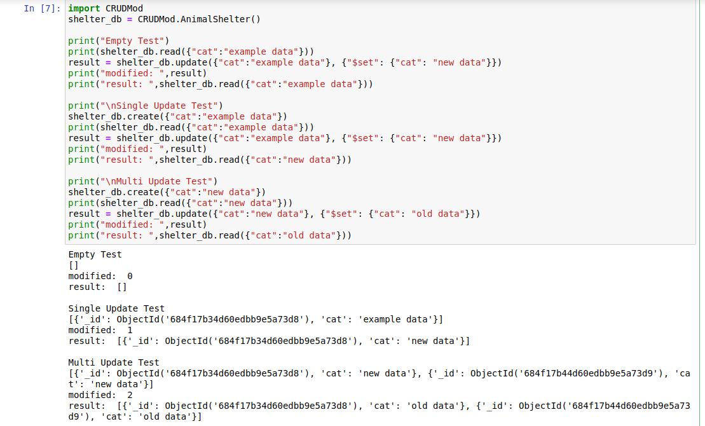

Deleting data from the database:
shelter_db.delete({“cat”:”old data”})

delete accepts a lookup dict
lookup - data to match and delete
The function returns the number of items deleted

Tests Ran:
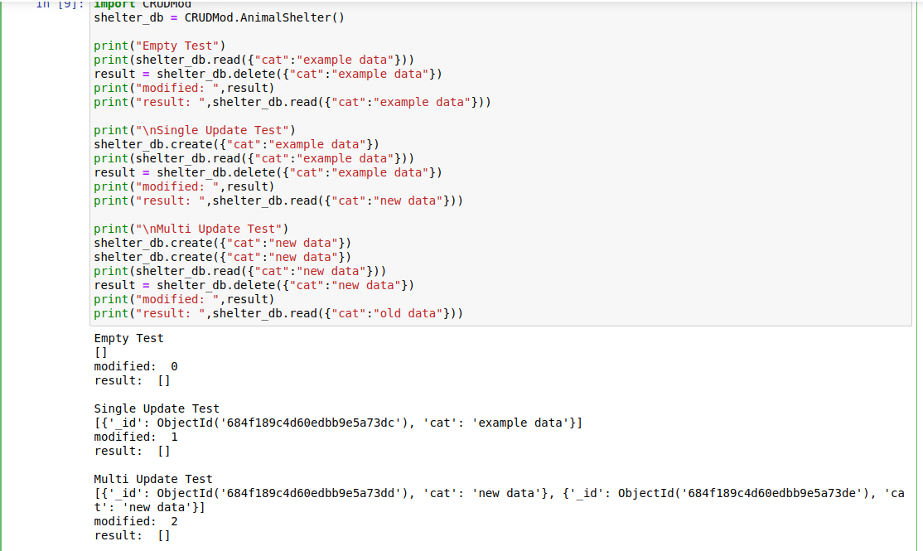

Contact
Matteo Russo

