DASHBOARD README

About the Project
Grazioso Salvare is a client of Global Rain who has requested a web dashboard that can identify and categorize available dogs using existing animal shelter data. Specifications for dogs and their compatibility for certain types of rescue have been identified to act as data filters for this dashboard.

Motivation
Grazioso Salvare identifies dogs that are good candidates for search-and-rescue training. When trained, these dogs are able to find and help to rescue humans or other animals, often in life-threatening conditions. To help identify dogs for training, Grazioso Salvare has reached an agreement with a non-profit agency that operates five animal shelters in the region around Austin, Texas. This non-profit agency will provide Grazioso Salvare with data from their shelters.

Getting Started
MongoDB
- Set up a MongoDB
- Import the AAC CSV Data set using mongoimport --type=csv --headline along with host, port, username, password, and authenticationdatabase
  - Austin Animal Center. (2020). Austin Animal Center Outcomes [Data set]. City of Austin, Texas Open Data Portal. https://doi.org/10.26000/025.000001
  - The authenticationdatabase is a separate MongoDB that holds user account info
- Create a User with read and write permissions
  - Use db.createUser({ user:”name”, pwd:”password”, roles:[{role:”readWrite”, db:”aac”}] })
  - This is done on the authenticationdatabase
Python
- Install Jupyter Notebook, Dash, Pandas, and any other necessary python imports
- Using Jupyter Notebook to run the code in the .ipynb file will now launch the dashboard
  - The dashboard will connect to the Mongo database through the use of the CRUD python module developed for this project which makes use of pymongo
  - The dashboard will also use modules such as Pandas and Dash to allow sorting the data and displaying it in an interactive web page
This project follows the Model View Controller pattern through the use of MongoDB and Dash. MongoDB is the database, which holds all the data for the dashboard, making it the model. Dash provides both the interface and the control logic making it both the view and controller. This is because it creates the interface with web elements and provides callbacks that attach to the elements allowing code to be executed to change the view based on input.

Installation
Python 3.9 or newer (download)
- Easy to use programming language with wide support and runs on all platforms
- Python provides ties together different modules in order to connect the database to the user interface

PyMongo (instructions)
- Allows python to interact with MongoDB
- Used for ease of access and to help prevent user error when interacting with the database

A Mongo Database with a user account set up (MongoDB, Users)
- NoSQL database management software that is widely used, supported and well document
- The NoSQL format allows MongoDB to easily integrate with the existing animal data

Dash (install)
- A python module that provides tools to quickly make a webpage
- Allows for setting up interact webpage elements

Jupyter Notebook (install)
- A web based development platform that allows for sharing projects
- Used to run and test the dashboard app

Pandas (install)
- Data management module for python
- Used to store data from database, then filter or display the data in web elements

Usage
Once the dashboard is launched a data table will be displayed showing all animals in the database by default. Below the data table will be a pie chart showing the distribution of dog breeds on the left, and on the right will be a map showing the location of the animal that is selected.
Select an animal in the data table by clicking on the row. A variety of filters are available by selecting the arrows by the column names. This can be useful for sorting animals by any of the columns such as bread or date of birth. They can also be sorted by desired rescue type (Water, Mountains, Disaster) which filters the animals by a list of requirements such as breed and age range to find animals more suited for that type of rescue training. This type of sorting is done by selecting the rescue type at the top of the data table and may be turned off by selecting “None”.
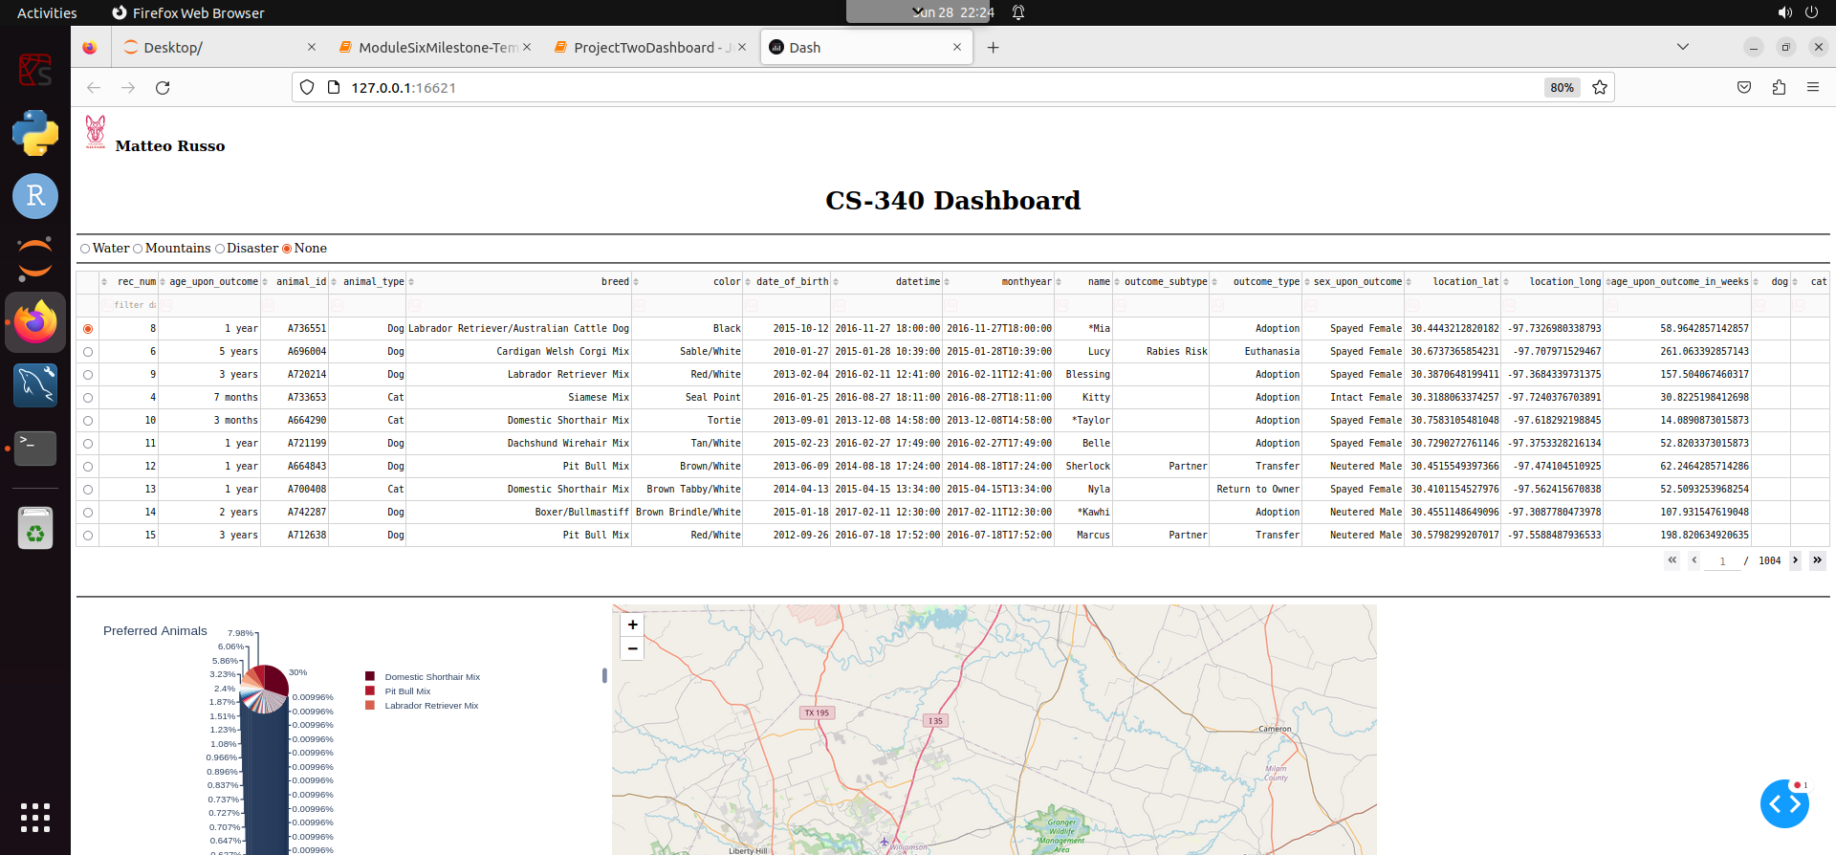
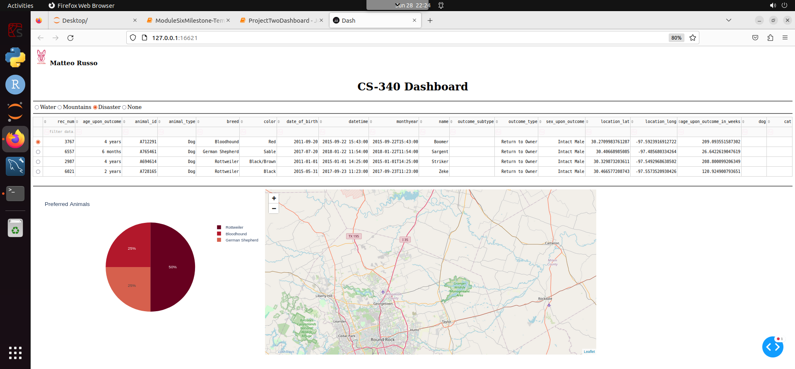
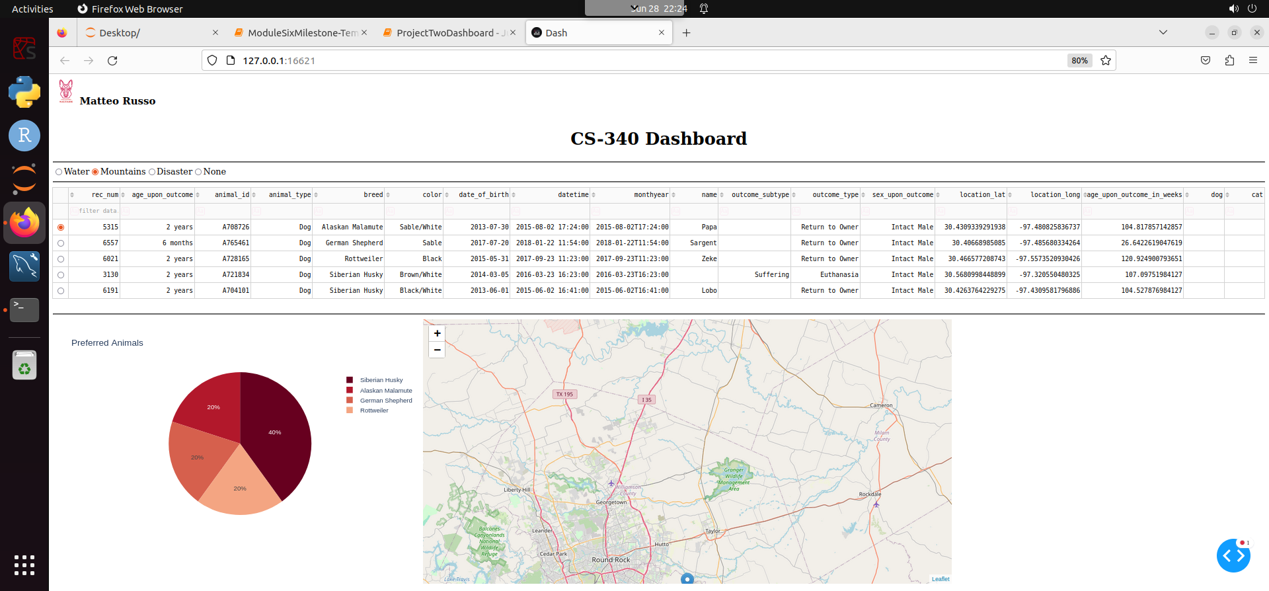
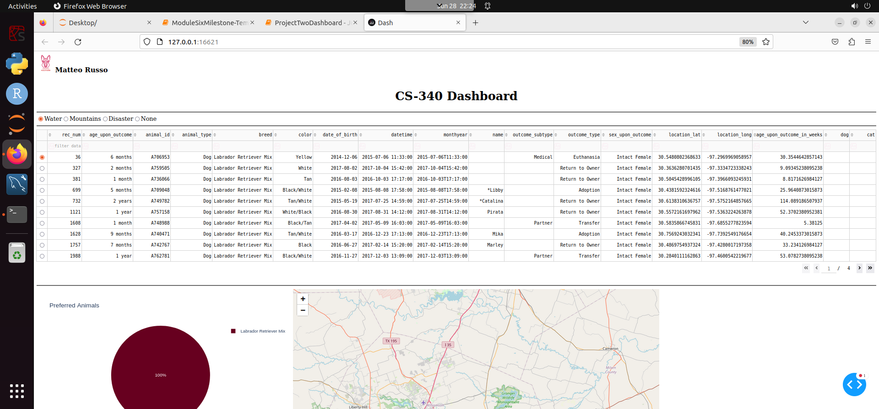

Challenges
A primary challenge of this project for me personally was the use of new technology I have never used, primarily MongoDB, Dash, and Jupyter Notebook. These challenges came in the form of not knowing how to use the software properly, but by reading the documentation I was able to complete the project. A specific example would be making the rescue filter buttons properly call the database with the right query in order to get dogs of the right breed and age range. After finding the documentation on comparison queries I was able to properly construct the needed queries to filter the animals.

Contact
Matteo Russo

