Matteo Russo
CS 330
M7 Final Project Reflection

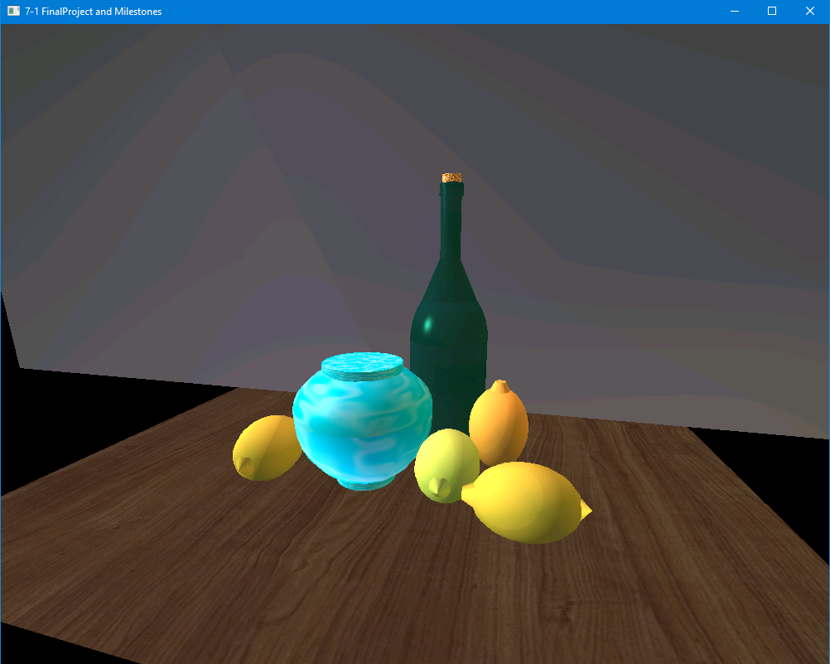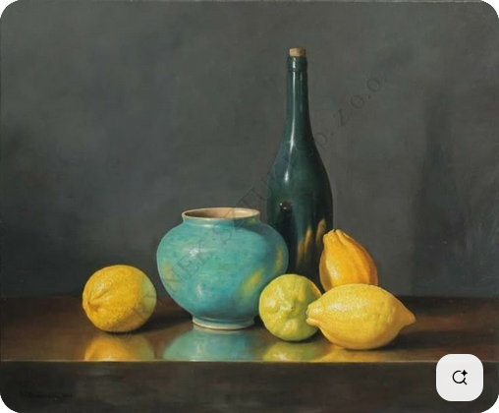

Justify development choices for your 3D scene.
I chose these objects because I felt I would be able to replicate them at my skill level with 3D modeling and with the environment we were given. Only simple shapes could be used, making some convex shapes impossible to make. With these shapes I could clearly see how to make them, excluding the hollow vase which would be changed to be closed. Additionally I was able to implement the required functionality using OpenGL, which provided the methods used for rendering simple shapes, textures, and lights.

Explain how a user can navigate your 3D scene.
To move through the scene the user can use their mouse to change the direction the camera faces, WASD to move the camera, mouse wheel to change the movement speed, Q and E to move up and down, P to change to perspective mode, and O to change to orthographic mode.

Utilizing the OpenGL API, input handling callbacks and the camera matrix are modified at runtime. Movement changes the camera transform and perspective changes are done by modifying the camera’s projection matrix.

Explain the custom functions in your program that you are using to make your code more modular and organized.
In order to make the program organized, functionality is split between a Scene Manager and a View Manager. The scene manager holds code related to drawing and rendering shapes, lights and shaders on the shapes. This is further broken down to include functions specifically for handling each of those components so that all similar elements are handled together, making it easier to put it all together before finally rendering the scene. The view manager holds camera functionality input, and window display functionality. This makes it so that all display output and interactivity is contained together.

By having the code organized as such it is more modular, meaning it would be relatively easy to swap out the view manager with another to change the camera, controls, or even the display window and still display the same scene. The same could be done with the scene manager so the current camera could display an entirely different scene.

