**NAME :Panthiv Patel**

**ROLL NO :72**

**FYCS**

**Practical 4- writing email**

Step 1: login to your google account

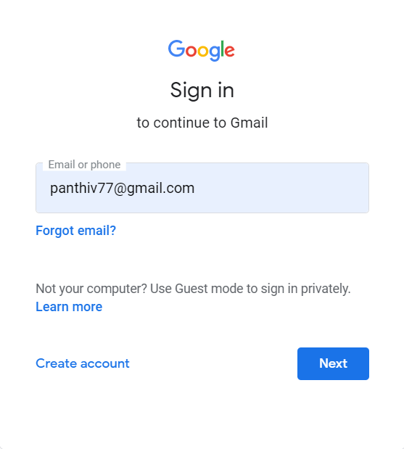

Step 2: search gmail and click on compose

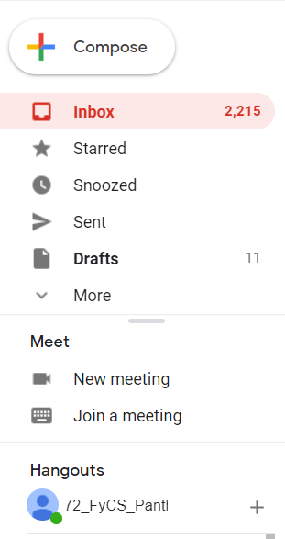

You will see a window like this

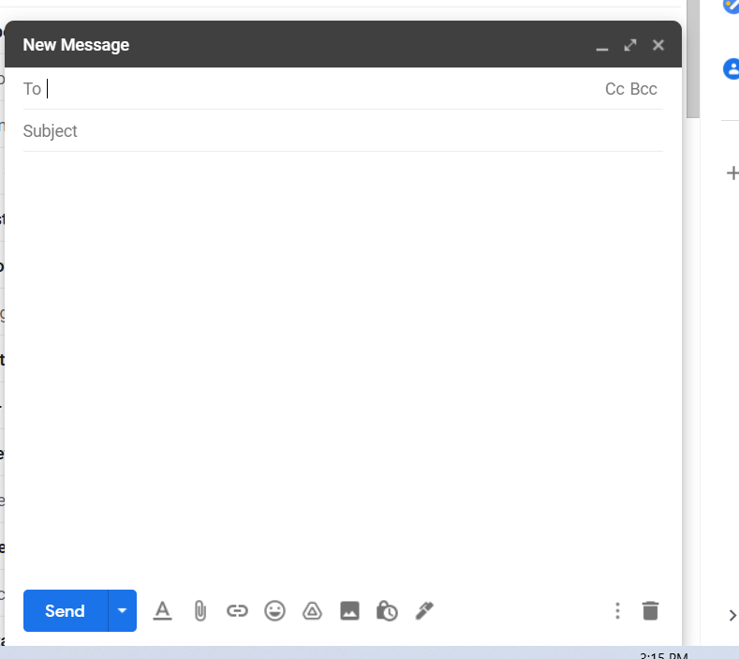

Step 3: in the ‘To’ section type the gmail id of the name or organization to whom you want to send the mail and write the subject below in the subject section.

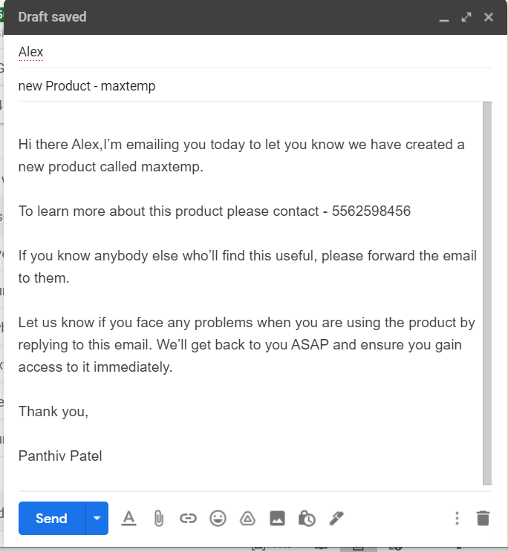

Step 4: use attach button to attach the images or files

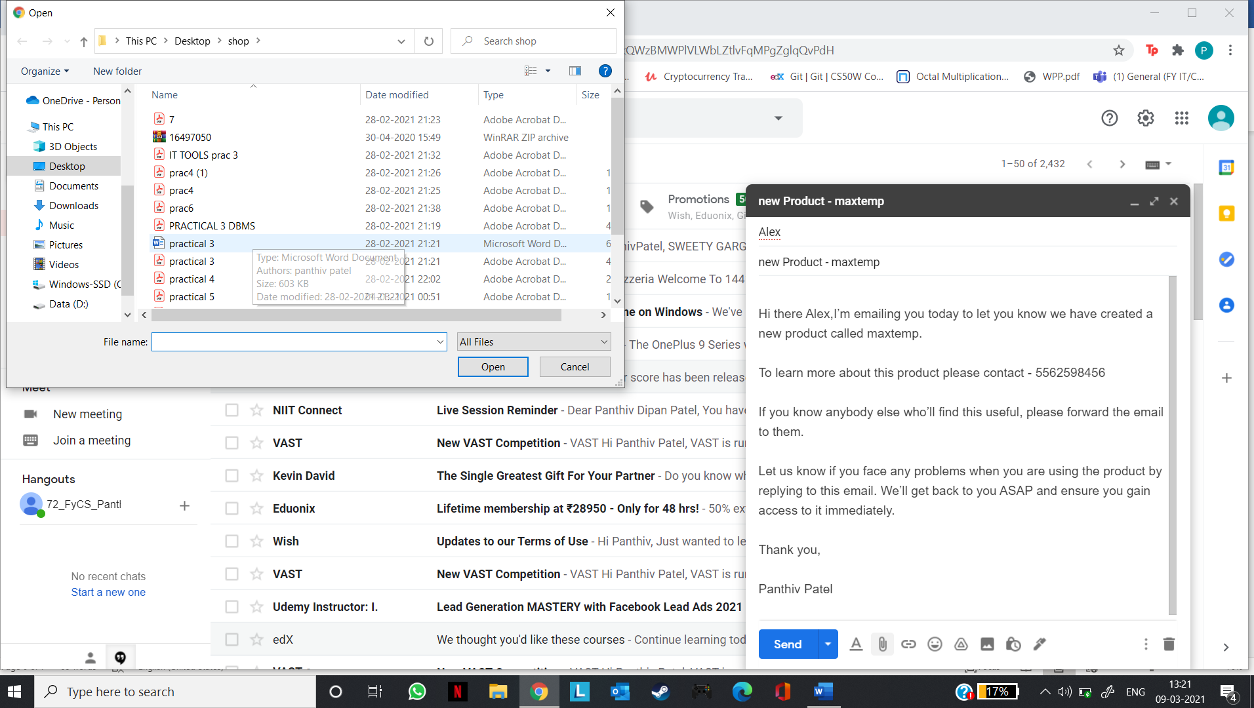

Step 5: click on the 3 dots to add some additional features

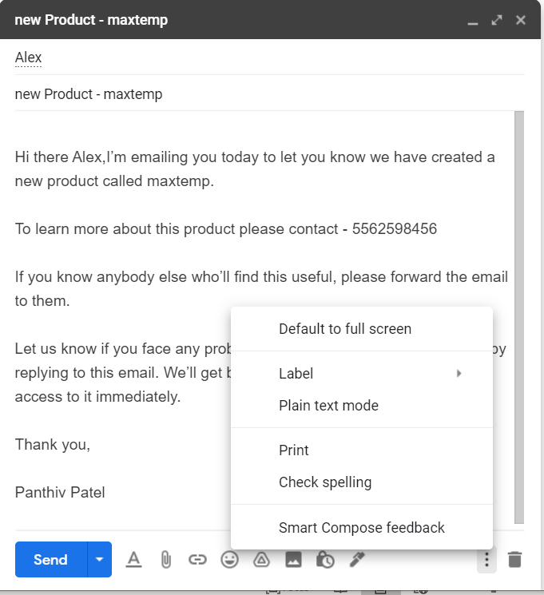

Step5: once done editing click on send to send your mail

