Candice Walls

November 21, 2021

CSD 310 – Module 6.3

<https://github.com/Panthrys/CSD-310.git>

Insert_one(Vesemir)

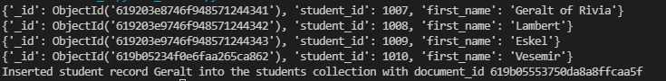

Find() after delete_one({‘student_id’: 1010})



find_one({‘student_id’: 1010})

