GS3M PoE
Tri Band Industrial ADS-B Receiver with PoE

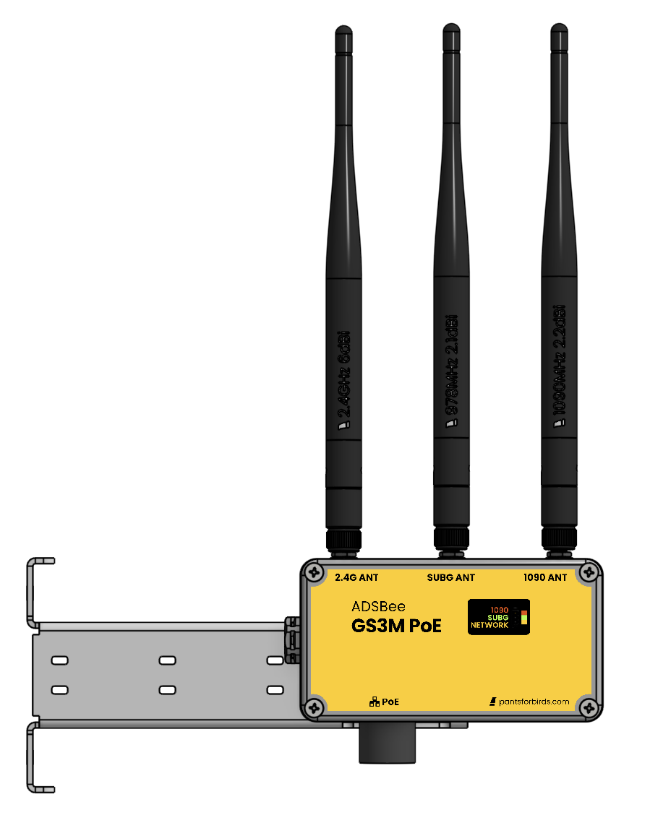

Features
- 1090MHz Mode S and ADS-B packet decoding.
- Adjustable receive gain and trigger levels for customized tuning in diverse RF environments.
- Tunable sub-GHz transceiver for UAT / additional protocols.
- Multiple output formats over IP: Raw Frames / ADSBee CSV / MAVLINK1 / MAVLINK2 / Mode S Beast / GDL90
- 2.4GHz 802.11 module for Remote ID In (under development).
- Firmware updates over Ethernet.

NOTE: This datasheet complements the ADSBee 1090 datasheet. Please refer to the ADSBee 1090 datasheet for AT commands, protocols, and more detailed information.

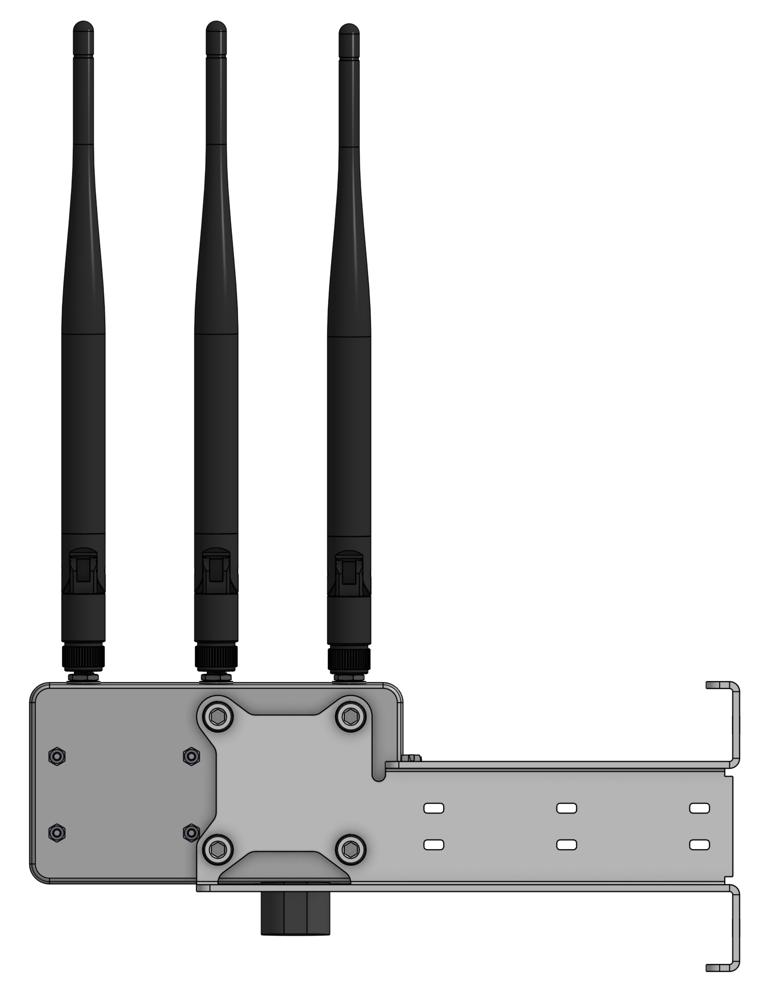

Applications
- Aircraft and drone detection for infrastructure.
- Outdoor feeder (fixed / portable) for aircraft tracking networks.

Quick Specs
Electrical Supply | PoE 802.3af (2.5W)
Minimum RF Input Power Level | -90dBm
Simultaneous Aircraft Tracks Supported | ≤400
Connectors | 1090MHz RF In: SMA  Sub-GHz RF In/Out: SMA  802.11 RF In/Out: SMA  Power / Data: RJ45 (100 BASE-T)

Contents
Features 1
Applications 1
Quick Specs 1
Revision History 2
1 Packing List 3
2 Assembly 4
2.1 Mounting Bracket 4
2.2 Ethernet Cable 6
2.3 Antennas 8
3 Installation 9
4 Network Setup 10

Revision History
20251204 – Initial release.
20251224 – Fix typos and add PoE spec.
20251225 – Add M5 hardware to packing list.

Packing List
- 1x ADSBee GS3M PoE
  - 4x M5x10mm Socket Head Cap Screw
  - 4x M5 Spring Washer
- M5 Allen Key
- 1x GS3M Mounting Bracket
- 1x Waterproof R45 Cable Gland Cover
- 1x 1090MHz IP67 Antenna
- 1x 978MHz IP67 Antenna
- 1x 2.4GHz IP67 Antenna
- 2x 3/4in to 1 3/4in Stainless Steel Hose Clamp

Assembly

Mounting Bracket
    - Remove GS3M PoE from the package.
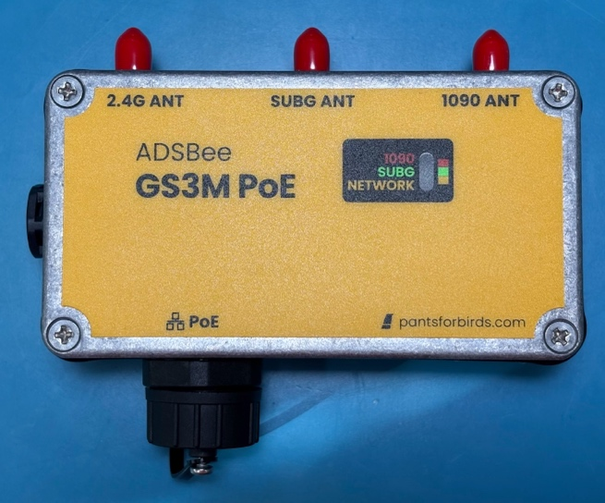
    - Remove 4x M5x10mm socket head cap screws and spring washers from the rear of the GS3M PoE enclosure.
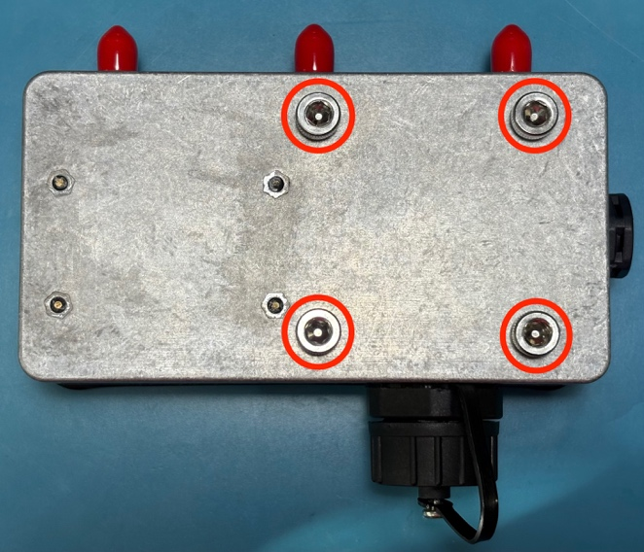

    - Use the M5 spring washers and screws to install the GS3M mounting bracket.
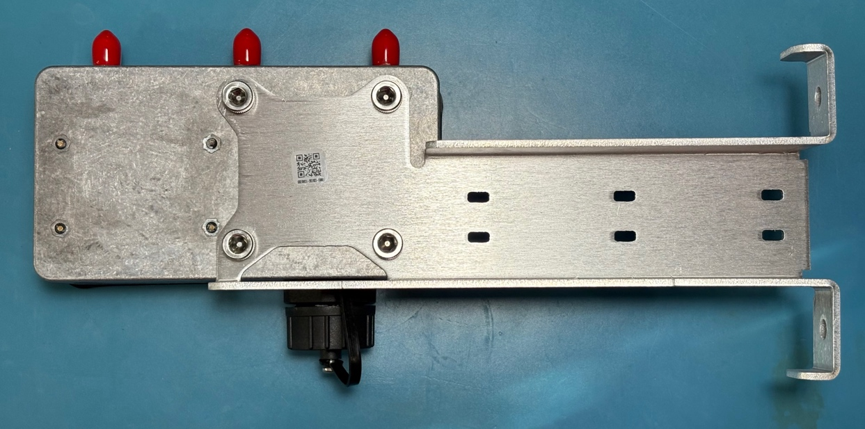
Note: bracket can be installed in an alternate orientation to enable mounting to a horizontal pole or surface.
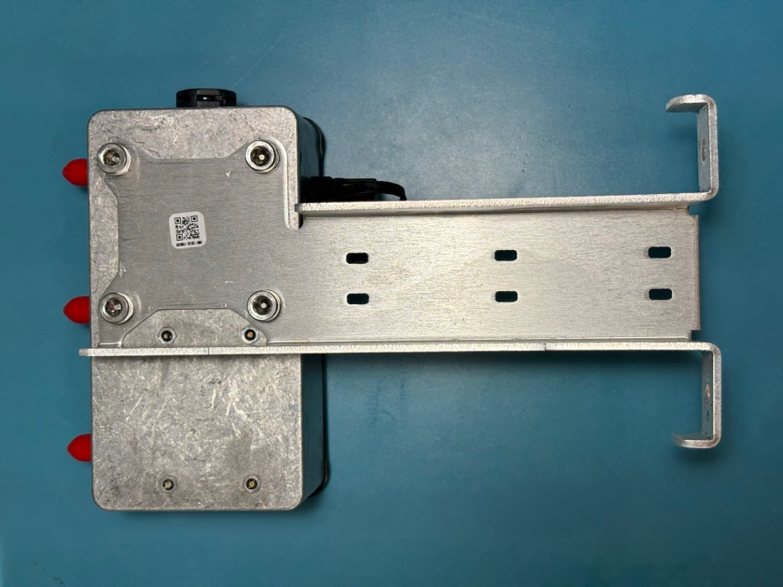

Ethernet Cable
    - Source a waterproof ethernet cable with a minimum performance rating of CAT5. Stranded cables with pure copper conductors around 24AWG are best for minimizing voltage drop across long runs. Note that maximum cable jacket diameter should not exceed 8mm to enable termination using the included waterproof cable gland.

Example Ethernet Cable:
CAT6 Outdoor Ethernet Cable, 23 AWG Pure Copper, Waterproof Direct-Burial UV Resistant, 50ft

    - Most RJ45 cables come with a strain relief boot attached to their connector on each end of the cable. This strain relief boot must be removed in order for the RJ45 cable to fit through the waterproof cable gland. Remove the strain relief boot by sliding it back along the cable. The strain relief boot can be carefully cut and discarded, as it is not needed for the GS3M PoE’s waterproof RJ45 termination.
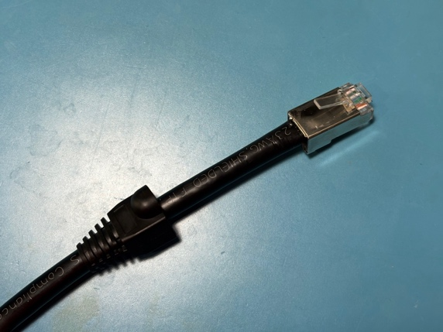
    - Slide the disassembled cable gland assembly over the RJ45 termination piece by piece, in the order shown in the image below. Note that the cable gland’s sealing ring has a split line that allows it to be opened and slid over the cable jacket.
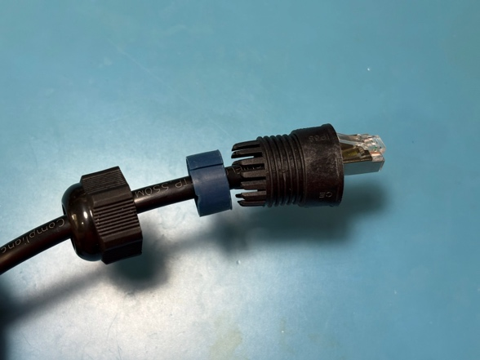
    - Slide the sealing ring into the back of the cable gland body.
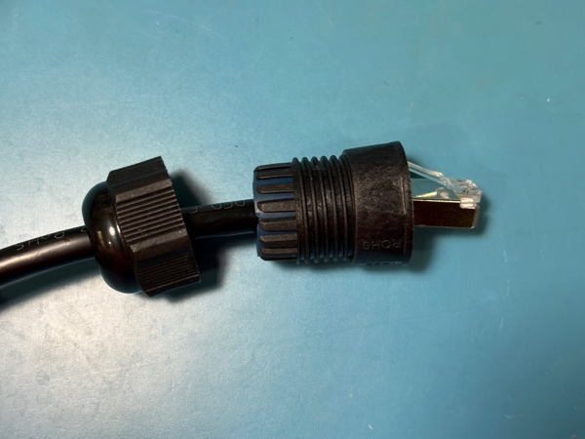

    - Unscrew the waterproof dust cover from the network port of the GS3M PoE, and plug in the cable’s RJ45 connector.
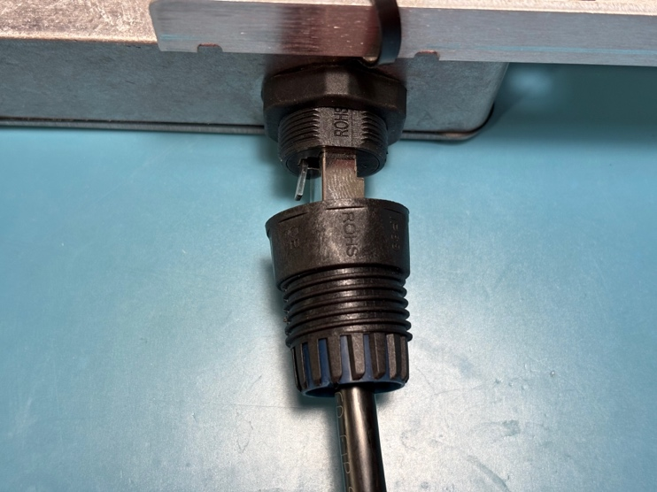
    - Hand-tighten the cable gland body onto the threads of the GS3M PoE’s waterproof bulkhead connector.
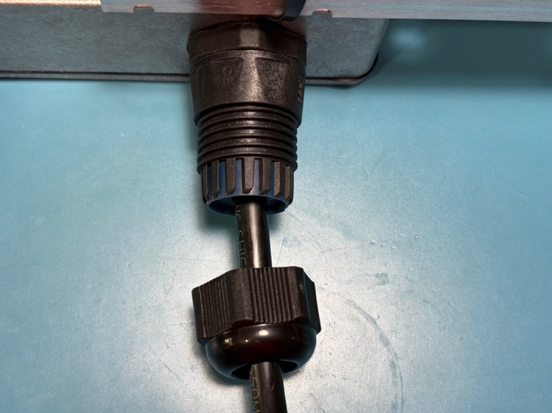
    - Hand-tighten the tail cap of the cable gland assembly onto the cable gland body.
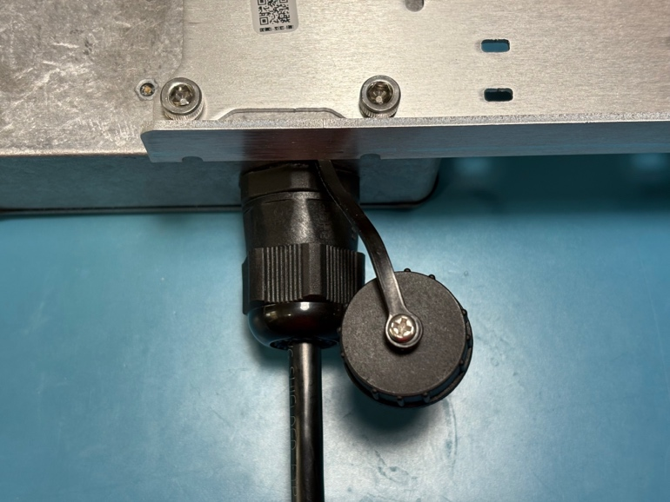

Antennas
    - Hand-tighten antennas onto the GS3M PoE to match the image below. Note that each antenna needs to be matched with its corresponding port.
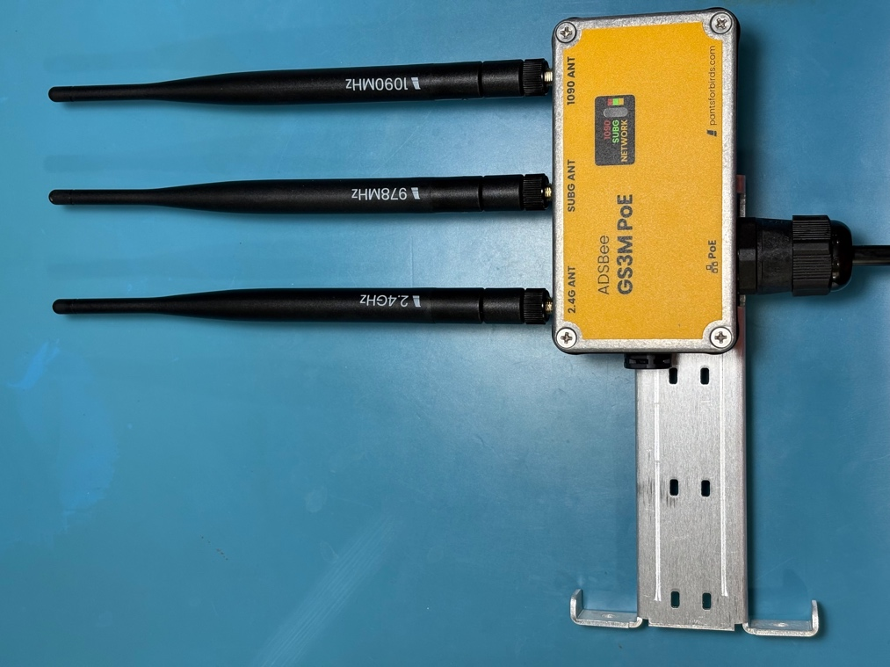

NOTE: If an SMA feed line is used instead of an antenna an any port, SMA connectors can be torqued to 0.8N*m using a calibrated torque wrench.
    - Mount the GS3M PoE with the antennas vertically polarized (pointing straight up), clear of obstructions. Effective range is usually most heavily influenced by mounting location (the higher the better) and proximity to dense or electrically conductive obstructions that could shield the receiver from transmitters in the surrounding area.

Installation
GS3M PoE can be installed in a variety of locations. The included mounting bracket can be screwed to horizontal or vertical surfaces using its built-in mounting holes. Additionally, the mounting bracket can be combined with the included hose clamps to attach the bracket to horizontal or vertical pipes up to 1 3/4 in diameter.
The 40x40mm M5 mounting hole pattern on the back of the GS3M PoE can be used to attach it to assemblies where the mounting bracket is not required.
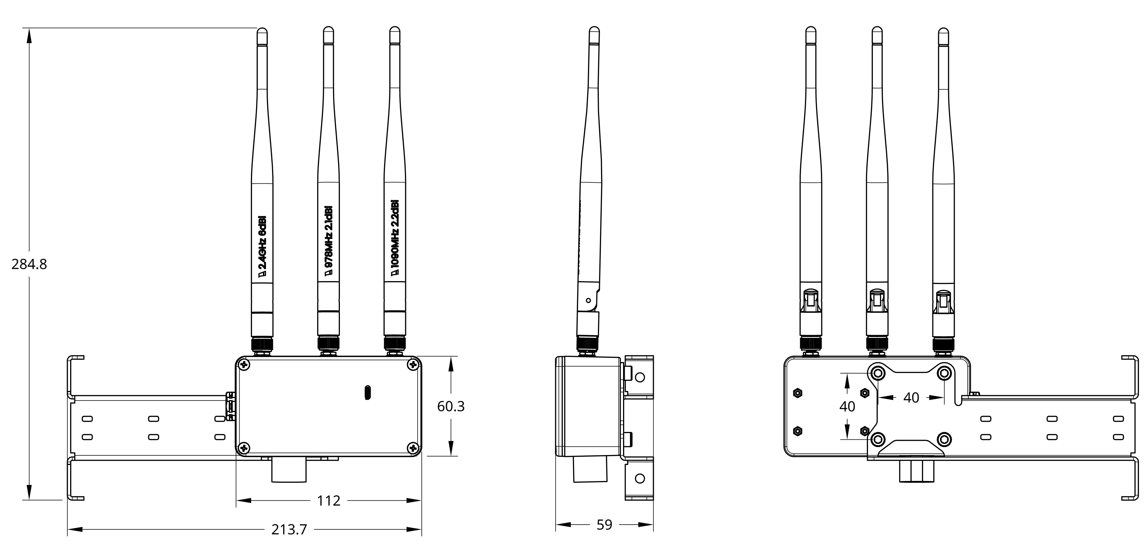

Network Setup
Connect the GS3M PoE to a PoE Ethernet switch that is in on an IP network. The switch should indicate that the GS3M PoE is receiving power, and the lights on the front of the GS3M PoE should display the standard ADSBee startup sequence. Once the device is booted (takes ~3 seconds), it will connect to the IP network and claim an IP address via DHCP. Connect to your router in order to discover the GS3M PoE’s IP address. The device hostname will default to something like “ADSBee1090-0250613020082” (this is a unique ID that is a combination of the device manufacturing date, manufacturer code, and serial number). For ease of use, it is recommended that you assign a static IP address to the GS3M PoE and/or change its device hostname using the AT+HOSTNAME command to a memorable phrase (see the ADSBee 1090 datasheet for information on how to do this). Once the hostname is set and settings are saved, your GS3M PoE should be accessible at http://<your-hostname>.local.
The device webpage (accessible at your GS3M PoE’s IP address) can be used to view live packet reception metrics, change device settings (via the virtual serial terminal), download / restore settings, or apply firmware updates.
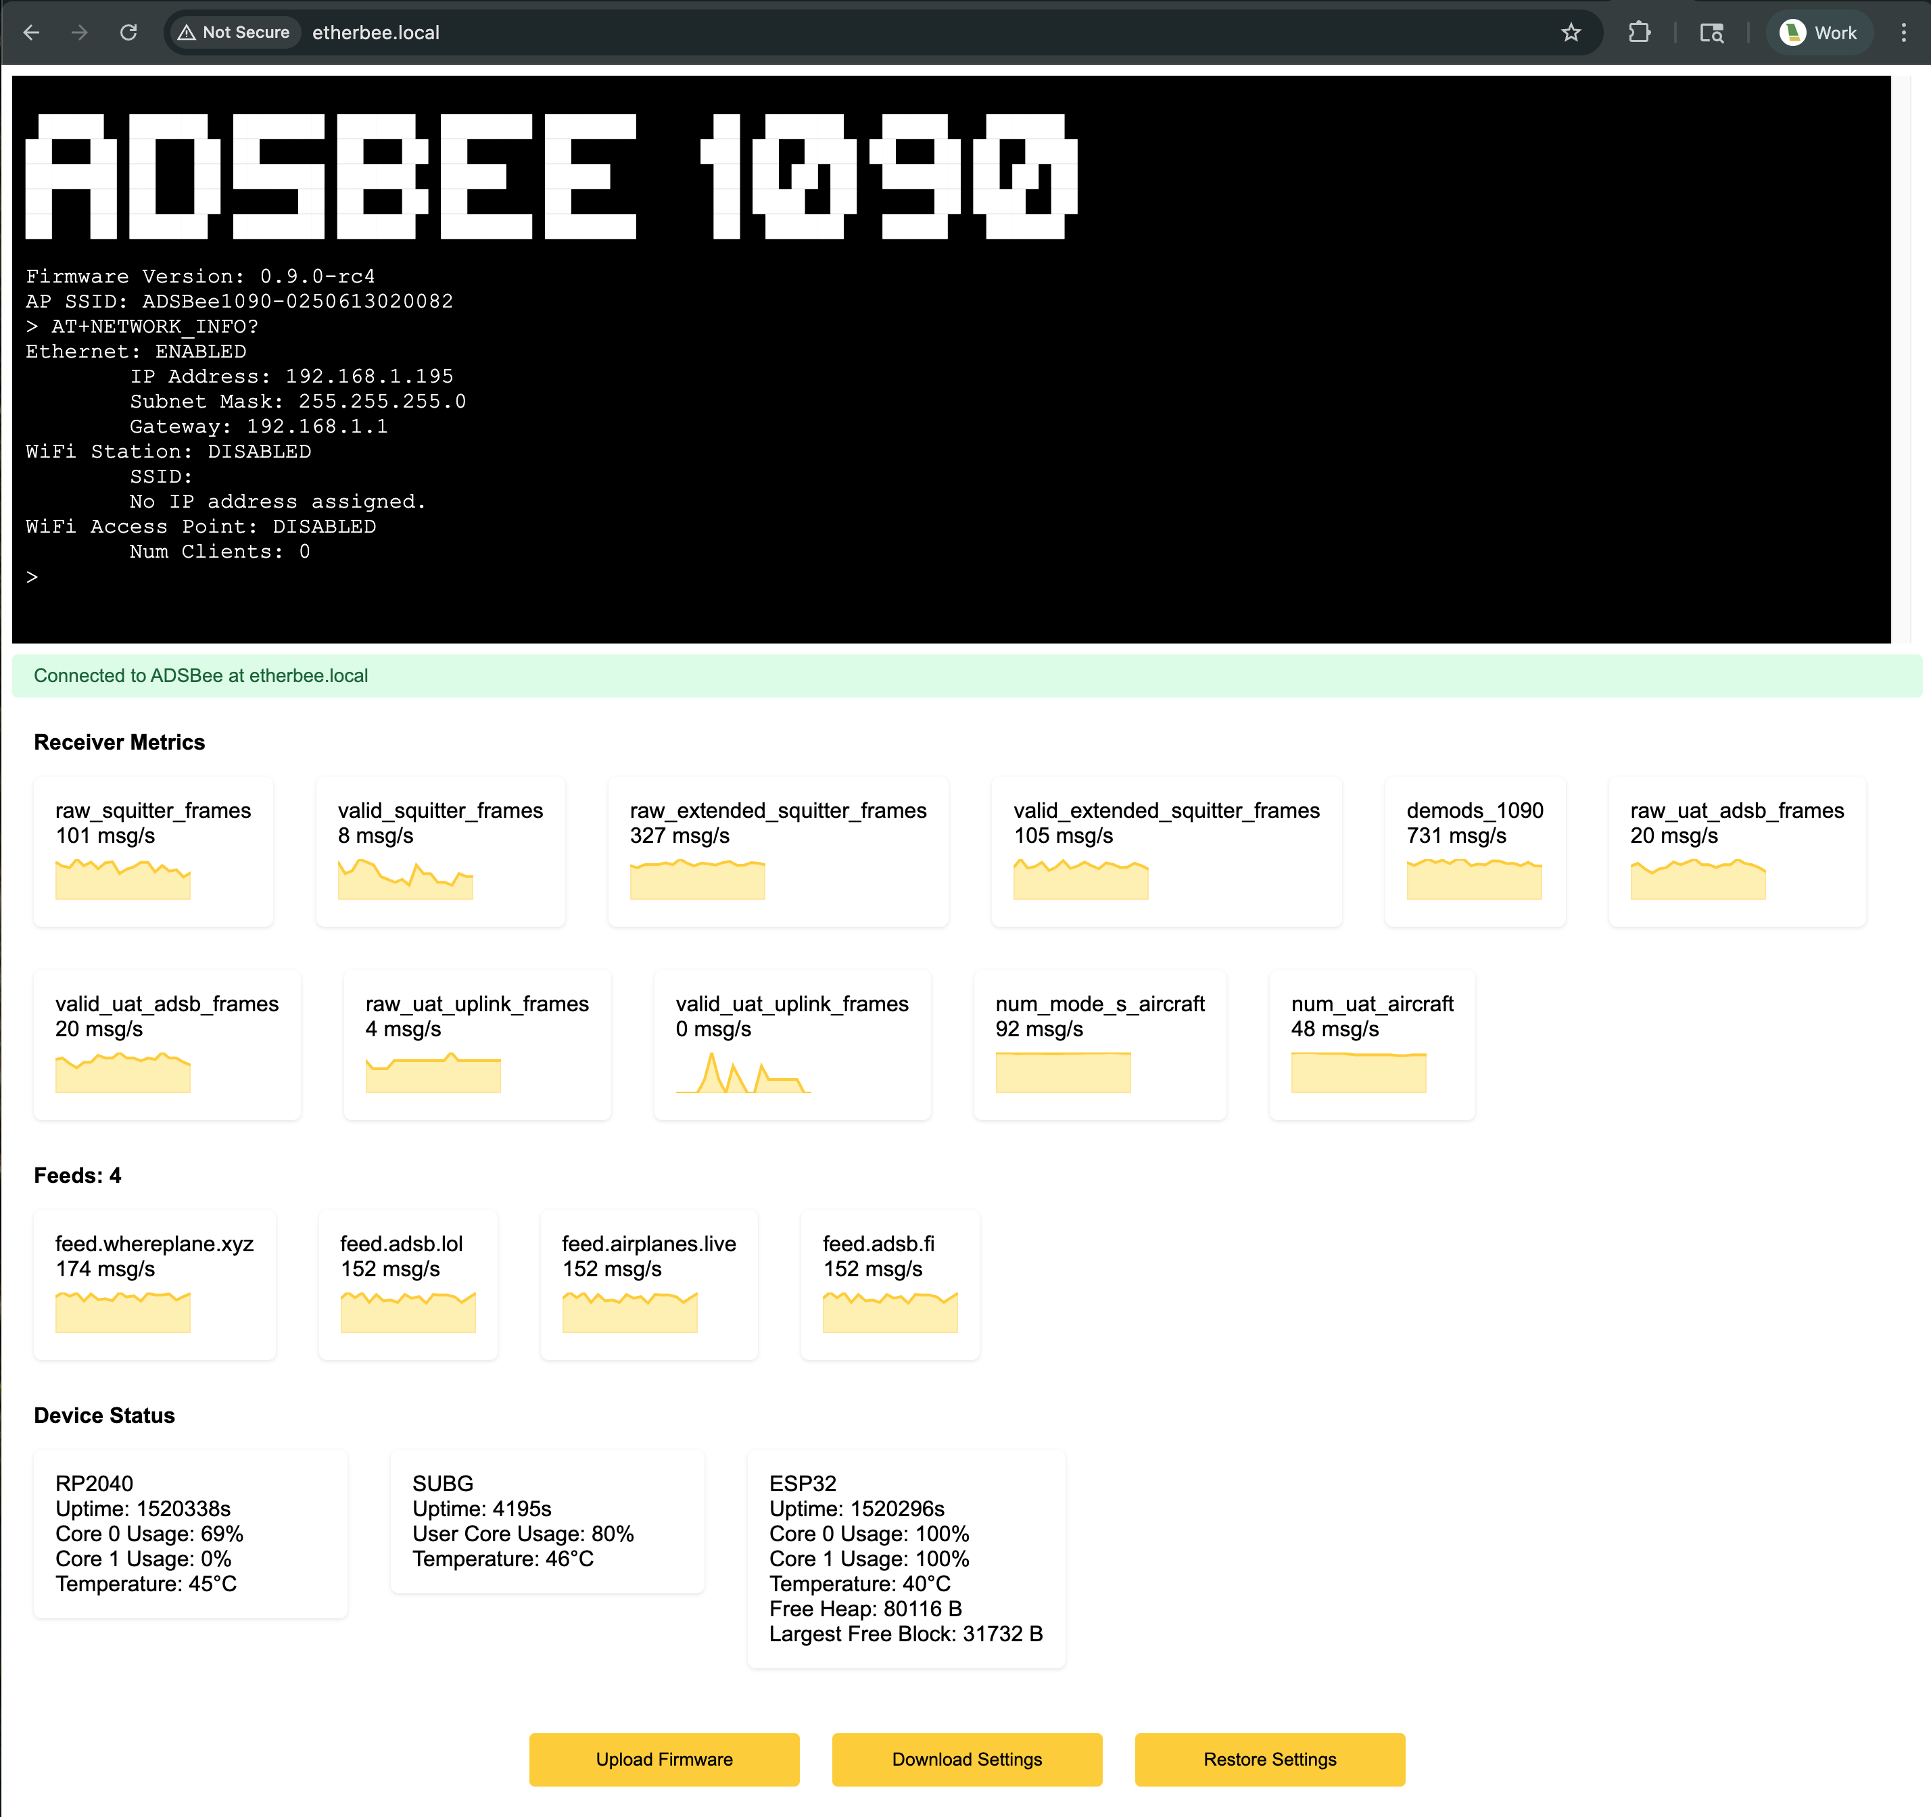

WARNING: The web serial terminal has no guard rails, and will allow you to do things like disable Ethernet communication, which would require opening the enclosure to repair settings via the actual USB serial terminal. This could be annoying if your GS3M PoE is mounted in a difficult to access location. Proceed with caution!

