


INSTITUTE FOR ADVANCED COMPUTING AND SOFTWARE DEVELOPMENT, AKURDI, PUNE

“CliniCare”

PG-DAC Aug 2024

Submitted By:

Group No: 19

Roll No. Name of Student
248031 Harsh Tyagi
248178 Pranav Birnale

Mrs. Geeta Darunte Mr. Rohit Puranik
Project Guide Centre Coordinator

ABSTRACT

CliniCare is a web-based Hospital Management System designed to streamline and enhance healthcare services by digitizing hospital operations. The platform enables efficient management of patient registrations, appointments, and medical records, ensuring seamless access to critical healthcare information while reducing paperwork. Built with React JS for a dynamic and user-friendly frontend and Java EE for a robust backend, CliniCare leverages RESTful APIs for smooth data communication and MySQL for secure data storage.

The system enhances hospital efficiency by automating administrative workflows, minimizing manual errors, and improving coordination between healthcare providers. With real-time data accessibility, CliniCare ensures better patient care, faster decision-making, and optimized resource allocation. Designed for scalability and security, the platform aims to modernize hospital management, making healthcare services more accessible, organized, and efficient.

ACKNOWLEDGEMENT

I take this occasion to thank God, almighty for blessing us with his grace and taking our endeavor to a successful culmination. I extend my heartfelt thanks to our esteemed guide, Mrs. Geeta Darunte for providing me with the right guidance and advice at the crucial juncture and showing me the right way. I sincerely thank our respected Centre Co- Ordinator, Mr. Rohit Puranik, for allowing us to use the available facilities. I would also like to thank the other faculty members at this occasion. Last but not least, I would like to thank my friends and family for the support and encouragement they have given me during our work.

Harsh Tyagi (240841220059)

Pranav Birnale (240841220123)

IACSD CliniCare

Table of Contents

Sr. No | Description | Page No.
1 | Introduction | 1
2 | SRS | 9
3 | Diagrams | 12
3.1 | ER Diagram | 12
3.2 | Use Case Diagram | 13
3.3 | Data Flow Diagram | 14
3.4 | Activity Diagram | 15
3.5 | Class Diagram | 16
3.6 | Sequence Diagram | 17
4 | Database Design | 18
5 | Snapshots | 22
6 | Conclusion | 27
7 | Future Extensions and Scope | 28
8 | References | 29

- INTRODUCTION

The web based ‘CliniCare’ project is an attempt to stimulate the basic concepts of providing service to the patient. This software will help the company to be more efficient in registration of their patients and manage appointments, records of patients. The purpose of this project is to computerize all details regarding patient details and hospital details.
The Hospital Management System is a software solution designed to automate and integrate various processes within a hospital or healthcare institution. It encompasses functionalities such as patient registration, appointment scheduling, medical records management, billing, Ward Details.
The project Hospital Management system includes registration of patients, storing their details into the system, and also computerized billing. It includes a facility to know the availability beds in each ward room. The Hospital Management System can be entered using a username and password. It is accessible by an administrator, receptionist, Doctor, Accountant according to their functionality and can add data into the database. The data can be retrieved easily. The interface is very user-friendly. The data are well protected for personal use and makes the data processing very fast.
The Hospital Management System is designed for any hospital to replace their existing manual paper-based system. The new system is to control the information of patients. Room availability, staff and operating room schedules and patient invoices. These services are to be provided in an efficient, cos effective manner, with the goal of reducing the time and resources currently required for such tasks.

Admin Role
The admin role is the most powerful in the CliniCare system, providing full control over the platform's functionalities. Admins are typically hospital administrators, IT personnel, or management staff responsible for overseeing and managing hospital operations efficiently. They have comprehensive access to handle patient records, staff management, appointments, and overall system settings.

Responsibilities:

  - Admin module:
Manage department of Hospitals, Patient, Doctor, Accountant, Receptionist.
Availability of Bed, ward, medicine status of hospital stock.

Patient module:

Status with doctors, View prescription details, View medication from doctor, View operation history, View admits history. like bed, ward, icu etc., Manage own profile.

Doctor module:

Manage patient. Account opening and updating, Create, Manage appointment with patient, create prescription for patient, provide medication for patients, Manage own profile

Accountant module:

Accountant module, create invoice for payment, Order invoice to patient, take payment, Watch payment history of patients.

Receptionist module:
Manage Patient like Add Patient, Update, assign ward, Assign Doctor to
the patient as per diagnosis.
Once payment is done then release patient

User Role
Users in the Inventory Sell-Mart system typically refer to customers or employees with limited access. Their access level is more restricted compared to Admins, focusing on tasks related to inventory tracking, order placement, or basic system interactions.

Responsibilities:
  - Admin: -
Admin is the highest privileged user, who can Manage all Resources and Activities of Hospital Management System.

Patient: -
Patient can easily book appointment and able to access medical History.

Doctor: -
Doctors can check scheduled Patients and also give prescription to their Patient.

Receptionist: -
Receptionist can admit and discharge the patient with concern of doctor. Also, Schedule doctor to patients as per their primary symptoms mentioned by patient while booking appointment. Also Allocate Ward to Patient while admitting

Accountant: -
Accountant can generate Invoice (In pdf format) and manage all transactions.

Role-Based Access Control (RBAC)
The system implements Role-Based Access Control (RBAC) using Spring Security. This ensures that users only have access to the functionalities they need based on their roles. For instance:
- Admins have unrestricted access to all resources and can manage both the system and its users.
- Users have limited access, often restricted to viewing and interacting with inventory items, placing orders, and managing their profiles.

Security Considerations
Both roles are secured through robust authentication mechanisms provided by Spring Security. This includes:
  - Authentication: Verifying the identity of users before granting access to the system.
  - Authorization: Ensuring that users can only access the resources permitted by their role.
  - Session Management: Secure handling of user sessions to prevent unauthorized access.

Purpose
The establishment and improvement of doctor-patient interaction system is a very important requirement, especially now when the communication technology is developing rapidly

    - The advantages of web can be made full use of to make up the time and distance gap between doctors and patients and to provide fast and adequate medical services.

    - Our Web Application helps health care organizations to manage their day-to-day operations, patients record, employee records, appointments and other administrative tasks.

    - he platform, Web services and database technology are all gradually maturing, so that we can develop a doctor patient interaction system on web application platform to meet the needs of the patient and provide doctors more efficient and convenient means of communication with patients

    - The goal of HMS Project is to simplifies the work of healthcare professionals and improve patient care by providing a centralized platform for managing all hospital-related task.

.

Functionalities Provided by Inventory Sell-Mart

User Management
  - User Registration and Login:
Users can create accounts, log in, and manage their profiles.
Secure authentication and authorization using Spring Security.
  - Role-Based Access Control:
Different user roles (e.g., Admin, Employee, Customer) with specific permissions.
Admins can create and manage these roles and assign them to users.
  - Profile Management:
Users can update their personal information, such as name, email, and contact details.
Password management, including options for changing and resetting passwords.

Inventory Management
  - Product Catalog Management:
Admins can add, update, and delete products in the inventory.
Manage product details such as name, description, price, SKU, category, and images.
  - Stck Level Monitoring:
Real-time tracking of inventory levels for each product.
Automatic notifications for low stock levels to ensure timely reordering.
  - Inventory Adjustment:
Manual adjustments to inventory levels to account for discrepancies, damage, or loss.
  - Automated Reordering:
Automatic generation of purchase orders or alerts when inventory falls below a predefined threshold.

Sales Management
  - Order Processing:
Customers can place orders, and the system automatically processes them, updating inventory levels accordingly.
Order confirmation and status updates are sent to customers.
  - Payment Integration:
Integration with Razorpay for secure online payments, supporting multiple payment
methods (credit/debit cards, UPI, wallets).

  - Order Tracking:
Customers can track the status of their orders, from processing to delivery.
  - Invoicing and Billing:
Automatic generation of invoices for completed orders.
Customers and admins can view and download invoices.

Customer Management
  - Customer Profiles:
Maintain detailed profiles for each customer, including order history, preferences, and contact information.
  - Loyalty Programs and Discounts:
Implementation of loyalty programs or discounts to reward frequent customers and encourage repeat business.
  - Customer Support:
Provide customer support through features like live chat, FAQs, or contact forms.
  - Feedback and Reviews:
Customers can leave feedback and reviews on products, which can be managed by admins.

Reporting and Analytics
  - Sales Reporting:
Detailed reports on sales performance, including revenue, profit margins, and top- selling products.
  - Inventory Reporting:
Reports on inventory levels, turnover rates, and stock valuation.
  - Customer Analytics:
Analysis of customer behavior, purchase patterns, and demographics to inform marketing strategies.
  - Financial Reporting:
Overview of financial metrics, including sales revenue, expenses, and profitability.

Security and Compliance
  - Data Encryption:

Encryption of sensitive data such as payment information and personal details to protect against unauthorized access.
  - Audit Trails:
Logging of significant actions within the system, such as inventory changes, order processing, and user management for accountability and compliance.
  - Compliance with Legal Requirements:
Ensuring that the system complies with relevant legal and regulatory requirements, such as data protection laws (e.g., GDPR).

Customer Experience Enhancement
  - Search and Filtering:
Advanced search and filtering options for customers to find products based on various criteria such as category, price, or brand.
  - Wishlist and Shopping Cart:
Features allowing customers to save products for future purchases or add them to their shopping cart.
  - Responsive Design:
A user interface that adapts to different devices, ensuring a seamless experience on desktops, tablets, and smartphones.

Integration and Extensibility
  - API Integration:
RESTful APIs for external systems to interact with the Inventory SellMart platform, enabling data exchange with other applications.
  - Third-Party Integrations:
Integration with third-party services such as accounting software, CRM systems, or e-commerce platforms.

SOFTWARE REQUIREMENT SPECIFICATION

Software Requirements deal with defining software resource requirements and pre-requisites that need to be installed on a computer to provide optimal functioning of an application. These requirements or pre-requisites are generally not included in the software installation package and need to be installed separately before the software is installed.

Functional Requirements for CliniCare
Functional requirements define the specific capabilities and features that a system must possess to meet the needs of its users. In the context of a Hospital Management System (HMS) project, these requirements outline the various functions and operations the system should be able to perform. Here are some key functional requirements for a hospital management system:

Patient Management:
      - Registration: Allow staff to register new patients, capturing personal and medical information.
      - Medical Records: Maintain a comprehensive digital record of patient medical history, diagnoses, treatments, and prescriptions.

Staff Management:
      - User Accounts: Create and manage user accounts with different roles (doctor, Accountant, Receptionist, etc.).
      - Roles and Permissions: Define access levels and permissions based on staff roles.

Medical Supplies & Stock Monitoring:
      - Keep Track Medicine stock.
      - Stock Monitoring: Alert staff when inventory levels are low to prevent shortages.

Billing and Payments:

      - Invoicing: Generate bills for medical services, treatments, and procedures.
      - Payment Recording: Record and manage patient payments

Security and Data Privacy:
      - User Authentication: Implement secure login mechanisms for authorized access.
      - Data Encryption: Ensure that patient data is encrypted both during transmission and storage.

Search and Retrieval:
      - Provide efficient search functionality to retrieve patient records, Employees, and other data.
      - Data Encryption: Ensure that patient data is encrypted both during transmission and storage.

Notification and Alerts:
      - Gives alerts/PopUp for Successful Login, Update, Delete the Data.
      - Inserting Wrong Details (Like username, password) or any invalid Entry gives Alert message.

Non-Functional Requirements for CliniCare

To be used efficiently, all computer software needs certain hardware components or the other software resources to be present on a computer. These pre-requisites are known as(computer) system requirements and are often used as a guideline as a guideline as opposed to an absolute rule.

- Other Requirements:

Hardware and Network Interfaces:
Back-end Server Configuration:

  - Intel Core i5 Processor

  - 8 GB RAM

  - Hard Disk- 100GB

Front-end Client Configuration:

  - Intel Core i5 Processor

  - 128 MB SDRAM

  - 10 GB Hard Disk Drive

Software Interfaces:
Software configuration for back-end Services:

  - Java EE Spring Boot, JPA

  - MySQL

- STS 3.9.18

Software configuration for front-end Services:

  - ReactJS,

  - HTML, CSS, JS

  - Bootstrap

  - VS Co

DIAGRAMS

Entity Relationship Diagram:

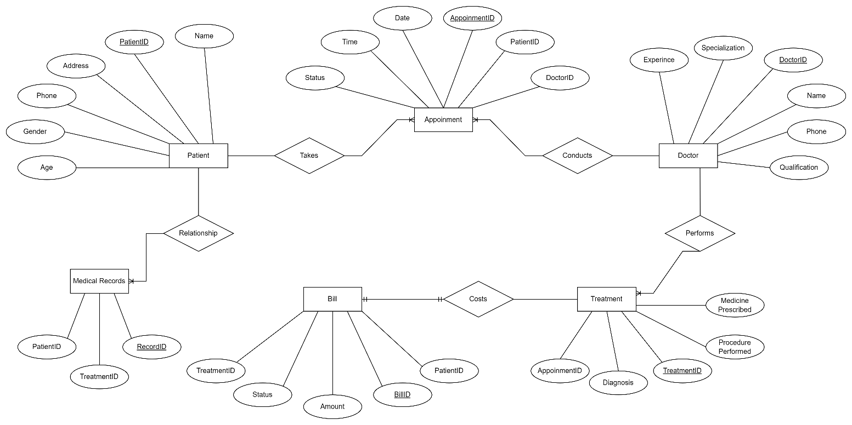

Fig. ER Diagram for CliniCare

Use Case Diagram:

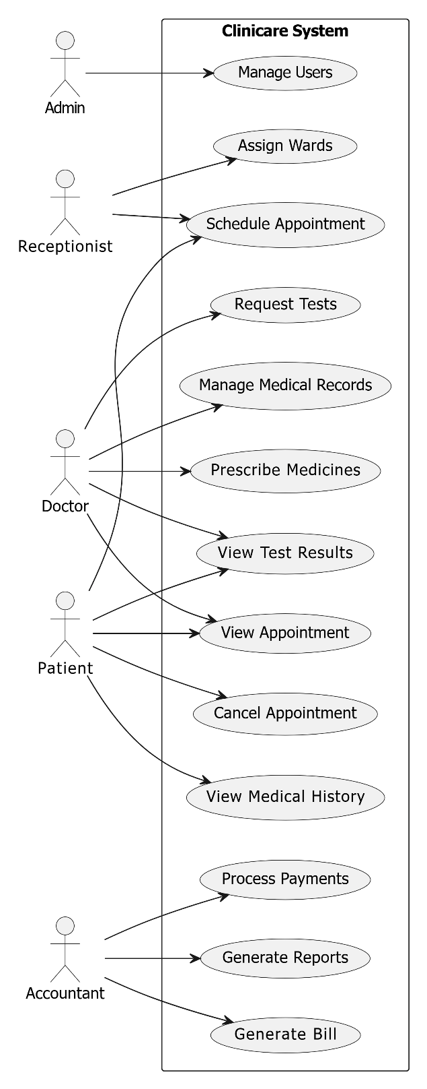

3.3 Data Flow Diagram:

DFD Level 0 :

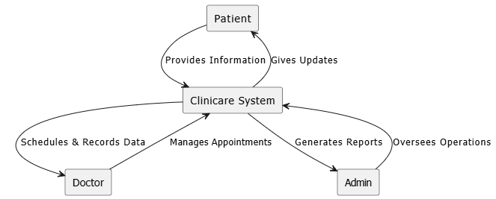

DFD Level 1:

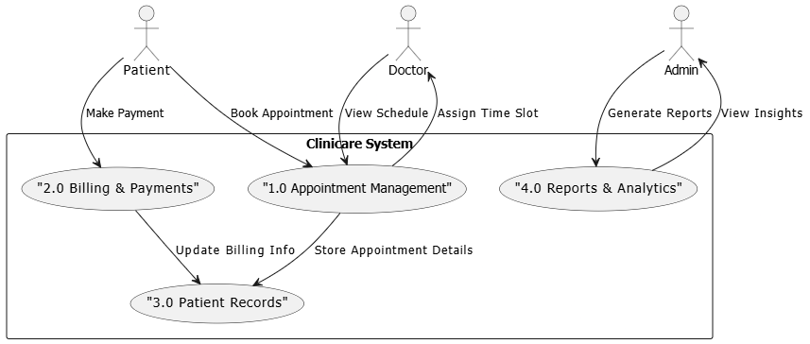

3.4 Activity Diagram:

Admin Activity Diagram:

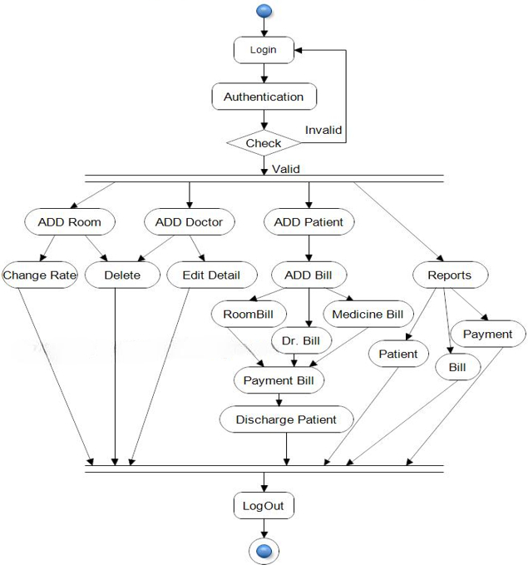

  - Class Diagram:

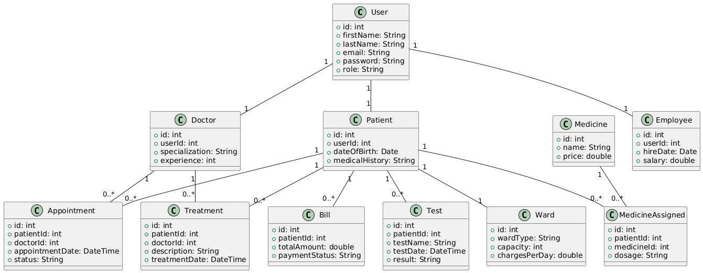

  - Sequence Diagram

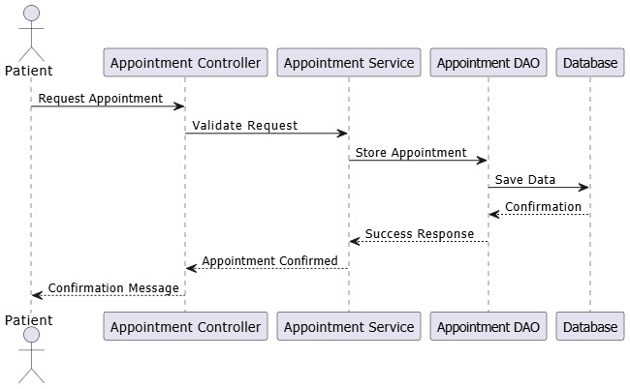

DATABASE DESIGN

Design:
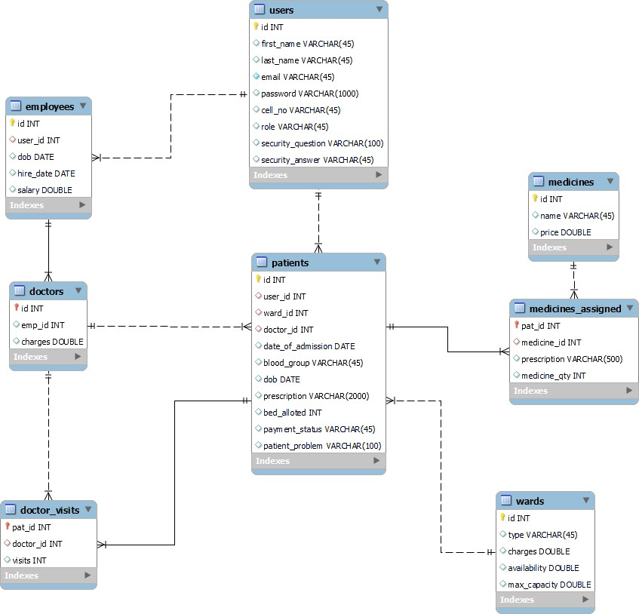

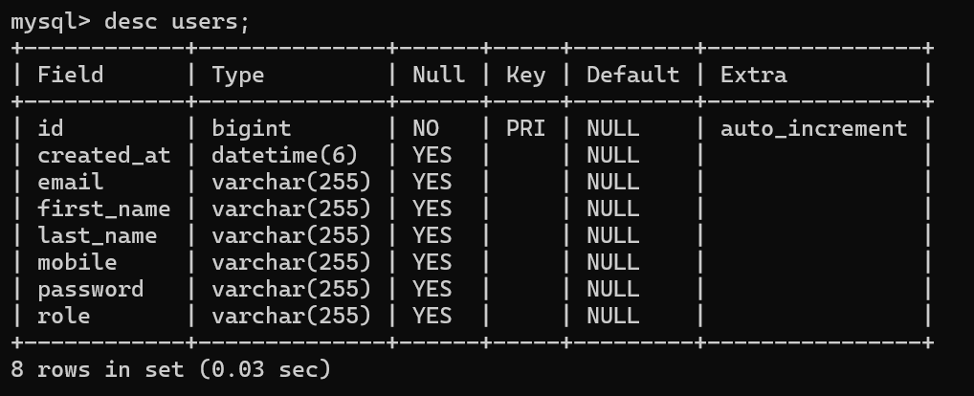
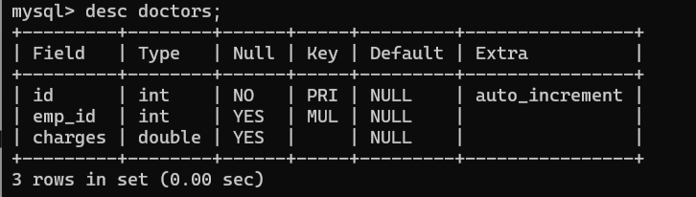

  - Tables:

The following table structures depict the database design.
Table 1: Users

Table 2: doctors

Table 1: user

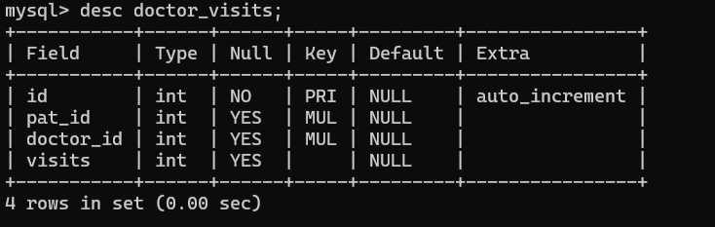
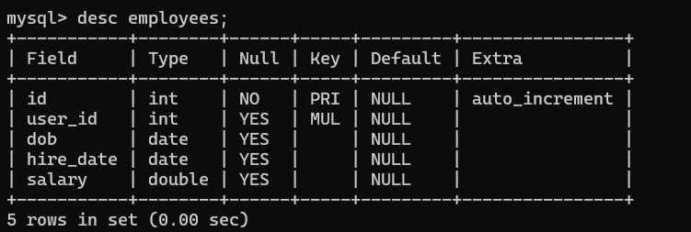
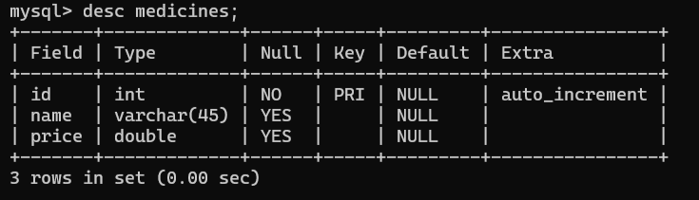

Table 3: doctors_visits

Table 4: employees

Table 5: medicines

Table 6: medicines_assigned;
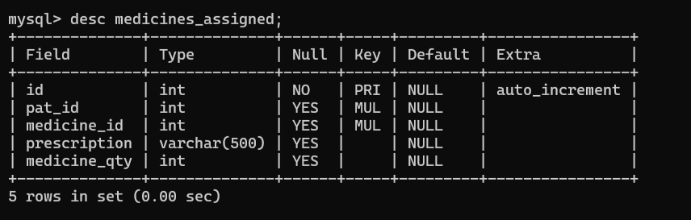

Table 7: wards

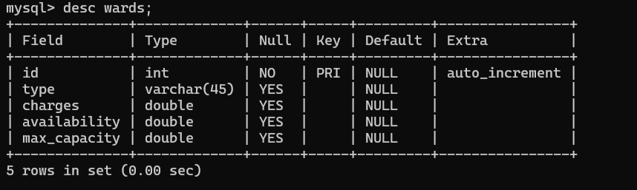

SNAPSHOTS

Home Page:

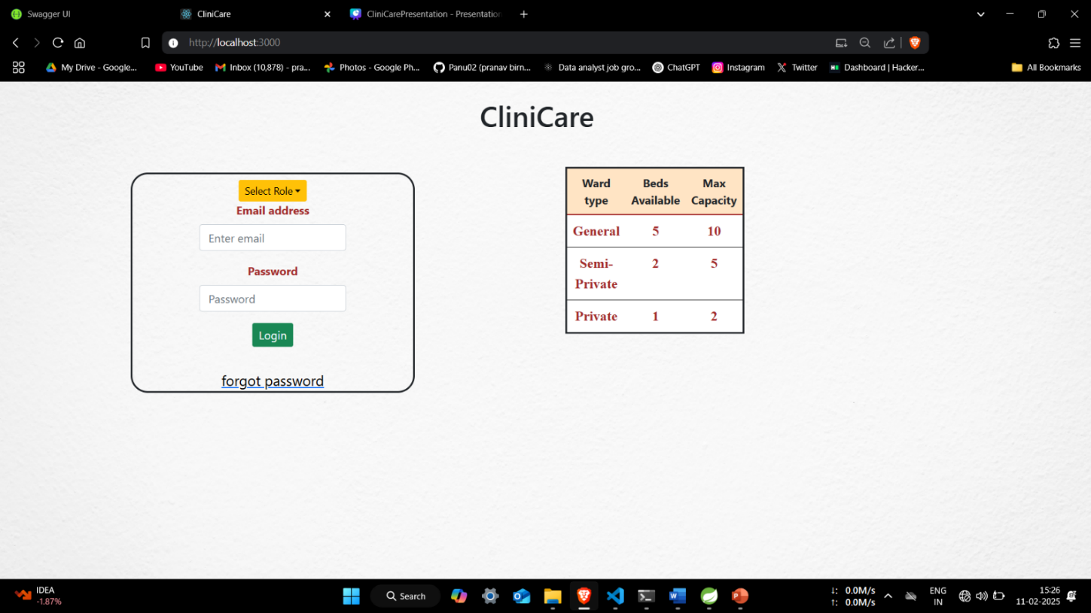

Login:

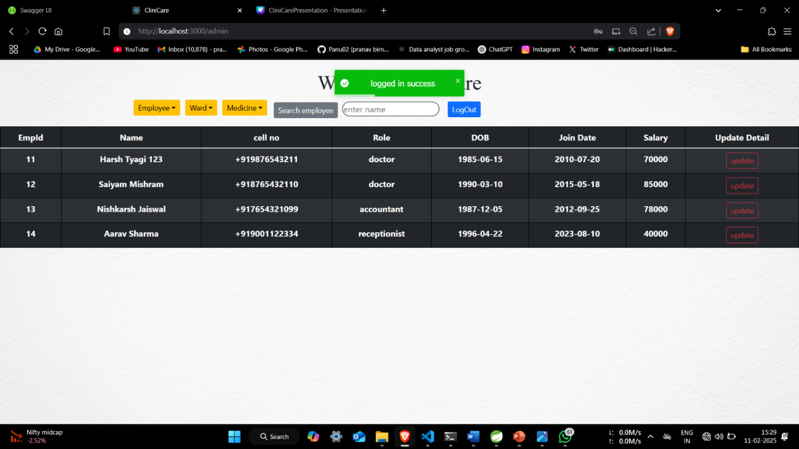

Registration:
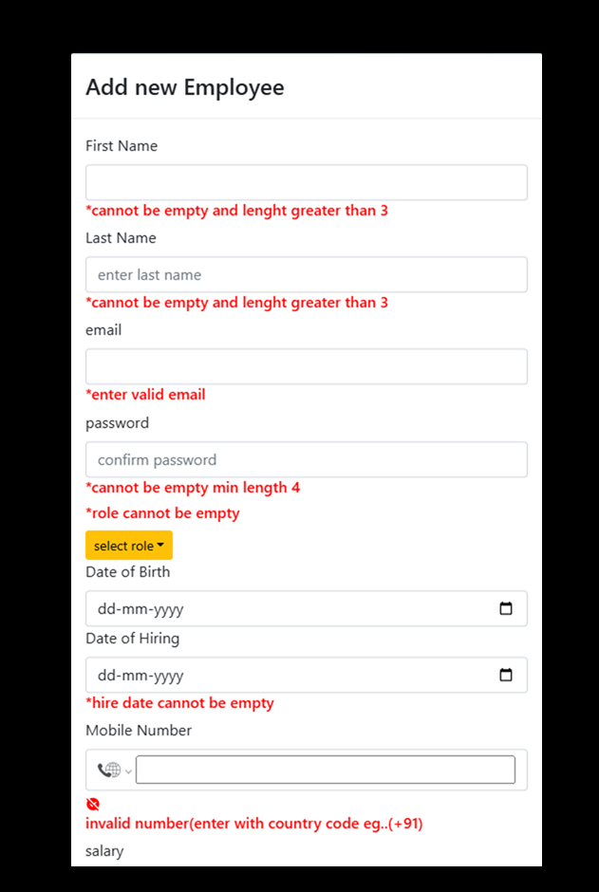
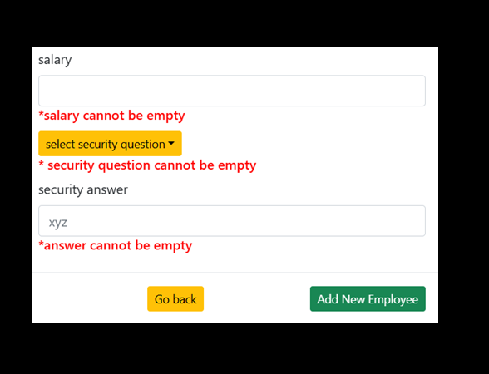

24

Patient Page :

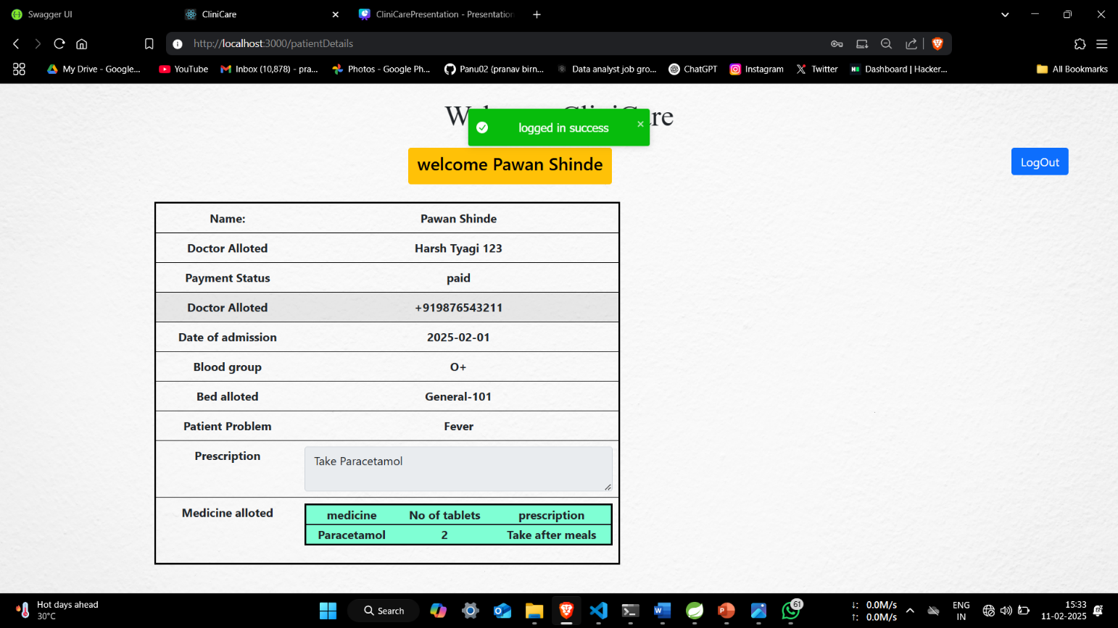

25

Add Patient :

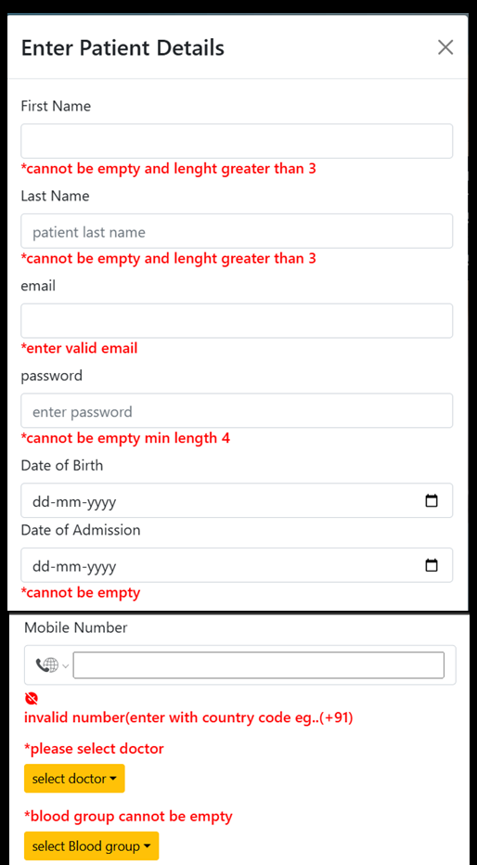

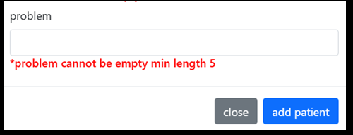

26

CONCLUSION

The Hospital Management System (CliniCare) effectively streamlines hospital operations by integrating patient registration, appointment scheduling, medical record management, billing, and ward details into a centralized platform. This system enhances efficiency by replacing traditional paper-based records with a secure, automated solution that ensures quick data retrieval and improved patient care.
By leveraging web technologies and database management systems, HMS provides a robust and user-friendly interface for administrators, doctors, receptionists, and accountants. This facilitates seamless communication, reduces administrative workload, and enables better resource management within the hospital.
The project not only simplifies hospital management tasks but also enhances doctor-patient interaction, ensuring timely and effective medical services. Its scalable and modular design allows for future improvements, making it adaptable to evolving healthcare needs and technological advancements. With its focus on efficiency, security, and usability, the Hospital Management System serves as a valuable tool for modern healthcare institutions, driving digital transformation in the medical sector.

27

Future Extensions and Scope

1 . Telemedicine Integration
  - Enable virtual consultations with doctors via video calls.
  - Secure chat for doctor-patient communication.

2. Mobile App Development
  - Android & iOS apps for seamless appointment booking and health tracking.
  - Push notifications for appointment reminders and reports.

3. Insurance and Third-Party Integrations
  - Integration with health insurance providers for direct billing.
  - Pharmacy and diagnostic lab integrations for e-prescriptions and reports.

4. Multi-Clinic & Cloud Support
  - Expand support for multiple clinics with centralized management.
  - Cloud-based solution for remote access and better scalability.

5. Enhanced Security & Compliance
  - Implementation of HIPAA, GDPR standards for better data privacy.
  - Biometric authentication for enhanced security.

28

REFERENCES

- https://docs.spring.io/spring-security/reference/
- https://docs.spring.io/spring-boot/index.html/
- https://www.amazon.com/Agile-Software-Development-Principles- Patterns/dp/0135974445
- Garcia-Molina, H., Ullman, J. D., & Widom, J. (2008). Database Systems: The Complete Book. Prentice Hall.
- Codd, E. F. (1970). A Relational Model of Data for Large Shared Data Banks. Communications of the ACM, 13(6), 377-387.
- Fowler, M. (2003). Patterns of Enterprise Application Architecture. Addison- Wesley.
- Evans, E. (2003). Domain-Driven Design: Tackling Complexity in the Heart of Software. Addison-Wesley.
- Soni, D., Nord, R. L., & Hofmeister, C. (1995). Software Architecture in Industrial Applications. Proceedings of the 17th International Conference on Software Engineering, 196-207.

29

