* 1. **Find the factorial of a number obtained through user input. Code:**

**Default.aspx.cs**

using System;

using System.Collections.Generic; using System.Linq;

using System.Web; using System.Web.UI;

using System.Web.UI.WebControls;

namespace WebApplication1

{

public partial class _Default : Page

{

protected void Page_Load(object sender, EventArgs e)

{

}

protected void txtnum_TextChanged(object sender, EventArgs e)

{

Int64 n, fact = 1;

n = Int64.Parse(txtnum.Text); for (Int64 i = 1; i <= n; i++)

{

fact *= i;

}

lblResult.Text = "the factorial of" + n + "is" + fact.ToString();

}

}

}

**Default.aspx**

<%@ Page Title="Home Page" Language="C#" MasterPageFile="~/Site.Master" AutoEventWireup="true" CodeBehind="Default.aspx.cs" Inherits="WebApplication1._Default" %>

<asp:Content ID="BodyContent" ContentPlaceHolderID="MainContent" runat="server">

<asp:TextBox runat="server">SYIT34</asp:TextBox><br /><br />

<asp:Label ID="lbmnumber" runat="server" Text="Enter a Number:"></asp:Label><br /><br />

<asp:TextBox ID="txtnum" runat="server" OnTextChanged="txtnum_TextChanged" TextMode="Number"></asp:TextBox><br /><br />

<asp:Button ID="btnClick" runat="server" Text="Generate" /><br /><br />

<asp:Label ID="lblResult" runat="server" Text=""></asp:Label>

</asp:Content>

**Output:**

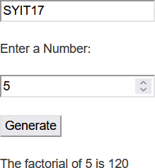

* 1. **Write a console application that obtains three int values from the user and displays the product. Code:**

**Default.aspx.cs**

using System;

using System.Collections.Generic; using System.Linq;

using System.Web; using System.Web.UI;

using System.Web.UI.WebControls;

namespace WebApplication1

{

public partial class _Default : Page

{

protected void Page_Load(object sender, EventArgs e)

{

}

protected void genProduct(object sender, EventArgs e)

{

Int32 num1, num2, num3, result; num1 = Int32.Parse(TextBox1.Text); num2 = Int32.Parse(TextBox2.Text); num3 = Int32.Parse(TextBox3.Text);

result = num1 * num2 * num3;

lblResult.Text = "The product of numbers is: " + result.ToString();

}

}

}

**Default.aspx**

<%@ Page Title="Home Page" Language="C#" MasterPageFile="~/Site.Master" AutoEventWireup="true" CodeBehind="Default.aspx.cs" Inherits="WebApplication1._Default" %>

<asp:Content ID="BodyContent" ContentPlaceHolderID="MainContent" runat="server">

<asp:TextBox runat="server">SYIT34</asp:TextBox><br /><br />

<asp:Label ID="Label1" runat="server" Text="Enter a Number 1:"></asp:Label>

<asp:TextBox ID="TextBox1" runat="server" TextMode="Number" Width="126px"></asp:TextBox><br /><br />

<asp:Label ID="Label2" runat="server" Text="Enter a Number 2:"></asp:Label>

<asp:TextBox ID="TextBox2" runat="server" TextMode="Number" Width="126px"></asp:TextBox><br /><br />

<asp:Label ID="Label3" runat="server" Text="Enter a Number 3:"></asp:Label>

<asp:TextBox ID="TextBox3" runat="server" TextMode="Number" Width="126px"></asp:TextBox><br /><br />

<asp:Button ID="btnClick" runat="server" OnClick="genProduct" Text="Generate" /><br /><br />

<asp:Label ID="lblResult" runat="server" Text=""></asp:Label><br /><br />

</asp:Content>

**Output:**

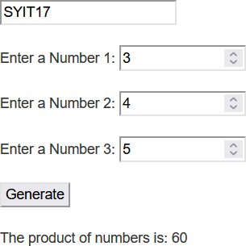

* 1. **Write application to input two variables var1 and var2 and Boolean test to see if one or the other (but not both) is greater than 10?**

**Code: Default.aspx.cs** using System;

using System.Collections.Generic; using System.Linq;

using System.Web; using System.Web.UI;

using System.Web.UI.WebControls;

namespace WebApplication1

{

public partial class _Default : Page

{

protected void Page_Load(object sender, EventArgs e)

{

}

protected void checkNum(object sender, EventArgs e)

{

Int32 num1, num2;

num1 = Int32.Parse(TextBox1.Text); num2 = Int32.Parse(TextBox2.Text);

if(num1<10)

{

lblResult.Text = num1 + " is less than 10";

}

else if(num2<10)

{

lblResult.Text = num2 + " is less than 10";

}

else

{

lblResult.Text ="Process succeded";

}

}

}

}

**Default.aspx**

<%@ Page Title="Home Page" Language="C#" MasterPageFile="~/Site.Master" AutoEventWireup="true" CodeBehind="Default.aspx.cs" Inherits="WebApplication1._Default" %>

<asp:Content ID="BodyContent" ContentPlaceHolderID="MainContent" runat="server">

<asp:TextBox runat="server">SYIT34</asp:TextBox><br /><br />

<asp:Label ID="Label1" runat="server" Text="Enter a Number 1:"></asp:Label>

<asp:TextBox ID="TextBox1" runat="server" TextMode="Number" Width="126px"></asp:TextBox><br /><br />

<asp:Label ID="Label2" runat="server" Text="Enter a Number 2:"></asp:Label>

<asp:TextBox ID="TextBox2" runat="server" TextMode="Number" Width="126px"></asp:TextBox><br /><br />

<asp:Button ID="btnClick" runat="server" OnClick="checkNum" Text="Check" /><br /><br />

<asp:Label ID="lblResult" runat="server" Text=""></asp:Label><br /><br />

</asp:Content>

**Output:**

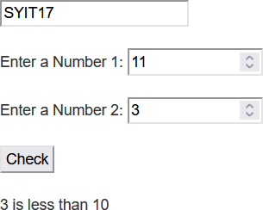

* 1. **Find the reverse of a number obtained through user input. Code:**

**Default.aspx.cs**

using System;

using System.Collections.Generic; using System.Linq;

using System.Web; using System.Web.UI;

using System.Web.UI.WebControls;

namespace WebApplication1

{

public partial class _Default : Page

{

protected void Page_Load(object sender, EventArgs e)

{

}

protected void checkNum(object sender, EventArgs e)

{

Int32 num1, rev=0, holder;

num1 = Int32.Parse(TextBox1.Text); holder = num1;

while(num1>0)

{

Int32 x = num1 % 10; rev = (rev * 10) + x;

num1 /= 10;

}

lblResult.Text = "Reverse of number " + holder + " is " + rev;

}

}

}

**Default.aspx**

<%@ Page Title="Home Page" Language="C#" MasterPageFile="~/Site.Master" AutoEventWireup="true" CodeBehind="Default.aspx.cs" Inherits="WebApplication1._Default" %>

<asp:Content ID="BodyContent" ContentPlaceHolderID="MainContent" runat="server">

<asp:TextBox runat="server">SYIT34</asp:TextBox><br /><br />

<asp:Label ID="Label1" runat="server" Text="Enter a Number 1:"></asp:Label>

<asp:TextBox ID="TextBox1" runat="server" TextMode="Number" Width="126px"></asp:TextBox><br /><br />

<asp:Button ID="btnClick" runat="server" OnClick="checkNum" Text="Generate" /><br /><br />

<asp:Label ID="lblResult" runat="server" Text=""></asp:Label><br /><br />

</asp:Content>

**Output:**

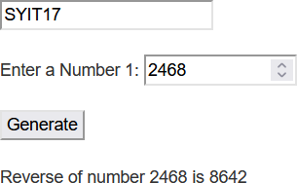

* 1. **Create an application to show the following: Factorial, Prime, Vowel, Reverse and Sum, forEach loop.**

**Code: Default.aspx.cs:**

using System;

using System.Collections.Generic; using System.Linq;

**: 02**

using System.Web; using System.Web.UI;

using System.Web.UI.WebControls;

namespace WebApplication2

{

public partial class _Default : Page

{

protected void Page_Load(object sender, EventArgs e)

{

}

protected void handleClick(object sender, EventArgs e)

{

if(dropDownList.SelectedItem.Text.Equals("Fibonacci"))

{

int n = Convert.ToInt32(inputBox.Text.ToString()); int a = 0, b = 1;

resultLabel.Text = "The fibonacci series is: "; for(int i=0; i<n; i++)

{

resultLabel.Text = resultLabel.Text + " " + a; int c = a + b;

a = b;

b = c;

}

}

else if (dropDownList.SelectedItem.Text.Equals("Prime"))

{

int n = Convert.ToInt32(inputBox.Text.ToString()); bool isPrime = true;

if(n < 2)

{

resultLabel.Text = "Better input next time";

}

else if(n == 2)

**: 02**

{

isPrime = true;

resultLabel.Text = "The number " + n + " is Prime";

}

else

{

for(int i=3; i<=n/2; i++)

{

if(n % i == 0)

{

isPrime = false;

}

}

resultLabel.Text = (isPrime) ? "The number " + n + " is Prime" : "The number " + n + " is not Prime";

}

}

else if(dropDownList.SelectedItem.Text.Equals("Vowels"))

{

char c = Convert.ToChar(inputBox.Text.ToString()); bool isVowel = "aeiouAEIOU".IndexOf(c) >= 0;

resultLabel.Text = (isVowel) ? "The character " + c + " is a vowel" : "The character " + c + " is a consonant";

}

else if(dropDownList.SelectedItem.Text.Equals("Reverse & Sum"))

{

int n = Convert.ToInt32(inputBox.Text.ToString()); int sum = 0, rev = 0, holder = n;

while(holder > 0)

{

int x = holder % 10; sum += x;

rev = (rev * 10) + x; holder /= 10;

}

resultLabel.Text = "The reverse of the number " + n + " is " + rev + "Sum of digits of " + n + " is " + sum;

}

**: 02**

else if(dropDownList.SelectedItem.Text.Equals("forEach"))

{

char c = Convert.ToChar(inputBox.Text.ToString()); String label = "Character: " + c;

resultLabel.Text = ""; foreach(char value in label)

{

resultLabel.Text = resultLabel.Text + "*" + value;

}

}

}

}

}

**Default.aspx:**

<%@ Page Title="Home Page" Language="C#" MasterPageFile="~/Site.Master" AutoEventWireup="true" CodeBehind="Default.aspx.cs" Inherits="WebApplication2._Default" %>

<asp:Content ID="BodyContent" ContentPlaceHolderID="MainContent" runat="server">

<asp:TextBox runat="server">SYIT34</asp:TextBox><br /><br />

<asp:Label ID="lbl1" runat="server" Text="Select operation: "></asp:Label>&nbsp;&nbsp;

<asp:DropDownList ID="dropDownList" runat="server">

<asp:ListItem>Fibonacci</asp:ListItem>

<asp:ListItem>Prime</asp:ListItem>

<asp:ListItem>Vowels</asp:ListItem>

<asp:ListItem>Reverse &amp; Sum</asp:ListItem>

<asp:ListItem Value="forEach"></asp:ListItem>

</asp:DropDownList><br /><br />

<asp:Label runat="server" ID="lbl2" Text="Enter the number/string/character:">&nbsp;&nbsp;</asp:Label>

<asp:TextBox runat="server" ID="inputBox"></asp:TextBox><br /><br />

<asp:Button runat="server" ID="btn1" OnClick="handleClick" Text="Submit" /><br /><br />

<asp:Label runat="server" ID="resultLabel" ></asp:Label>

</asp:Content>

**Output:**

**: 02**

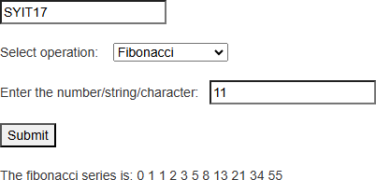

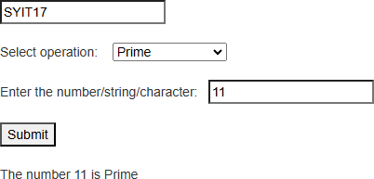

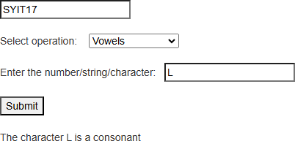

**: 02**

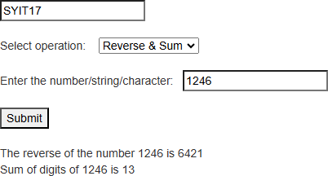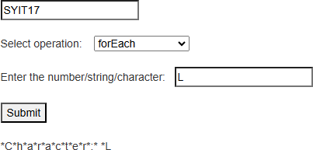

* 1. **Create a currency converter system to convert from rupees to dollars and euros. Code:**

**Converter.cs**

using System;

using System.Collections.Generic; using System.Linq;

using System.Web;

namespace MoneyConverter

{

public class Converter

{

private const double valueOfDollar = 84.43, valueOfEuro = 87.99; private double amount, dollars, euros;

**: 02**

public Converter(double amount = 100)

{

this.amount = amount;

}

public string rtd()

{

dollars = amount / valueOfDollar;

return dollars.ToString() + " Conversion rate @" + valueOfDollar;

}

public string rte()

{

euros = amount / valueOfEuro;

return euros.ToString() + " Conversion rate @" + valueOfEuro;

}

}

}

**Default.aspx.cs:**

using System;

using System.Collections.Generic; using System.Linq;

using System.Web; using System.Web.UI;

using System.Web.UI.WebControls;

namespace MoneyConverter

{

public partial class _Default : Page

{

protected void Page_Load(object sender, EventArgs e)

{

}

protected void handleClick(object sender, EventArgs e)

{

double amount = Convert.ToDouble(inputbox.Text.ToString()); Converter obj = new Converter(amount);

**: 02**

resultLabel.Text = "Rupees to Dollar: " + obj.rtd() + "<br />Rupees to Euros: " + obj.rte();

}

}

}

**Default.aspx**

<%@ Page Title="Home Page" Language="C#" MasterPageFile="~/Site.Master" AutoEventWireup="true" CodeBehind="Default.aspx.cs" Inherits="MoneyConverter._Default" %>

<asp:Content ID="BodyContent" ContentPlaceHolderID="MainContent" runat="server">

<asp:Label Text="Money Converter" runat="server" /><br /><br />

<asp:Label runat="server" Text="Enter the amount: "></asp:Label>&nbsp;&nbsp;

<asp:TextBox runat="server" ID="inputbox"></asp:TextBox><br /><br />

<asp:Button ID="btn1" runat="server" Text="Convert" onClick="handleClick" /><br /><br />

<asp:Label runat="server" ID="resultLabel"></asp:Label>

</asp:Content>

**Output:**

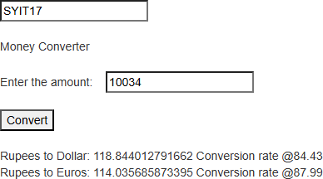

* 1. **Create a class Quadratic that solves the quadratic equation.**

**Code: Quadratic.cs:**

using System;

using System.Collections.Generic; using System.Linq;

**: 02**

using System.Web;

namespace QuadEq

{

public class Quadratic

{

public static string calc(int num1, int num2, int num3)

{

double d = num2 * num2 - (4 * num1 * num3); if(d == 0)

{

double x, y;

x = num2 / (2 * num1); y = x;

string message = "Both roots are equal<br />1st root: " + x + "<br />2nd root: " + y; return message;

}

else if(d > 0)

{

double x, y;

x = (-num2 + Math.Sqrt(d)) / (2 * num1); y = (-num2 - Math.Sqrt(d)) / (2 * num1);

string message = "Both roots are different<br />1st root: " + x + "<br />2nd root: " + y; return message;

}

else

{

return "Roots are imaginary, no solution";

}

}

}

}

**Default.aspx.cs:**

using System;

using System.Collections.Generic; using System.Linq;

**: 02**

using System.Web; using System.Web.UI;

using System.Web.UI.WebControls;

namespace QuadEq

{

public partial class _Default : Page

{

protected void Page_Load(object sender, EventArgs e)

{

}

protected void handleClick(object sender, EventArgs e)

{

int num1, num2, num3;

num1 = Convert.ToInt32(inputbox1.Text.ToString()); num2 = Convert.ToInt32(inputbox2.Text.ToString()); num3 = Convert.ToInt32(inputbox3.Text.ToString());

string result = Quadratic.calc(num1, num2, num3); resultLabel.Text = result;

}

}

}

**Default.aspx:**

<%@ Page Title="Home Page" Language="C#" MasterPageFile="~/Site.Master" AutoEventWireup="true" CodeBehind="Default.aspx.cs" Inherits="QuadEq._Default" %>

<asp:Content ID="BodyContent" ContentPlaceHolderID="MainContent" runat="server">

<asp:TextBox runat="server">SYIT34</asp:TextBox><br /><br />

<asp:Label Text="Quadratic equation solver" runat="server" />&nbsp;&nbsp;<br /><br />

<asp:Label Text="Enter 1st number:" runat="server" />&nbsp;&nbsp;

<asp:TextBox runat="server" ID="inputbox1"/><br /><br />

<asp:Label Text="Enter 1st number:" runat="server" />&nbsp;&nbsp;

<asp:TextBox runat="server" ID="inputbox2"/><br /><br />

<asp:Label Text="Enter 1st number:" runat="server" />&nbsp;&nbsp;

**: 02**

<asp:TextBox runat="server" ID="inputbox3"/><br /><br />

<asp:Button Text="Calculate" ID="btn1" OnClick="handleClick" runat="server" /><br /><br />

<asp:Label ID="resultLabel" runat="server" />

</asp:Content>

**Output:**

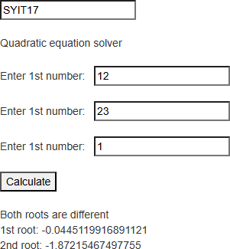

* 1. **Write a program to show function overloading. Code:**

**Func.cs:**

using System;

using System.Collections.Generic; using System.Linq;

using System.Web;

namespace FuncOverloading

{

public class Func

{

public static int add(int a, int b)

{

**: 02**

return a + b;

}

public static int add(int a, int b, int c)

{

return a + b + c;

}

public static float add(float a, float b)

{

return a + b;

}

public static float add(float a, float b, float c)

{

return a + b + c;

}

}

}

**Default.aspx.cs:**

using System;

using System.Collections.Generic; using System.Linq;

using System.Web; using System.Web.UI;

using System.Web.UI.WebControls;

namespace FuncOverloading

{

public partial class _Default : Page

{

protected void Page_Load(object sender, EventArgs e)

{

}

protected void handleClick(object sender, EventArgs e)

{

int a = 10, b = 15, c = 20; float x = 10f, y = 15f, z = 20f;

**: 02**

Label2.Text = Func.add(a, b).ToString(); Label4.Text = Func.add(a, b, c).ToString(); Label6.Text = Func.add(x, y).ToString(); Label8.Text = Func.add(x, y, z).ToString();

}

}

}

**Default.aspx:**

<%@ Page Title="Home Page" Language="C#" MasterPageFile="~/Site.Master" AutoEventWireup="true" CodeBehind="Default.aspx.cs" Inherits="FuncOverloading._Default" %>

<asp:Content ID="BodyContent" ContentPlaceHolderID="MainContent" runat="server">

<asp:Label Text="Function 1" ID="Label1" runat="server" />&nbsp;&nbsp;

<asp:Label ID="Label2" runat="server" /><br /><br />

<asp:Label Text="Function 2" ID="Label3" runat="server" />&nbsp;&nbsp;

<asp:Label ID="Label4" runat="server" /><br /><br />

<asp:Label Text="Function 3" ID="Label5" runat="server" />&nbsp;&nbsp;

<asp:Label ID="Label6" runat="server" /><br /><br />

<asp:Label Text="Function 4" ID="Label7" runat="server" />&nbsp;&nbsp;

<asp:Label ID="Label8" runat="server" /><br /><br />

<asp:Button Text="Overload" OnClick="handleClick" runat="server" />

</asp:Content>

**Output:**

**: 02**

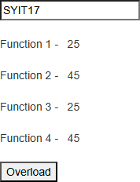

* 1. **Create a program to demonstrate single inheritance.**

**Code: Inheritance.cs:**

using System;

using System.Collections.Generic; using System.Linq;

using System.Web;

namespace WebApplication3

{

public class Parent

{

public string getParentMessage()

{

return "This is parent class";

}

}

public class Child: Parent

{

public string getChildMessage()

{

return "This is child class";

}

}

**25/11/2024**

**: 03**

}

**Default.aspx.cs:**

using System;

using System.Collections.Generic; using System.Linq;

using System.Web; using System.Web.UI;

using System.Web.UI.WebControls;

namespace WebApplication3

{

public partial class _Default : Page

{

protected void Page_Load(object sender, EventArgs e)

{

}

protected void handleClick(object sender, EventArgs e)

{

Parent p = new Parent();

Label1.Text = "Calling parent method from parent class: " + p.getParentMessage(); Child c = new Child();

Label2.Text = "Calling parent method from child class: " + c.getParentMessage(); Label3.Text = "Calling child method from child class: " + c.getChildMessage();

}

}

}

**Default.aspx:**

<%@ Page Title="Home Page" Language="C#" MasterPageFile="~/Site.Master" AutoEventWireup="true" CodeBehind="Default.aspx.cs" Inherits="WebApplication3._Default" %>

<asp:Content ID="BodyContent" ContentPlaceHolderID="MainContent" runat="server">

<asp:TextBox runat="server" >SYIT34</asp:TextBox><br /><br />

<asp:Label Text="Function 1" ID="Label1" runat="server" /><br /><br />

<asp:Label Text="Function 2" ID="Label2" runat="server" /><br /><br />

<asp:Label Text="Function 3" ID="Label3" runat="server" /><br /><br />

<asp:Button Text="Single Inheritance" OnClick="handleClick" runat="server" />

**25/11/2024**

**: 03**

</asp:Content>

**Output:**

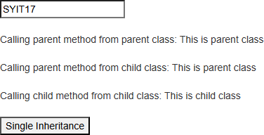

* 1. **Create a program to demonstrate multilevel inheritance.**

**Code: Inheritance.cs:**

using System;

using System.Collections.Generic; using System.Linq;

using System.Web;

namespace WebApplication3

{

public class Parent

{

public string getParentMessage()

{

return "This is parent class";

}

}

public class Child: Parent

{

public string getChildMessage()

{

return "This is child class";

**25/11/2024**

**: 03**

}

}

public class ThirdChild: Child

{

public string getThirdChildMessage()

{

return "This is the 3rd child class";

}

}

}

**Default.aspx.cs:**

using System;

using System.Collections.Generic; using System.Linq;

using System.Web; using System.Web.UI;

using System.Web.UI.WebControls;

namespace WebApplication3

{

public partial class _Default : Page

{

protected void Page_Load(object sender, EventArgs e)

{

}

protected void handleClick(object sender, EventArgs e)

{

ThirdChild tc = new ThirdChild(); Label1.Text = tc.getParentMessage(); Label2.Text = tc.getChildMessage(); Label3.Text = tc.getThirdChildMessage();

}

}

}

**Default.aspx:**

<%@ Page Title="Home Page" Language="C#" MasterPageFile="~/Site.Master" AutoEventWireup="true"

**25/11/2024**

**: 03**

CodeBehind="Default.aspx.cs" Inherits="WebApplication3._Default" %>

<asp:Content ID="BodyContent" ContentPlaceHolderID="MainContent" runat="server">

<asp:TextBox runat="server" >SYIT34</asp:TextBox><br /><br />

<asp:Label Text="Function 1" ID="Label1" runat="server" /><br /><br />

<asp:Label Text="Function 2" ID="Label2" runat="server" /><br /><br />

<asp:Label Text="Function 3" ID="Label3" runat="server" /><br /><br />

<asp:Button Text="Multilevel Inheritance" OnClick="handleClick" runat="server" />

</asp:Content>

**Output:**

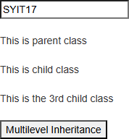

* 1. **Create a program to demonstrate multiple inheritance.**

**Code: Inheritance.cs:**

using System;

using System.Collections.Generic; using System.Linq;

using System.Web;

namespace WebApplication3

{

public class Rect

**25/11/2024**

**: 03**

{

protected double length, breadth;

public Rect(double length, double breadth)

{

this.length = length; this.breadth = breadth;

}

}

public interface Calculate

{

double area();

}

public class MultiInheritance: Rect, Calculate

{

public MultiInheritance(double length, double breadth): base(length, breadth)

{

}

public double area()

{

return length * breadth;

}

}

}

**Default.aspx.cs:**

using System;

using System.Collections.Generic; using System.Linq;

using System.Web; using System.Web.UI;

using System.Web.UI.WebControls;

namespace WebApplication3

{

public partial class _Default : Page

{

**25/11/2024**

**: 03**

protected void Page_Load(object sender, EventArgs e)

{

}

protected void handleClick(object sender, EventArgs e)

{

MultiInheritance obj = new MultiInheritance( Convert.ToDouble(inputbox1.Text.ToString()), Convert.ToDouble(inputbox2.Text.ToString())

);

resultLabel.Text = "Area is: " + obj.area() + "sq.cm";

}

}

}

**Default.aspx:**

<%@ Page Title="Home Page" Language="C#" MasterPageFile="~/Site.Master" AutoEventWireup="true" CodeBehind="Default.aspx.cs" Inherits="WebApplication3._Default" %>

<asp:Content ID="BodyContent" ContentPlaceHolderID="MainContent" runat="server">

<asp:TextBox runat="server" >SYIT34</asp:TextBox><br /><br />

<asp:Label Text="Enter length:" runat="server" />&nbsp;&nbsp;

<asp:TextBox runat="server" ID="inputbox1"/><br /><br />

<asp:Label Text="Enter breadth:" runat="server" />&nbsp;&nbsp;

<asp:TextBox runat="server" ID="inputbox2"/><br /><br />

<asp:Button Text="Multiple Inheritance" OnClick="handleClick" runat="server" /><br /><br />

<asp:Label ID="resultLabel" runat="server" /><br /><br />

</asp:Content>

**Output:**

**25/11/2024**

**: 03**

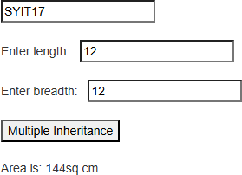

* 1. **Create a program to demonstrate hierarchical inheritance.**

**Code: Heirarchical.cs:**

using System;

using System.Collections.Generic; using System.Linq;

using System.Web;

namespace WebApplication4

{

public class Parent

{

public string showParent()

{

return "This is parent class";

}

}

public class Child1: Parent

{

public string showChild1()

{

return "1st child class";

}

}

**26/11/2024**

**: 04**

public class Child2 : Parent

{

public string showChild2()

{

return "2nd child class";

}

}

}

**Default.aspx.cs**

using System;

using System.Collections.Generic; using System.Linq;

using System.Web; using System.Web.UI;

using System.Web.UI.WebControls;

namespace WebApplication4

{

public partial class _Default : Page

{

protected void Page_Load(object sender, EventArgs e)

{

}

protected void handleClick(object sender, EventArgs e)

{

Child1 obj1 = new Child1(); Child2 obj2 = new Child2();

label1.Text = obj1.showParent() + " called from " + obj1.showChild1(); label2.Text = obj2.showParent() + " called from " + obj2.showChild2();

}

}

}

**Default.aspx**

<%@ Page Title="Home Page" Language="C#" MasterPageFile="~/Site.Master" AutoEventWireup="true"

**26/11/2024**

**: 04**

CodeBehind="Default.aspx.cs" Inherits="WebApplication4._Default" %>

<asp:Content ID="BodyContent" ContentPlaceHolderID="MainContent" runat="server">

<asp:TextBox runat="server" >SYIT34</asp:TextBox><br /><br />

<asp:Label ID="label1" runat="server" /><br /><br />

<asp:Label ID="label2" runat="server" /><br /><br />

<asp:Button Text="Heirarchical Inheritance" onClick="handleClick" ID="btn1" runat="server" />

</asp:Content>

**Output:**

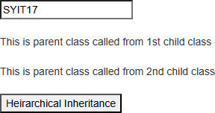

* 1. **Show constructor overloading in a C# program.**

**Code: Constructor.cs:**

using System;

using System.Collections.Generic; using System.Linq;

using System.Web;

namespace WebApplication4

{

public class Marksheet

{

private float sub1, sub2, sub3;

public Marksheet()

{

this.sub1 = 20;

**26/11/2024**

**: 04**

this.sub2 = 30;

this.sub3 = 40;

}

public Marksheet(float sub1)

{

this.sub1 = sub1; this.sub2 = 0;

this.sub3 = 0;

}

public Marksheet(float sub1, float sub2)

{

this.sub1 = sub1; this.sub2 = sub2; this.sub3 = 0;

}

public Marksheet(float sub1, float sub2,float sub3)

{

this.sub1 = sub1; this.sub2 = sub2; this.sub3 = sub3;

}

public float getMarks()

{

return sub1 + sub2 + sub3;

}

}

}

**Default.aspx.cs:**

using System;

using System.Collections.Generic; using System.Linq;

using System.Web; using System.Web.UI;

using System.Web.UI.WebControls;

namespace WebApplication4

**26/11/2024**

**: 04**

{

public partial class _Default : Page

{

protected void Page_Load(object sender, EventArgs e)

{

}

protected void handleClick(object sender, EventArgs e)

{

Marksheet m1 = new Marksheet(); Marksheet m2 = new Marksheet(10); Marksheet m3 = new Marksheet(10, 20); Marksheet m4 = new Marksheet(10, 20, 30);

label1.Text = "Marks Obtained = " + m1.getMarks(); label2.Text = "Marks Obtained = " + m2.getMarks(); label3.Text = "Marks Obtained = " + m3.getMarks(); label4.Text = "Marks Obtained = " + m4.getMarks();

}

}

}

**Default.aspx:**

<%@ Page Title="Home Page" Language="C#" MasterPageFile="~/Site.Master" AutoEventWireup="true" CodeBehind="Default.aspx.cs" Inherits="WebApplication4._Default" %>

<asp:Content ID="BodyContent" ContentPlaceHolderID="MainContent" runat="server">

<asp:TextBox runat="server" >SYIT34</asp:TextBox><br /><br />

<asp:Label ID="label1" runat="server" /><br /><br />

<asp:Label ID="label2" runat="server" /><br /><br />

<asp:Label ID="label3" runat="server" /><br /><br />

<asp:Label ID="label4" runat="server" /><br /><br />

<asp:Button Text="Constructor Overloading" onClick="handleClick" ID="btn1" runat="server" />

</asp:Content>

**Output:**

**26/11/2024**

**: 04**

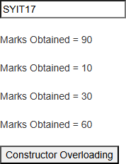

* 1. **Create an interface and show its workings.**

**Code:**

**Interface.cs**

using System;

using System.Collections.Generic; using System.Linq;

using System.Web;

namespace WebApplication4

{

public interface Area

{

float area();

}

public class Circle : Area

{

float r;

public Circle(float r = 0)

{

this.r = r;

}

public float area()

**26/11/2024**

**: 04**

{

return 3.14f * r * r;

}

}

}

**Default.aspx.cs**

using System;

using System.Collections.Generic; using System.Linq;

using System.Web; using System.Web.UI;

using System.Web.UI.WebControls;

namespace WebApplication4

{

public partial class _Default : Page

{

protected void Page_Load(object sender, EventArgs e)

{

}

protected void handleClick(object sender, EventArgs e)

{

Circle obj = new Circle(float.Parse(inputbox1.Text.ToString())); resultLabel.Text = "Area of Circle: " + obj.area() + "sq.cm";

}

}

}

**Default.aspx**

<%@ Page Title="Home Page" Language="C#" MasterPageFile="~/Site.Master" AutoEventWireup="true" CodeBehind="Default.aspx.cs" Inherits="WebApplication4._Default" %>

<asp:Content ID="BodyContent" ContentPlaceHolderID="MainContent" runat="server">

<asp:TextBox runat="server" >SYIT34</asp:TextBox><br /><br />

<asp:Label runat="server" >Enter the radius: </asp:Label>&nbsp;&nbsp;

<asp:TextBox runat="server" ID="inputbox1" /><br /><br />

**26/11/2024**

**: 04**

<asp:Button Text="Calculate" onClick="handleClick" ID="btn1" runat="server" /><br /><br />

<asp:Label ID="resultLabel" runat="server" /><br /><br />

</asp:Content>

**Output:**

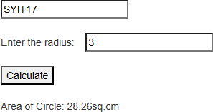

* 1. **Display a message using calendar controls.**

**Code: Default.aspx.cs:**

using System;

using System.Collections.Generic; using System.Linq;

using System.Web; using System.Web.UI;

using System.Web.UI.WebControls;

namespace WebApplication2

{

public partial class _Default : Page

{

protected void Page_Load(object sender, EventArgs e)

{

}

protected void calendarDayRender(object sender, DayRenderEventArgs e)

{

if(e.Day.Date == new DateTime(2024, 11, 14))

{

e.Cell.Controls.Add(new LiteralControl("<br/>Children's Day"));

**26/11/2024**

**: 04**

}

if (e.Day.Date == new DateTime(2024, 11, 01))

{

e.Cell.Controls.Add(new LiteralControl("<br/>Diwali"));

}

}

}

}

**Default.aspx:**

<%@ Page Title="Home Page" Language="C#" MasterPageFile="~/Site.Master" AutoEventWireup="true" CodeBehind="Default.aspx.cs" Inherits="WebApplication2._Default" %>

<asp:Content ID="BodyContent" ContentPlaceHolderID="MainContent" runat="server">

<asp:TextBox runat="server" >SYIT34</asp:TextBox><br /><br />

<asp:Calendar runat="server" ID="calendar" FirstDayOfWeek="Sunday" NextPrevFormat="CustomText" OnDayRender="calendarDayRender" TitleFormat="Month" ></asp:Calendar>

</asp:Content>

**Output:**

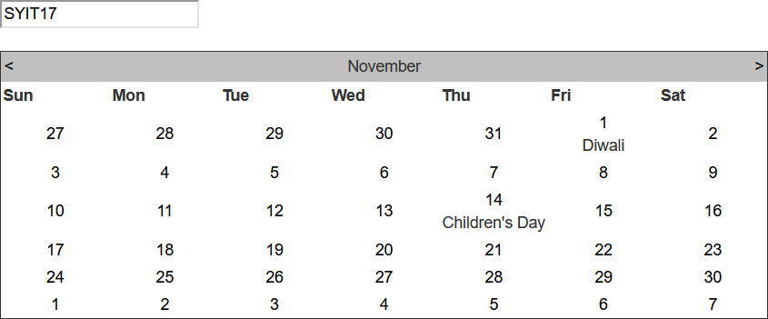

* 1. **Display holidays using calendar controls.**

**Code:**

**26/11/2024**

**: 04**

**Default.aspx.cs**

using System;

using System.Collections.Generic; using System.Linq;

using System.Web; using System.Web.UI;

using System.Web.UI.WebControls;

namespace WebApplication2

{

public partial class _Default : Page

{

protected void Page_Load(object sender, EventArgs e)

{

}

protected void calendarDayRender(object sender, DayRenderEventArgs e)

{

if (

)

{

}

}

}

}

(e.Day.Date >= new DateTime(2024, 11, 14)) && (e.Day.Date <= new DateTime(2024, 11, 18))

|| e.Day.Date.DayOfWeek == DayOfWeek.Sunday

e.Cell.BackColor = System.Drawing.Color.LightSteelBlue;

**Default.aspx**

<%@ Page Title="Home Page" Language="C#" MasterPageFile="~/Site.Master" AutoEventWireup="true" CodeBehind="Default.aspx.cs" Inherits="WebApplication2._Default" %>

<asp:Content ID="BodyContent" ContentPlaceHolderID="MainContent" runat="server">

<asp:TextBox runat="server" >SYIT34</asp:TextBox><br /><br />

<asp:Calendar runat="server" ID="calendar" FirstDayOfWeek="Sunday" BackColor="Salmon" BorderColor="Black" NextPrevFormat="CustomText" OnDayRender="calendarDayRender" TitleFormat="Month" ></asp:Calendar>

**26/11/2024**

**: 04**

</asp:Content>

**Output:**

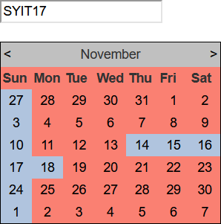

* 1. **Display selected day in calendar controls using only styles.**

**Code: Default.aspx.cs** using System;

using System.Collections.Generic; using System.Linq;

using System.Web; using System.Web.UI;

using System.Web.UI.WebControls;

namespace WebApplication2

{

public partial class _Default : Page

{

protected void Page_Load(object sender, EventArgs e)

{

**26/11/2024**

**: 04**

}

protected void calendarDayRender(object sender, DayRenderEventArgs e)

{

}

}

}

**Default.aspx**

<%@ Page Title="Home Page" Language="C#" MasterPageFile="~/Site.Master" AutoEventWireup="true" CodeBehind="Default.aspx.cs" Inherits="WebApplication2._Default" %>

<asp:Content ID="BodyContent" ContentPlaceHolderID="MainContent" runat="server">

<asp:TextBox runat="server" >SYIT34</asp:TextBox><br /><br />

<asp:Calendar runat="server" ID="calendar" FirstDayOfWeek="Sunday" ShowGridLines="true" NextPrevFormat="CustomText" OnDayRender="calendarDayRender" TitleFormat="Month" SelectedDayStyleBackColor="Maroon" DayHeaderStyle-BorderColor="Wheat" BorderStyle="Dotted"></asp:Calendar>

</asp:Content>

**Output:**

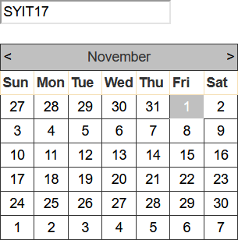

* 1. **Display the difference between 2 dates.**

**26/11/2024**

**: 04**

**Code: Default.aspx.cs** using System;

using System.Collections.Generic; using System.Linq;

using System.Web; using System.Web.UI;

using System.Web.UI.WebControls;

namespace WebApplication2

{

public partial class _Default : Page

{

protected void Page_Load(object sender, EventArgs e)

{

}

protected void handleClick(object sender, EventArgs e)

{

TimeSpan t = calendar2.SelectedDate - calendar1.SelectedDate; resultLabel.Text = "Difference between the 2 dates is: " + t;

}

}

}

**Default.aspx**

<%@ Page Title="Home Page" Language="C#" MasterPageFile="~/Site.Master" AutoEventWireup="true" CodeBehind="Default.aspx.cs" Inherits="WebApplication2._Default" %>

<asp:Content ID="BodyContent" ContentPlaceHolderID="MainContent" runat="server">

<asp:TextBox runat="server" >SYIT34</asp:TextBox><br /><br />

<asp:Calendar ID="calendar1" FirstDayOfWeek="Sunday" TitleFormat="Month" runat="server" BackColor="LavenderBlush" Caption="Calendar 1" />

<asp:Calendar ID="calendar2" FirstDayOfWeek="Sunday" TitleFormat="Month" runat="server" BackColor="LavenderBlush" Caption="Calendar 2" /><br />

<asp:Button Text="Calculate" ID="btn1" OnClick="handleClick" runat="server" /><br /><br />

<asp:Label ID="resultLabel" runat="server" />

**26/11/2024**

**: 04**

</asp:Content>

**Output:**

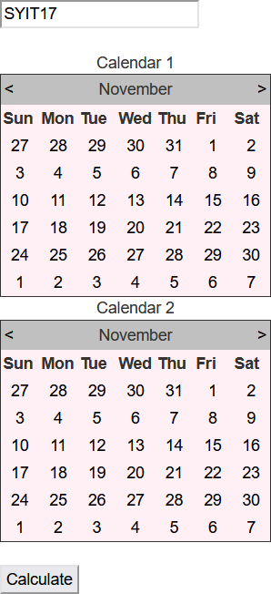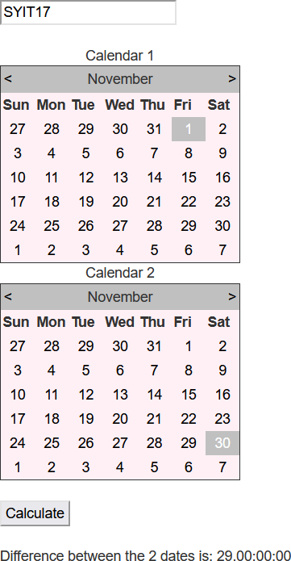

Q1. Create a simple web program with various server controls to demonstrate setting and use of their properties.

**Default.aspx.cs:**

using System;

**27/11/24**

**:**

**: 5**

using System.Collections.Generic; using System.Linq;

using System.Web; using System.Web.UI;

using System.Web.UI.WebControls;

namespace wfc

{

public partial class _Default : Page

{

protected void Page_Load(object sender, EventArgs e)

{

}

protected void Button1_Click(object sender, EventArgs e)

{

string s;

if (rb1.Checked == true)

{

s = rb1.Text;

}

else if (rb2.Checked == true)

{

s = rb2.Text;

}

else

{

s = rb3.Text;

}

res.Text = "You've been enrolled in " + s + "" + ddl1.SelectedItem + ".";

}

}

}

**27/11/24**

**:**

**: 5 Default.aspx:**

<%@ Page Title="Home Page" Language="C#" MasterPageFile="~/Site.Master" AutoEventWireup="true" CodeBehind="Default.aspx.cs" Inherits="wfc._Default" %>

<asp:Content ID="BodyContent" ContentPlaceHolderID="MainContent" runat="server">

<div class="jumbotron">

<asp:Label ID="Label1" runat="server" Text="Name: "></asp:Label>&nbsp;

<asp:TextBox ID="TextBox1" runat="server"></asp:TextBox> <br />

<asp:Label ID="Label2" runat="server" Text="Roll no: "></asp:Label>

<asp:TextBox ID="TextBox2" runat="server"></asp:TextBox><br />

<asp:Label ID="Label3" runat="server" Text="Class: "></asp:Label>

<asp:RadioButton ID="rb1" runat="server" Text="FY" />&nbsp;&nbsp;

<asp:RadioButton ID="rb2" runat="server" Text="SY" />&nbsp;&nbsp;

<asp:RadioButton ID="rb3" runat="server" Text="TY" /><br />

<asp:Label ID="Label4" runat="server" Text="Course: "></asp:Label>

<asp:DropDownList ID="ddl1" runat="server">

<asp:ListItem>BSC(IT)</asp:ListItem>

<asp:ListItem>BSC(CS)</asp:ListItem>

<asp:ListItem>BMS</asp:ListItem>

</asp:DropDownList><br />

&nbsp;&nbsp;&nbsp;&nbsp;&nbsp;&nbsp;&nbsp;<asp:Button ID="Button1" runat="server" Text="SUBMIT" OnClick="Button1_Click" /><br />

<asp:Label ID="res" runat="server" Text=" "></asp:Label>

</div>

</asp:Content>

**OUTPUT:**

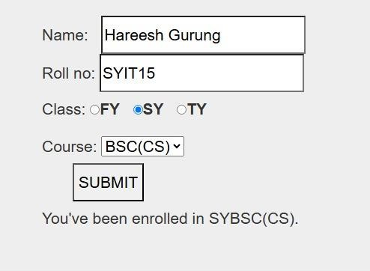

**29/11/24**

**:**

**: 6**

Q1. Demonstrate the use of Delegate with Web Application.

**CODE:**

**Default.aspx:**

<%@ Page Title="Home Page" Language="C#" MasterPageFile="~/Site.Master" AutoEventWireup="true" CodeBehind="Default.aspx.cs" Inherits="pr1._Default" %>

<asp:Content ID="BodyContent" ContentPlaceHolderID="MainContent" runat="server">

<asp:Label ID="Label3" runat="server" Text="Hareesh"></asp:Label><br /><br />

<asp:Label ID="Label1" runat="server" Text=" "></asp:Label><br /><br />

<asp:Label ID="Label2" runat="server" Text=" "></asp:Label><br /><br />

<asp:Button ID="Button1" runat="server" OnClick="Button1_Click" Text="Button" />

</asp:Content>

**Default.aspx.cs:**

using System;

using System.Collections.Generic; using System.Linq;

using System.Web; using System.Web.UI;

using System.Web.UI.WebControls;

namespace pr1

{

public partial class _Default : Page

{

protected void Page_Load(object sender, EventArgs e)

{}

public delegate void SimpleDelegate(); public void firstfunction()

{

Label1.Text = "1st funtion called through simpledelegate() method <br>";

}

public void secondfunction()

{

Label2.Text = "2nd funtion called through simpledelegate() method <br>";

}

protected void Button1_Click(object sender, EventArgs e)

{

SimpleDelegate d1 = new SimpleDelegate(firstfunction); d1();

SimpleDelegate d2 = new SimpleDelegate(secondfunction); d2();

}

}

}

**29/11/24**

**:**

**: 6 OUTPUT:**

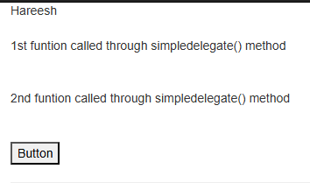

**29/11/24**

**:**

**: 6**

Q2. Demonstrate the use of Delegate with Console Application.

**CODE:**

**Program.cs**

using System;

using System.Collections.Generic; using System.Linq;

using System.Text;

using System.Threading.Tasks;

namespace ConsoleApplication7

{

delegate string strMethod(string str); class DelegateTest

{

static string ReplaceSpaces(string s)

{

Console.WriteLine("Changing Spaces with -"); return s.Replace(' ', '-');

}

static string RemoveSpaces(string s)

{

string temp = ""; int i;

Console.WriteLine("Removing Spaces"); for (i = 0; i < s.Length; i++)

{

if (s[i] != ' ')

{

temp += s[i];

}

}

return temp;

}

static string Reverse(string s)

{

string temp = ""; int i;

Console.WriteLine("Reversing Spaces"); for (i = s.Length - 1; i >= 0; i--)

{

temp += s[i];

}

return temp;

**29/11/24**

**:**

**: 6**

}

static void Main(string[] args)

{

strMethod s = new strMethod(ReplaceSpaces); Console.WriteLine("Hareesh SYIT15");

string str = "This is test";

Console.WriteLine("Resulting string uses replaces spaces: " + str); strMethod a = new strMethod(RemoveSpaces);

str = a("Now the try listeing the delegates"); Console.WriteLine("Resulting string uses remove spaces: " + str); strMethod b = new strMethod(Reverse);

str = b("Reverse");

Console.WriteLine("Resulting string user reverse: " + str); Console.WriteLine();

Console.ReadLine();

}

}

}

**OUTPUT:**

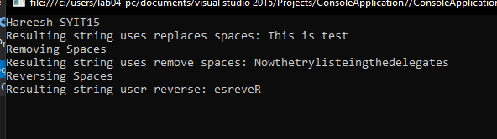

* 1. **Create a program to show the use of user controls.**

**Code: WebApplicationUC.ascx.cs:** using System;

**30/11/2024**

**: 07**

using System.Collections.Generic; using System.Linq;

using System.Web; using System.Web.UI;

using System.Web.UI.WebControls;

namespace WebApplication10

{

public partial class WebUserControl1 : System.Web.UI.UserControl

{

protected void Page_Load(object sender, EventArgs e)

{

}

protected void handleClick(object sender, EventArgs e)

{

Label1.Text = "Your name is: " + TextBox1.Text + " You are from: " + TextBox2.Text;

}

}

}

**WebApplicationUC.ascx**

<%@ Control Language="C#" AutoEventWireup="true" CodeBehind="WebUserControl1.ascx.cs" Inherits="WebApplication10.WebUserControl1" %>

<asp:Label Text="Name:" runat="server" />&nbsp;&nbsp;

<asp:TextBox ID="TextBox1" runat="server"></asp:TextBox><br><br>

<asp:Label Text="City:" runat="server" />&nbsp;&nbsp;

<asp:TextBox ID="TextBox2" runat="server"></asp:TextBox><br><br>

<asp:Label ID="Label1" runat="server" Text="Label"></asp:Label><br /><br />

<asp:Button ID="Button1" runat="server" OnClick="handleClick" Text="Button" />

**Default.aspx:**

<%@ Page Title="Home Page" Language="C#" MasterPageFile="~/Site.Master" AutoEventWireup="true" CodeBehind="Default.aspx.cs" Inherits="WebApplication10._Default" %>

<%@ Register src="WebUserControl1.ascx" tagname="WebUserControl1" tagprefix="uc1" %>

<asp:Content ID="BodyContent" ContentPlaceHolderID="MainContent" runat="server">

<uc1:WebUserControl1 ID="WebUserControl11" runat="server" />

</asp:Content>

**30/11/2024**

**: 07**

**Output:**

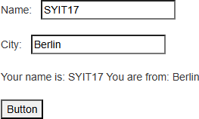

* 1. **Write a user control program to set the copyrights to entered name**

**Code: UserControl.ascx.cs:**

using System;

using System.Collections.Generic; using System.Linq;

using System.Web; using System.Web.UI;

using System.Web.UI.WebControls;

namespace WebApplication2

{

public partial class UserControl : System.Web.UI.UserControl

{

protected void Page_Load(object sender, EventArgs e)

{

}

protected void handleClick(object sender, EventArgs e)

{

string name = inputbox1.Text.ToString();

resultLabel.Text = "© Copyrights reserved at<br />" + name + " 2024-2024";

}

}

**30/11/2024**

**: 07**

}

**UserControl.ascs:**

<%@ Control Language="C#" AutoEventWireup="true" CodeBehind="UserControl.ascx.cs" Inherits="WebApplication2.UserControl" %>

<asp:Label ID="Label1" runat="server" Text="Enter your name: "></asp:Label>

<asp:TextBox ID="inputbox1" runat="server"></asp:TextBox><br /><br />

<asp:Button ID="Button1" runat="server" OnClick="handleClick" Text="Generate" /><br /><br />

<asp:Label ID="resultLabel" runat="server"></asp:Label>

**Default.aspx:**

<%@ Page Title="Home Page" Language="C#" MasterPageFile="~/Site.Master" AutoEventWireup="true" CodeBehind="Default.aspx.cs" Inherits="WebApplication2._Default" %>

<%@ Register Src="~/UserControl.ascx" TagPrefix="uc1" TagName="UserControl" %>

<asp:Content ID="BodyContent" ContentPlaceHolderID="MainContent" runat="server">

<uc1:UserControl runat="server" id="UserControl" />

</asp:Content>

**Output:**

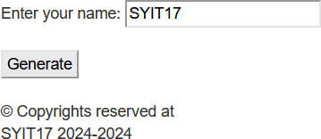

* 1. **Create a program that demonstrates AdRotator.**

**Steps to Use AdRotator in a Web Application -**

**Open Visual Studio -** Open Visual Studio and create a new project.

**Create a New Project -** Create a new project by selecting "(link unavailable) Web Application" under the "C#" section. **Add a New XML File -** Go to Solution Explorer, right-click on the project, select "Add" > "New Item" > "XML File", and click "Add".

**Download and Add Images -** Download three images and save them in an appropriate folder. Then, go to Solution

**3/12/2024**

**: 08**

Explorer, right-click on the project, select "Add" > "Existing Item", and select the three images to add them to the project. **Write Code in Default.aspx and XMLFile1.xml -** Write the necessary code in Default.aspx and XMLFile1.xml to configure the AdRotator control.

**Run the Code -** Run the code to see the AdRotator control in action.

**Code:**

**XMLFile1.xml:**

<?xml version="1.0" encoding="utf-8" ?>

<Advertisements>

<Ad>

<ImageUrl>https://shop.rosesarerosie.com/cdn/shop/files/DIGITAL.jpg?v=1727715705</ImageUrl>

<Impressions>20</Impressions>

<NavigateUrl>https://shop.rosesarerosie.com/products/rosie-digital-album</NavigateUrl>

<Keywords>ROSÉ, ROSIE</Keywords>

<AlternateText>ROSÉ's 1st album</AlternateText>

<br />

</Ad>

</Advertisements>

**XMLFile2.xml:**

<?xml version="1.0" encoding="utf-8" ?>

<Advertisements>

<Ad>

<ImageUrl>https://taypedia.com/wp-content/uploads/2024/05/ttpd4.jpeg</ImageUrl>

<Impressions>25</Impressions>

<NavigateUrl>https://taypedia.com/wiki/the-tortured-poets-department/</NavigateUrl>

<Keywords>the-tortured-poets-department, Toylor Swift</Keywords>

<AlternateText>Studio album by Taylor Swift</AlternateText>

<br />

</Ad>

</Advertisements>

**Default.aspx:**

<%@ Page Title="Home Page" Language="C#" MasterPageFile="~/Site.Master" AutoEventWireup="true" CodeBehind="Default.aspx.cs" Inherits="WebApplication2._Default" %>

<asp:Content ID="BodyContent" ContentPlaceHolderID="MainContent" runat="server">

<asp:Label Text="Buy Rosie" runat="server"/><br />

**3/12/2024**

**: 08**

<asp:XmlDataSource runat="server" ID="XmlDataSource1" DataFile="~/XMLFile1.xml"/>

<asp:AdRotator runat="server" ID="adRotator1" DataSourceID="XmlDataSource1" Height='500px' Width='500px' /><br

/><br />

<asp:Label Text="Buy The Tortured Poets Department" runat="server" /><br />

<asp:XmlDataSource runat="server" ID="XmlDataSource2" DataFile="~/XMLFile2.xml"/>

<asp:AdRotator runat="server" ID="adRotator2" DataSourceID="XmlDataSource2" Height='500px' Width='500px' /><br

/><br />

</asp:Content>

**Output:**

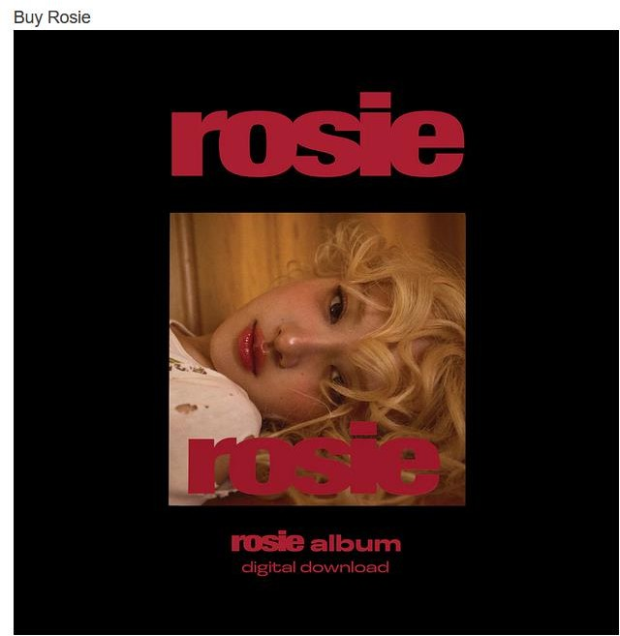

**3/12/2024**

**: 08**

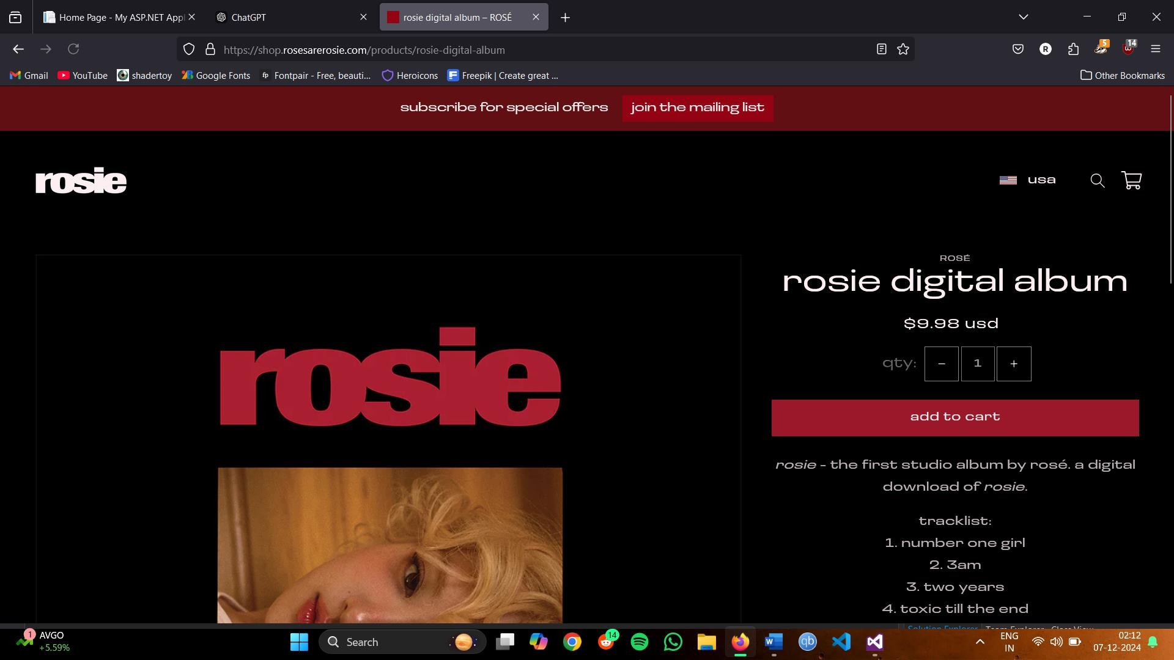

**3/12/2024**

**: 08**

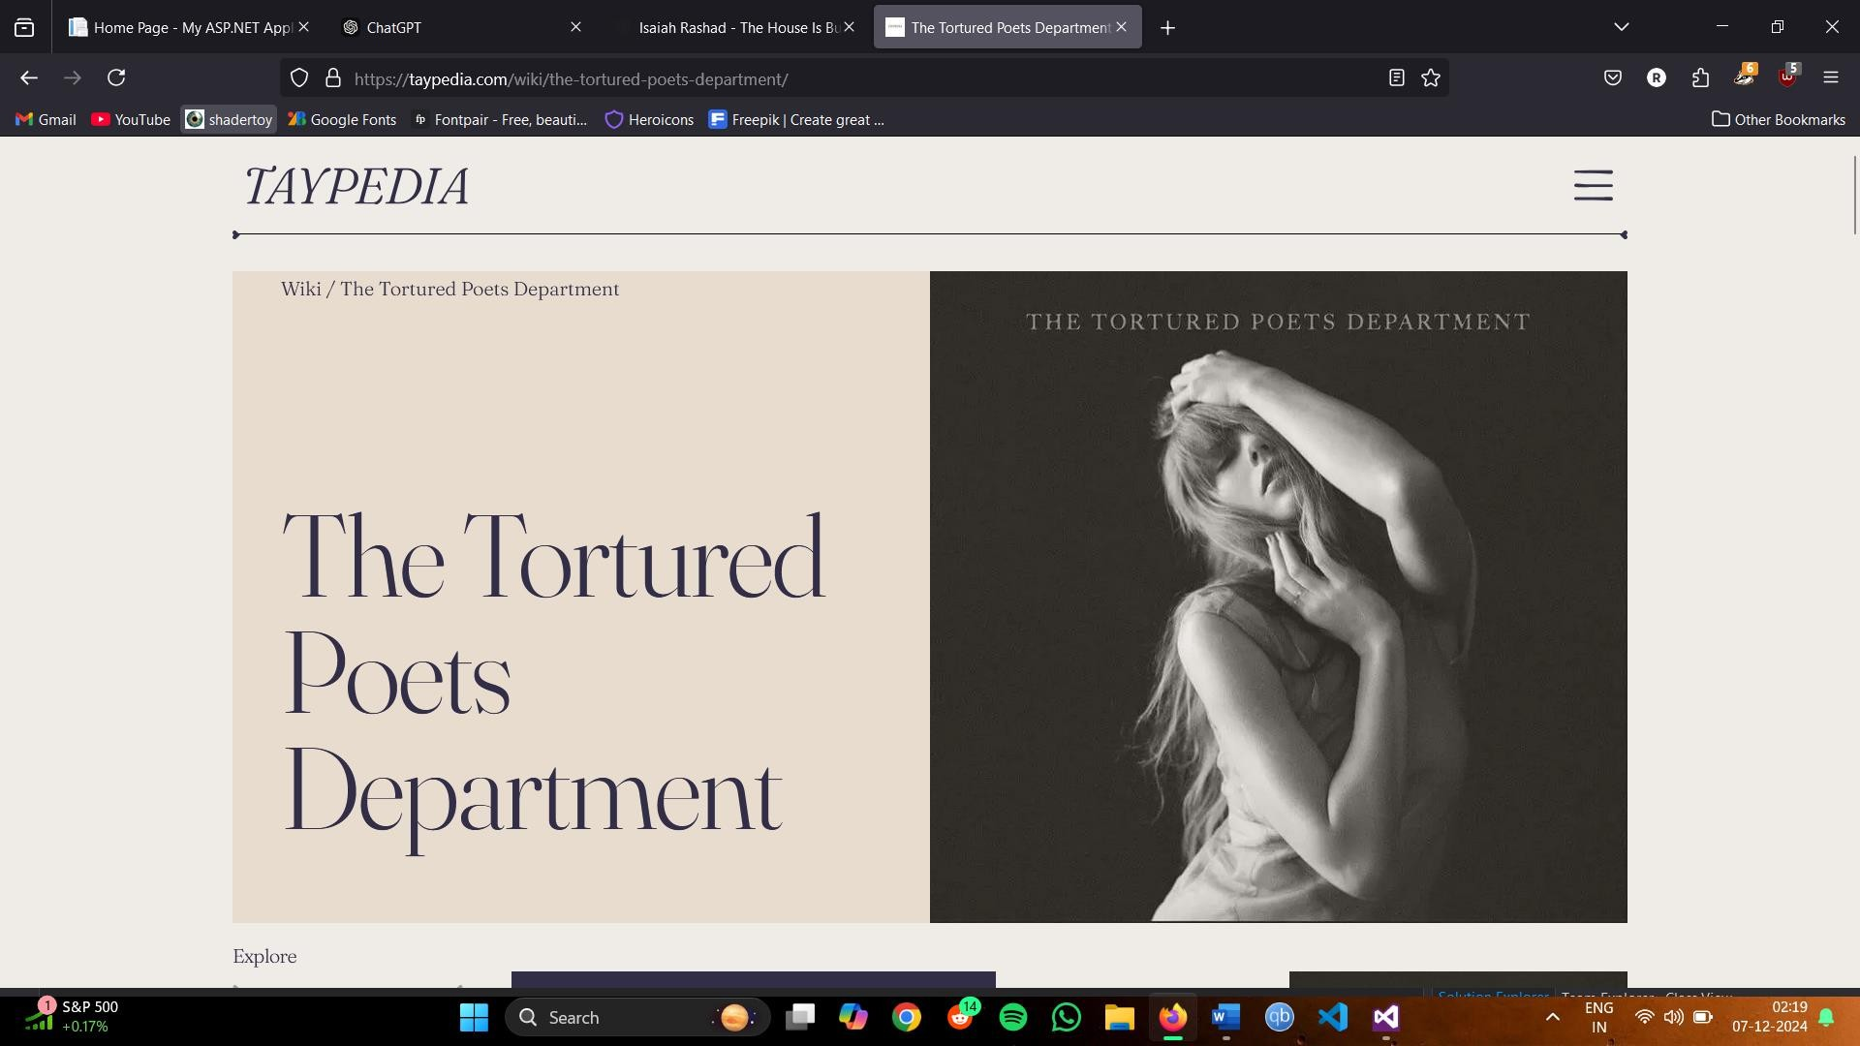

* 1. **Perform input validation for forms**

**Code:**

**Derfault.aspx:**

<%@ Page Title="Home Page" Language="C#" MasterPageFile="~/Site.Master" AutoEventWireup="true" CodeBehind="Default.aspx.cs" Inherits="InputValidation._Default" %>

<asp:Content ID="BodyContent" ContentPlaceHolderID="MainContent" runat="server">

<asp:Label Text="Enter a class: " runat="server" />&nbsp;&nbsp;

<asp:TextBox ID="inputBox1" runat="server" />

<asp:RangeValidator MinimumValue="6" MaximumValue="12" Type="Integer" ForeColor="Red" ControlToValidate="inputBox1" ID="RangeValidator1" runat="server" ErrorMessage="Enter a value between 6- 12"></asp:RangeValidator>

<br /><br />

<asp:Label Text="Choose a color: " runat="server" />&nbsp;&nbsp;

<asp:DropDownList runat="server" ID="dropdown1">

**14/12/2024**

**: 09**

<asp:ListItem Text="" />

<asp:ListItem Text="Red" />

<asp:ListItem Text="Blue" />

</asp:DropDownList>

<asp:RequiredFieldValidator ErrorMessage="Field cannot be empty" ForeColor="Red" ControlToValidate="dropdown1" runat="server" />

<br /><br />

<asp:Label Text="Enter your email: " runat="server" />&nbsp;&nbsp;

<asp:TextBox ID="inputBox2" runat="server" />

<asp:RegularExpressionValidator ErrorMessage="Invalid email expression!! Enter again" ForeColor="Red" ValidationExpression="\w+([-+.']\w+)*@\w+([-.]\w+)*\.\w+([-.]\w+)*" ControlToValidate="inputBox2" runat="server" />

<br /><br />

<asp:Button Text="Submit" runat="server" /><br /><br />

<asp:ValidationSummary ForeColor="Red" runat="server" />

</asp:Content>

**Output:**

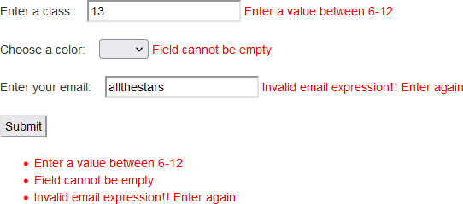

* 1. **Perform input validation for forms**

**Code: Default.aspx.cs:**

**14/12/2024**

**: 09**

using System;

using System.Collections.Generic; using System.Linq;

using System.Web; using System.Web.UI;

using System.Web.UI.WebControls;

namespace InputValidation2

{

public partial class _Default : Page

{

protected void Page_Load(object sender, EventArgs e)

{

}

protected void handleClick(object sender, EventArgs e)

{

float marksInAWP = float.Parse(marksInput1.Text); float marksInDBMS = float.Parse(marksInput2.Text); float marksInCoreJava = float.Parse(marksInput3.Text);

float resultPercentage = (marksInAWP + marksInDBMS + marksInCoreJava) * 100 / 180; resultLabel1.Text = "Mr./Ms. " + nameInput.Text;

resultLabel2.Text = "You obtained " + resultPercentage + "% this year"; if (resultPercentage <= 40.0f) {

resultLabel3.Text = "You Fail";

}

else

{

resultLabel3.Text = "You Pass";

}

}

}

}

**Default.aspx:**

<%@ Page Title="Home Page" Language="C#" MasterPageFile="~/Site.Master" AutoEventWireup="true"

**14/12/2024**

**: 09**

CodeBehind="Default.aspx.cs" Inherits="InputValidation2._Default" %>

<asp:Content ID="BodyContent" ContentPlaceHolderID="MainContent" runat="server">

<asp:Label Text="Enter your name: " runat="server" />&nbsp;&nbsp;

<asp:TextBox ID="nameInput" runat="server" />

<asp:RequiredFieldValidator ErrorMessage="Name cannot be empty" ForeColor="Red" ControlToValidate="nameInput" runat="server" />

<br /><br />

<asp:Label Text="Enter your ABC-ID: " runat="server" />&nbsp;&nbsp;

<asp:TextBox ID="ABCIDInput" runat="server" />

<asp:RangeValidator ErrorMessage="ABC-ID must be 13 digits" ForeColor="Red" MaximumValue="9999999999999" MinimumValue="1000000000000" Type="Double" ControlToValidate="ABCIDInput" runat="server" />

<br /><br />

<asp:Label Text="Enter your email: " runat="server" />&nbsp;&nbsp;

<asp:TextBox ID="emailInput" runat="server" />

<asp:RegularExpressionValidator ErrorMessage="Invalid email expression!! Enter again" ForeColor="Red" ValidationExpression="\w+([-+.']\w+)*@\w+([-.]\w+)*\.\w+([-.]\w+)*" ControlToValidate="emailInput" runat="server" />

<br /><br />

<asp:Label Text="Enter your marks in AWP: " runat="server" />&nbsp;&nbsp;

<asp:TextBox ID="marksInput1" runat="server" />

<asp:RangeValidator ErrorMessage="Marks must be between 0-60" ForeColor="Red" MaximumValue="60" MinimumValue="0" Type="Integer" ControlToValidate="marksInput1" runat="server" />

<br /><br />

<asp:Label Text="Enter your marks in DBMS: " runat="server" />&nbsp;&nbsp;

<asp:TextBox ID="marksInput2" runat="server" />

<asp:RangeValidator ErrorMessage="Marks must be between 0-60" ForeColor="Red" MaximumValue="60" MinimumValue="0" Type="Integer" ControlToValidate="marksInput2" runat="server" />

<br /><br />

<asp:Label Text="Enter your marks in Core Java: " runat="server" />&nbsp;&nbsp;

<asp:TextBox ID="marksInput3" runat="server" />

**14/12/2024**

**: 09**

<asp:RangeValidator ErrorMessage="Marks must be between 0-60" ForeColor="Red" MaximumValue="60" MinimumValue="0" Type="Integer" ControlToValidate="marksInput3" runat="server" />

<br /><br />

<asp:Button Text="Submit" ID="btn1" OnClick="handleClick" runat="server" /><br /><br />

<asp:ValidationSummary ForeColor="Red" runat="server" />

<div style="padding:4px;border:2px solid black;text-align:center;">

<asp:Label ID="resultLabel1" runat="server" /><br /><br />

<asp:Label ID="resultLabel2" runat="server" /><br /><br />

<asp:Label ID="resultLabel3" runat="server" /><br /><br />

</div>

</asp:Content>

**Output:**

**14/12/2024**

**: 09**

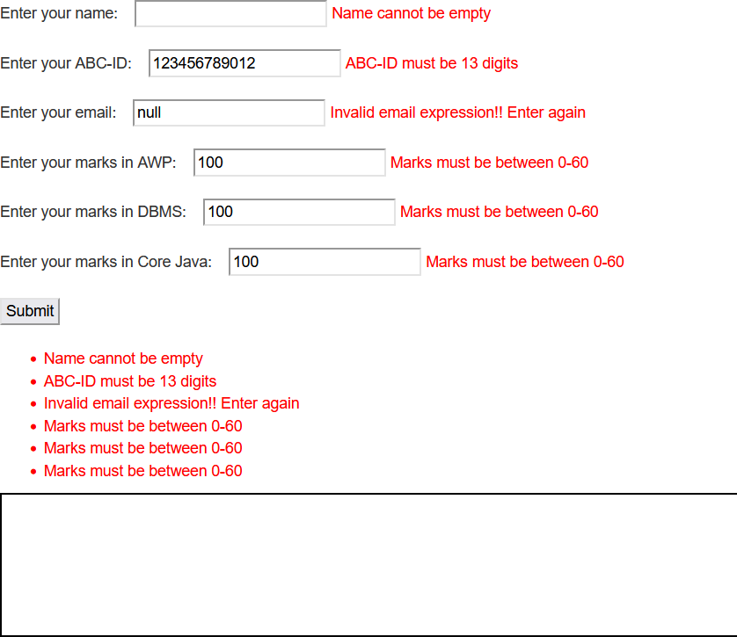

**14/12/2024**

**: 09**

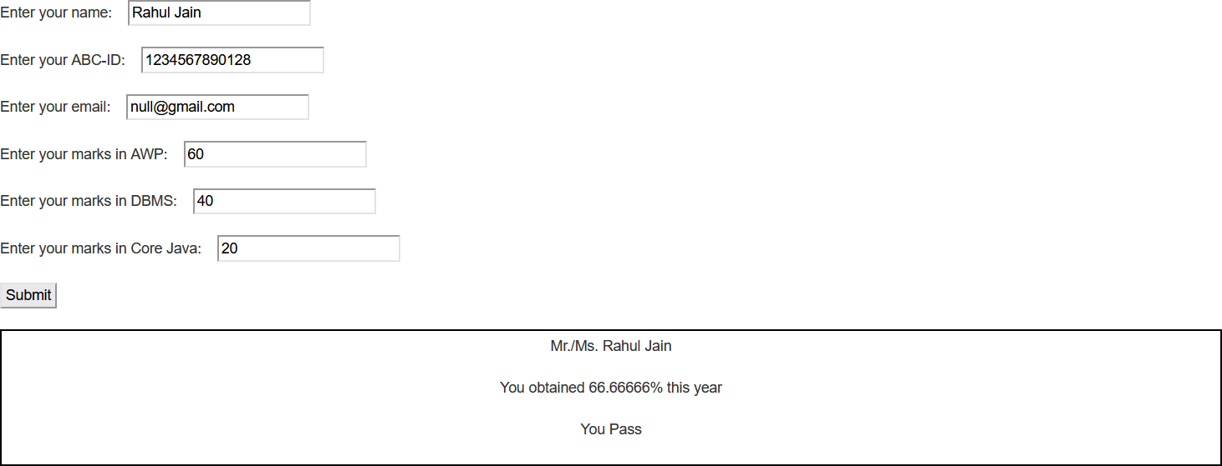

**07/01/2025**

**: 10**

**Q.1) Create a site master of your own and link it with multiple pages.**

# Code:

**Site1.master:**

<%@ Master Language="C#" AutoEventWireup="true" CodeBehind="Site1.master.cs" Inherits="WebApplication3.Site1" %>

<!DOCTYPE html>

<html xmlns="<http://www.w3.org/1999/xhtml>">

<head runat="server">

<title></title>

<asp:ContentPlaceHolder ID="head" runat="server">

</asp:ContentPlaceHolder>

<style type="text/css">

.auto-style1 { width: 100%;

}

.auto-style2 { width: 447px; height: 385px;

}

.auto-style3 { width: 447px;

}

</style>

</head>

<body>

<form id="form1" runat="server">

<table class="auto-style1">

<tr>

<td class="auto-style3">

<asp:Menu ID="Menu1" runat="server">

<Items>

**07/01/2025**

**: 10**

<asp:MenuItem NavigateUrl="~/WebForm1.aspx" Text="Page 1" Value="Page 1"></asp:MenuItem>

<asp:MenuItem NavigateUrl="~/WebForm2.aspx" Text="Page 2" Value="Page 2"></asp:MenuItem>

<asp:MenuItem NavigateUrl="~/WebForm3.aspx" Text="Page 3" Value="Page 3"></asp:MenuItem>

</Items>

</asp:Menu>

</td>

<td>Bhavans College SybscIT Orina Guha</td>

</tr>

<tr>

<td class="auto-style3">

<img alt="stone" class="auto-style2" src="Untitled.jpg" /></td>

<td>

<asp:GridView ID="GridView1" runat="server" AutoGenerateColumns="False" DataKeyNames="CategoryID" DataSourceID="SqlDataSource1">

<Columns>

<asp:BoundField DataField="CategoryID" HeaderText="CategoryID" InsertVisible="False" ReadOnly="True" SortExpression="CategoryID" />

<asp:BoundField DataField="CategoryName" HeaderText="CategoryName" SortExpression="CategoryName" />

<asp:BoundField DataField="Description" HeaderText="Description" SortExpression="Description" />

</Columns>

</asp:GridView>

<asp:SqlDataSource ID="SqlDataSource1" runat="server" ConnectionString="<%$ ConnectionStrings:NorthwindConnectionString3 %>" ProviderName="<%$ ConnectionStrings:NorthwindConnectionString3.ProviderName %>" SelectCommand="SELECT * FROM [Categories]"></asp:SqlDataSource>

</td>

</tr>

**07/01/2025**

**: 10**

<tr>

<td class="auto-style3">

<asp:ContentPlaceHolder ID="ContentPlaceHolder1" runat="server">

</asp:ContentPlaceHolder>

</td>

<td>&nbsp;</td>

</tr>

</table>

</form>

</body>

</html>

# WebForm1.aspx

<%@ Page Title="" Language="C#" MasterPageFile="~/Site1.Master" AutoEventWireup="true" CodeBehind="WebForm1.aspx.cs" Inherits="WebApplication3.WebForm1" %>

<asp:Content ID="Content1" ContentPlaceHolderID="head" runat="server">

<style type="text/css">

.auto-style5 { width: 241px; height: 209px;

}

</style>

</asp:Content>

<asp:Content ID="Content2" ContentPlaceHolderID="ContentPlaceHolder1" runat="server">

<p>The gentle rustle of leaves whispers a serenity only nature can provide.</p>

</asp:Content>

# WebForm2.aspx

<%@ Page Title="" Language="C#" MasterPageFile="~/Site1.Master" AutoEventWireup="true" CodeBehind="WebForm2.aspx.cs" Inherits="WebApplication3.WebForm2" %>

<asp:Content ID="Content1" ContentPlaceHolderID="head" runat="server">

<style type="text/css">

**07/01/2025**

**: 10**

.auto-style5 { width: 225px; height: 225px;

}

</style>

</asp:Content>

<asp:Content ID="Content2" ContentPlaceHolderID="ContentPlaceHolder1" runat="server">

<p>Peace flows like a quiet stream, nourishing the soul with each moment of stillness.</p>

</asp:Content>

# WebForm3.aspx

<%@ Page Title="" Language="C#" MasterPageFile="~/Site1.Master" AutoEventWireup="true" CodeBehind="WebForm3.aspx.cs" Inherits="WebApplication3.WebForm3" %>

<asp:Content ID="Content1" ContentPlaceHolderID="head" runat="server">

<style type="text/css">

.auto-style5 { width: 225px; height: 225px;

}

</style>

</asp:Content>

<asp:Content ID="Content2" ContentPlaceHolderID="ContentPlaceHolder1" runat="server">

<p> Nature’s calm embraces the heart, turning chaos into tranquil harmony.</p>

</asp:Content>

**Output: WebForm 1:**

**07/01/2025**

**: 10**

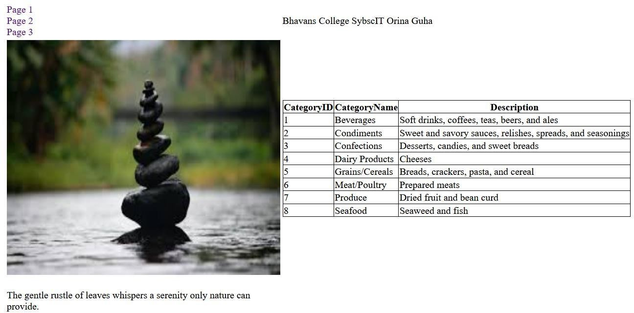

**WebForm 2:**

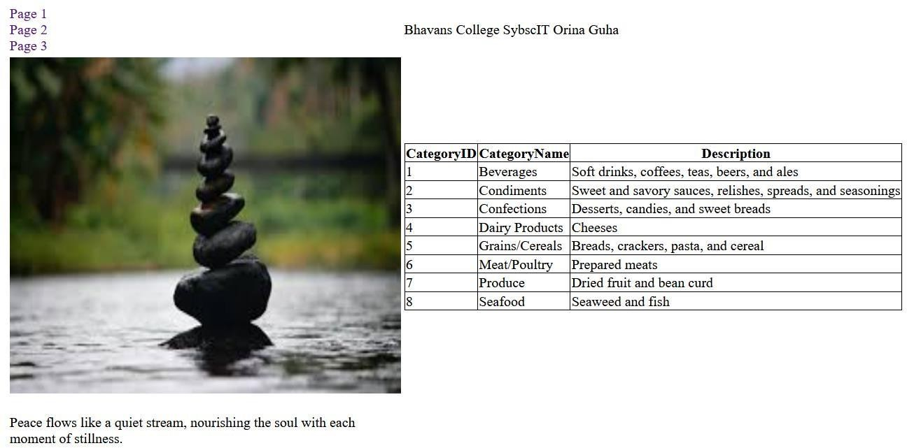

**07/01/2025**

**: 10**

**WebForm 3:**

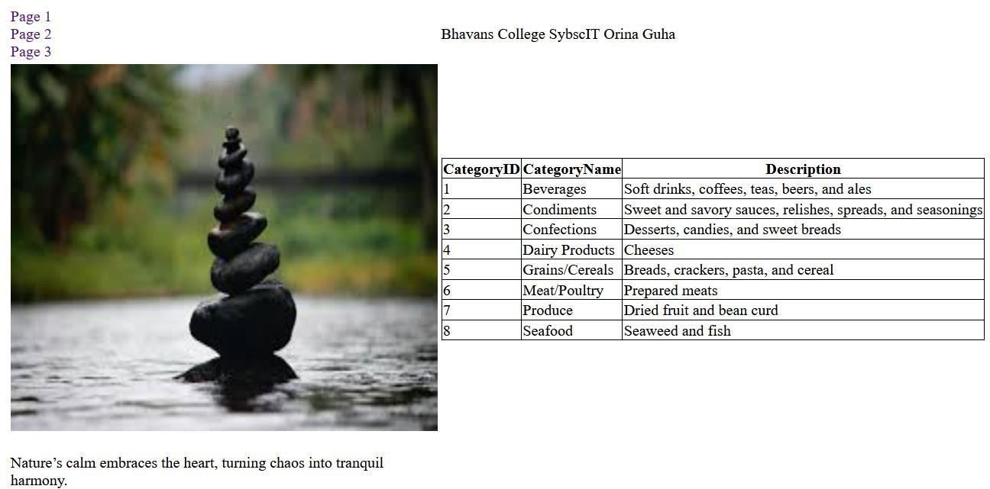

**(NEP ) 07-01-2025**

**66**

**: 11**

1. **Demonstrate the use of following tools:**
   1. **GridView:**

<%@ Page Title="Home Page" Language="C#" MasterPageFile="~/Site.Master" AutoEventWireup="true" CodeBehind="Default.aspx.cs" Inherits="WebApplication19._Default" %>

<asp:Content ID="BodyContent" ContentPlaceHolderID="MainContent" runat="server"> &nbsp;&nbsp;&nbsp;&nbsp;&nbsp;&nbsp;&nbsp;&nbsp;&nbsp;&nbsp;

<asp:Label ID="Label1" runat="server" BorderStyle="Double" Text="Mayuresh Morye

SYIT32"></asp:Label>

<br />

<asp:GridView ID="GridView1" runat="server" AllowPaging="True" AllowSorting="True" AutoGenerateColumns="False" DataKeyNames="SupplierID" DataSourceID="SqlDataSource1">

<Columns>

<asp:BoundField DataField="SupplierID" HeaderText="SupplierID" InsertVisible="False" ReadOnly="True" SortExpression="SupplierID" />

<asp:BoundField DataField="CompanyName" HeaderText="CompanyName" SortExpression="CompanyName" />

<asp:BoundField DataField="ContactName" HeaderText="ContactName" SortExpression="ContactName" />

<asp:BoundField DataField="ContactTitle" HeaderText="ContactTitle" SortExpression="ContactTitle" />

<asp:BoundField DataField="Address" HeaderText="Address" SortExpression="Address" />

<asp:BoundField DataField="City" HeaderText="City" SortExpression="City" />

<asp:BoundField DataField="Region" HeaderText="Region" SortExpression="Region" />

<asp:BoundField DataField="Country" HeaderText="Country" SortExpression="Country" />

<asp:BoundField DataField="Phone" HeaderText="Phone" SortExpression="Phone" /> </Columns>

</asp:GridView>

<asp:SqlDataSource ID="SqlDataSource2" runat="server"></asp:SqlDataSource>

<asp:SqlDataSource ID="SqlDataSource1" runat="server" ConnectionString="<%$ ConnectionStrings:NorthwindConnectionString %>" ProviderName="<%$ ConnectionStrings:NorthwindConnectionString.ProviderName %>" SelectCommand="SELECT * FROM [Suppliers]"></asp:SqlDataSource>

</asp:Content>

**Output:**

**(NEP ) 07-01-2025**

**67**

**: 11**

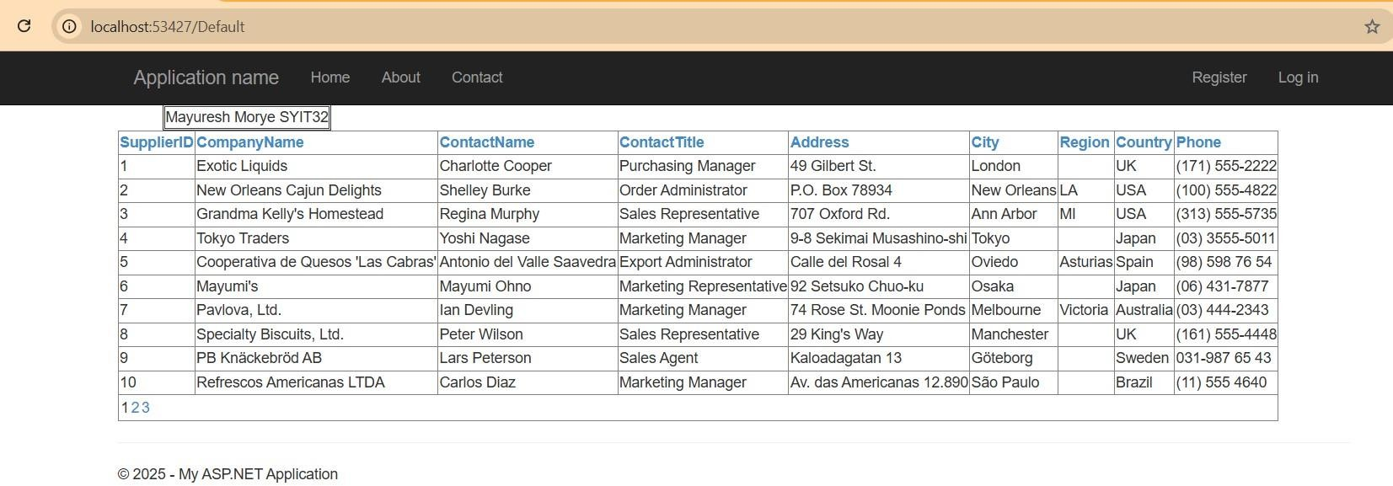

* 1. **DataList:**

<%@ Page Title="Home Page" Language="C#" MasterPageFile="~/Site.Master" AutoEventWireup="true" CodeBehind="Default.aspx.cs" Inherits="WebApplication20._Default" %>

<asp:Content ID="BodyContent" ContentPlaceHolderID="MainContent" runat="server"> &nbsp;&nbsp;&nbsp;&nbsp;&nbsp;&nbsp;&nbsp;&nbsp;&nbsp;&nbsp;&nbsp;&nbsp;&nbsp;&nbsp;

<asp:Label ID="Label1" runat="server" BorderStyle="Double" Text="Mayuresh Morye

SYIT32"></asp:Label>

<br />

<asp:DataList ID="DataList1" runat="server" DataKeyField="EmployeeID" DataSourceID="SqlDataSource1">

<ItemTemplate> EmployeeID:

<asp:Label ID="EmployeeIDLabel" runat="server" Text='<%# Eval("EmployeeID") %>' />

<br /> LastName:

<asp:Label ID="LastNameLabel" runat="server" Text='<%# Eval("LastName") %>' />

<br /> FirstName:

<asp:Label ID="FirstNameLabel" runat="server" Text='<%# Eval("FirstName") %>' />

**(NEP ) 07-01-2025**

**68**

**: 11**

<br /> Title:

<asp:Label ID="TitleLabel" runat="server" Text='<%# Eval("Title") %>' />

<br /> BirthDate:

<asp:Label ID="BirthDateLabel" runat="server" Text='<%# Eval("BirthDate") %>' />

<br /> HireDate:

<asp:Label ID="HireDateLabel" runat="server" Text='<%# Eval("HireDate") %>' />

<br /> City:

<asp:Label ID="CityLabel" runat="server" Text='<%# Eval("City") %>' />

<br /> Address:

<asp:Label ID="AddressLabel" runat="server" Text='<%# Eval("Address") %>' />

<br /> PostalCode:

<asp:Label ID="PostalCodeLabel" runat="server" Text='<%# Eval("PostalCode") %>' />

<br /> HomePhone:

<asp:Label ID="HomePhoneLabel" runat="server" Text='<%# Eval("HomePhone") %>' />

<br />

<br />

</ItemTemplate> </asp:DataList>

<asp:SqlDataSource ID="SqlDataSource1" runat="server" ConnectionString="<%$ ConnectionStrings:NorthwindConnectionString2 %>" ProviderName="<%$ ConnectionStrings:NorthwindConnectionString2.ProviderName %>" SelectCommand="SELECT [EmployeeID], [LastName], [FirstName], [Title], [BirthDate], [HireDate], [City], [Address], [PostalCode], [HomePhone] FROM [Employees]"></asp:SqlDataSource>

</asp:Content>

**Output:**

**(NEP ) 07-01-2025**

**69**

**: 11**

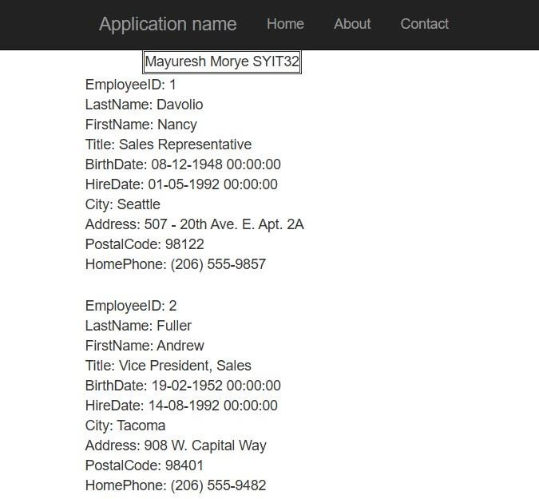

* 1. **FormView:**

<%@ Page Title="Home Page" Language="C#" MasterPageFile="~/Site.Master" AutoEventWireup="true" CodeBehind="Default.aspx.cs" Inherits="WebApplication21._Default" %>

<asp:Content ID="BodyContent" ContentPlaceHolderID="MainContent" runat="server"> &nbsp;&nbsp;&nbsp;&nbsp;&nbsp;&nbsp;&nbsp;&nbsp;&nbsp;&nbsp;&nbsp;&nbsp;&nbsp;

<asp:Label ID="Label1" runat="server" BorderStyle="Double" Text="Mayuresh Morye

SYIT32"></asp:Label>

<br />

<asp:FormView ID="FormView1" runat="server" AllowPaging="True" DataKeyNames="EmployeeID" DataSourceID="SqlDataSource1"> <EditItemTemplate> EmployeeID:

<asp:Label ID="EmployeeIDLabel1" runat="server" Text='<%# Eval("EmployeeID") %>' />

<br /> LastName:

<asp:TextBox ID="LastNameTextBox" runat="server" Text='<%# Bind("LastName") %>' />

<br />

Title:

**(NEP ) 07-01-2025**

**70**

**: 11**

<asp:TextBox ID="TitleTextBox" runat="server" Text='<%# Bind("Title") %>' />

<br /> FirstName:

<asp:TextBox ID="FirstNameTextBox" runat="server" Text='<%# Bind("FirstName") %>' />

<br /> BirthDate:

<asp:TextBox ID="BirthDateTextBox" runat="server" Text='<%# Bind("BirthDate") %>' />

<br /> HireDate:

<asp:TextBox ID="HireDateTextBox" runat="server" Text='<%# Bind("HireDate") %>' />

<br />

City:

<asp:TextBox ID="CityTextBox" runat="server" Text='<%# Bind("City") %>' />

<br />

Country:

<asp:TextBox ID="CountryTextBox" runat="server" Text='<%# Bind("Country") %>' />

<br /> PostalCode:

<asp:TextBox ID="PostalCodeTextBox" runat="server" Text='<%# Bind("PostalCode") %>' />

<br /> HomePhone:

<asp:TextBox ID="HomePhoneTextBox" runat="server" Text='<%# Bind("HomePhone") %>' />

<br />

<asp:LinkButton ID="UpdateButton" runat="server" CausesValidation="True" CommandName="Update" Text="Update" />

&nbsp;<asp:LinkButton ID="UpdateCancelButton" runat="server" CausesValidation="False" CommandName="Cancel" Text="Cancel" />

</EditItemTemplate>

<InsertItemTemplate> LastName:

<asp:TextBox ID="LastNameTextBox" runat="server" Text='<%# Bind("LastName") %>' />

<br />

Title:

<asp:TextBox ID="TitleTextBox" runat="server" Text='<%# Bind("Title") %>' />

<br />

FirstName:

<asp:TextBox ID="FirstNameTextBox" runat="server" Text='<%# Bind("FirstName") %>' />

<br /> BirthDate:

<asp:TextBox ID="BirthDateTextBox" runat="server" Text='<%# Bind("BirthDate") %>' />

**(NEP ) 07-01-2025**

**71**

**: 11**

<br /> HireDate:

<asp:TextBox ID="HireDateTextBox" runat="server" Text='<%# Bind("HireDate") %>' />

<br />

City:

<asp:TextBox ID="CityTextBox" runat="server" Text='<%# Bind("City") %>' />

<br />

Country:

<asp:TextBox ID="CountryTextBox" runat="server" Text='<%# Bind("Country") %>' />

<br /> PostalCode:

<asp:TextBox ID="PostalCodeTextBox" runat="server" Text='<%# Bind("PostalCode") %>' />

<br /> HomePhone:

<asp:TextBox ID="HomePhoneTextBox" runat="server" Text='<%# Bind("HomePhone") %>' />

<br />

<asp:LinkButton ID="InsertButton" runat="server" CausesValidation="True" CommandName="Insert" Text="Insert" />

&nbsp;<asp:LinkButton ID="InsertCancelButton" runat="server" CausesValidation="False" CommandName="Cancel" Text="Cancel" />

</InsertItemTemplate>

<ItemTemplate> EmployeeID:

<asp:Label ID="EmployeeIDLabel" runat="server" Text='<%# Eval("EmployeeID") %>' />

<br /> LastName:

<asp:Label ID="LastNameLabel" runat="server" Text='<%# Bind("LastName") %>' />

<br />

Title:

<asp:Label ID="TitleLabel" runat="server" Text='<%# Bind("Title") %>' />

<br />

FirstName:

<asp:Label ID="FirstNameLabel" runat="server" Text='<%# Bind("FirstName") %>' />

<br /> BirthDate:

<asp:Label ID="BirthDateLabel" runat="server" Text='<%# Bind("BirthDate") %>' />

<br /> HireDate:

<asp:Label ID="HireDateLabel" runat="server" Text='<%# Bind("HireDate") %>' />

**(NEP ) 07-01-2025**

**72**

**: 11**

City:

<br />

<asp:Label ID="CityLabel" runat="server" Text='<%# Bind("City") %>' />

<br />

Country:

<asp:Label ID="CountryLabel" runat="server" Text='<%# Bind("Country") %>' />

<br /> PostalCode:

<asp:Label ID="PostalCodeLabel" runat="server" Text='<%# Bind("PostalCode") %>' />

<br /> HomePhone:

<asp:Label ID="HomePhoneLabel" runat="server" Text='<%# Bind("HomePhone") %>' />

<br />

</ItemTemplate>

</asp:FormView>

<asp:SqlDataSource ID="SqlDataSource1" runat="server" ConnectionString="<%$ ConnectionStrings:NorthwindConnectionString %>" ProviderName="<%$ ConnectionStrings:NorthwindConnectionString.ProviderName %>" SelectCommand="SELECT [EmployeeID], [LastName], [Title], [FirstName], [BirthDate], [HireDate], [City], [Country], [PostalCode], [HomePhone] FROM [Employees]"></asp:SqlDataSource>

</asp:Content>

**Output:**

**(NEP ) 07-01-2025**

**73**

**: 11**

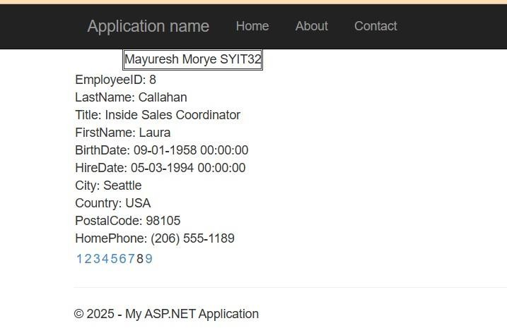

* 1. **DetailsView:**

<%@ Page Title="Home Page" Language="C#" MasterPageFile="~/Site.Master" AutoEventWireup="true" CodeBehind="Default.aspx.cs" Inherits="WebApplication22._Default"

%>

<asp:Content ID="BodyContent" ContentPlaceHolderID="MainContent" runat="server"> &nbsp;&nbsp;&nbsp;&nbsp;&nbsp;&nbsp;&nbsp;&nbsp;&nbsp;&nbsp;&nbsp;

<asp:Label ID="Label1" runat="server" BorderStyle="Double" Text="Mayuresh Morye

SYIT32"></asp:Label>

<br />

<asp:DetailsView ID="DetailsView1" runat="server" AllowPaging="True" AutoGenerateRows="False" DataKeyNames="CustomerID" DataSourceID="SqlDataSource1" Height="50px" Width="125px" BorderStyle="Solid">

<Fields>

<asp:BoundField DataField="CustomerID" HeaderText="CustomerID" ReadOnly="True" SortExpression="CustomerID" />

<asp:BoundField DataField="CompanyName" HeaderText="CompanyName"

**(NEP ) 07-01-2025**

**74**

**: 11**

SortExpression="CompanyName" />

<asp:BoundField DataField="ContactName" HeaderText="ContactName" SortExpression="ContactName" />

<asp:BoundField DataField="ContactTitle" HeaderText="ContactTitle" SortExpression="ContactTitle" />

<asp:BoundField DataField="Address" HeaderText="Address" SortExpression="Address" />

<asp:BoundField DataField="City" HeaderText="City" SortExpression="City" />

<asp:BoundField DataField="Region" HeaderText="Region" SortExpression="Region" />

<asp:BoundField DataField="PostalCode" HeaderText="PostalCode" SortExpression="PostalCode" />

<asp:BoundField DataField="Country" HeaderText="Country" SortExpression="Country" />

<asp:BoundField DataField="Phone" HeaderText="Phone" SortExpression="Phone" />

<asp:BoundField DataField="Fax" HeaderText="Fax" SortExpression="Fax" /> </Fields>

</asp:DetailsView>

<asp:SqlDataSource ID="SqlDataSource1" runat="server" ConnectionString="<%$ ConnectionStrings:NorthwindConnectionString %>" ProviderName="<%$ ConnectionStrings:NorthwindConnectionString.ProviderName %>" SelectCommand="SELECT * FROM [Customers]"></asp:SqlDataSource>

</asp:Content>

**Output:**

**(NEP ) 07-01-2025**

**75**

**: 11**

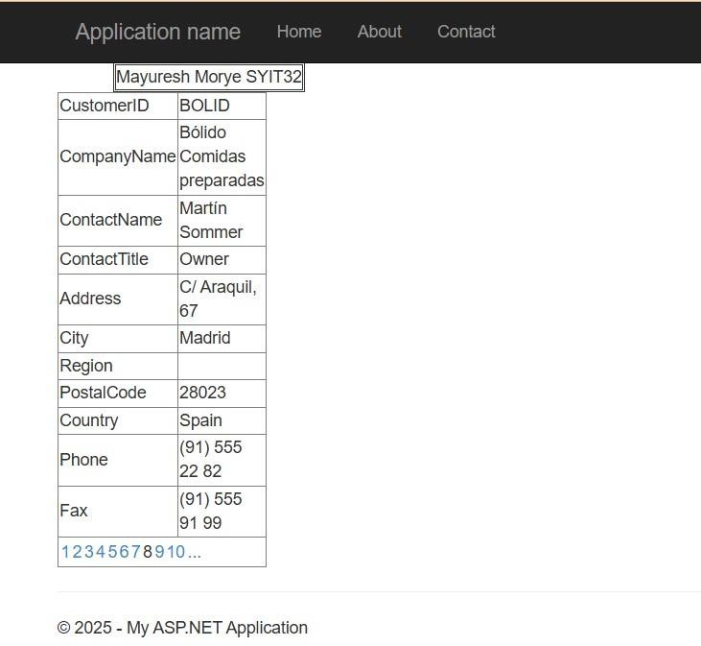

**07/01/2025 :**

**: 12**

1. **Demonstrate the use of GridView control in asp.net.**

**Default.aspx**

<%@ Page Title="Home Page" Language="C#" MasterPageFile="~/Site.Master" AutoEventWireup="true" CodeBehind="Default.aspx.cs" Inherits="WebApplication41._Default" %>

<asp:Content ID="BodyContent" ContentPlaceHolderID="MainContent" runat="server">

<asp:GridView ID="GridView1" runat="server" AutoGenerateColumns="False" DataKeyNames="ProductID" DataSourceID="SqlDataSource2" AllowPaging="True">

<Columns>

<asp:BoundField DataField="ProductID" HeaderText="ProductID" InsertVisible="False" ReadOnly="True" SortExpression="ProductID" />

<asp:BoundField DataField="ProductName" HeaderText="ProductName" SortExpression="ProductName"

/>

<asp:BoundField DataField="SupplierID" HeaderText="SupplierID" SortExpression="SupplierID" />

<asp:BoundField DataField="CategoryID" HeaderText="CategoryID" SortExpression="CategoryID" />

<asp:BoundField DataField="QuantityPerUnit" HeaderText="QuantityPerUnit"

SortExpression="QuantityPerUnit" />

<asp:BoundField DataField="UnitPrice" HeaderText="UnitPrice" SortExpression="UnitPrice" />

<asp:BoundField DataField="UnitsInStock" HeaderText="UnitsInStock" SortExpression="UnitsInStock" />

<asp:BoundField DataField="UnitsOnOrder" HeaderText="UnitsOnOrder" SortExpression="UnitsOnOrder"

/>

<asp:BoundField DataField="ReorderLevel" HeaderText="ReorderLevel" SortExpression="ReorderLevel"

/>

<asp:CheckBoxField DataField="Discontinued" HeaderText="Discontinued"

SortExpression="Discontinued" />

</Columns>

</asp:GridView>

<asp:SqlDataSource ID="SqlDataSource2" runat="server" ConnectionString="<%$ ConnectionStrings:NorthwindConnectionString3 %>" ProviderName="<%$ ConnectionStrings:NorthwindConnectionString3.ProviderName %>" SelectCommand="SELECT [ProductID], [ProductName], [SupplierID], [CategoryID], [QuantityPerUnit], [UnitPrice], [UnitsInStock], [UnitsOnOrder], [ReorderLevel], [Discontinued] FROM [Products]"></asp:SqlDataSource>

<asp:SqlDataSource ID="SqlDataSource1" runat="server" ConnectionString="<%$ ConnectionStrings:NorthwindConnectionString2 %>" ProviderName="<%$ ConnectionStrings:NorthwindConnectionString2.ProviderName %>" SelectCommand="SELECT [ProductID], [ProductName], [SupplierID], [CategoryID] FROM [Products]"></asp:SqlDataSource>

</asp:Content>

**07/01/2025 :**

**: 12**

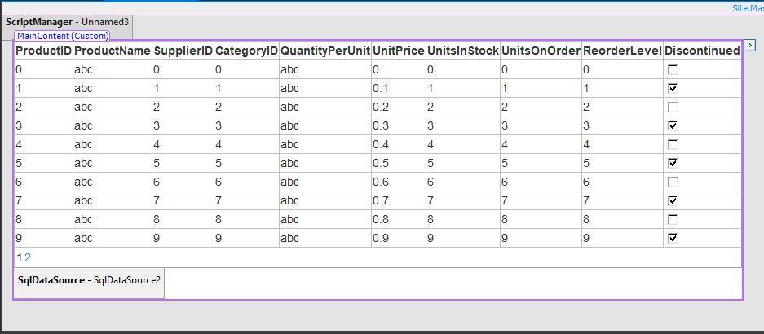

**OUTPUT :**

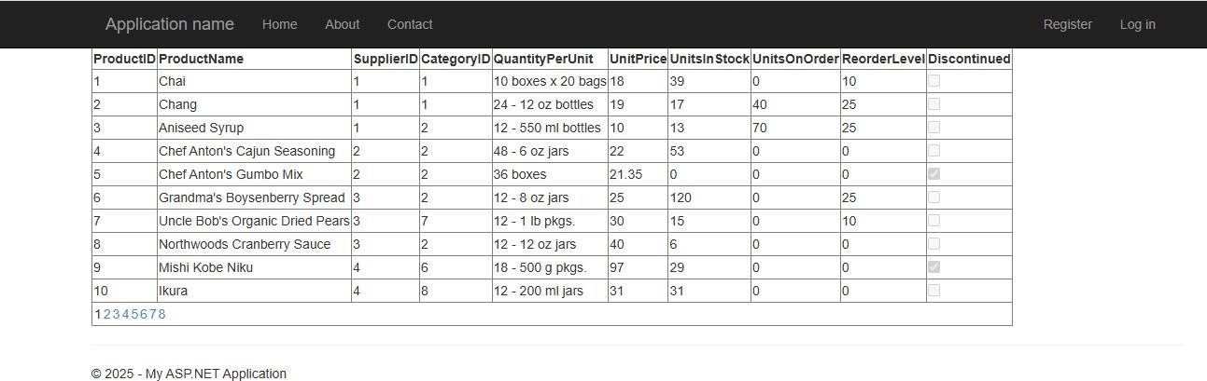

**Q1) Create an XML file to store records of four persons with their name, age and addresses.**

# Default.asp:

<%@ Page Title="Home Page" Language="C#" MasterPageFile="~/Site.Master" AutoEventWireup="true" CodeBehind="Default.aspx.cs" Inherits="WebApplication11._Default" %>

<asp:Content ID="BodyContent" ContentPlaceHolderID="MainContent" runat="server">

<asp:GridView ID="GridView1" runat="server">

</asp:GridView>

</asp:Content>

# Default.asp.cs:

using System;

using System.Collections.Generic; using System.Linq;

using System.Web; using System.Web.UI;

using System.Web.UI.WebControls; using System.Xml.Linq;

namespace WebApplication11

{

public partial class _Default : System.Web.UI.Page

{

protected void Page_Load(object sender, EventArgs e)

{

XDocument xmlDoc = XDocument.Load(HttpContext.Current.Server.MapPath("XMLFile1.xml")); var persons = from p in xmlDoc.Root.Elements("Person")

where (Convert.ToInt16(p.Element("Age").Value) < 60) select new

{

Name = p.Element("Name").Value, Address = p.Element("Address").Value, Age = p.Element("Age").Value

};

GridView1.DataSource = persons; GridView1.DataBind();

}

}

}

# XMLFile1.xml:

<?xml version="1.0" encoding="utf-8" ?>

<Persons>

<Person>

<Name>Yash Sawant</Name>

**21/01/2025 (AWP)**

**: 13**

<Address>Varsova</Address>

<Age>19</Age>

</Person>

<Person>

<Name>Mayuresh Morye</Name>

<Address>Virar</Address>

<Age>30</Age>

</Person>

<Person>

<Name>Prince Yadav</Name>

<Address>Andheri</Address>

<Age>34</Age>

</Person>

<Person>

<Name>Shivshankar Sahu</Name>

<Address>Kurla</Address>

<Age>65</Age>

</Person>

<Person>

<Name>Kartik Yadav</Name>

<Address>Marol Naka</Address>

<Age>27</Age>

</Person>

</Persons>

**Output:**

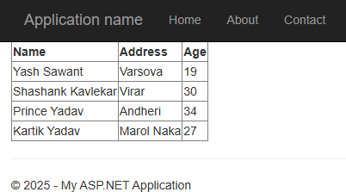

**21/01/2025 (AWP)**

**: 13**

**Q2) Create asynchronous timer using AJAX**

# WebForm1.aspx:

<%@ Page Language="C#" AutoEventWireup="true" CodeBehind="WebForm1.aspx.cs" Inherits="WebApplication15.WebForm1" %>

<form id="form1" runat="server">

<asp:Label ID="Label1" runat="server" Text="Current Time: "></asp:Label>

<asp:Label ID="Label4" runat="server" Text=" "></asp:Label> &nbsp;<asp:ScriptManager ID="ScriptManager1" runat="server">

</asp:ScriptManager>

<asp:Timer ID="Timer1" runat="server" OnTick="Timer1_Tick">

</asp:Timer><br />

<asp:Button ID="Button1" runat="server" Text="Stop" OnClick="Button1_Click" /><br />

<asp:Label ID="Label3" runat="server" Text="Welcome to AJAX"></asp:Label>

<asp:UpdatePanel ID="UpdatePanel1" runat="server">

</asp:UpdatePanel>

<asp:UpdateProgress ID="UpdateProgress1" runat="server">

</asp:UpdateProgress>

</form>

# WebForm1.aspx.cs:

using System;

using System.Collections.Generic; using System.Linq;

using System.Web; using System.Web.UI;

using System.Web.UI.WebControls;

namespace WebApplication15

{

public partial class WebForm1 : System.Web.UI.Page

{

protected void Page_Load(object sender, EventArgs e)

{

}

protected void Timer1_Tick(object sender, EventArgs e)

{

Label4.Text = DateTime.Now.ToString();

}

protected void Button1_Click(object sender, EventArgs e)

{

System.Threading.Thread.Sleep(1500);

}

**21/01/2025 (AWP)**

**: 13**

}

}

**Output:**

