**Q1) Write a java program to find reverse of a number.**

**Code:**

import java.util.Scanner;

public class Reverse

{

public static void main(String args[])

{

Scanner Sc= new Scanner (System.in);

int n,x,r,sum=0;

System.out.println("Enter a positive integer: ");

x=Sc.nextInt();

while(x<0)

{

System.out.println("Invalid positive integer");

x=Sc.nextInt();

}

n=x;

while(x>0)

{

r=x%10;

sum=(sum*10)+r;

x=x/10;

}

System.out.println("The Reverse of "+ n +" is "+ sum);

}

}

**Output:**

Correct Input:

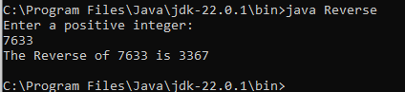

Incorrect Input:

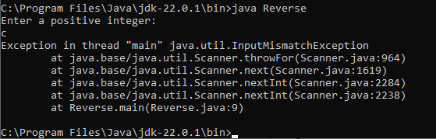

**Q2) Implement a Java function that calculates the sum of digits for a given char array consisting of the digits '0' to '9'. The function should return the digit sum as a long value.**

**Code:**

import java.util.Scanner;

public class SumOfDigits

{

public static long calc()

{

int i;

long x =0L,sum=0L;

char c[]={'0','1','2','3','4','5','6','7','8','9'};

for(i=c.length-1;i>=0;i--)

{

x=c[i]-'0';

sum=sum+x;

}

return sum;

}

public static void main(String args[])

{

long s=calc();

System.out.println("Sum is "+ s);

}

}

**Output:**

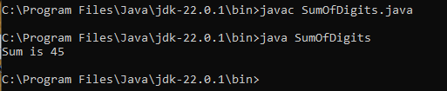

**Q3) Find the smallest and largest element from the array.**

**Code:**

import java.util.*;

class LargeSmallArray

{

public static void main(String args[])

{

int num[]=new int[]{13,22,27,11,4};

int s=num[0];

int l=num[0];

int i;

System.out.println("Array Elements are: ");

for(i=0;i<num.length-1;i++)

{

System.out.println(num[i]);

}

for(i=1;i<num.length-1;i++)

{

if(num[i]>l)

l=num[i];

else if(num[i]<s)

s=num[i];

}

System.out.println("Largest Number in array: "+ l);

System.out.println("Smallest Number in array: "+ s);

}

}

**Output:**

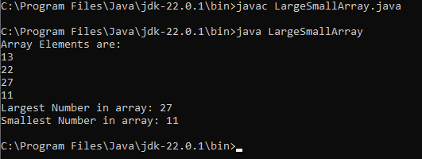

**Q4) Find the smallest and largest element from the array by taking input from the user.**

**Code:**

import java.util.Scanner;

public class LargeSmallArray2

{

public static void main(String args[])

{

Scanner scan = new Scanner(System.in);

System.out.print("Enter the number of elements in the array: ");

int n = scan.nextInt();

int[] array = new int[n];

System.out.println("Enter the elements of the array:");

for (int i = 0; i < n; i++)

{

array[i] = scan.nextInt();

}

int smallest = array[0];

int largest = array[0];

for (int i = 1; i < n; i++)

{

if (array[i] < smallest)

{

smallest = array[i];

}

if (array[i] > largest)

{

largest = array[i];

}

}

System.out.println("Smallest element: " + smallest);

System.out.println("Largest element: " + largest);

scan.close();

}

}

**Output:**

