**Q.1) Write a java program to demonstrate ‘Final Membership’.**

**CODE:**

class FinalVarDemo

{

final int a = 10;

void show()

{

a = 20;

System.out.println("a: " + a);

}

public static void main(String[] args)

{

FinalVarDemo var = new FinalVarDemo();

var.show();

}

}

**OUTPUT:**

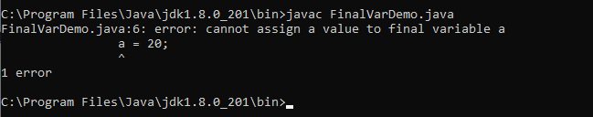

**Q.2) Write a java program to demonstrate ‘Final Method’.**

**CODE:**

class Animal

{

final void eat()

{

System.out.println("Animals are eating.");

}

}

public class DeerFinalMethod extends Animal

{

void eat()

{

System.out.println("Deer is eating.");

}

public static void main(String args[])

{

DeerFinalMethod deer = new DeerFinalMethod();

deer.eat();

}

}

**OUTPUT:**

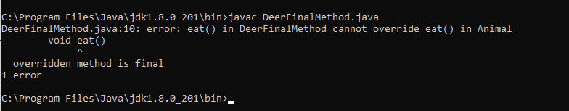

**Q.3) Write a java program to demonstrate ‘Final Class’.**

**CODE:**

final class Animal

{

void eat()

{

System.out.println("Animals are eating.");

}

}

class DeerFinalClass extends Animal

{

void eat()

{

System.out.println("Deer is eating.");

}

public static void main(String args[])

{

DeerFinalClass deer = new DeerFinalClass();

deer.eat();

}

}

**OUTPUT:**

