**Q1). Write a Java program to open a file and display the text in the console window.**

**CODE:**

import java.io.*;

public class InExam

{

public static void main(String[]args)throws FileNotFoundException,IOException

{

InputStream is = new FileInputStream("C:\\Program Files\\Java\\jdk1.8.0_201\\bin\\Demo.txt");

DataInputStream dis = new DataInputStream(is);

int count = is.available();

byte a[] = new byte[count];

is.read(a);

for(byte b:a)

{

char k = (char)b;

System.out.print(k+"-");

}

}

}

**Output:**

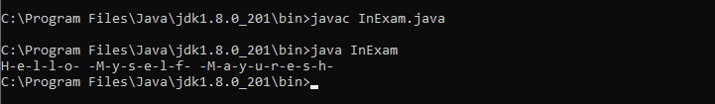

**Q2). Write a Java program to copy the content from one file to another file.**

**CODE:**

import java.io.*;

public class FileCopy

{

public static void main(String[] args) throws FileNotFoundException, IOException

{

FileInputStream fis=null;

FileOutputStream fos= null;

try

{

File inF= new File("C:\\Program Files\\Java\\jdk1.8.0_201\\bin\\Demo1.txt");

File outF= new File("C:\\Program Files\\Java\\jdk1.8.0_201\\bin\\Demo2.txt");

fis=new FileInputStream(inF);

fos=new FileOutputStream(outF);

byte buff[]= new byte[1024];

int length;

while((length=fis.read(buff))>0)

{

fos.write(buff,0,length);

}

fis.close();

fos.close();

System.out.println("The content of the file is successfully coppied...");

}

catch(Exception e)

{

e.printStackTrace();

}

}

}

**Output:**

