Q1) **Write a Java Program to Print the area and perimeter of a circle**.

**CODE:**

import java.util.Scanner;

class Circle

{

public static void main(String args[])

{

double r,cp,ca;

Scanner st=new Scanner(System.in);

System.out.print("Enter Raidus of a cricle Number:-");

r=st.nextDouble();

cp=2*3.14*r;

ca=3.14*r*r;

System.out.println("Perimeter="+cp);

System.out.println("Area="+ca);

}

}

**Output:**

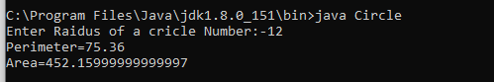

Q2) **Write a Java program That takes a number as Inpuit and prints its multiplication table up to 10**.

**CODE:**

import java.util.Scanner;

class Multi

{

public static void main(String args[])

{

int num,i;

Scanner st=new Scanner(System.in);

System.out.print("Enter Number:-");

num=st.nextInt();

System.out.println("Table of"+num);

for(i=1;i<=10;i++)

{

System.out.println(num+"*"+i+"="+num*i);

}

}

}

**OUTPUT:**

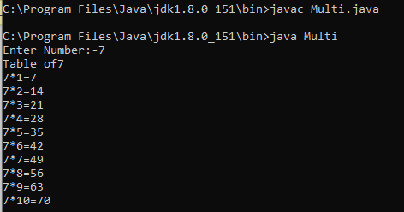

Q3) **Write a Java Program to add to binary numbers**

**CODE:**

import java.util.Scanner;

class Binary

{

public static void main(String args[])

{

long b1,b2;

int i=0,rem=0;

int[] sum=new int[20];

Scanner in=new Scanner(System.in);

System.out.print("Enter a first binary Number:-");

b1=in.nextLong();

System.out.print("Enter Second Binary Number:-");

b2=in.nextLong();

while(b1!=0||b2!=0)

{

sum[i++]=(int)((b1%10+b2%10+rem)%2);

rem=(int)((b1%10+b2%10+rem)/2);

b1=b1/10;

b2=b2/10;

}

if(rem!=0)

{

sum[i++]=rem;

}

--i;

System.out.print("Sum of b1+b2= ");

while(i>=0)

{

System.out.print(sum[i--]);

}

}

}

**OUTPUT:**

