Q1. Write a Java program to count the letters, spaces, numbers and other characters of an input string.

**Code:**

import java.util.Scanner;

class Pract3a {

public static void main(String args[]) {

String st;

Scanner in = new Scanner(System.in);

System.out.print("Enter a string: ");

st = in.nextLine();

count(st);

}

public static void count(String x) {

char[] ch = x.toCharArray();

int i, l = 0, s = 0, d = 0, a = 0;

for(i = 0; i < x.length(); i++) {

if (Character.isLetter(ch[i])) {

l++;

}

if (Character.isDigit(ch[i])) {

d++;

}

if (Character.isSpaceChar(ch[i])) {

s++;

}

else {

a++;

}

}

System.out.println("Letter: " +l);

System.out.println("Space: " +s);

System.out.println("Number: " +d);

System.out.println("Other: " +a);

}

}

**Output:**

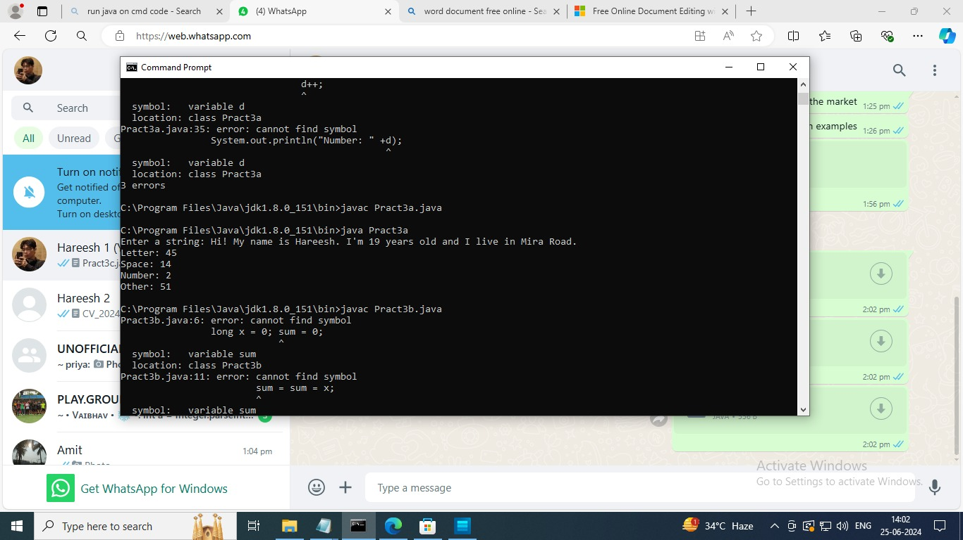

Q2. Write a Java Program to demonstrate the use of constructor and destructor.

**Code:**

public class Pract4b {

public Pract4b() {

System.out.println("Hi Hareesh!");

}

public void finalize() {

System.out.println("Sayonara");

}

public static void main(String[] args) {

Pract4b obj = new Pract4b();

obj = null;

System.gc();

}

}

**Output:**

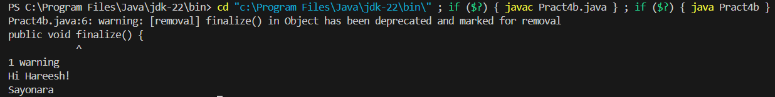

Q3. Design a class SortData that contains the method asec and desc.

**Code:**

public class Pract4a {

public static void main(String[] args) {

SortData obj = new SortData();

int arr[] = {12,44,45,28,9,87};

obj.asec(arr);

obj.desc(arr);

}

}

class SortData {

public void asec(int num[]) {

int temp;

for (int i = 0; i < num.length; i++) {

for (int j = i + 1; j < num.length; j++) {

if (num[i] > num[j]) {

temp = num[i] ;

num[i] = num[j];

num[j] = temp;

}

}

}

System.out.println("Ascending Order");

for (int i = 0; i < num.length; i++) {

System.out.println(num[i] + " ");

}

}

public void desc(int num[]) {

int temp;

for (int i = 0; i < num.length; i++) {

for (int j = i + 1; j < num.length; j++) {

if (num[i] < num[j]) {

temp = num[i] ;

num[i] = num[j];

num[j] = temp;

}

}

}

System.out.println("Descending Order");

for (int i = 0; i < num.length; i++) {

System.out.println(num[i] + " ");

}

System.out.println();

}

}

**Output:**

