**Q.1) Design an abstract class to find or check if the number is Armstrong number or not and generate result.**

**Code:**

import java.util.Scanner;

abstract class Check {

public abstract boolean ams(int n);

}

public class Armstrong extends Check {

@Override

public boolean ams(int n) {

int x = n;

int sum = 0;

while (x > 0) {

int r = x % 10;

sum += r * r * r;

x = x / 10;

}

return sum == n;

}

public static void main(String[] args) {

Scanner sc = new Scanner(System.in);

int x;

System.out.print("Enter a positive number: ");

x = sc.nextInt();

while (x <= 0) {

System.out.println("Invalid input");

System.out.print("Enter a positive number: ");

x = sc.nextInt();

}

Armstrong armst = new Armstrong();

if (armst.ams(x))

{

System.out.println(x + " is an Armstrong number");

} else

{

System.out.println(x + " is not an Armstrong number");

}

}

}

**Outputs:**

*Incorrect Input*:

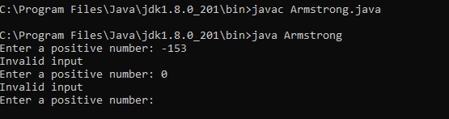

*Correct Input*:

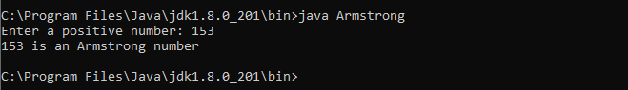

**Q.2) Write a java program to implement multiple inheritance.**

**Code:**

interface S

{

public void show();

}

interface T extends S

{

public void display();

}

public class Prac5c implements T

{

@Override

public void display()

{

System.out.println("From interface T");

}

@Override

public void show()

{

System.out.println("From interface S");

}

public static void main(String[] args)

{

Prac5c ob=new Prac5c();

ob.show();

ob.display();

}

}

**Output:**

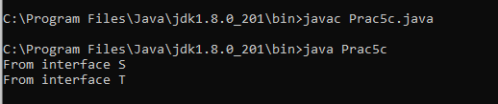

**Q.3) Write a java program for Adding two matrices and print the result for the same.**

**Code:**

import java.util.Scanner;

public class MatrixAddition

{

public static void main(String args[])

{

int i,j;

int mat1[][] = new int[2][2];

int mat2[][] = new int[2][2];

int mat3[][] = new int[2][2];

Scanner sc = new Scanner(System.in);

System.out.print("Enter Matrix 1 Elements: ");

for(i=0;i<2;i++)

{

for(j=0;j<2;j++)

{

mat1[i][j] = sc.nextInt();

}

}

System.out.print("Enter Matrix 2 Elements: ");

for(i=0;i<2;i++)

{

for(j=0;j<2;j++)

{

mat2[i][j] = sc.nextInt();

}

}

System.out.print("Adding both Matrix to from the Third Matrix...\n");

for(i=0;i<2;i++)

{

for(j=0;j<2;j++)

{

mat3[i][j] = mat1[i][j] + mat2[i][j];

}

}

System.out.print("The Two Matrix Added Successfully..!!\n");

System.out.print("The New Matrix will be :\n");

for(i=0;i<2;i++)

{

for(j=0;j<2;j++)

{

System.out.print(mat3[i][j]+" ");

}

System.out.println();

}

}

}

**Output:**

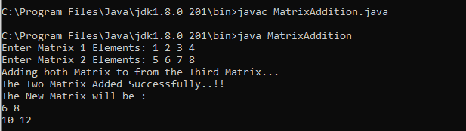

**Q.4) Write a java program for multiplying two matrices and print the product for the same.**

**Code:**

import java.util.Scanner;

public class MatrixMulti

{

public static void main(String args[])

{

int n;

Scanner input = new Scanner(System.in);

System.out.print("Enter the base of squared matrices: ");

n = input.nextInt();

int[][] a = new int[n][n];

int[][] b = new int[n][n];

int[][] c = new int[n][n];

System.out.print("Enter the elements of 1st martix row wise: \n");

for(int i=0;i<n;i++)

{

for(int j=0;j<n;j++)

{

a[i][j] = input.nextInt();

}

}

System.out.print("Enter the elements of 2nd martix row wise: \n");

for(int i=0;i<n;i++)

{

for(int j=0;j<n;j++)

{

b[i][j] = input.nextInt();

}

}

System.out.println("Multiplying the matrices...");

for(int i=0;i<n;i++)

{

for(int j=0;j<n;j++)

{

for(int k=0;k<n;k++)

{

c[i][j] = c[i][j] + a[i][k] * b[k][j];

}

}

}

System.out.println("The product is: ");

for(int i=0;i<n;i++)

{

for(int j=0;j<n;j++)

{

System.out.print(c[i][j]+" ");

}

System.out.println();

}

}

}

**Output:**

