**Q.1) Write a Java program to demonstrate Private access modifier.**

**CODE:**

class A

{

private int totalValue=50;

private int Multiply(int a, int b)

{

return a*b;

}

}

public class B

{

public static void main(String args[])

{

A object = new A();

System.out.println(object.totalValue);

System.out.println(object.Multiply(10,15));

}

}

**OUTPUT:**

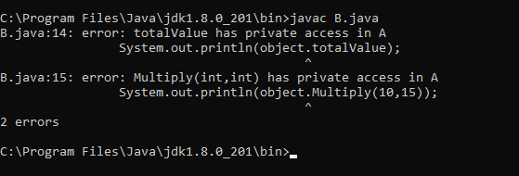

**Q.2) Write a Java program to demonstrate Public access modifier.**

**CODE:**

class A

{

public int totalValue=50;

public int Multiply(int a, int b)

{

return a*b;

}

}

public class B2

{

public static void main(String args[])

{

A object = new A();

System.out.println(object.totalValue);

System.out.println(object.Multiply(10,15));

}

}

**OUTPUT:**

