# Q1). Write a java program to implement a thread life cycle.

**CODE:**

import java.util.Vector;

class Mayuresh7B

{

public static void main(String args[])

{

System.out.println(Thread.currentThread().getName());

for(int i=0; i<10;i++)

{

new Thread(" "+i)

{

public void run()

{

System.out.println(" Thread:"+ getName()+"running ");

}

}.start();

}

}

}

**OUTPUT:**

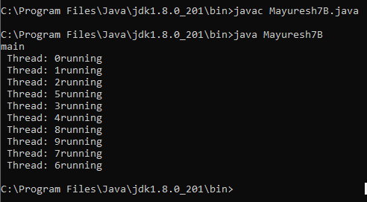

# Q2). Write a java program to implement Vector.

**CODE:**

import java.util.Vector;

class Mayuresh7a1

{

public static void main(String[] args)

{

Vector<String> v = new Vector<String>();

v.add("Red");

v.add("Green");

v.add("Blue");

System.out.println("Vector Elements are: " + v);

v.add(2, "Yellow");

System.out.println("After Adding Element at second position: " + v);

System.out.println("Element at third position: " + v.get(3));

System.out.println("First Element: " + v.firstElement());

System.out.println("Last Element: " + v.lastElement());

System.out.println("Is this vector empty? " + v.isEmpty());

}

}

**OUTPUT:**

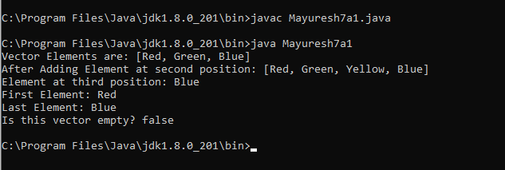

# Q3). Write a java program to implement Vector and take input from user.

**CODE:**

import java.util.Vector;

import java.util.Scanner;

class Mayuresh7a

{

public static void main(String[] args)

{

Scanner sc=new Scanner(System.in);

int n;

Vector<String> v = new Vector<String>();

System.out.println("How many vector you want to enter: ");

n=sc.nextInt();

System.out.println("Enter " + n + " words");

for(int i=0;i<n;i++)

{

String num =sc.next();

v.add(num);

}

System.out.println("Vector Elements are "+v);

}

}

**OUTPUT:**

