**Q1). Write a java program to demonstrate inheritance in java.**

**CODE:**

class Animal

{

void eat()

{

System.out.println("Eating...");

}

}

class Dog extends Animal

{

void bark()

{

System.out.println("Barking...");

}

}

class TestInheritance

{

public static void main(String args[])

{

Dog d=new Dog();

d.eat();

d.bark();

}

}

**OUTPUT:**

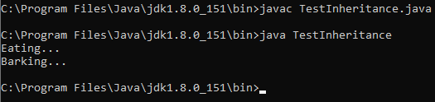

**Q2). Write a java program to demonstrate multilevel inheritance in java.**

**CODE:**

class Animal

{

void eat()

{

System.out.println("Eating...");

}

}

class Dog extends Animal

{

void bark()

{

System.out.println("Barking...");

}

}

class BabyDog extends Dog

{

void weep()

{

System.out.println("Weeping...");

}

}

class TestInheritance2

{

public static void main(String args[])

{

BabyDog d=new BabyDog();

d.eat();

d.bark();

d.weep();

}

}

**OUTPUT:**

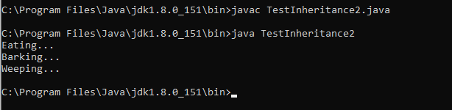

**Q3). Write a java program to demonstrate exception handling.**

**CODE:**

class main

{

public static void main(String[] args)

{

try

{

//code that generates exception

int divideByZero = 5/0;

}

catch(ArithmeticException e)

{

System.out.println("ArithmeticExcption => "+ e.getMessage());

}

finally

{

System.out.println("This is the finally block");

}

}

}

**OUTPUT:**

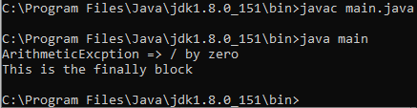

**Q4) Write a java program to demonstrate exception handling and take input from user.**

**CODE:**

import java.util.Scanner;

class ExcepHand

{

public static void main(String[] args)

{

Scanner sc = new Scanner(System.in);

int dividend;

int divisor;

System.out.print("Enter the Dividend: ");

dividend = sc.nextInt();

System.out.print("Enter the Divisor: ");

divisor = sc.nextInt();

try

{

int result = dividend/divisor;

System.out.println("Division of "+dividend+" and "+divisor+" is "+result);

}

catch(ArithmeticException e)

{

System.out.println("Arithmetic Exception -> Division "+ e.getMessage()+" is not possible");

}

finally

{

System.out.print("Did you wish to continue? If yes then type 'yes' and if no type 'no': ");

String a;

a = sc.next();

while(a.equals("yes"))

{

System.out.print("Enter the Dividend: ");

dividend = sc.nextInt();

System.out.print("Enter the Divisor: ");

divisor = sc.nextInt();

try

{

int result = dividend/divisor;

System.out.println("Division of "+dividend+" and "+divisor+" is "+result);

}

catch(ArithmeticException e)

{

System.out.println("Arithmetic Exception -> Division "+ e.getMessage()+" is not possible");

}

finally

{

System.out.print("Did you wish to continue? If yes then type 'yes' and if no type 'no': ");

a = sc.next();

}

}

}

}

}

**OUTPUT:**

