**Q.1) Write a Java program to demonstrate multiple inheritance using interface.**

**CODE:**

interface FirstInterface

{

public void myMethod();

}

interface SecondInterface

{

public void myOtherMethod();

}

class DemoClass implements FirstInterface, SecondInterface

{

public void myMethod()

{

System.out.println("Some text...");

}

public void myOtherMethod()

{

System.out.println("Some other text...");

}

}

class Interface

{

public static void main(String[] args)

{

DemoClass myObj = new DemoClass();

myObj.myMethod();

myObj.myOtherMethod();

}

}

**OUTPUT:**

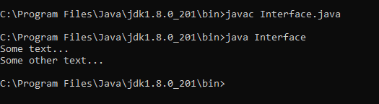

**Q.2) Write a Java program to show ‘this’ and ‘super’ keywords.**

**CODE:**

class A

{

public int x,y;

public A(int x, int y)

{

this.x = x;

this.y = y;

}

}

class B extends A

{

public int x,y;

public B()

{

this(0,0);

}

public B(int x, int y)

{

super(x + 1, y + 1);

this.x = x;

this.y = y;

}

public void print()

{

System.out.println("Base class: {" + x + "," + y + "}");

System.out.println("Super class: {" + super.x + "," + super.y + "}");

}

}

class Point

{

public static void main(String[] args)

{

B obj = new B();

obj.print();

obj = new B(1, 2);

obj.print();

}

}

**OUTPUT:**

