**Q. Import the legacy data from different sources such as ( Excel , SQL Server, Oracle etc.) and load in the target system. ( You can download sample database such as Adventureworks, Northwind, foodmart etc.)**

Steps:

1. Open Power BI software.
2. Under Home tab, find the ‘Get Data’ option in External Data group. Following list will be displayed.

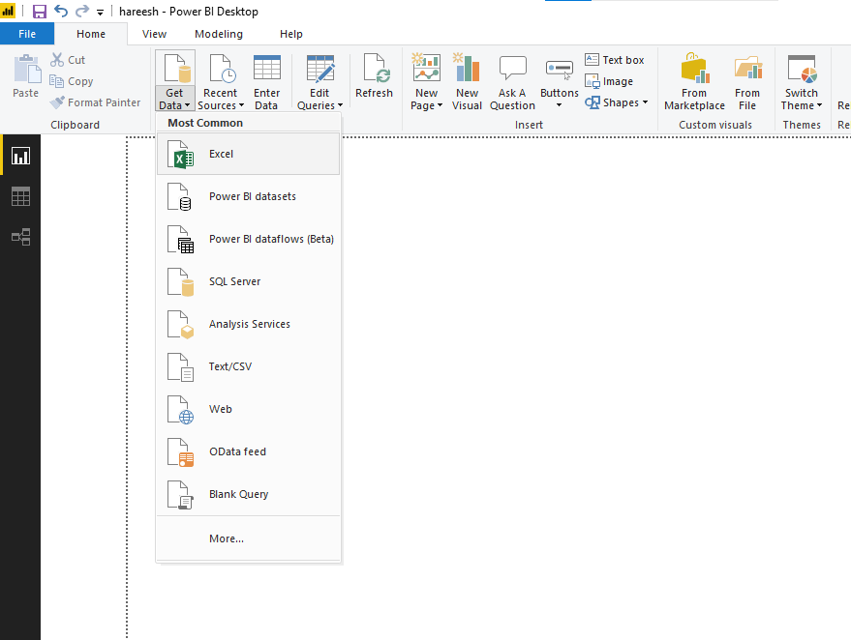

1. Select the required file format, enter file name and click open.

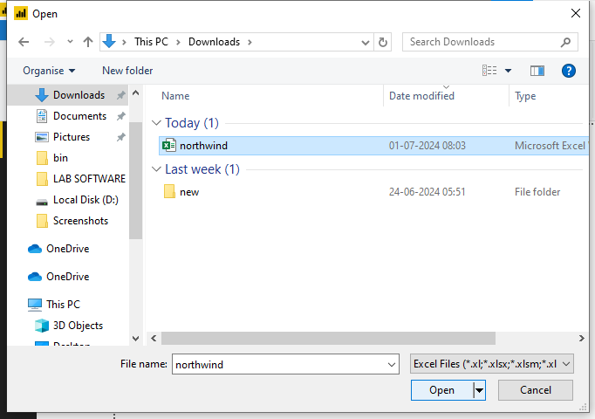

1. A navigator window opens. Select the sheets you want to work on and click edit.

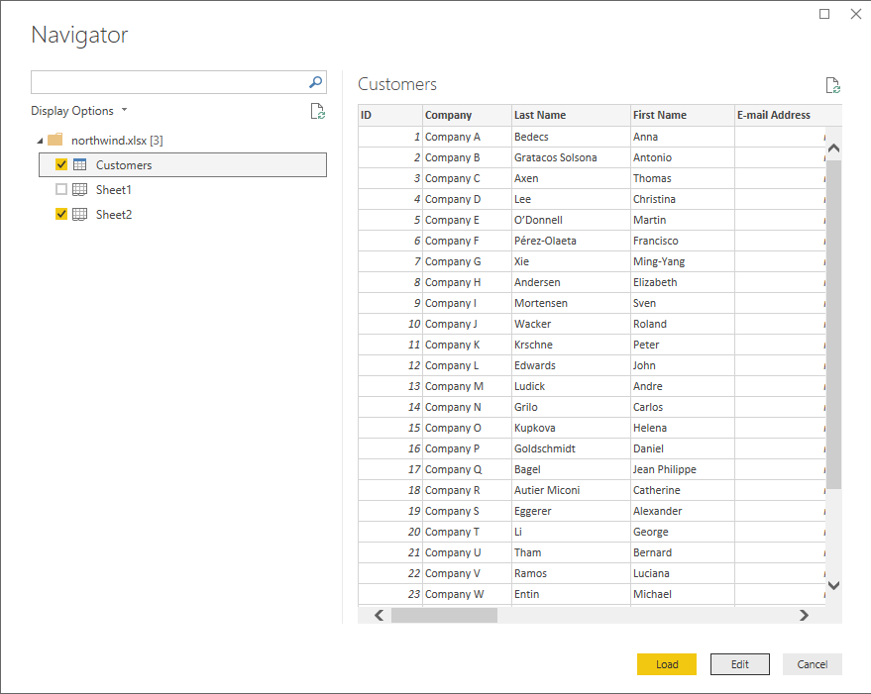

1. Power Query editor opens.

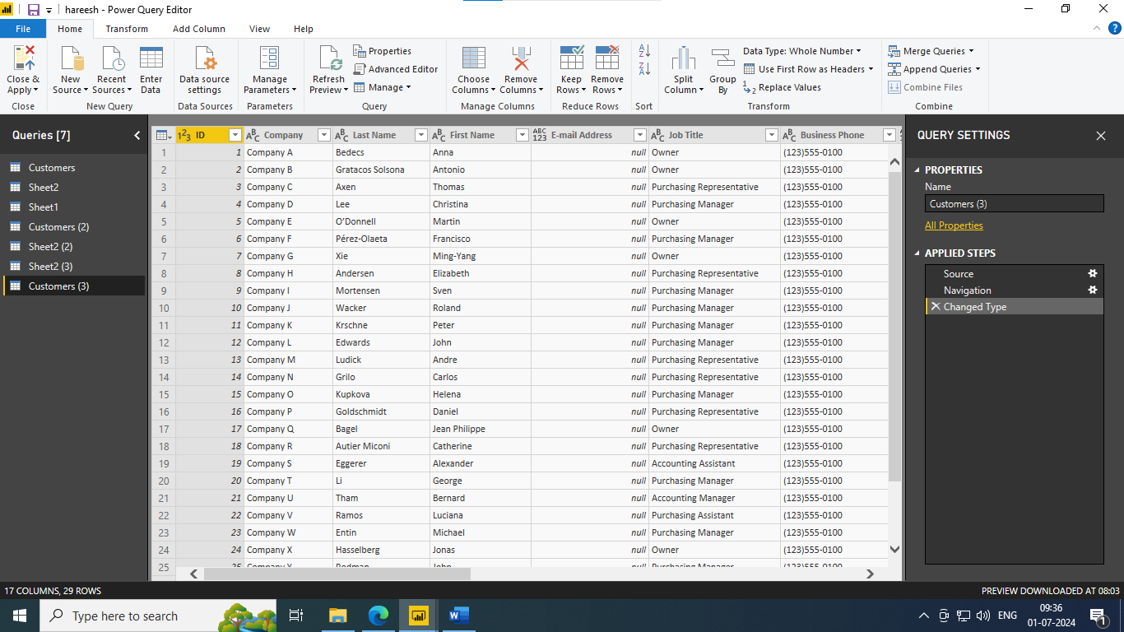

1. Again, go to Get data and select OData and enter the url.

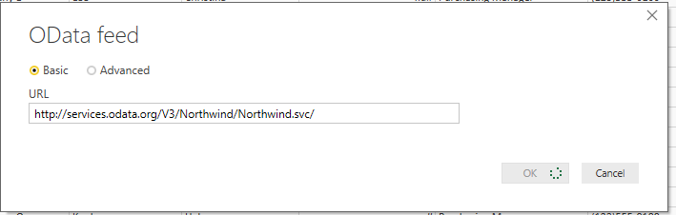

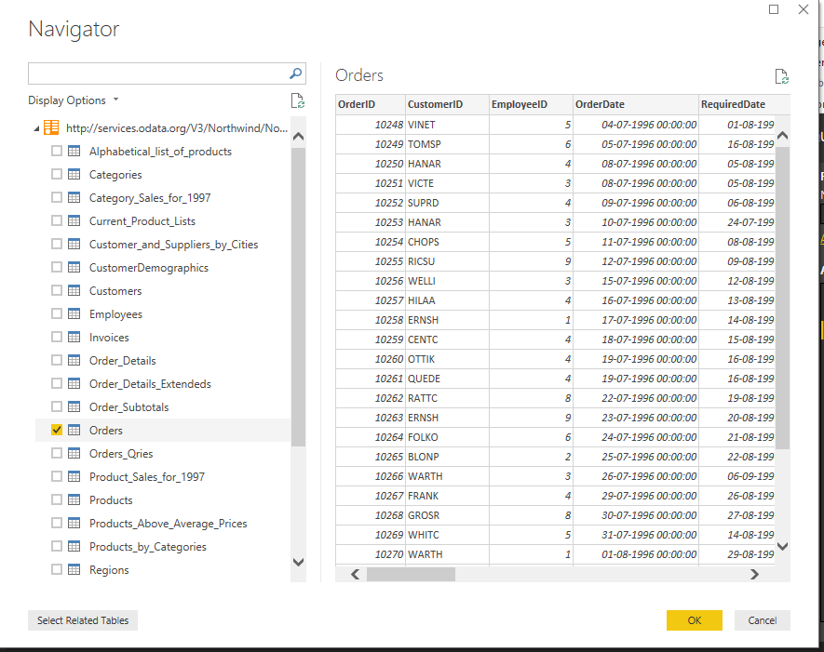

1. After clicking Ok, select the data sheets you want and click ‘Load’. Your data is now loaded.

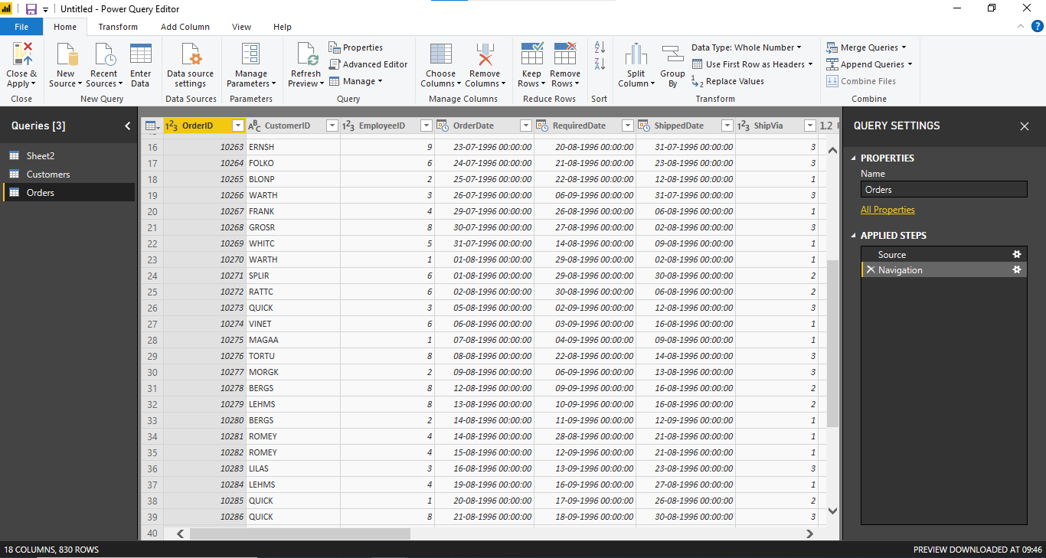

1. To view relationships, click on the Model View icon below Table View.

