Q. Perform the Extraction Transformation and Loading (ETL) process to construct the database in the Power BI.

Steps:

1. **Load data from ODataFeed.**
2. Open Power BI, click on Get Data and select OData Feed.

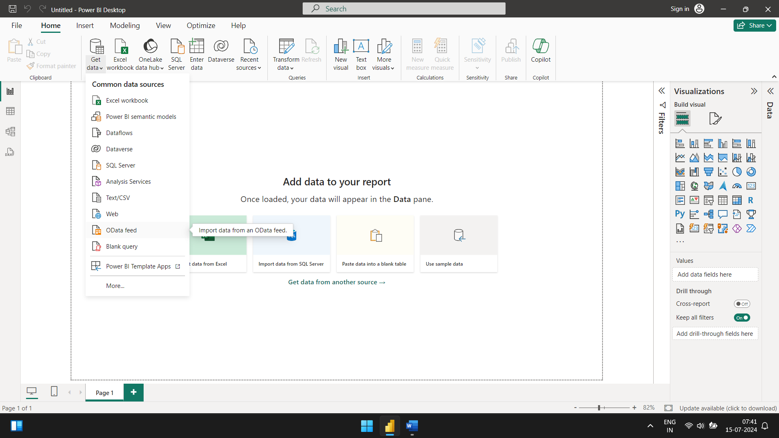

Paste the url for the data.’ <https://services.odata.org/V3/Northwind/Northwind.svc/>’.

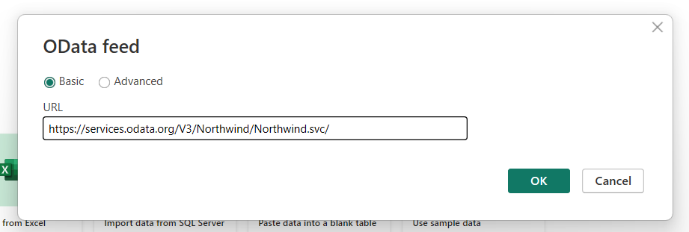

1. Click on Check Box of Products table and then click on Transform Data.

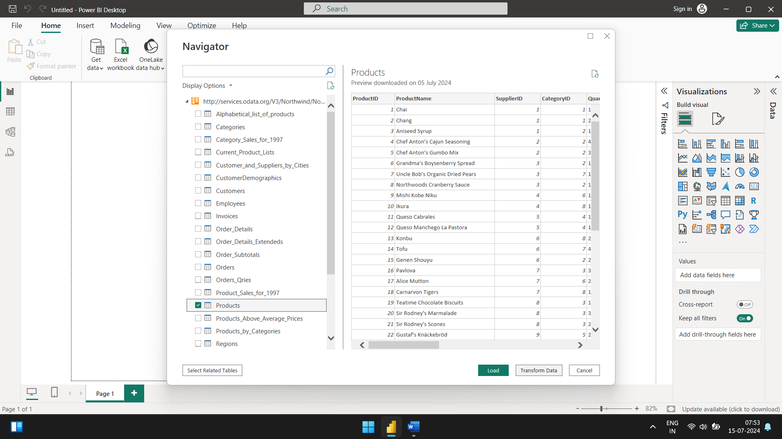

Power Query editor opens.

1. Remove other columns to only display columns of interest. In Query Editor, select the ProductID, ProductName, QuantityPerUnit, and UnitsInStock columns.
2. Select Remove columns, then remove other columns from the ribbon.

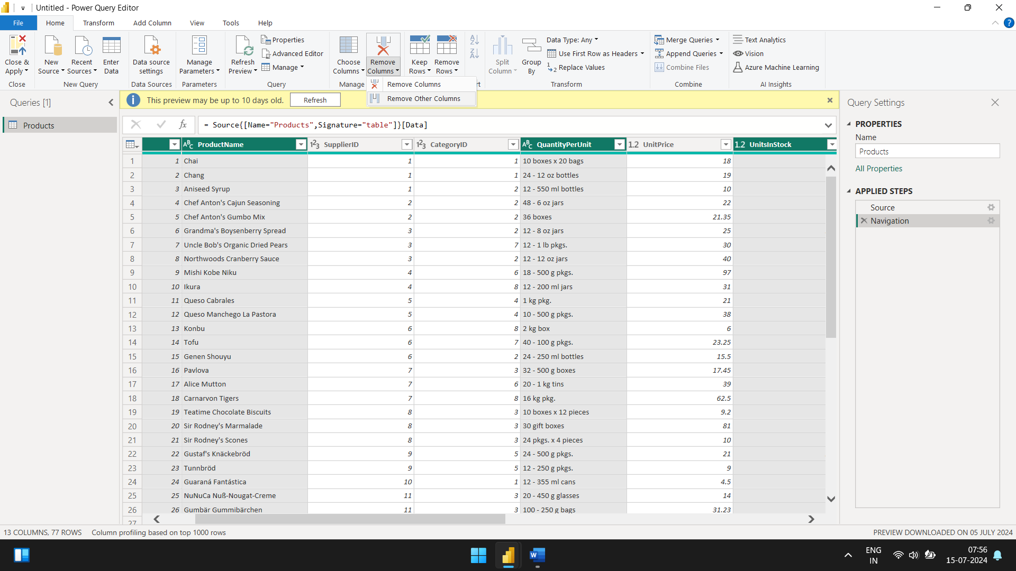

1. After clicking on Remove other columns, only the selected are visible.

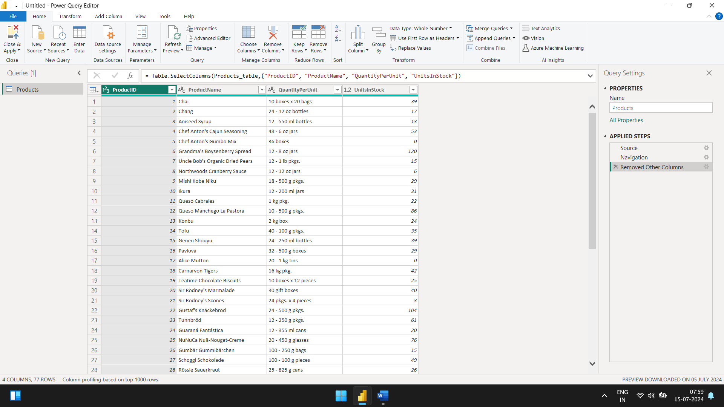

1. **Change datatype of UnitsinStock column.**
2. Select the UnitsInStock column
3. Inside home ribbon, go to transform section. Select Data Type drop-down. Change the data type to Whole numbers.

1. You will see the data type: has changed to whole number.
2. After this, close the query editor and make sure to save the changes.
3. Power BI will load the data from the query editor. You’ll see product table has appeared in the data field.

1. Check all the fields under the name to view the representation in charts form.

1. **Expand the orders table.**
2. Once you have loaded a data source, you can go to the Recent Sources in the Home ribbon to view the table.

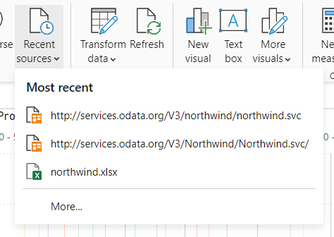

1. Click the 1st URL. You will see a Navigator window open up where you can select orders table.

1. Click on transform data. Power query window will appear.
2. Navigate to the order details column in the table and click on the expand icon . A modal will appear.

1. Uncheck (Select All Columns) and select only ProductID, UnitPrice, Quantity and click OK.

1. A new screen will appear with the combined columns.

1. **Calculate the line details for each Order_Details row. Power BI desktop allows you to create calculations based on the columns you are importing, so you can enrich the data that you connect to. In this step, we create a Custom Column to calculate the line total for each Order_Details row.**
2. In the Add Column Ribbon tab click on Add Custom Column. The Custom Column dialogue box will appear.
3. In the dialogue box, write the column name: LineTotal.
4. Enter the following formula in Custom column formula: “[Order_Details.UnitPrice] * [Order_Details.Quantity]

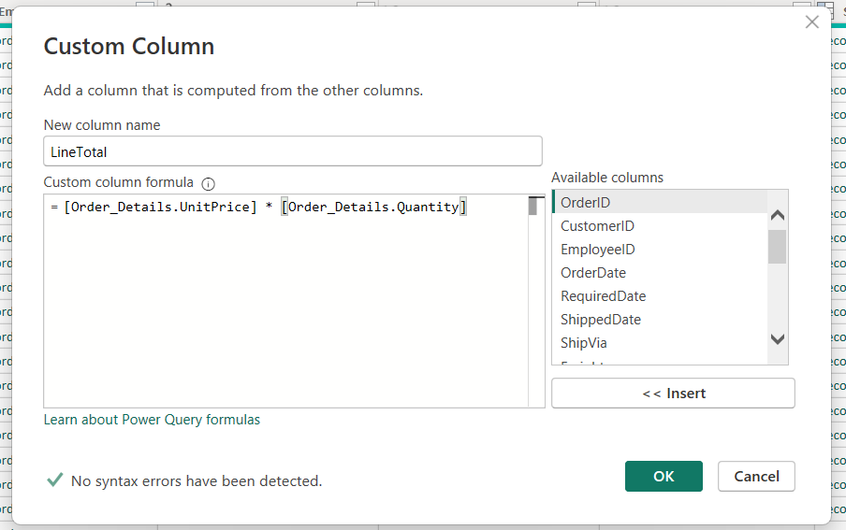

1. A new colum with the name LineTotal will be added.
2. **Rename and reorder columns in the table. In this step you finish making the model easy to work with when creating reports, by renaming the final columns and changing their order.**
3. In query editor, drag the LineTotal column to the left after ShipCountry. This will reorder the column.

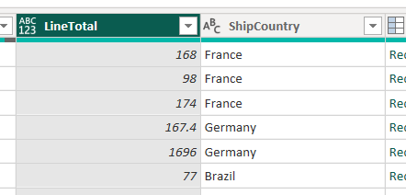

1. Remove the Order_Details. Prefix from the Order_Details.ProductID, Order_Details.UnitPrice and Order_Details.Quantity columns by double-clicking on each column header, and deleting the text from the column name.0

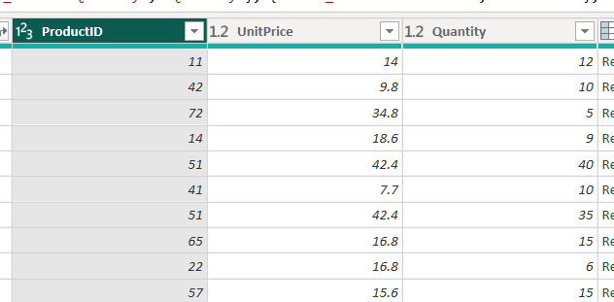

1. Combine the Products and Total Sales Queries.

* **Power Bi desktop doesn’t require you to combine queries to report on them. Instead you can create relationships between datasets. These relationships can be created on any column that is common to your datasets.**

1. Confirm the relationship between Products and Total_Sales.
2. 1st we will load the model that we created in query editor using Power BI. From home ribbon screen click Close and Apply.
3. Once the data is loaded, go to the data field and right-click on Orders drop-down. You will see a few options.

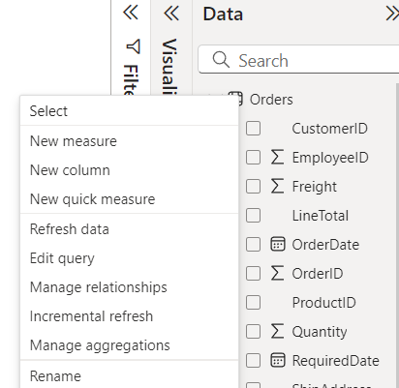

1. Select Manage relationships from the drop-down. The Manage relationships dialogue box will appear.

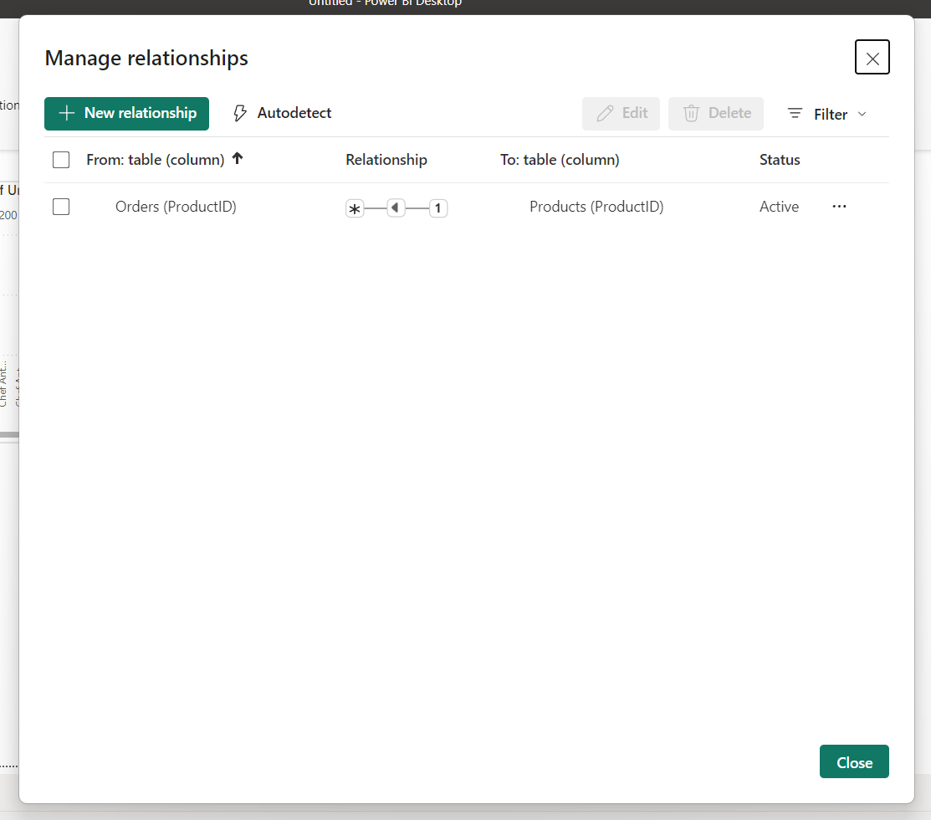

1. Select the new relationship button.

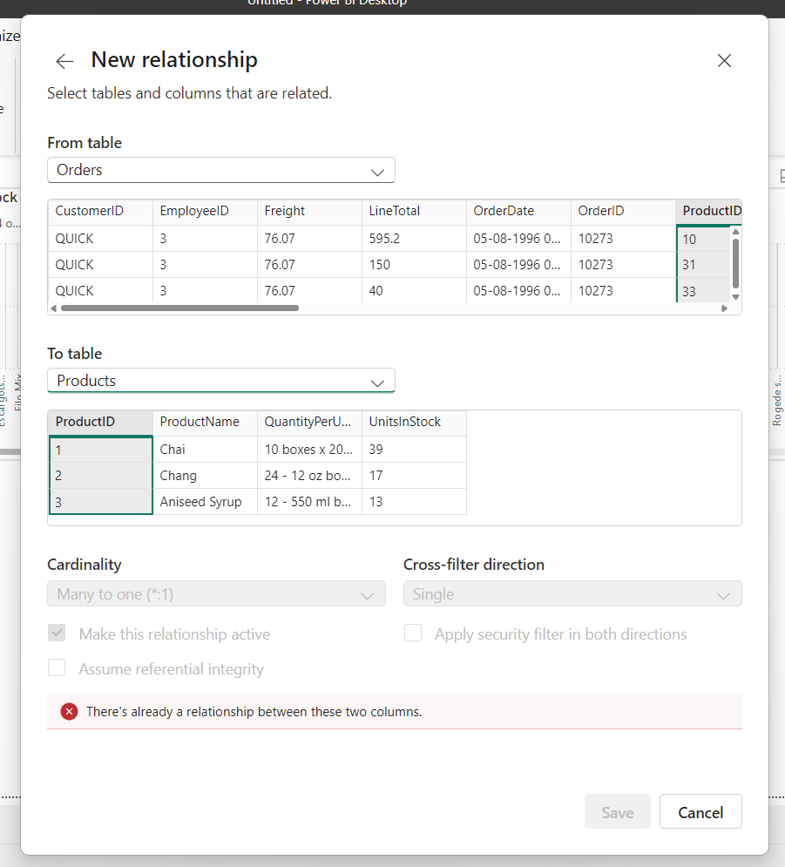

1. Select Orders table in from table option and Products table in to table option. As you can see an error will appear saying that one already exists. The productid column is already linked between the tables.



1. Select Cancel and head to the Modal view in the left panel. You will see a diagram which shows the relationship between the queries.

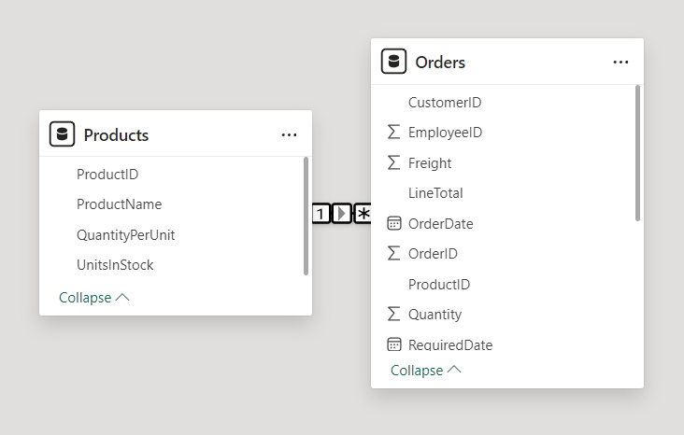

1. Click on the arrow in between the 2 tables, and check the properties field on the right you will see Open relationship editor.

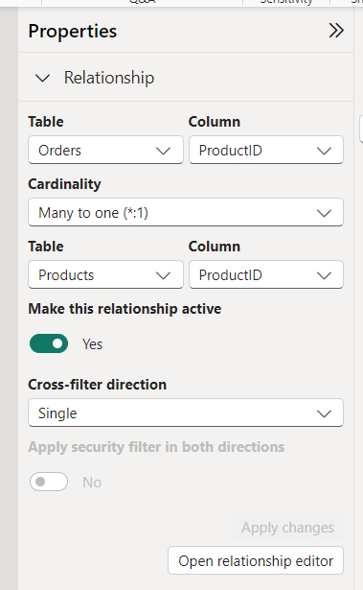

1. Open it and an edit relationship dialog appears.

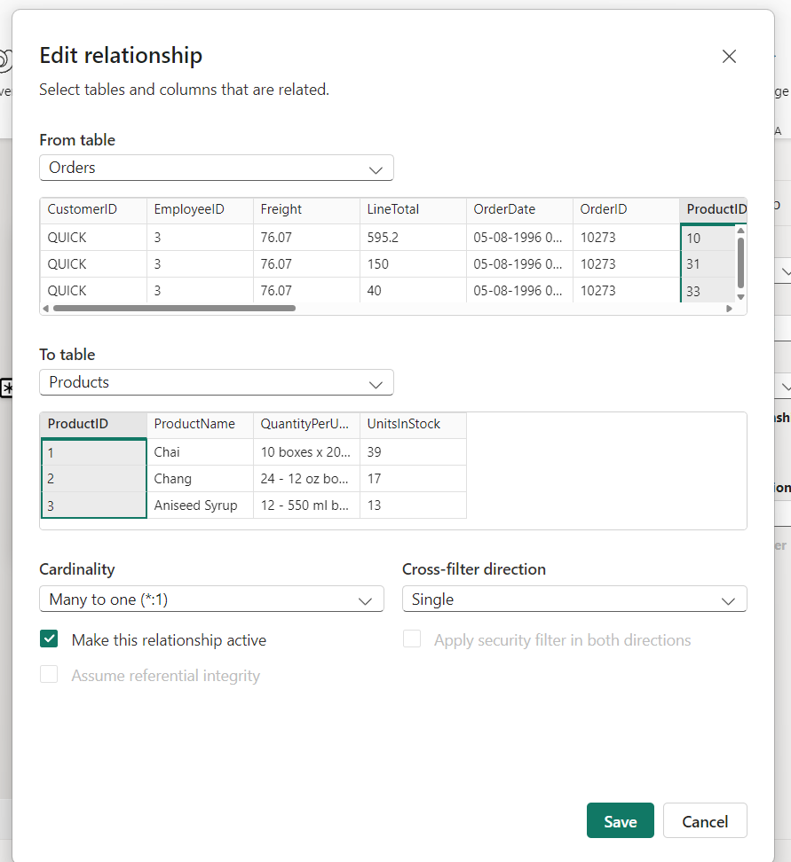

1. No need to make any changes, just select cancel to close the Edit relationship dialog.