Q. Perform the Extraction Transformation and Loading (ETL) process to construct the database in the SQL server.

Steps:

1. Open SQL Server Management Studio to restore backup file.

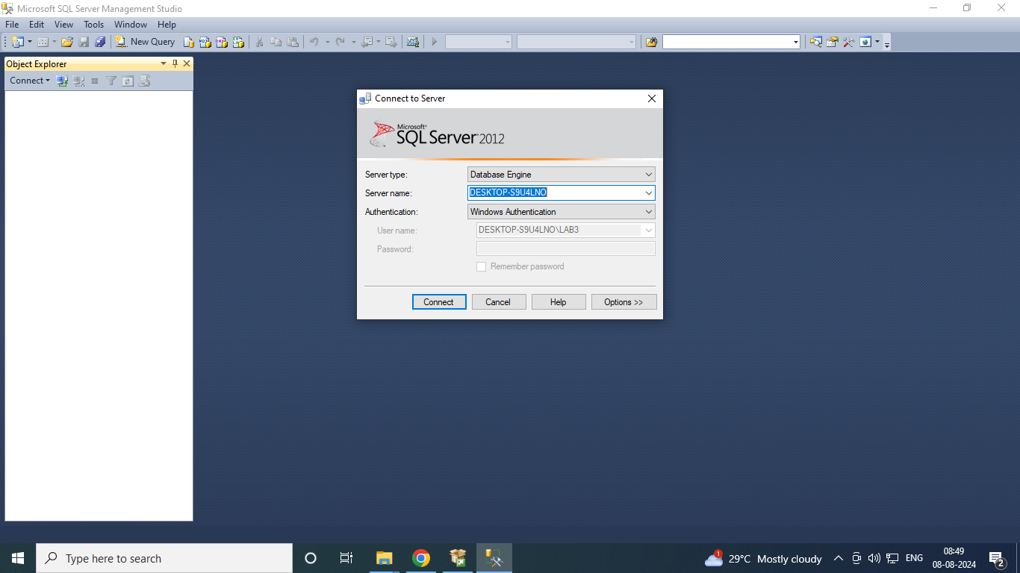

1. Right click on Databases → Restore Database.

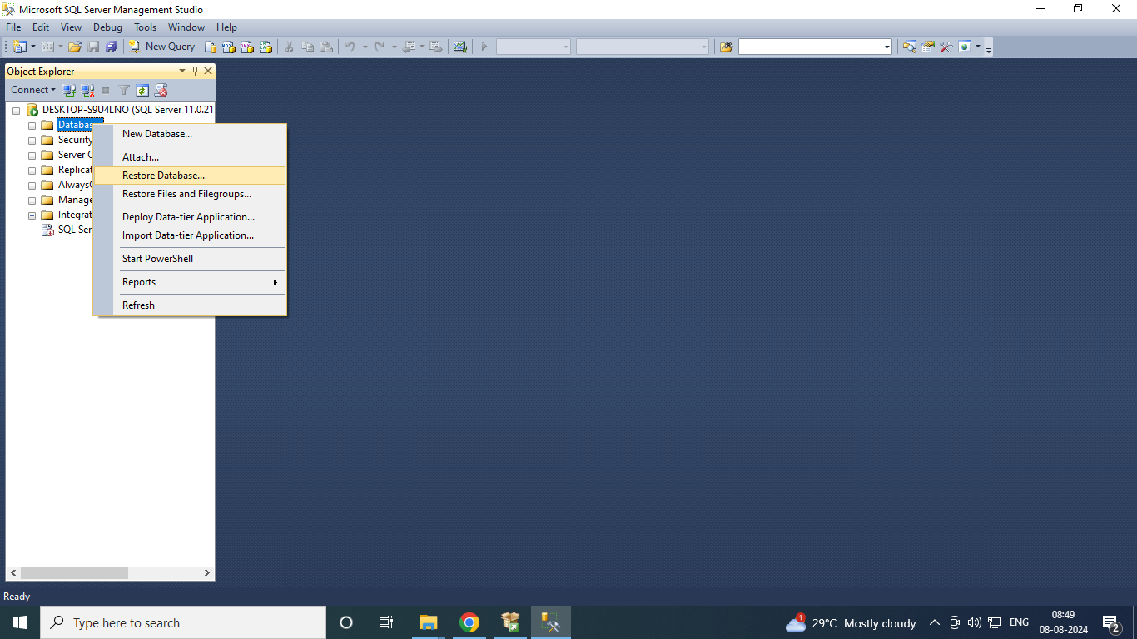

1. 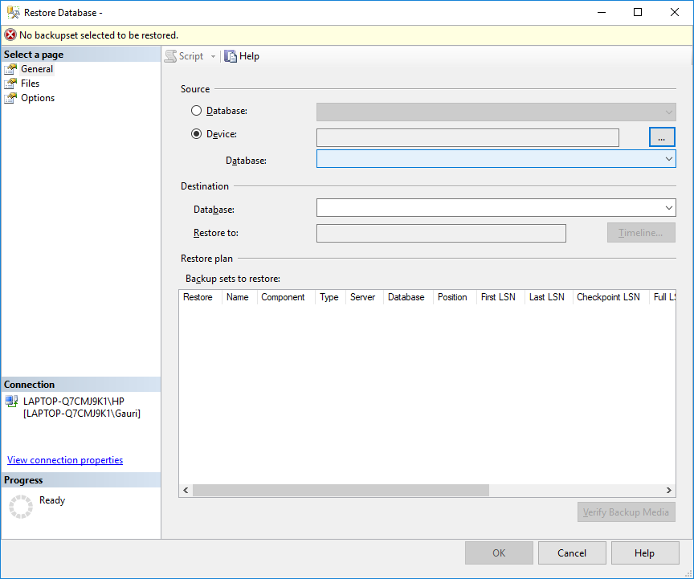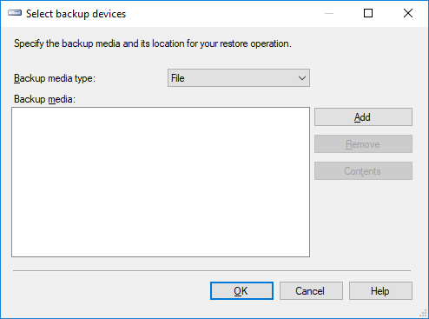Select Device → click on  icon towards end of device box.

1. Click on Add → Select path of backup files.

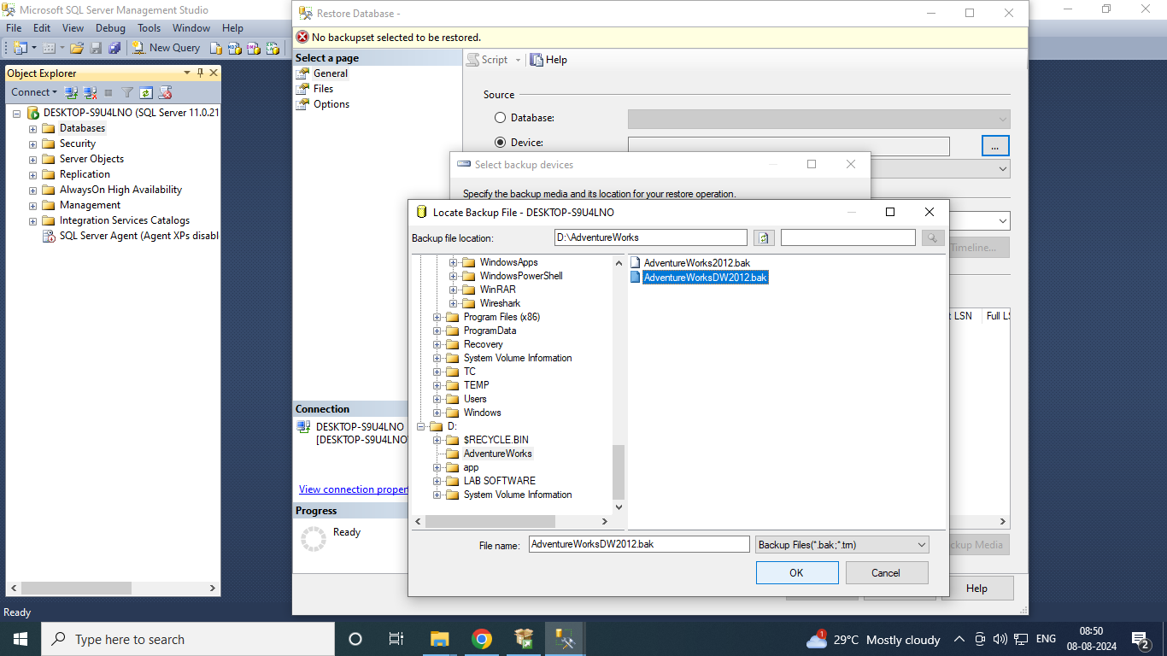

1. Click ok and in select backup devices window the file of AdventureWorks.

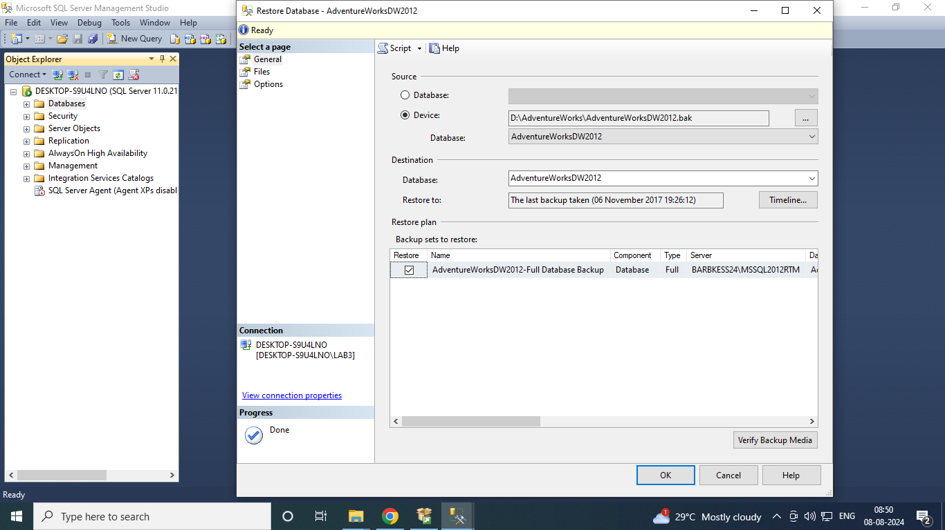

1. 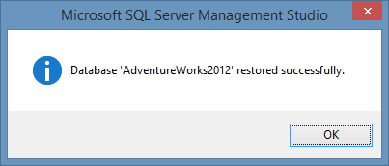Open SQL Data Server Tools. Select File → New → Project → Business Intelligence → Integration Services Project & give appropriate project name.

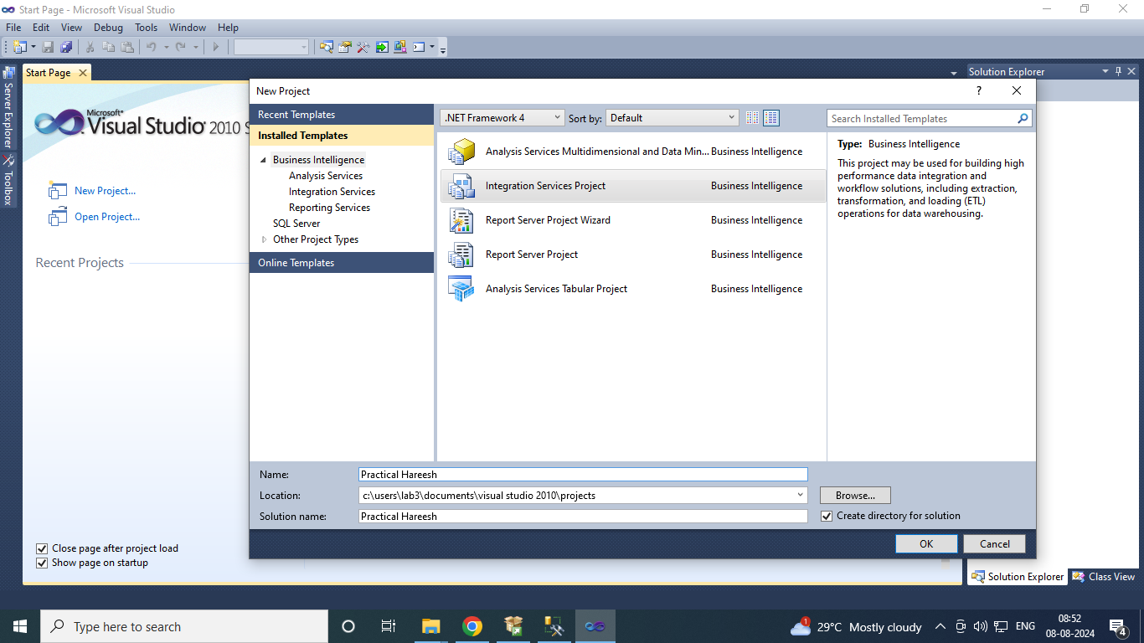

1. Right click on Connection Managers in solution explorer and click on New Connection Manager.

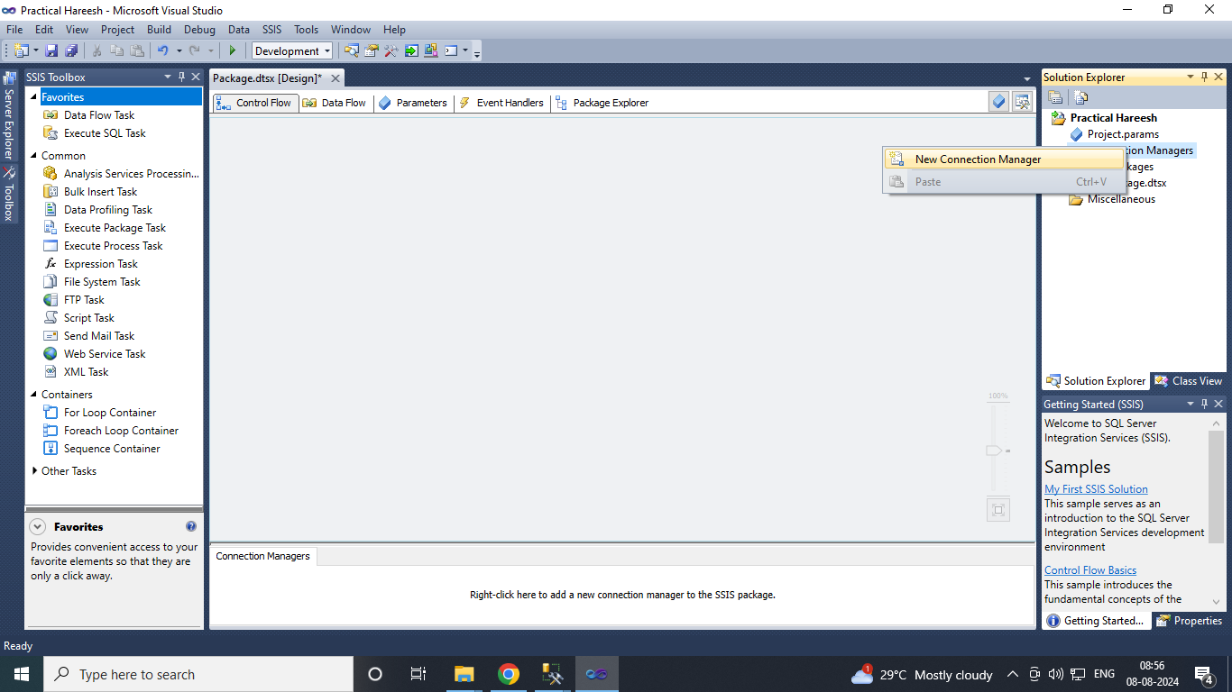

1. Select OLEDB Connection Manager and Click on Add.

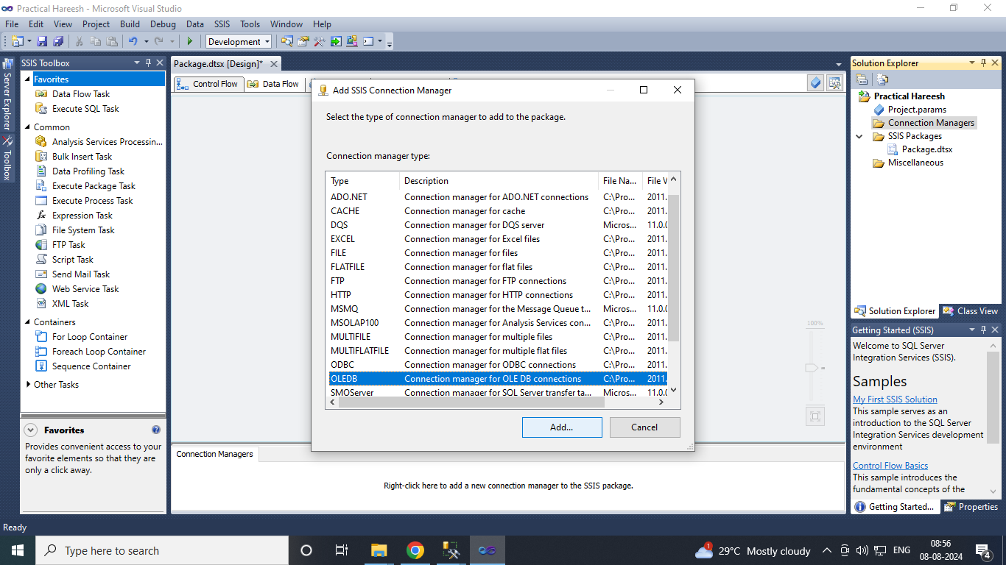

1. 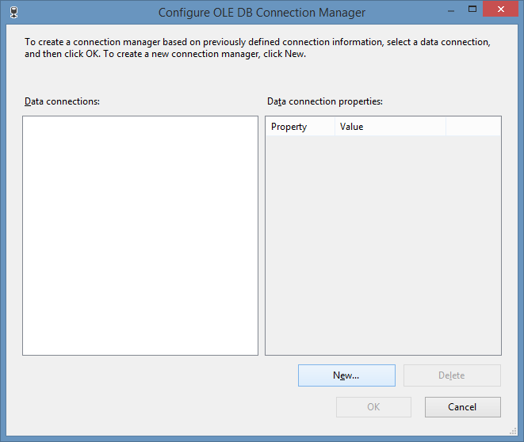Configure OLE DB Connection Manager window appears → Click on New. Select Server name(as per your machine) from drop down and database name and click on Test connection.

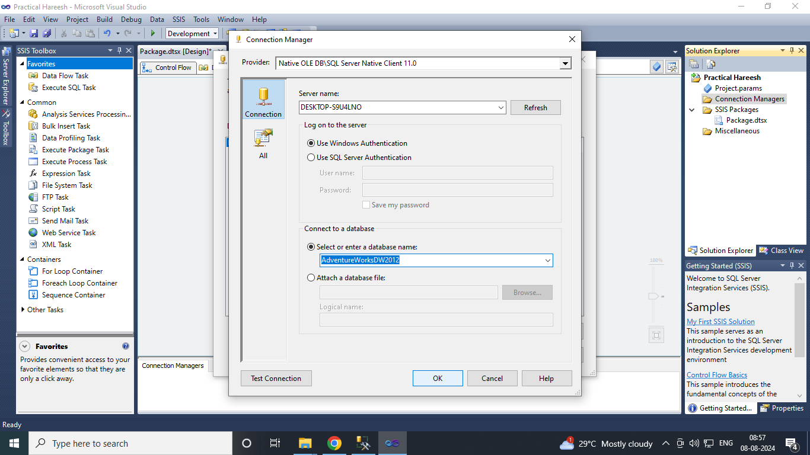

If test connection succeeded click on OK.

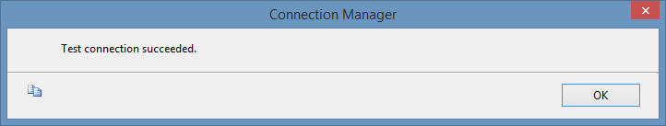

1. Click on OK. Connection is added to connection manager.

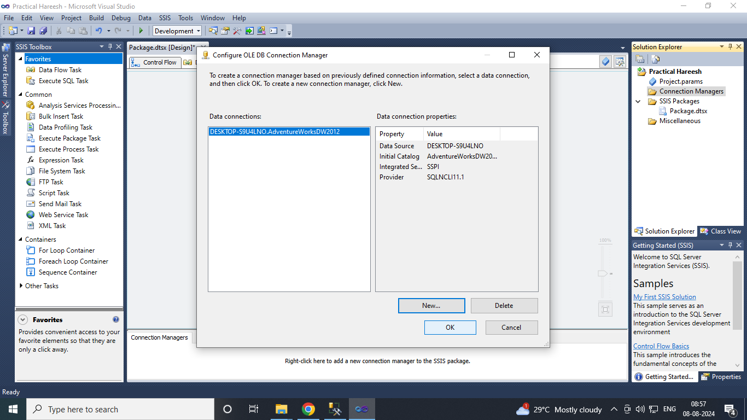

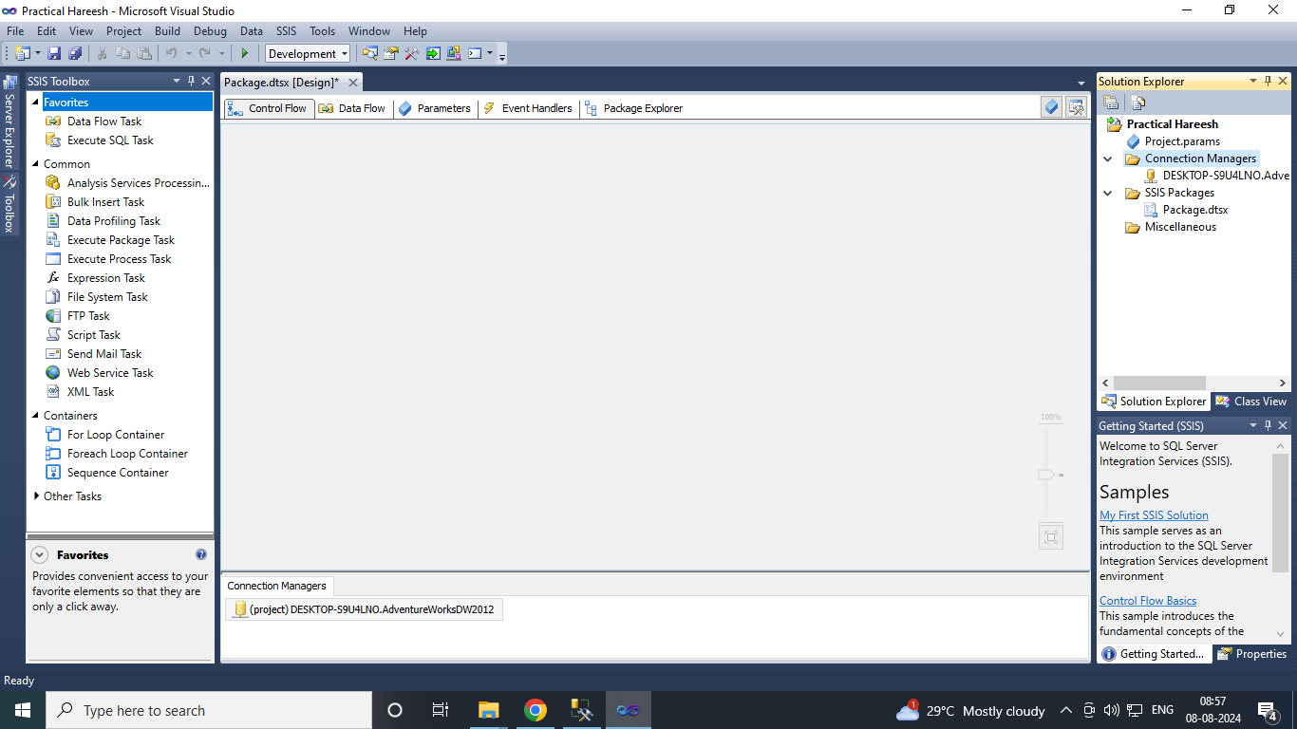

1. Drag and drop Data Flow Task in Control Flow tab.

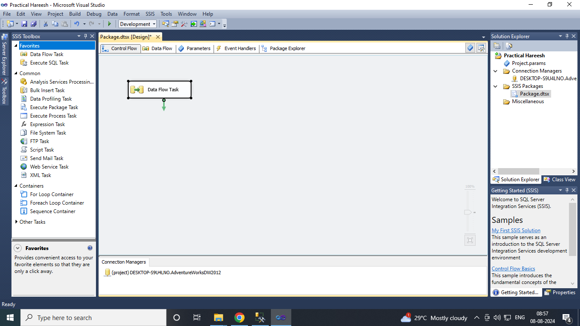

1. Drag OLE DB Source from Other Sources and drop into Data Flow tab

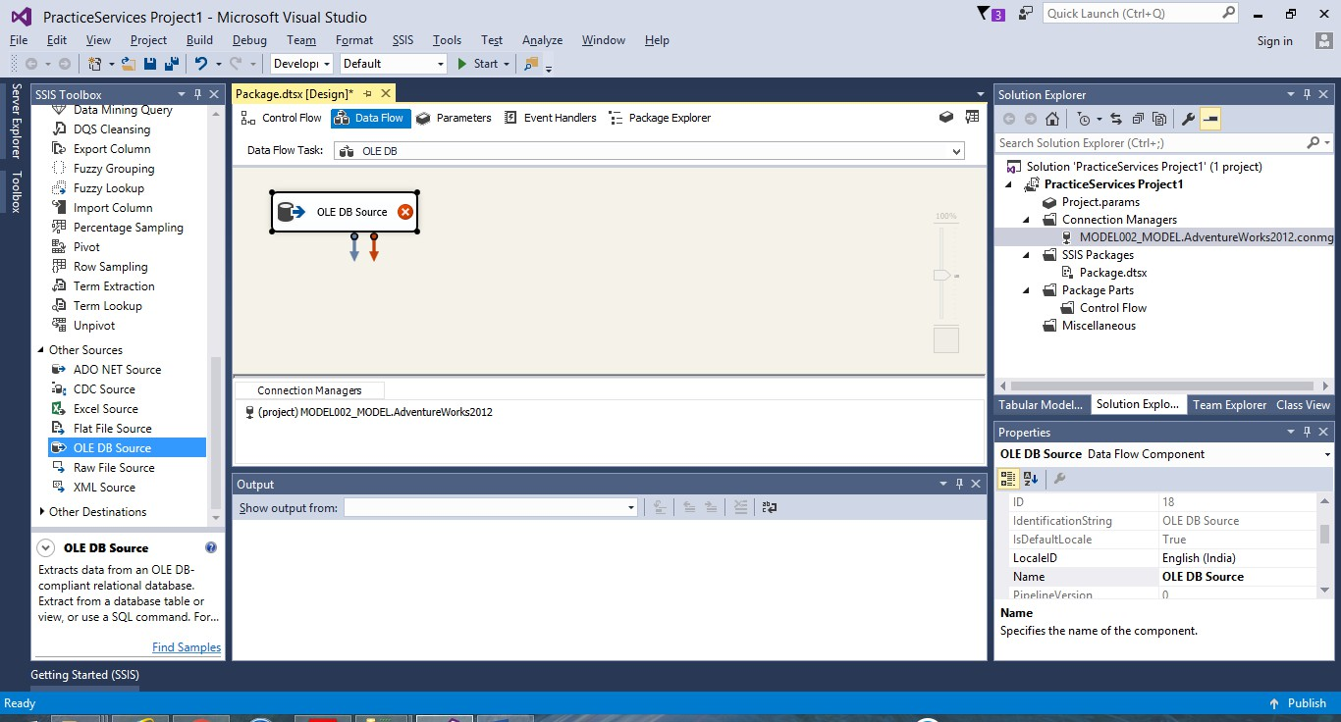

1. Double click on OLE DB source → OLE DB Source Editor appears→ click on New to add connection manager.

Select [Sales].[Store] table from drop down → ok.

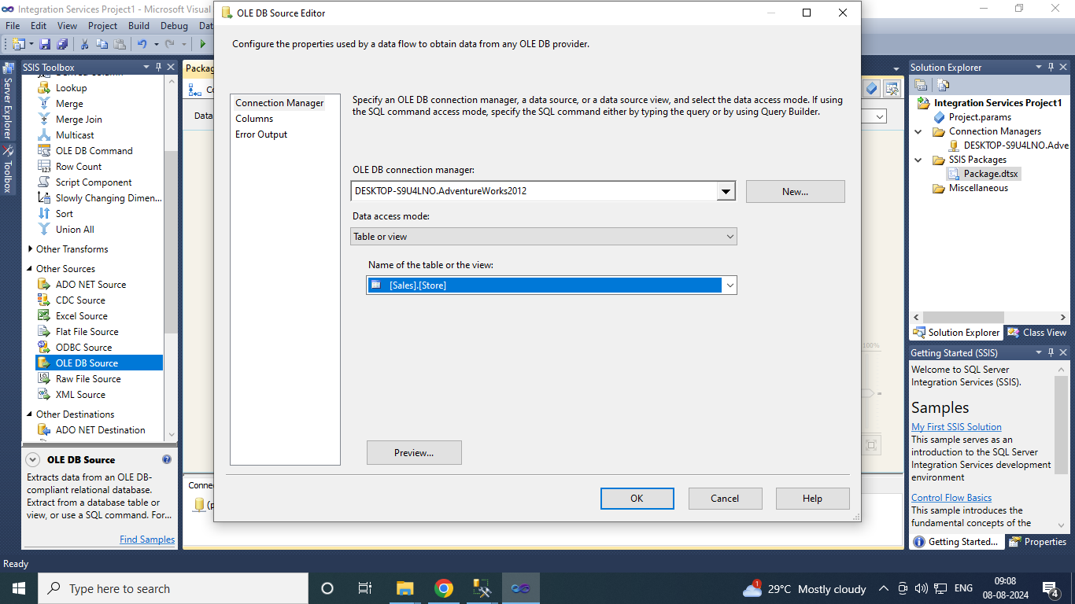

1. Drag OLE DB destination in data flow tab and connect both.

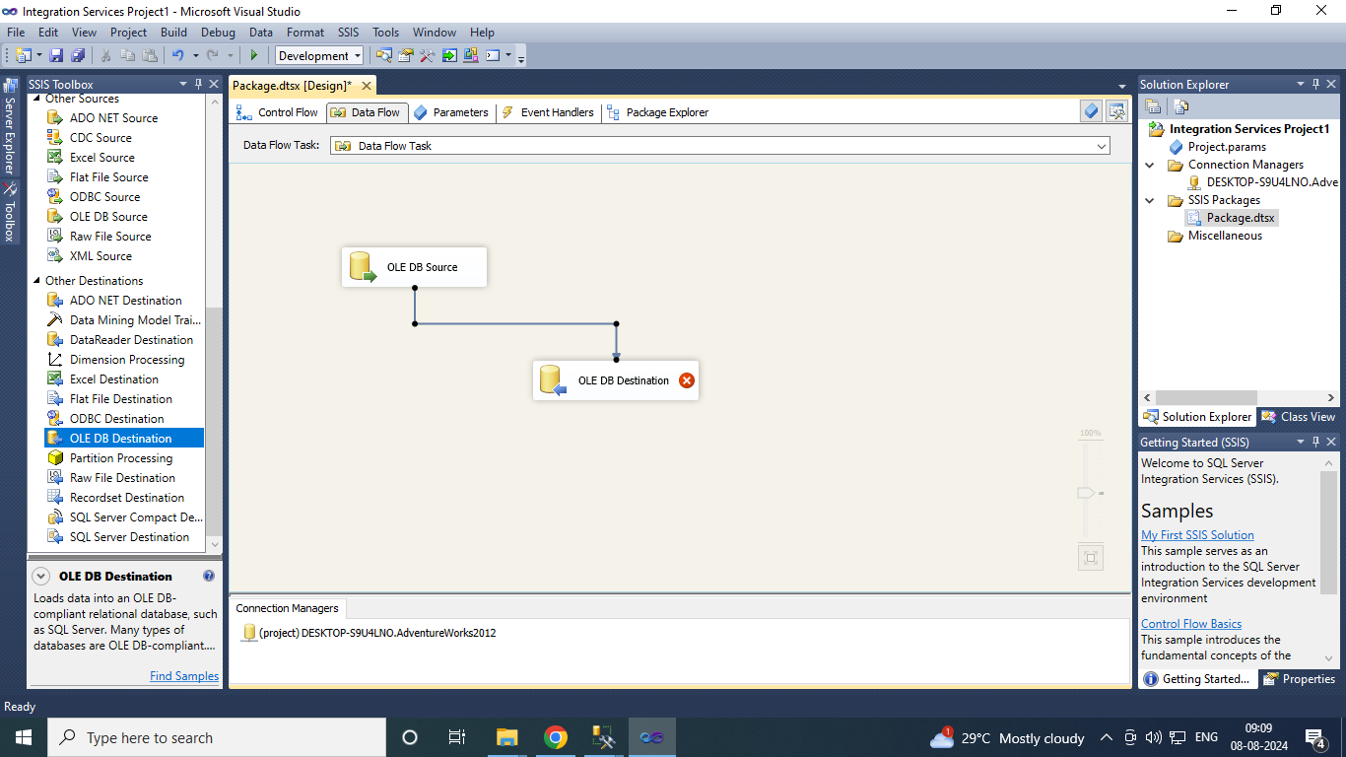

1. Double click on OLE DB destination. Click on New to run the query to get [OLE DB Destination] in Name of the table or the view.

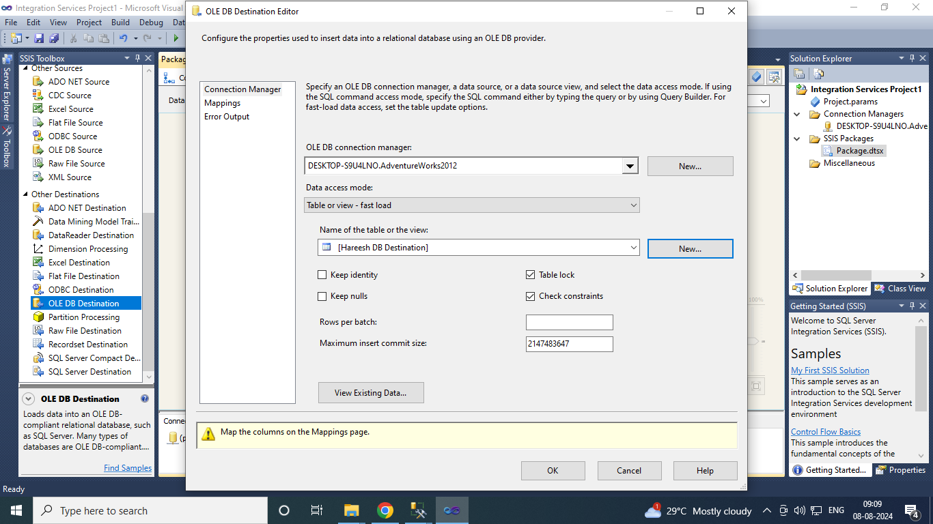

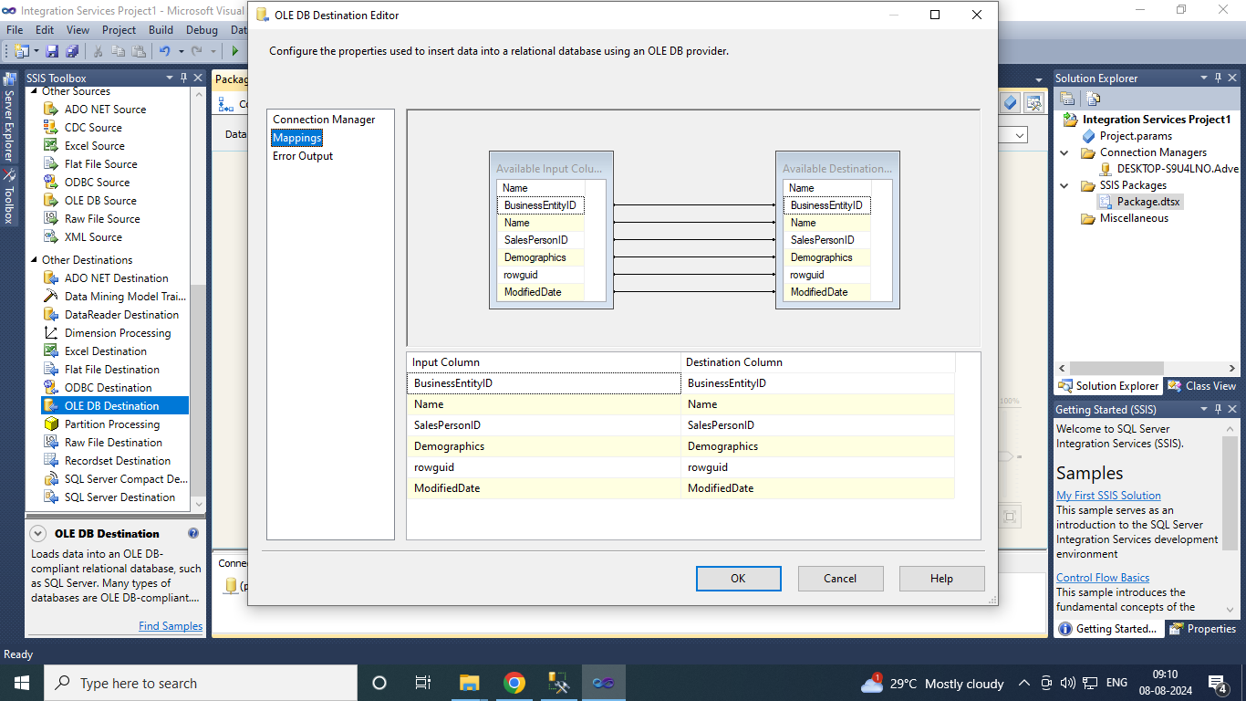

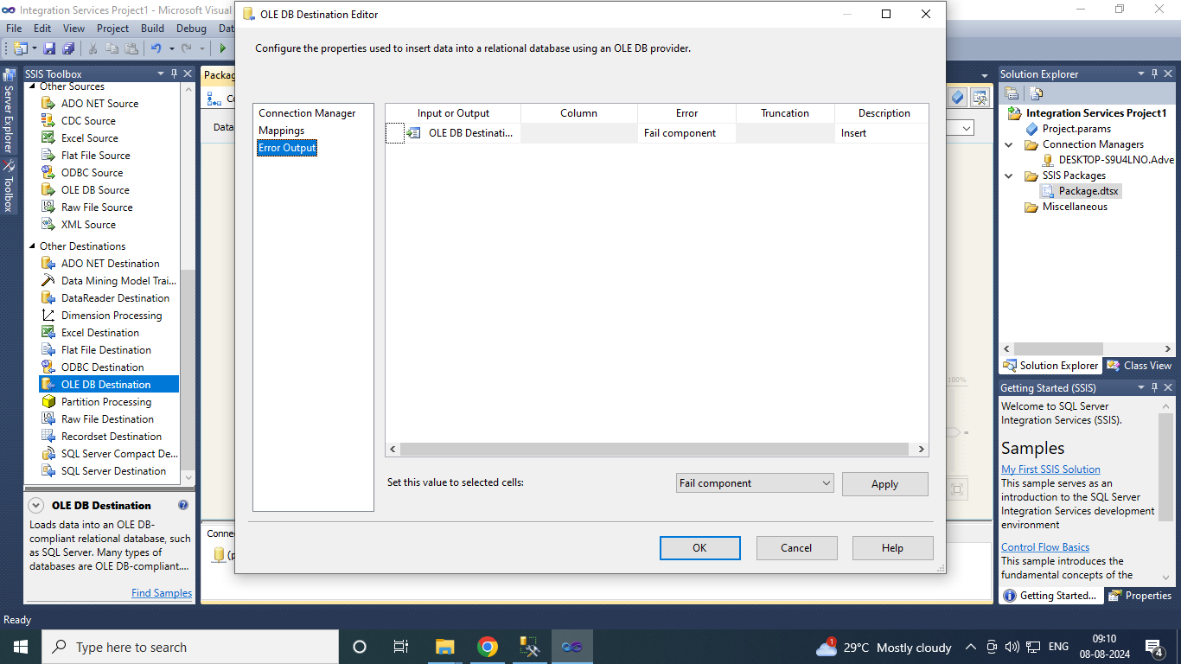

Click on ok.

1. Go to debug →Start debugging.

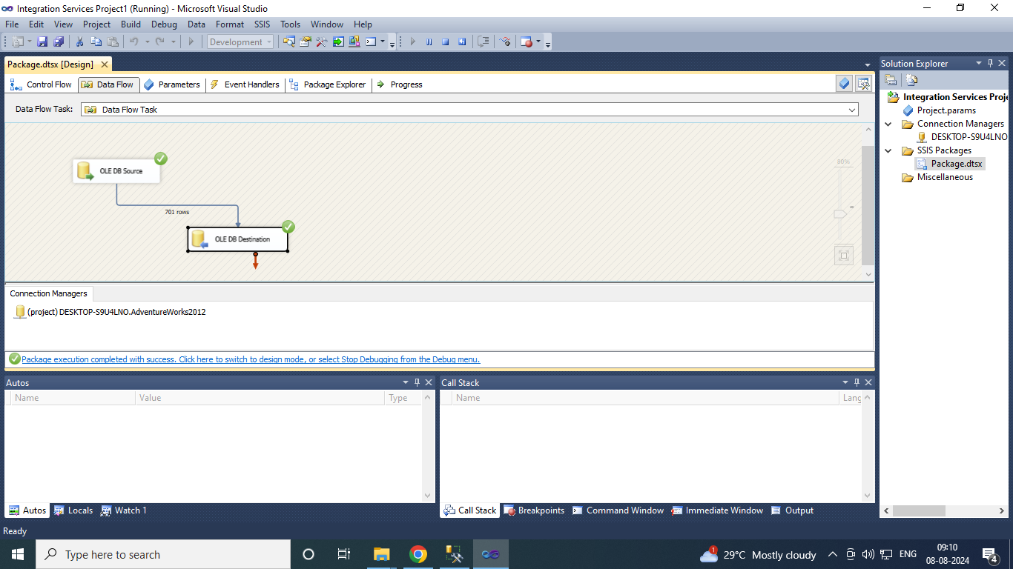

Make sure both Source and Destination have Green tick marks. If not, then follow the earlier steps again.

1. Go to SQL Server Management Studio. database tab → Adventureworks → Right click on [dbo].[OLE DB Destination] → Scrip Table as → SELECT To → New Query Editor Window.

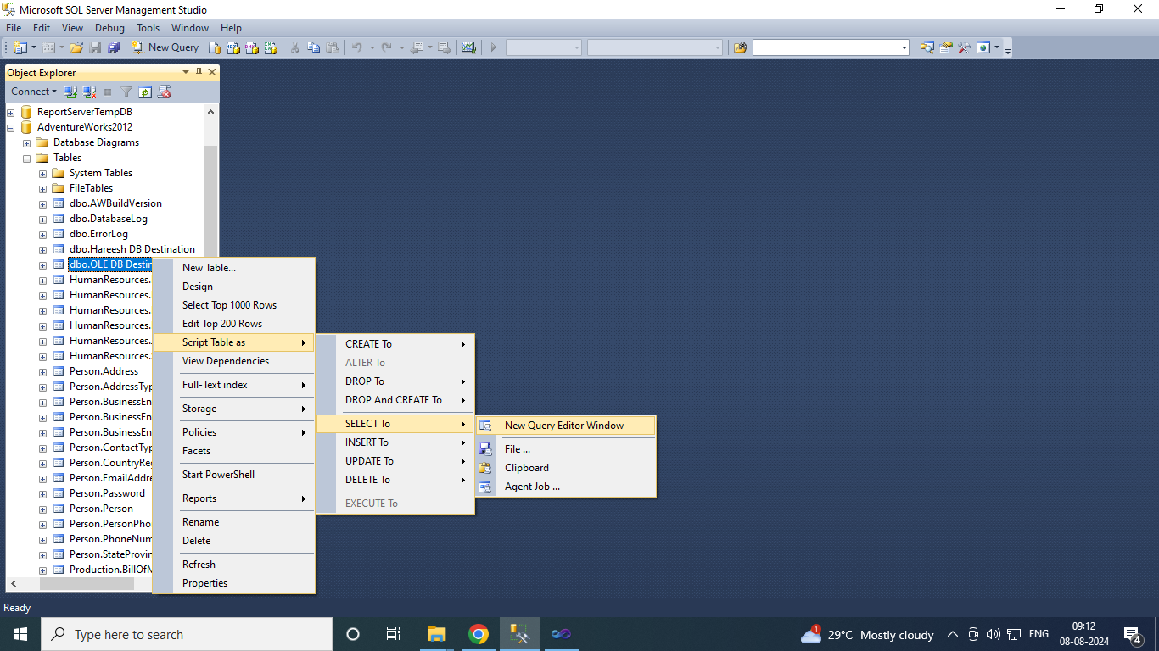

1. Execute Query to get the output.

