1. **Create the cube with suitable dimension and fact tables based on OLAP.**

**Steps:**

1. **SQL Server Management Studio.**
2. Download T-SQL script required from the codeproject website.
3. After downloading extract file in folder.
4. Go to the extracted sql file and double click on it.
5. SQL Server Management Studio will open.
6. Connect Database Engine

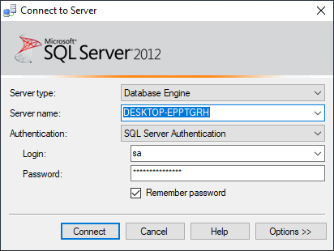

1. Click on connect.
2. New Sql Query Editor will be opened containing Sales_DW Database.

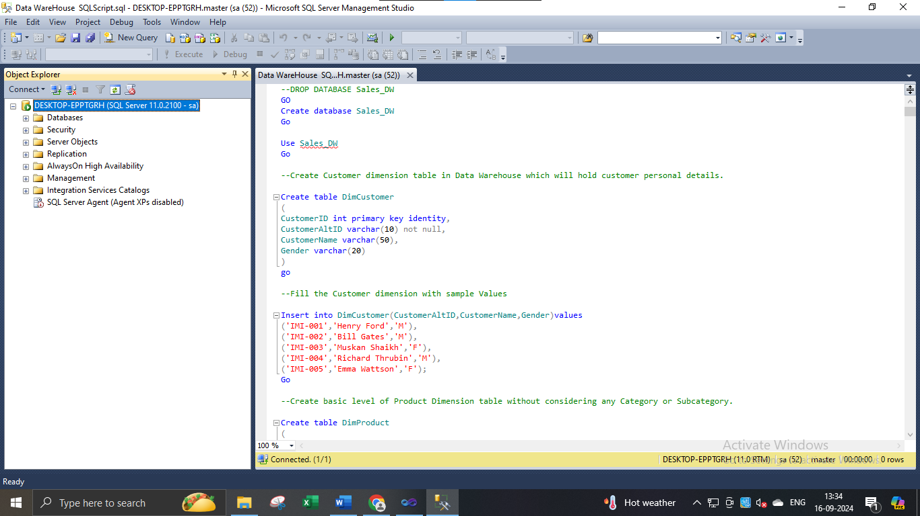

1. Click on execute or press F5.
2. After completing execution save and close SQL Server Management studio & Reopen to see Sales_DW in Databases Tab.

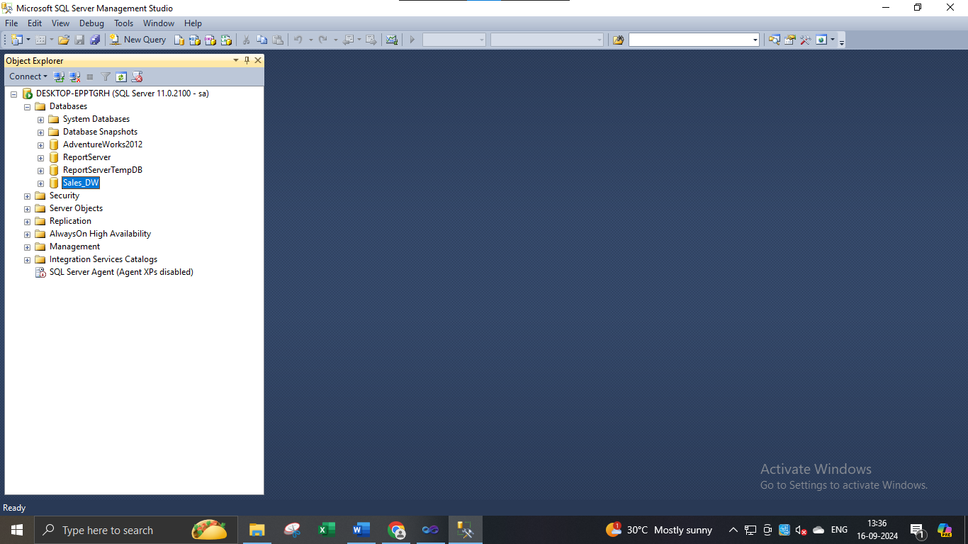

1. **Start SQL Server Data Tools (SSDT) environment and create New Data Source.**
2. Go to Sql Server Data Tools → Right click and run as administrator.
3. Click on File → New → Project.
4. In Business Intelligence → Analysis Services Multidimensional and Data Mining models → give appropriate project name → click OK.

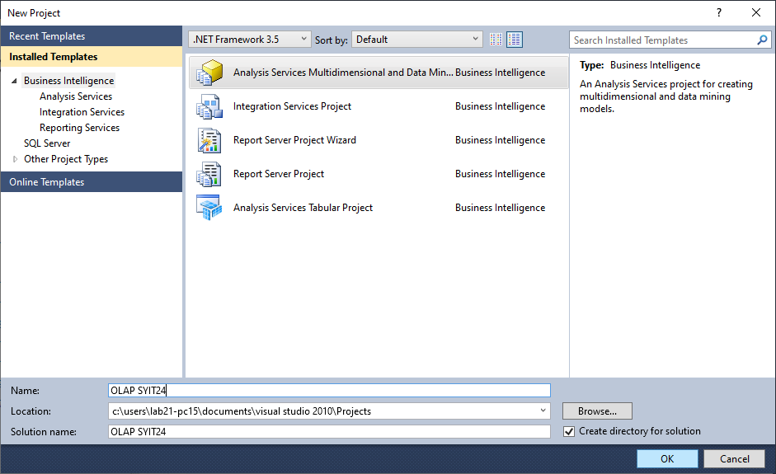

1. Right click on Data Sources in solution explorer → New Data Source.

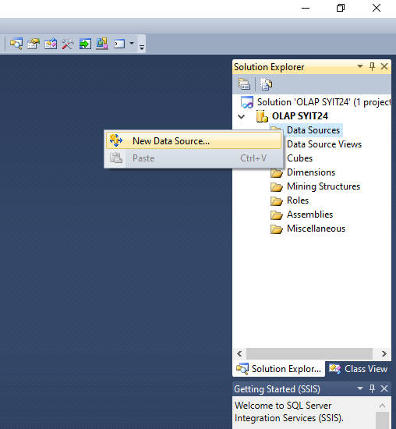

1. Data Source Wizard appears → Click on Next.

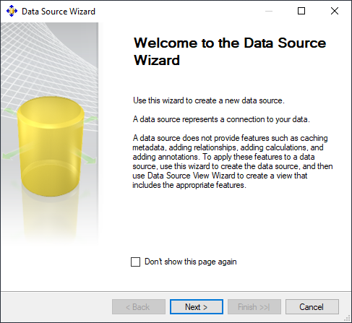 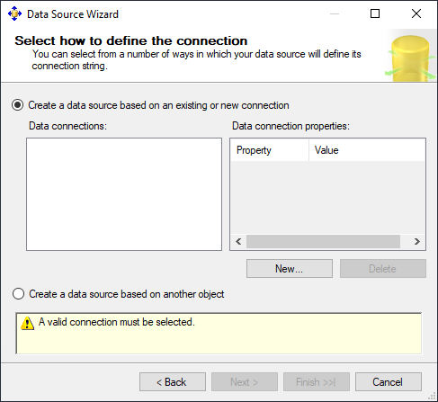

1. Click on New.

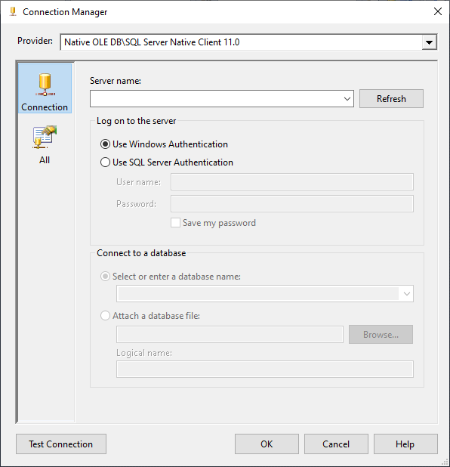

1. Select Server Name → select Use SQL Server Authentication → Select or enter a database name (Sales_DW)

→ Click on ‘Test Connection’.

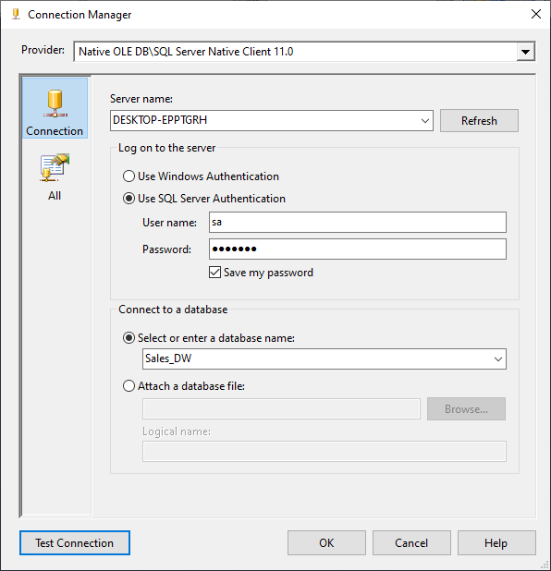

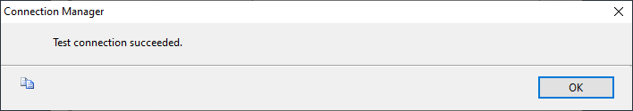

1. Click on OK → OK.

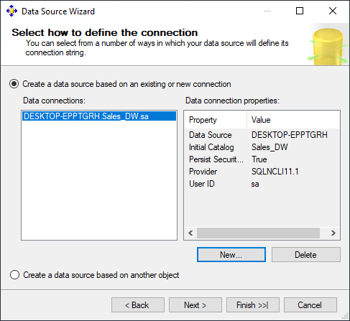 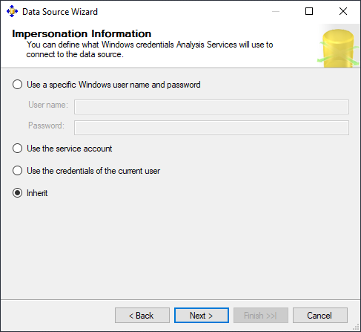

1. Click on Next → Select Inherit → Next.

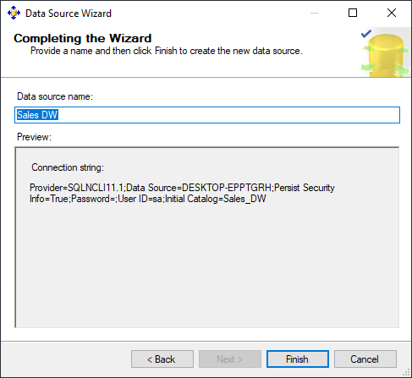

1. Click Finish.
2. Sales_DW.ds gets created under Data Sources in Solution Explorer.

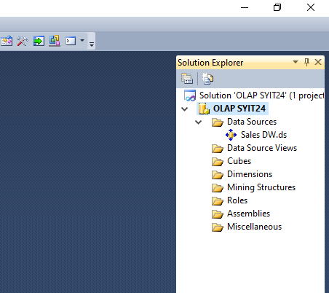

1. **Creating New Data Source View.**
2. In Solution explorer right click on Data Source Views → Select New Data Source View.

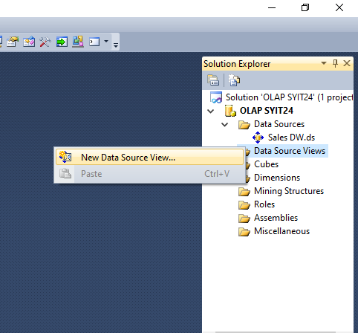

1. Click Next→ Next.

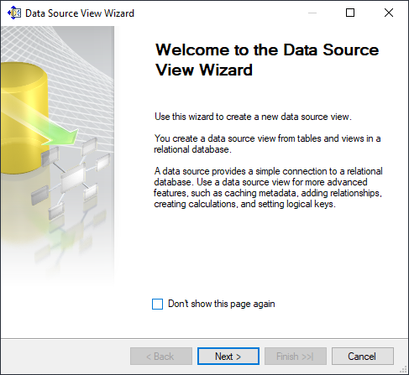 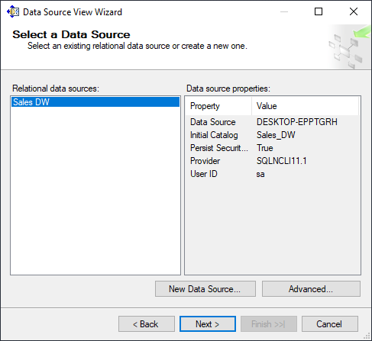

1. Select FactProductSales(dbo) from Available objects and put in Includes Objects by clicking on .

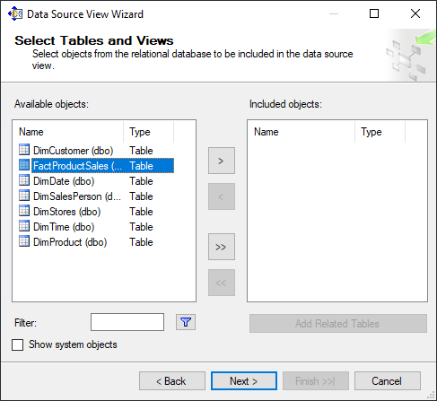 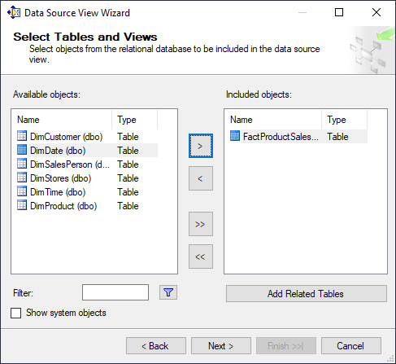

1. Click on Add Related Tables → Next → Finish.

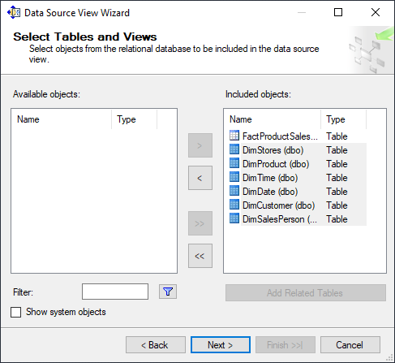 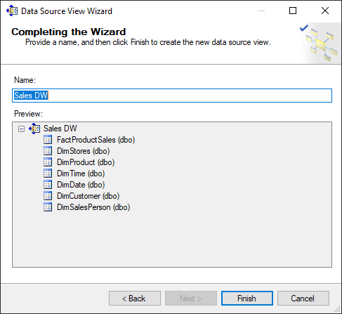

1. Sales DW.dsv appears in Data Source Views in Solution Explorer.

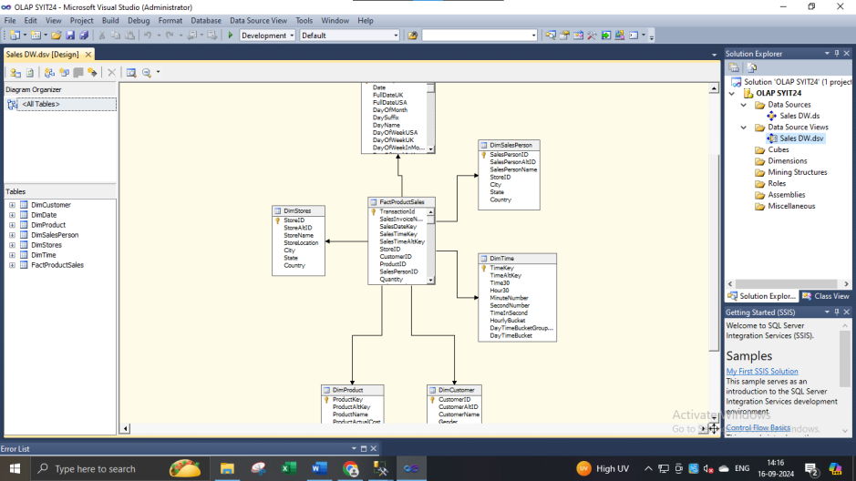

1. **Creating new cube.**
2. Right click on Cubes → New Cube → Next.

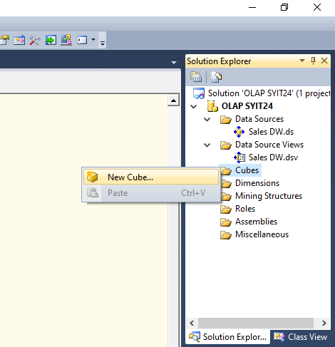 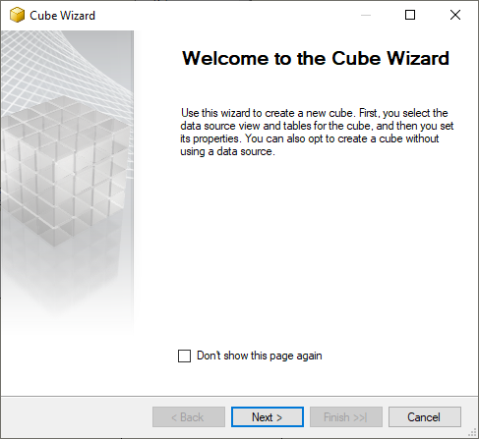

1. Select Use existing tables in Select Creation Method → Next.

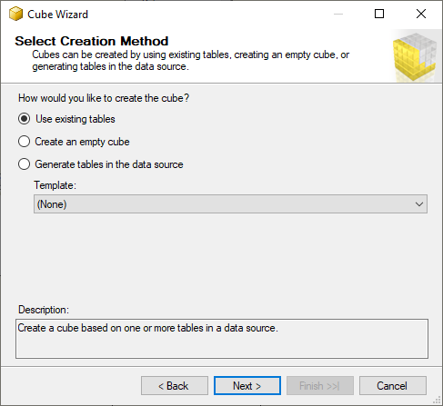

1. In Select Measure Group Tables → Select FactProductSales → Click Next.
2. In Select Measures → check all measures → Next.

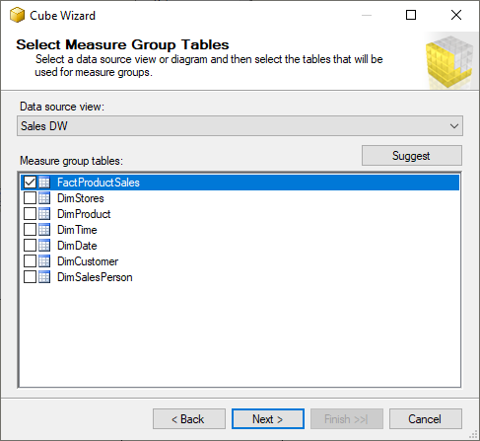 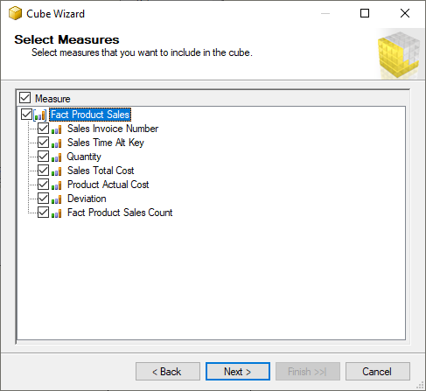

1. In Select New Dimensions → Check all Dimensions → Next → Finish.

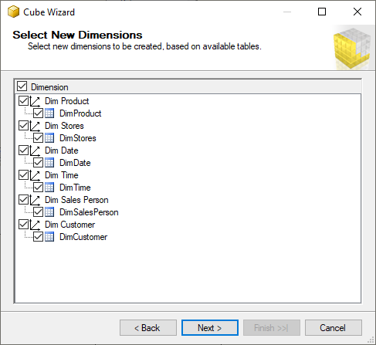 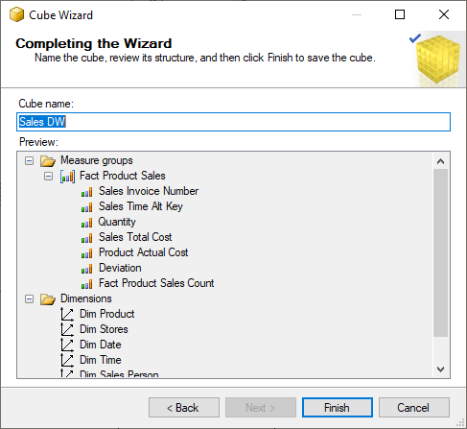

1. Sales_DW.cube is created.

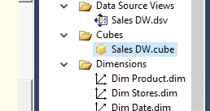

1. **Dimension Modification.**
2. In dimension tab → Double Click Dim Product.dim.

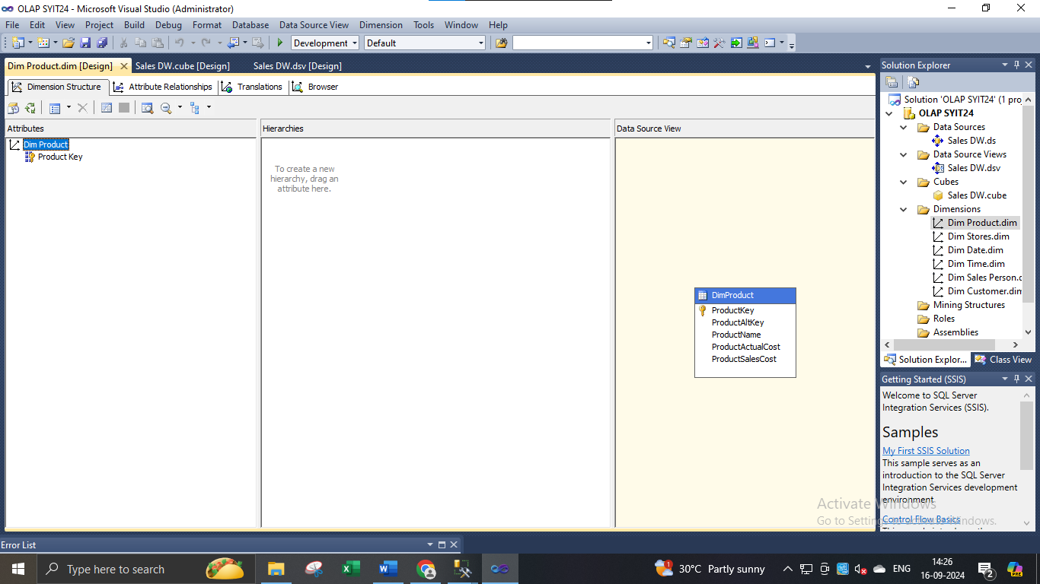

1. Drag and Drop Product Name from Table in Data Source View and Add in Attribute Pane at left side. 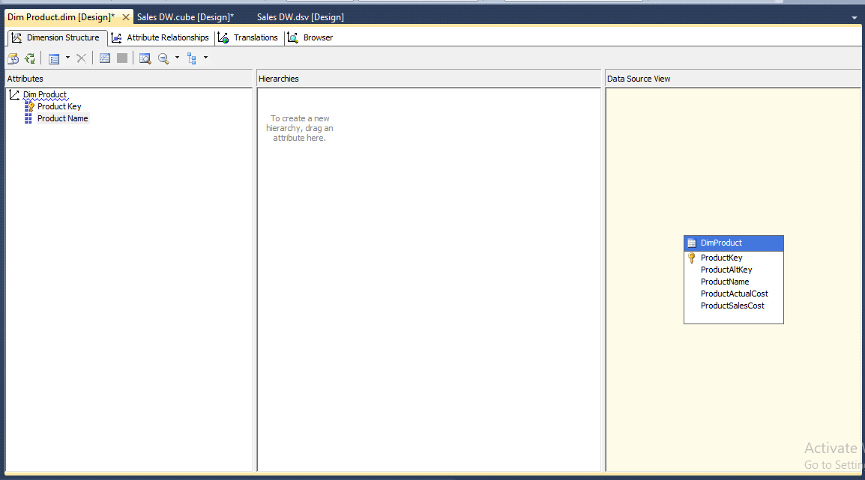
2. **Creating Attribute Hierarchy in Date Dimension.**

Double click On Dim Date dimension → Drag and Drop Fields from Table shown in Data Source View to Attributes → Drag and Drop attributes from leftmost pane of attributes to middle pane of Hierarchy.

Drag fields in sequence from Attributes to Hierarchy window (Year, Quarter Name, Month Name, Week of the Month, Full Date UK).

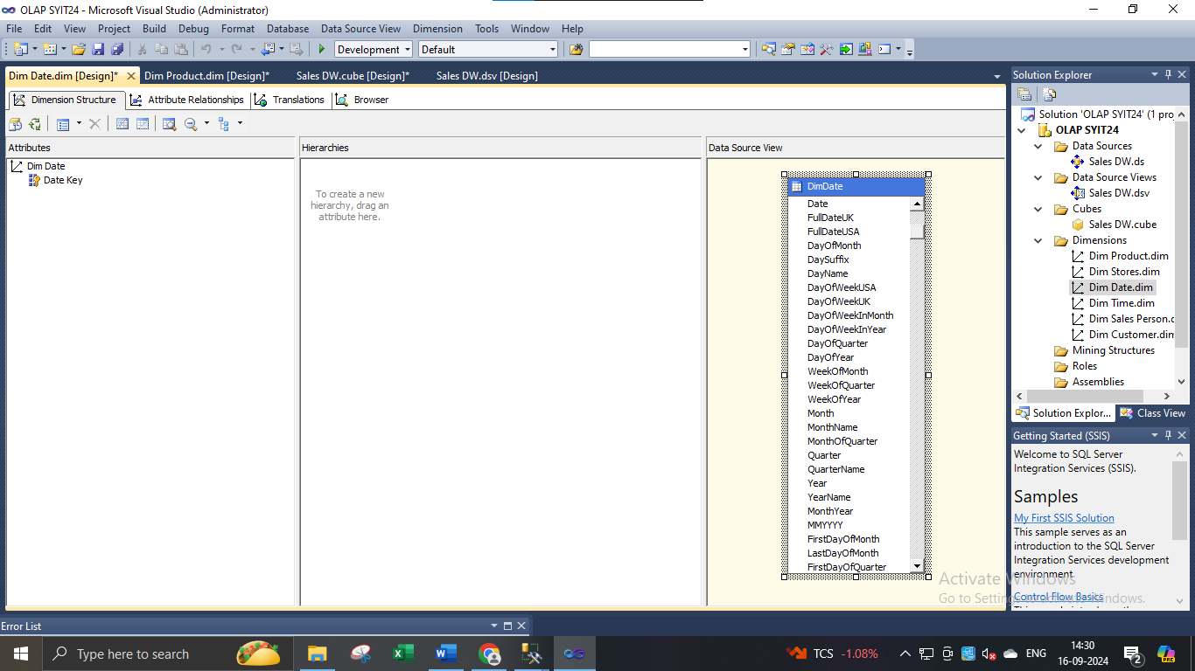

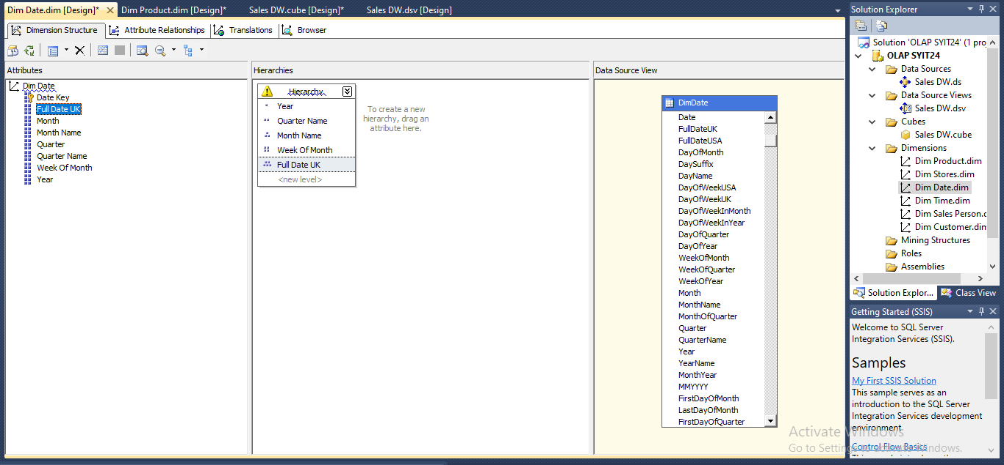

1. **Deploy Cube.**
2. Right click on Project name → Properties.

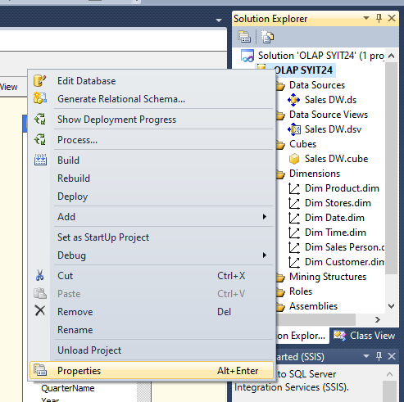

1. A window will appear -> Do the following changes as shown below -> OK.

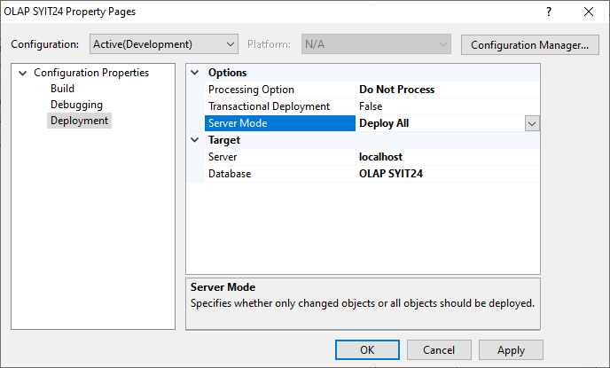

1. Right click on project name → Deploy.

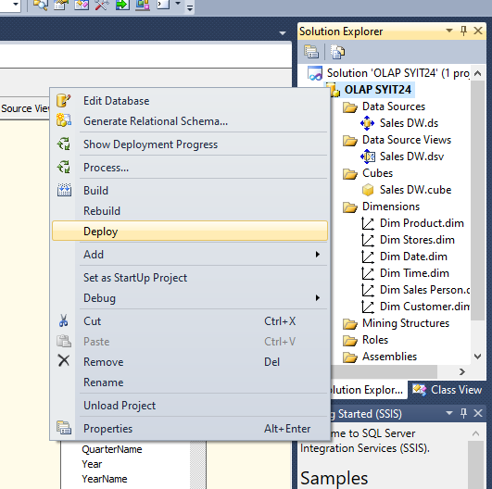

1. Deployment Successful.

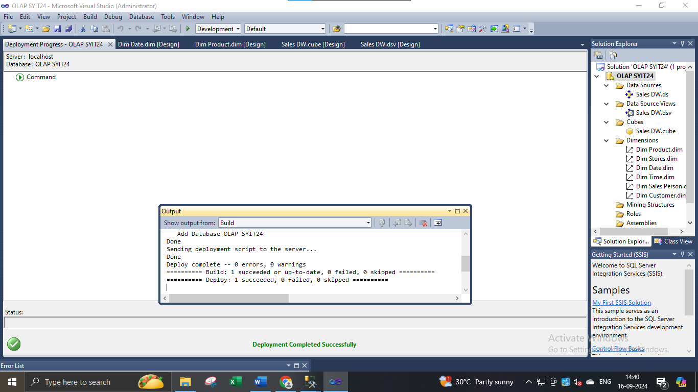

1. To process cube right click on Sales_DW.cube → Process → Run → Close.

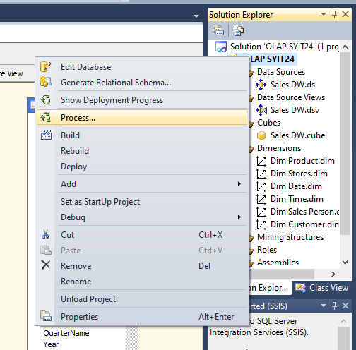

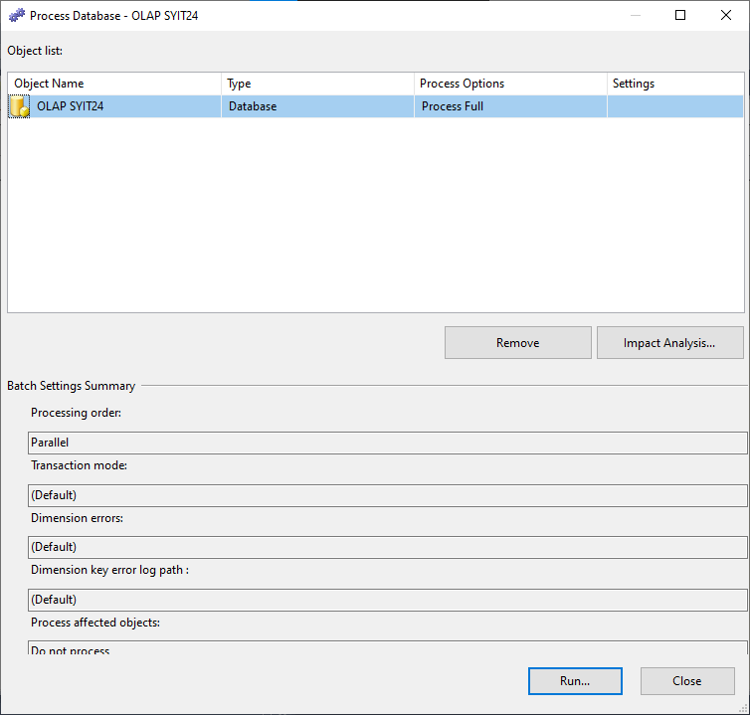

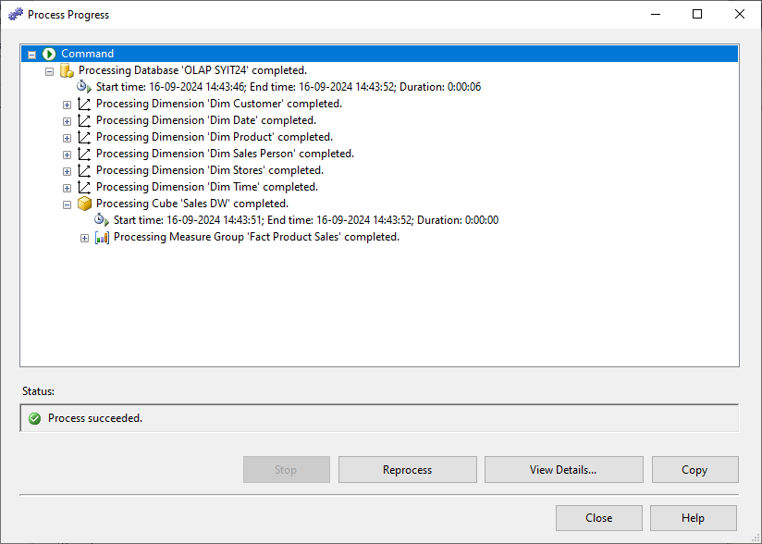

1. Browse the cube for analysis in solution explorer.

