Perform the Extraction Transformation and Loading (ETL) process to construct the database in the SQL server.

Software requirements: SQL SERVER 2012 FULL VERSION (SQLServer2012SP1-FullSlipstream-ENU-x86)

Steps to install SQL SERVER 2012 FULL VERSION (SQLServer2012SP1- FullSlipstream-ENU-x86) are given in my previous post.

**Step 1:** Open SQL Server Management Studio to restore backup file

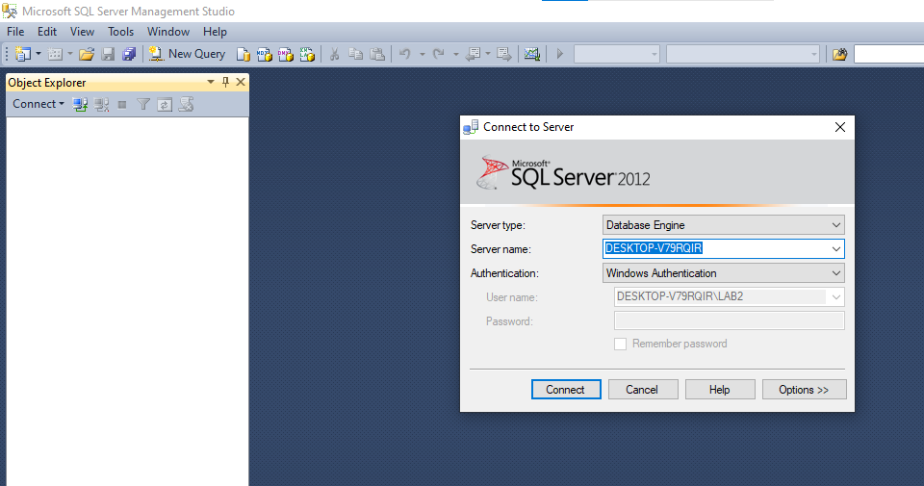

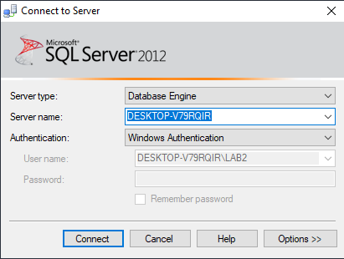

**Step 2:** Right click on Databases → Restore Database

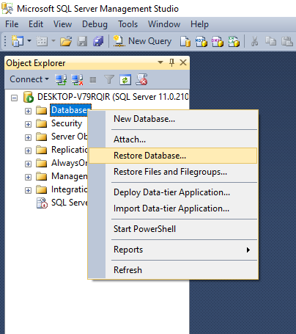

**Step 3:** Select Device → click on  icon towards end of device box

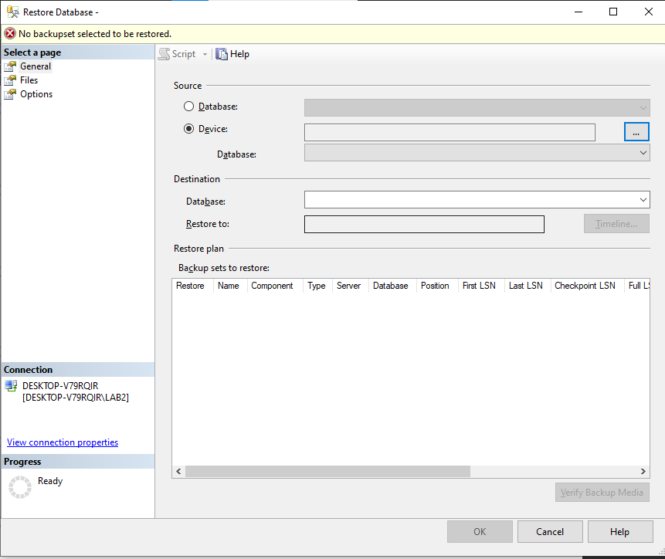

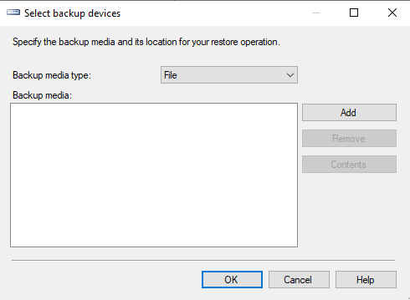

**Step 4:** Click on Add → Select path of backup files

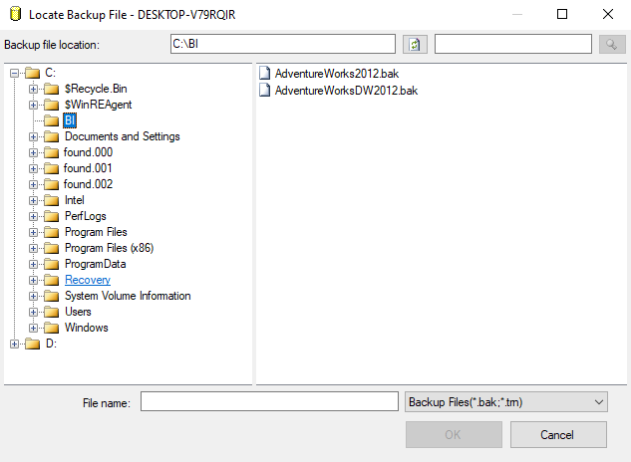

**Step 5:** Select both files at a time

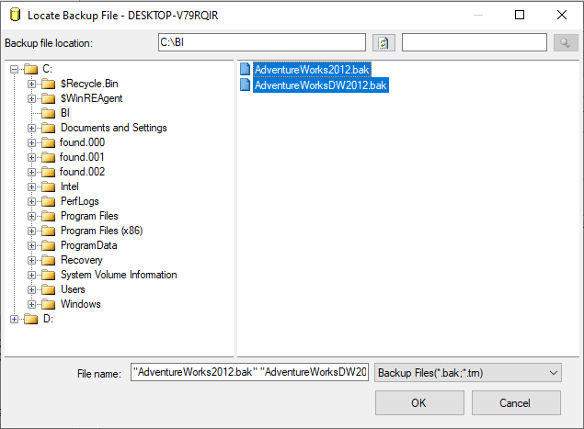

**Step 6:** Click ok and in select backup devices window Add both files of AdventureWorks

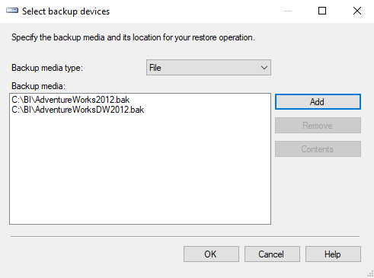

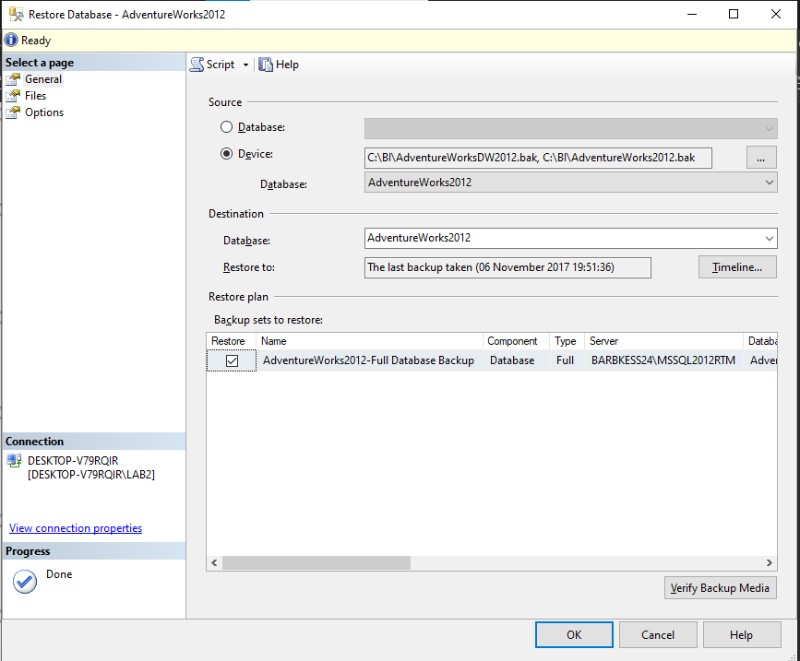

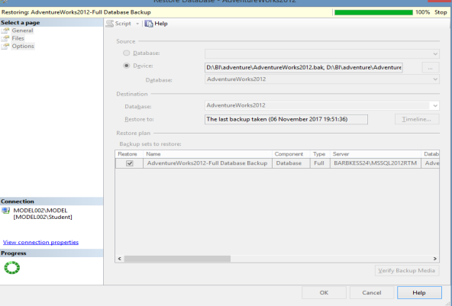

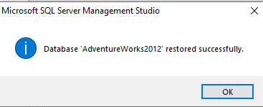

**Step 7:** Open SQL Server Data Tools Select File → New → Project → Business Intelligence → Integration Services Project & give appropriate project name.

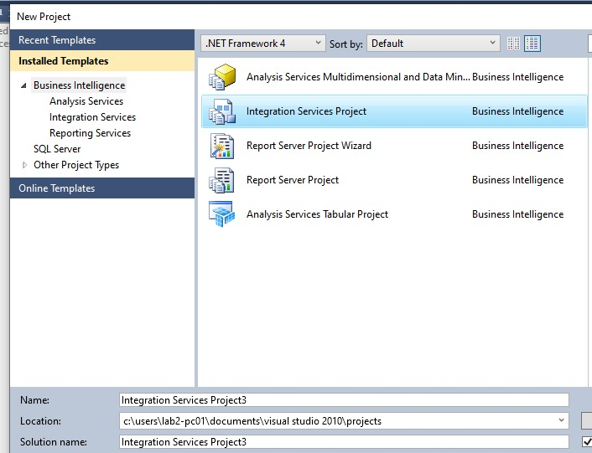

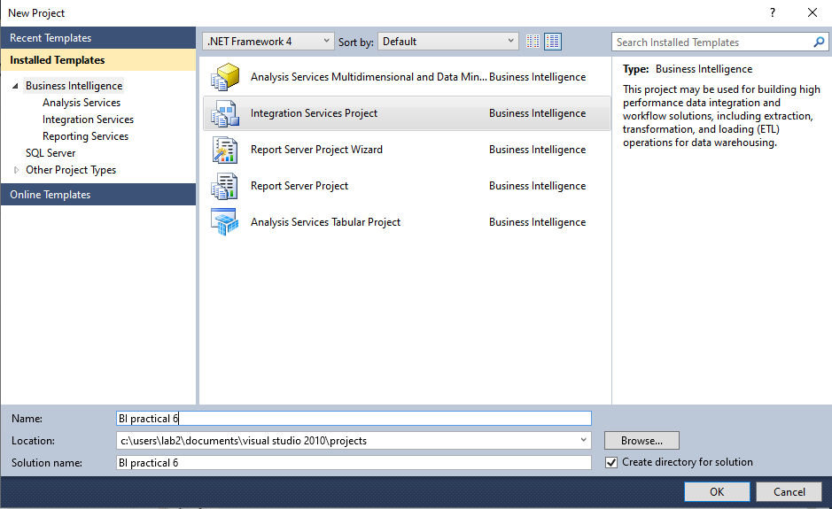

Environment consists of SQL Server Integration Services(SSIS)

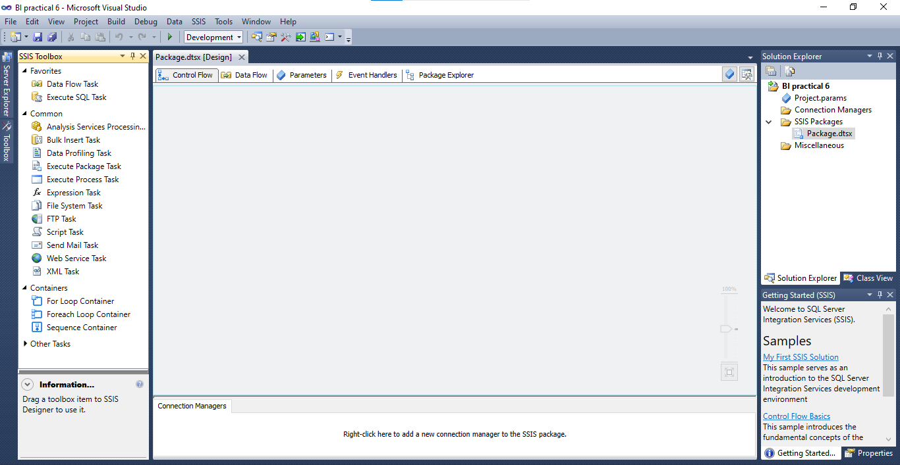

**Step 8:** Right click on Connection Managers in solution explorer and click on New Connection Manager. Add SSIS connection manager window appears.

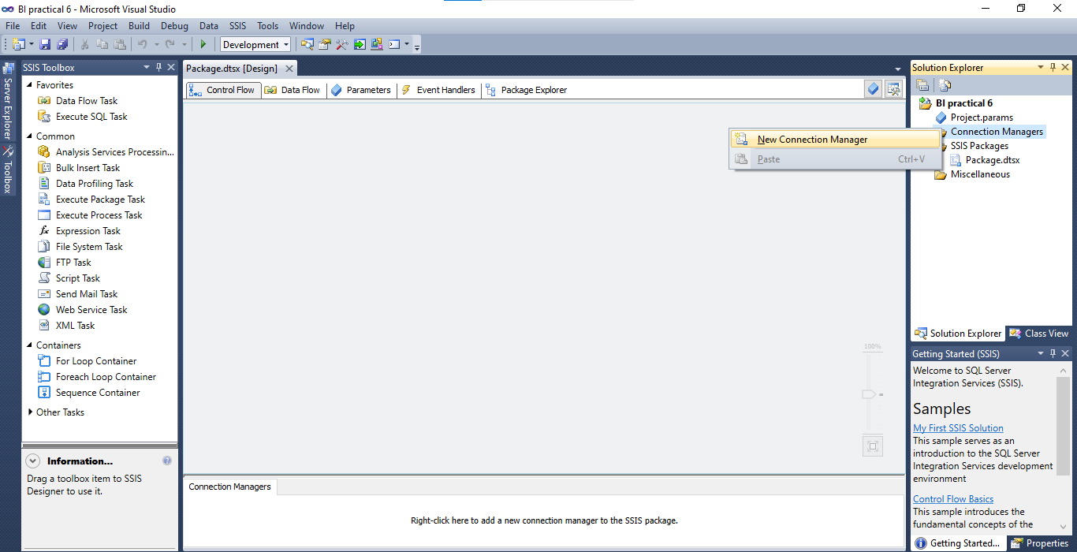

**Step 9:** Select OLEDB Connection Manager and Click on Add

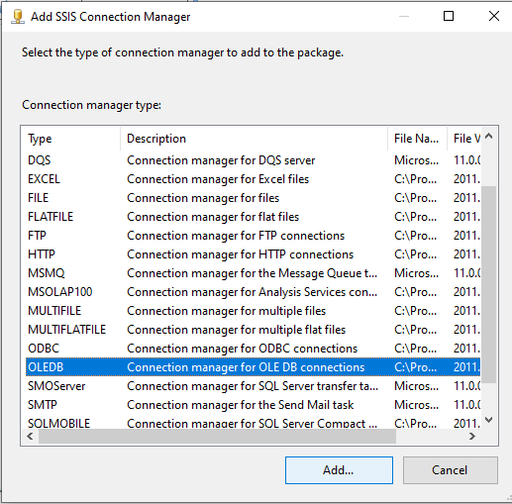

**Step 10:** Configure OLE DB Connection Manager window appears → Click on New

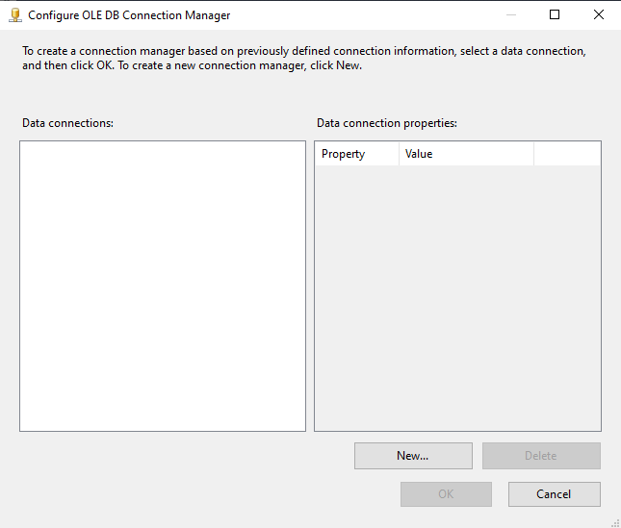

**Step 11:** Select Server name(as per your machine) from drop down and database name and click on Test connection.

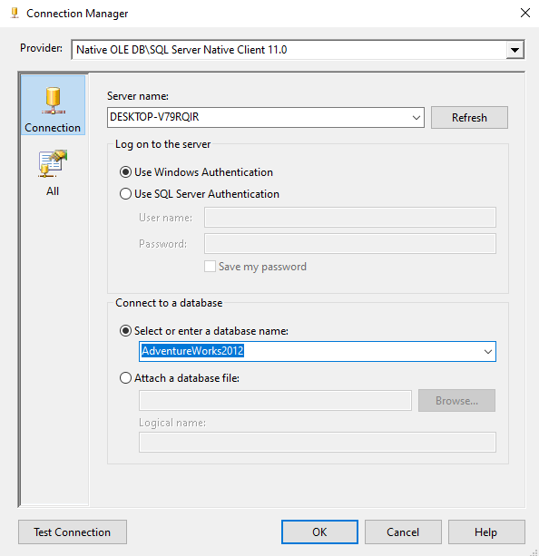

If test connection succeeded click on OK

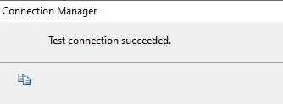

**Step 12:** Click on OK

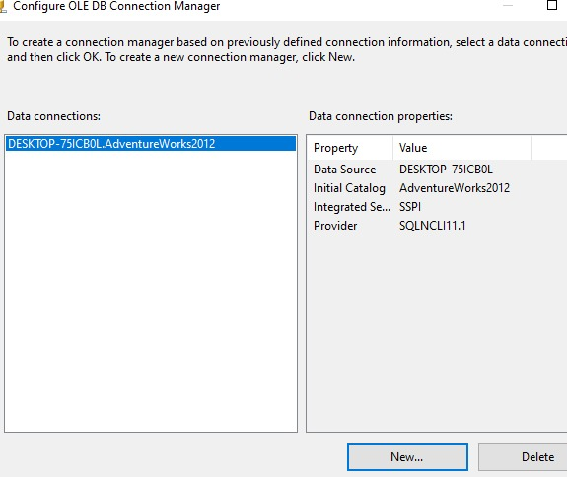

Connection is added to connection manager

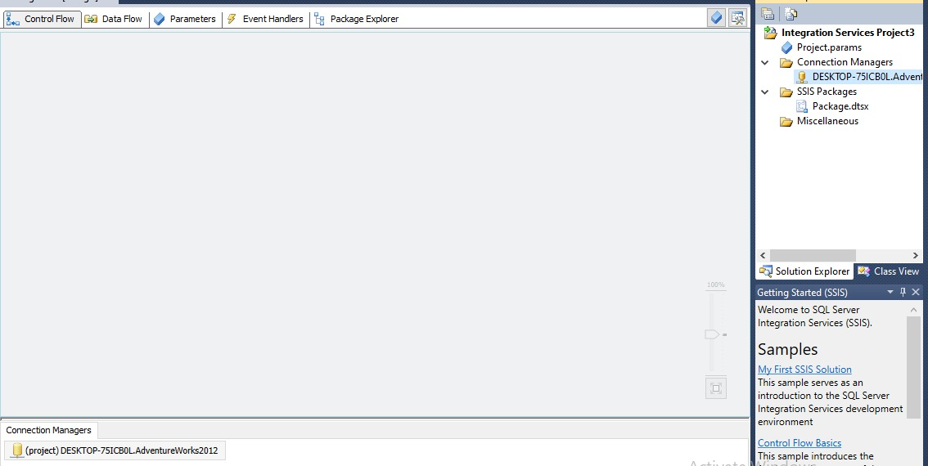

**Step 13:** Drag and drop Data Flow Task in Control Flow tab

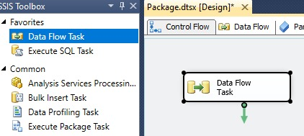

**Step 14:** Drag OLE DB Source from Other Sources and drop into Data Flow tab

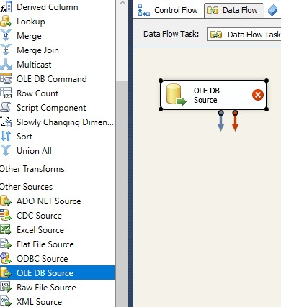

**Step 15:** Double click on OLE DB source → OLE DB Source Editor appears→ click on New to add connection manager. Select [Sales].[Store] table from drop down → ok

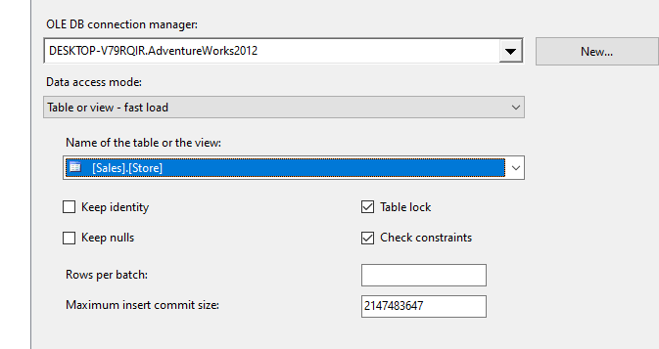

**Step 16:** Drag ole db destination in data flow tab and connect both

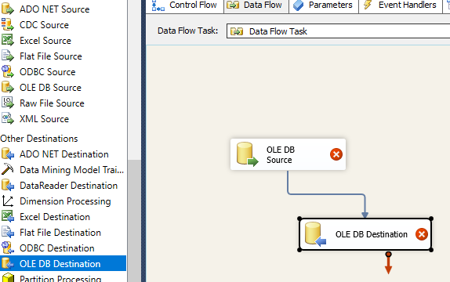

**Step 17:** Double click on OLE DB destination Click on New to run the query to get [OLE DB Destination] in Name of the table or the view.

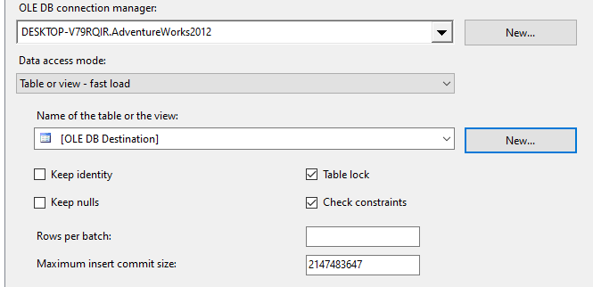

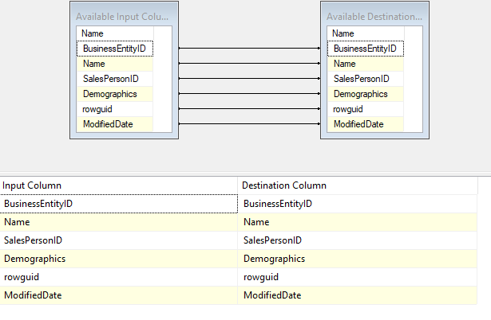

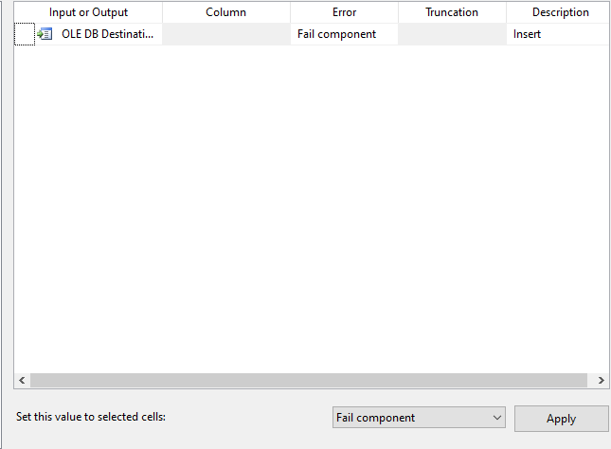

Click on ok

**Step 18:** Click on start

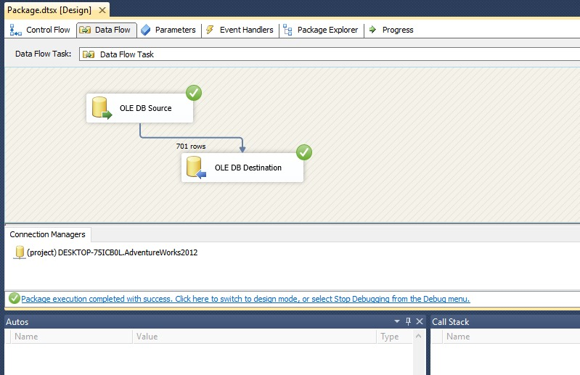

**Step 19:** Go to SQL Server Management Studio In database tab → Adventureworks → Right click on [dbo].[OLE DB Destination] → Scrip Table as → SELECT To → New Query Editor Window

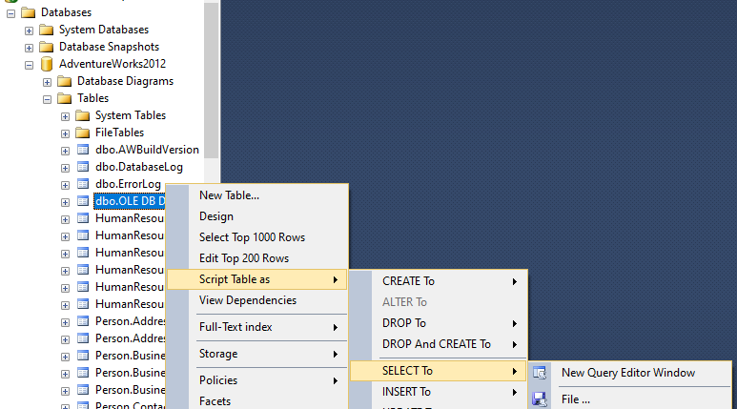

**Step 20:** Execute following query to get output

