**Q. Execute the MDX queries to extract the data from the data warehouse.**

Step 1: Open SQL Server Management Studio and connect to Analysis Services. Server type: Analysis Services Server Name: (according to base machine) Click on connect

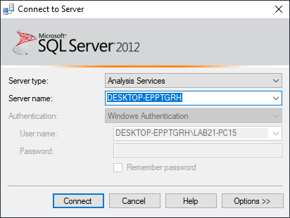

Step 2: Click on New Query & type following query based on Sales_DW

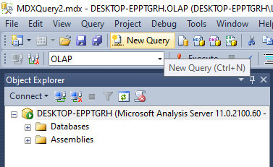

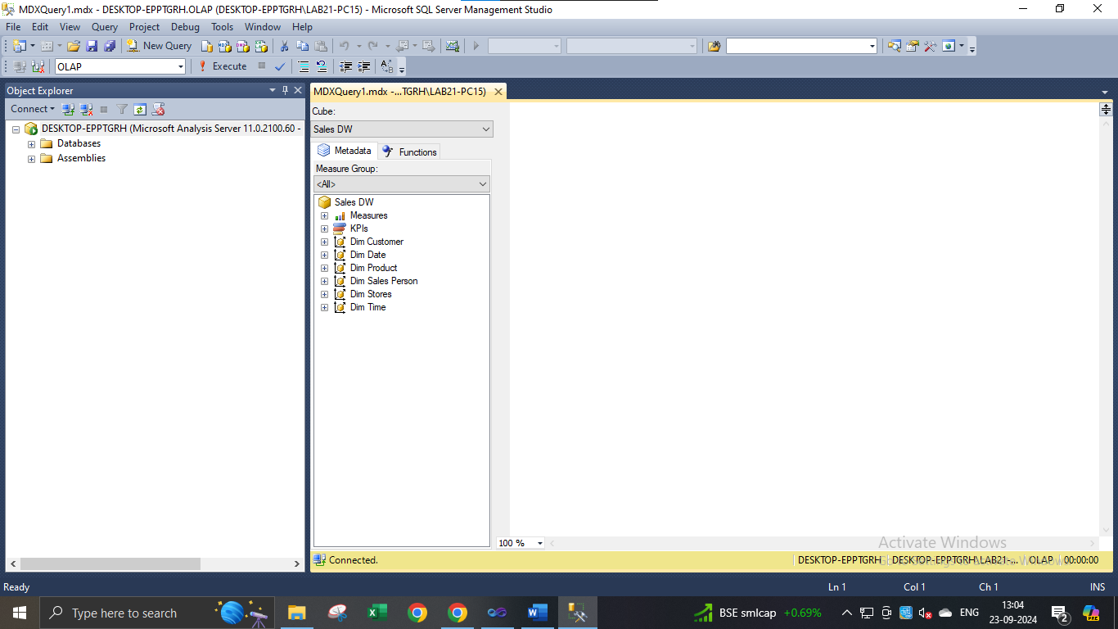

Query 1:

select [Measures].[Sales Time Alt Key] on columns from [Sales DW]

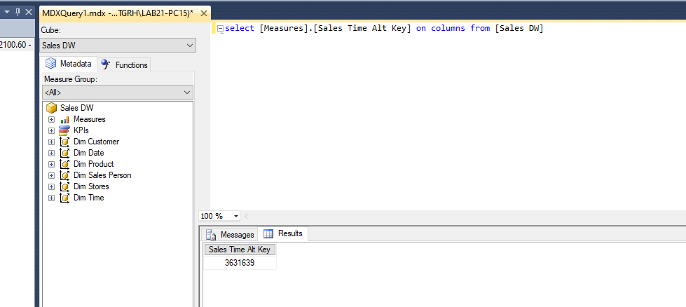

Query 2:

select [Measures].[Quantity] on columns from [Sales DW]

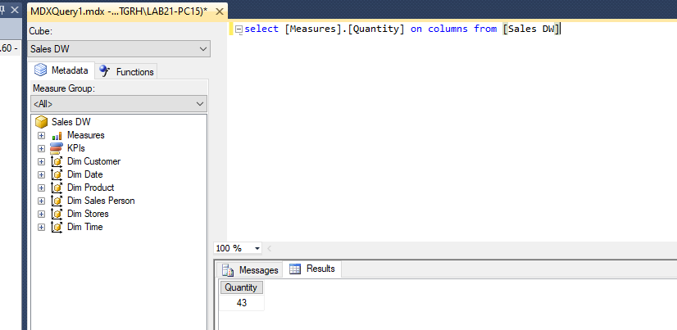

Query 3:

select [Measures].[Sales Invoice Number] on columns from [Sales DW]

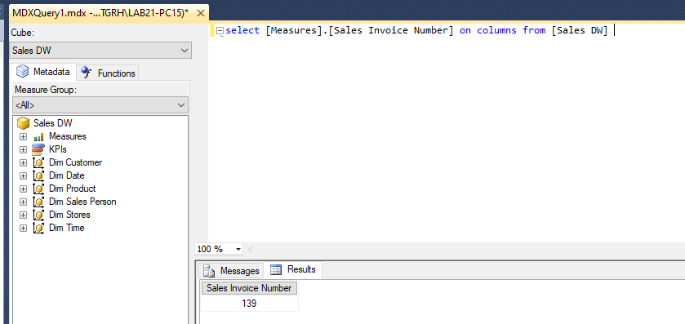

Query 4:

select [Measures].[Sales Total Cost] on columns from [Sales DW]

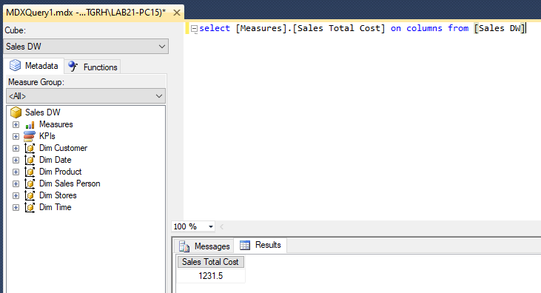

Query 5:

select [Measures].[Sales Total Cost] on columns , [Dim Date].[Year].[Year] on rows from [Sales DW]

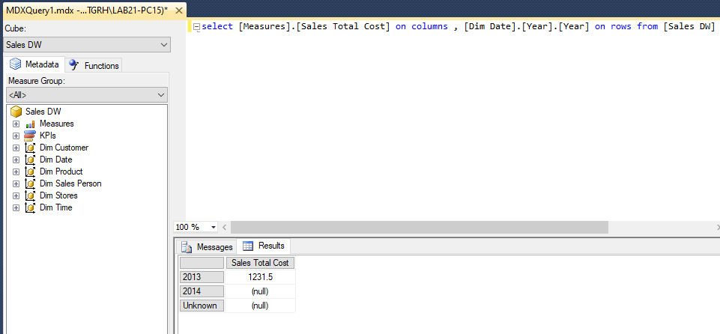

Query 6:

select [Measures].[Sales Total Cost] on columns , NONEMPTY({[Dim Date].[Year].[Year]}) on rows from [Sales DW]

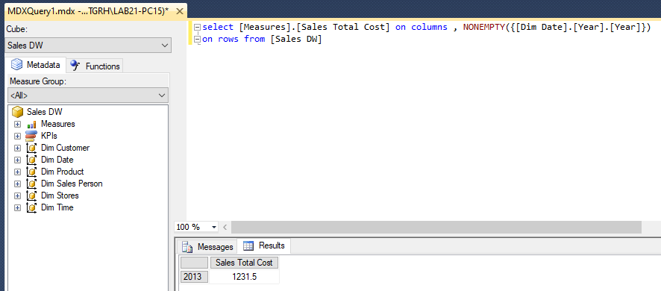

Query 7:

select [Measures].[Sales Total Cost] on columns from [Sales DW] Where [Dim Date].[Year].[Year].&[2013]

