**Q.1) Import the data warehouse data in Microsoft Excel and create the Pivot table and Pivot Chart.**

**Steps:**

1. Open excel. In the search bar search for “From Data Connection Wizard”



1. Select Microsoft SQL wizard and click on Next.

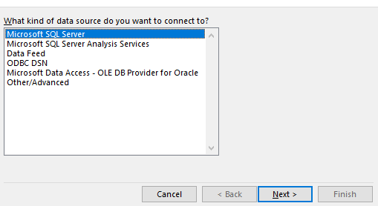

1. Enter your desktop’s server name and click on Next.

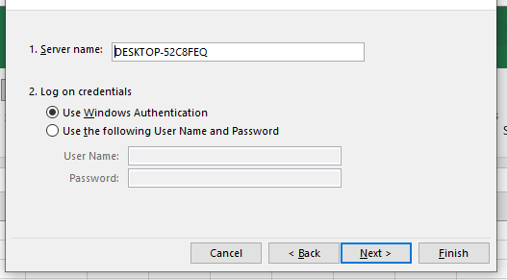

1. In Select Database and Table, Select Sales_DW (already created in SQL). Check all dimensions and import relationships between selected tables.

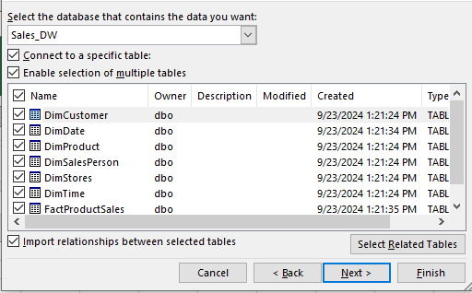

1. In save data connection files browse path and click on Finish

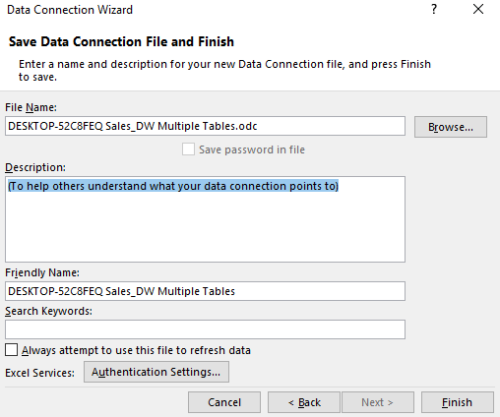

1. Select Pivot chart in view data options. Navigate to the location you want the chart to be in.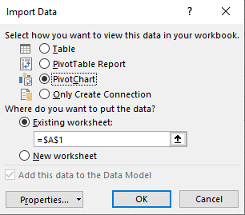
2. Drag and drop the following fields. In fields put SalesDateKey in filters, FullDateUK in axis and Sum of ProductActualCost in values. The chart will look like this

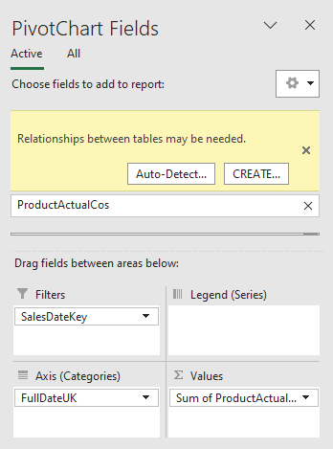 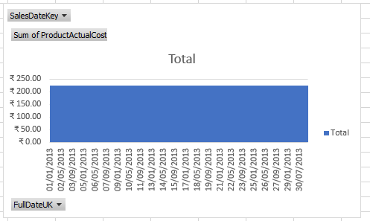

1. In Insert Tab, go to Pivot Table. Select “From external data source”.

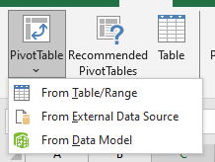

1. Click on Choose Connection to select existing connection with Sales_DW and click on open. Click on OK

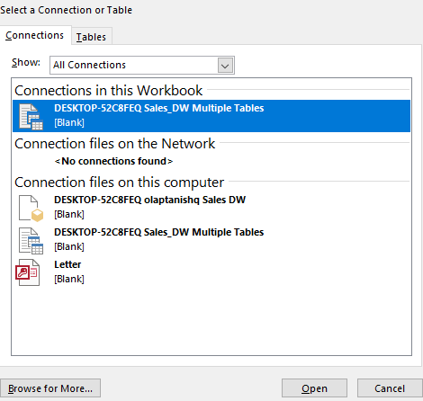

1. Pivot table is created. Now drag and drop the fields to the respective places for analysis.

