**Q.1) Import the cube in Microsoft Excel and create the Pivot table and Pivot Chart to perform data analysis.**

**Steps:**

1. Open excel. In the search bar search for “From Analysis Services”



1. Enter your desktop’s server name and click on Next.

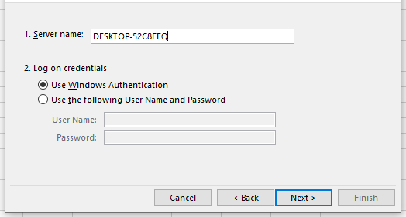

1. Select OLAP(as per created before) click on Next.

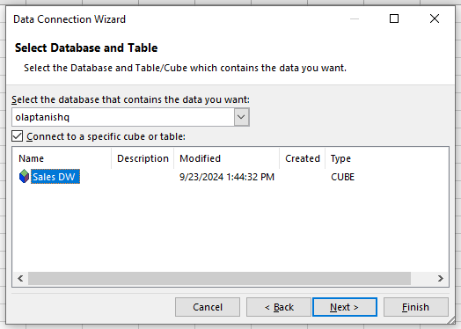

1. In save data connection files browse path and click on Finish

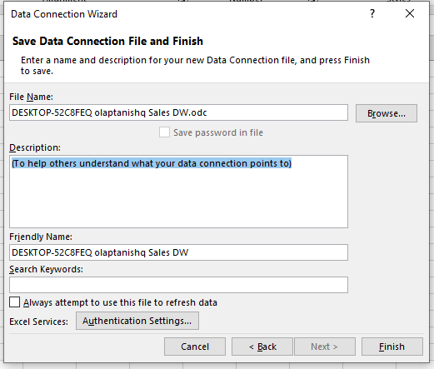

1. Select PivotTable Report in view data options. Navigate to the location you want the chart to be in. 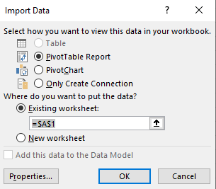
2. Drag and Drop Fields in rows column and values.

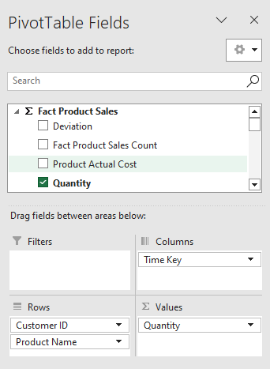

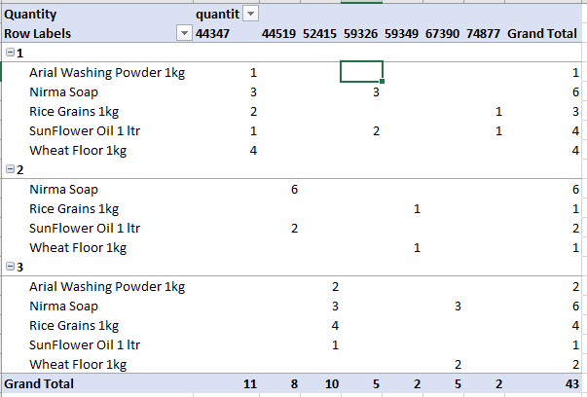

1. In Insert Tab, go to Pivot Charts. Select “From existing connection” and choose Sales_DW database and click open. Then click on OK.

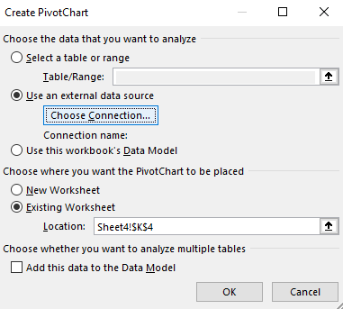

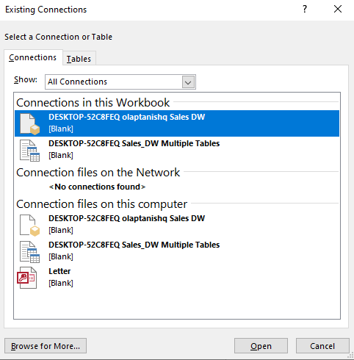

1. Drag and drop fields from the table.

