DRIP PILATES CLUB
Member Guide
Book classes, buy packages and manage your account
For studio members
16/09/2026

Contents
1. Getting started
2. Buy a package
3. Book a class
4. Manage your bookings
5. My account
6. Key rules at a glance
7. Frequently asked questions

How to Use
Learn the app in 5 minutes — tap any image to enlarge

1. Getting started

Step 1 Create your account
There are two ways to sign up — enter your phone number and a password, or tap the LINE button to sign in with your LINE account (faster, no password to remember).
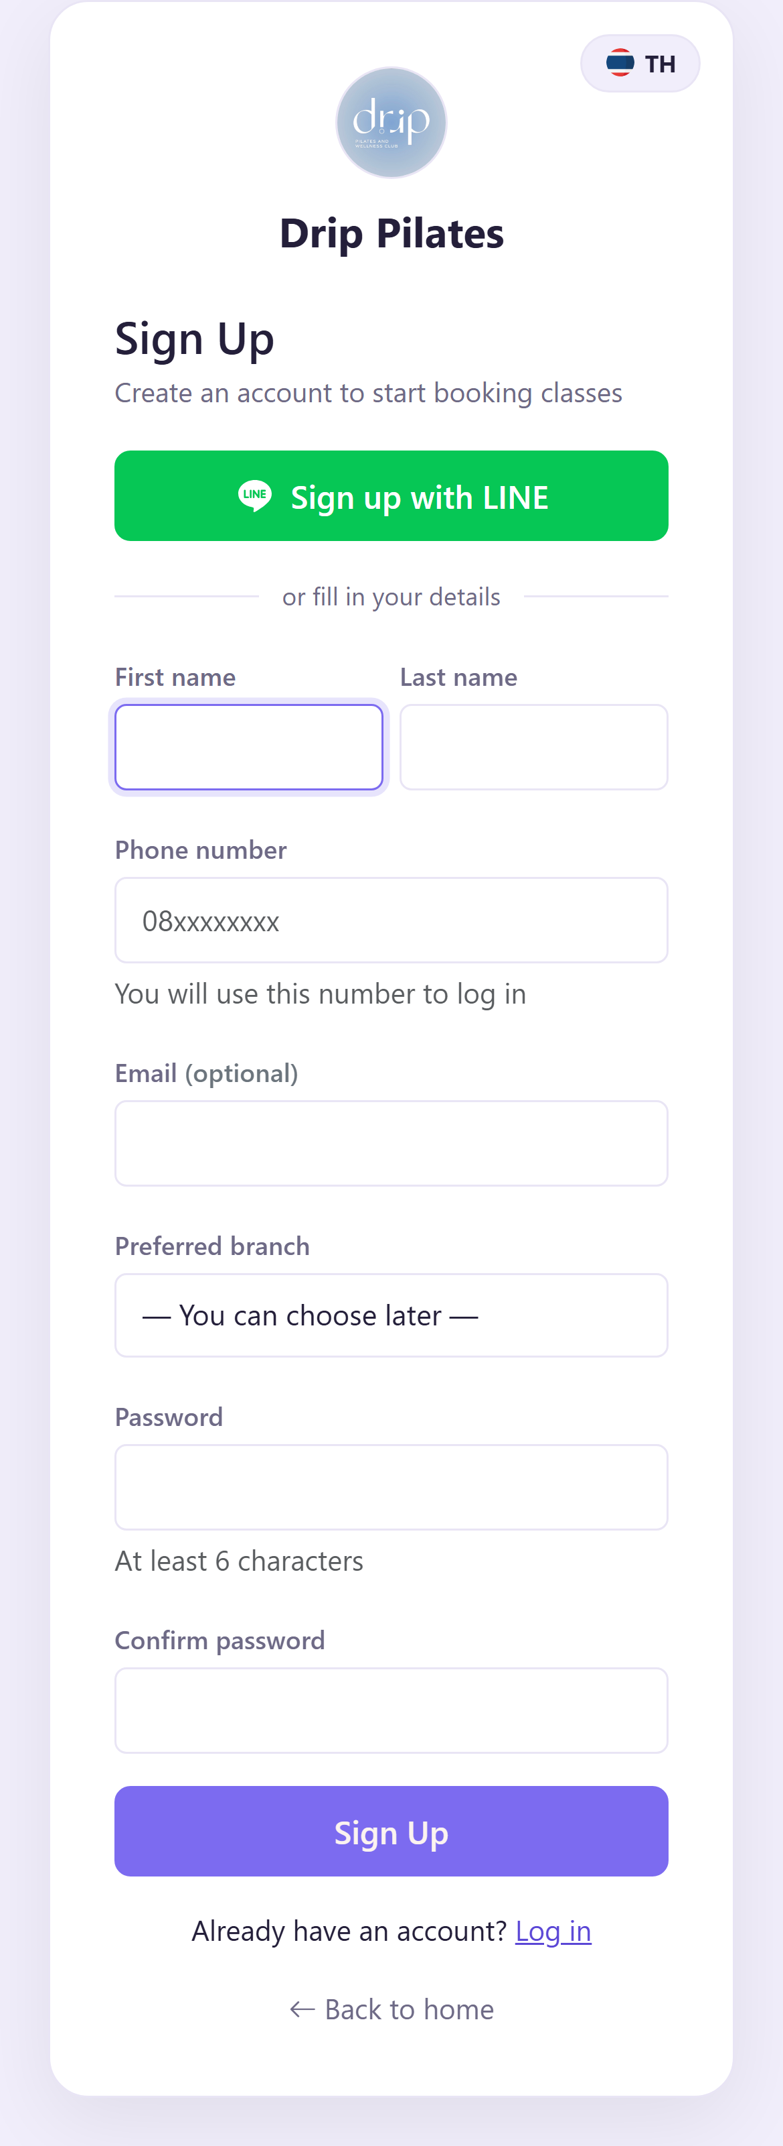
Figure 1 — Sign-up screen
⚑ Tip Your phone number is your username. Use a real number — you will need it to sign in and to receive OTP codes.

Step 2 Sign in
Enter your phone number and password, or tap Sign in with LINE if you have already linked your account.
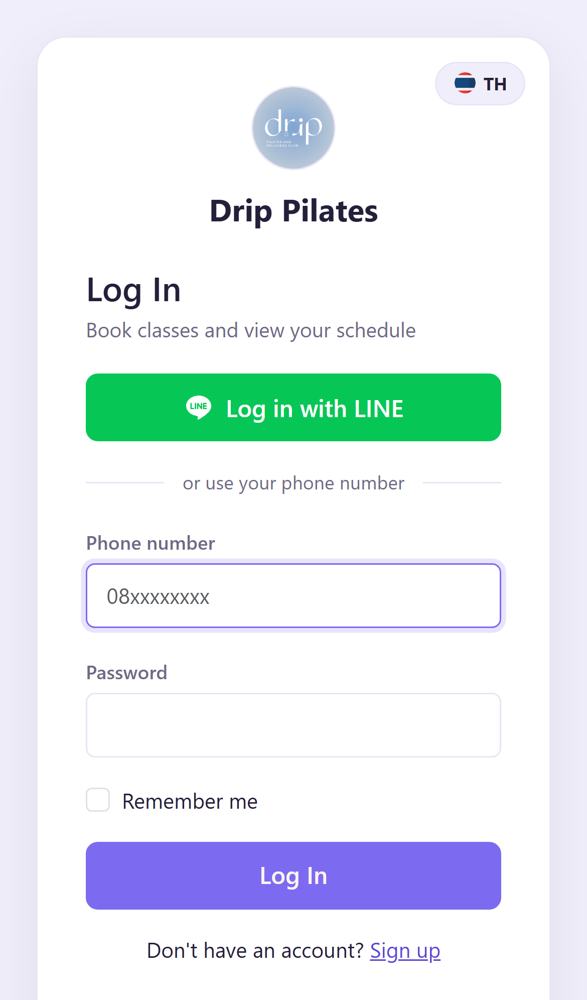
Figure 2 — Sign-in screen
⚠ Caution If you sign up with LINE and the phone number matches an account the studio already created for you, we will send an OTP to confirm before merging — so your class history and credits are kept.

Step 3 Find your way around
The home screen shows everything at a glance — your remaining credits, expiry date, your next booked class, and shortcuts to the things you do most.
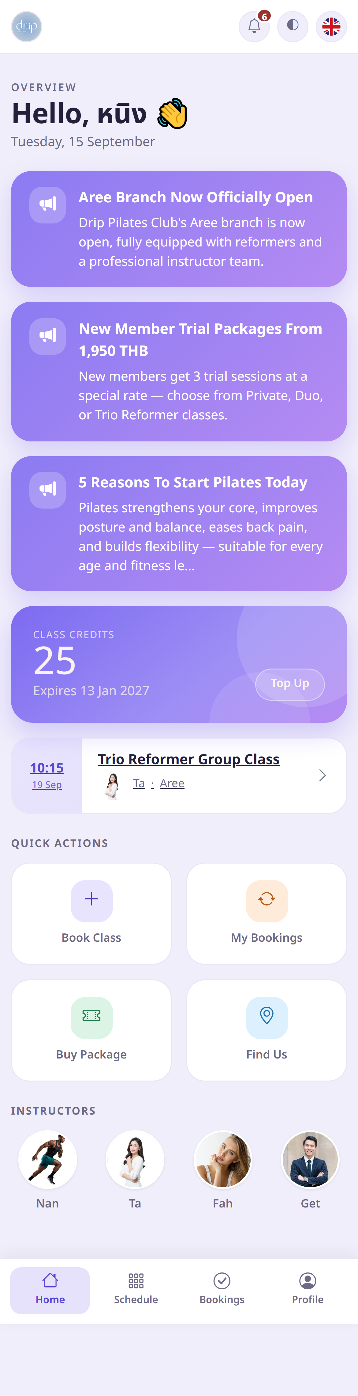
Figure 3 — Home screen
The bar at the bottom has four main tabs:
- Home — overview and announcements
- Schedule — browse classes and book
- Bookings — your upcoming classes and history
- Profile — your details, packages and settings
⚑ Tip Tap the flag at the top right to switch language, and the icon beside it to switch between light and dark mode.

2. Buy a package

⚠ Caution You need credits before you can book. If you have just signed up, buying a package is your first step.

Step 1 Choose a package
Go to Profile → Buy Packages, or tap "Buy Package" on the home screen. Each package shows how many sessions you get, the price, and how long it stays valid.
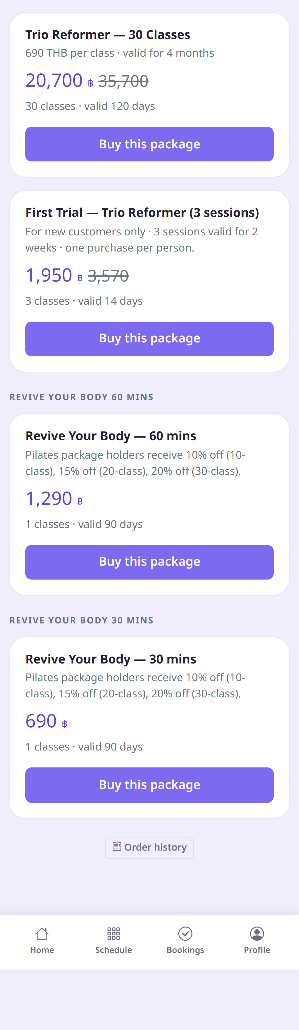
Figure 4 — Pick the package you want
⚑ Tip New here? Start with a trial package — special price, but each member can buy one only once.

Step 2 Confirm your order
Check the package details and the total, then confirm to create your order.
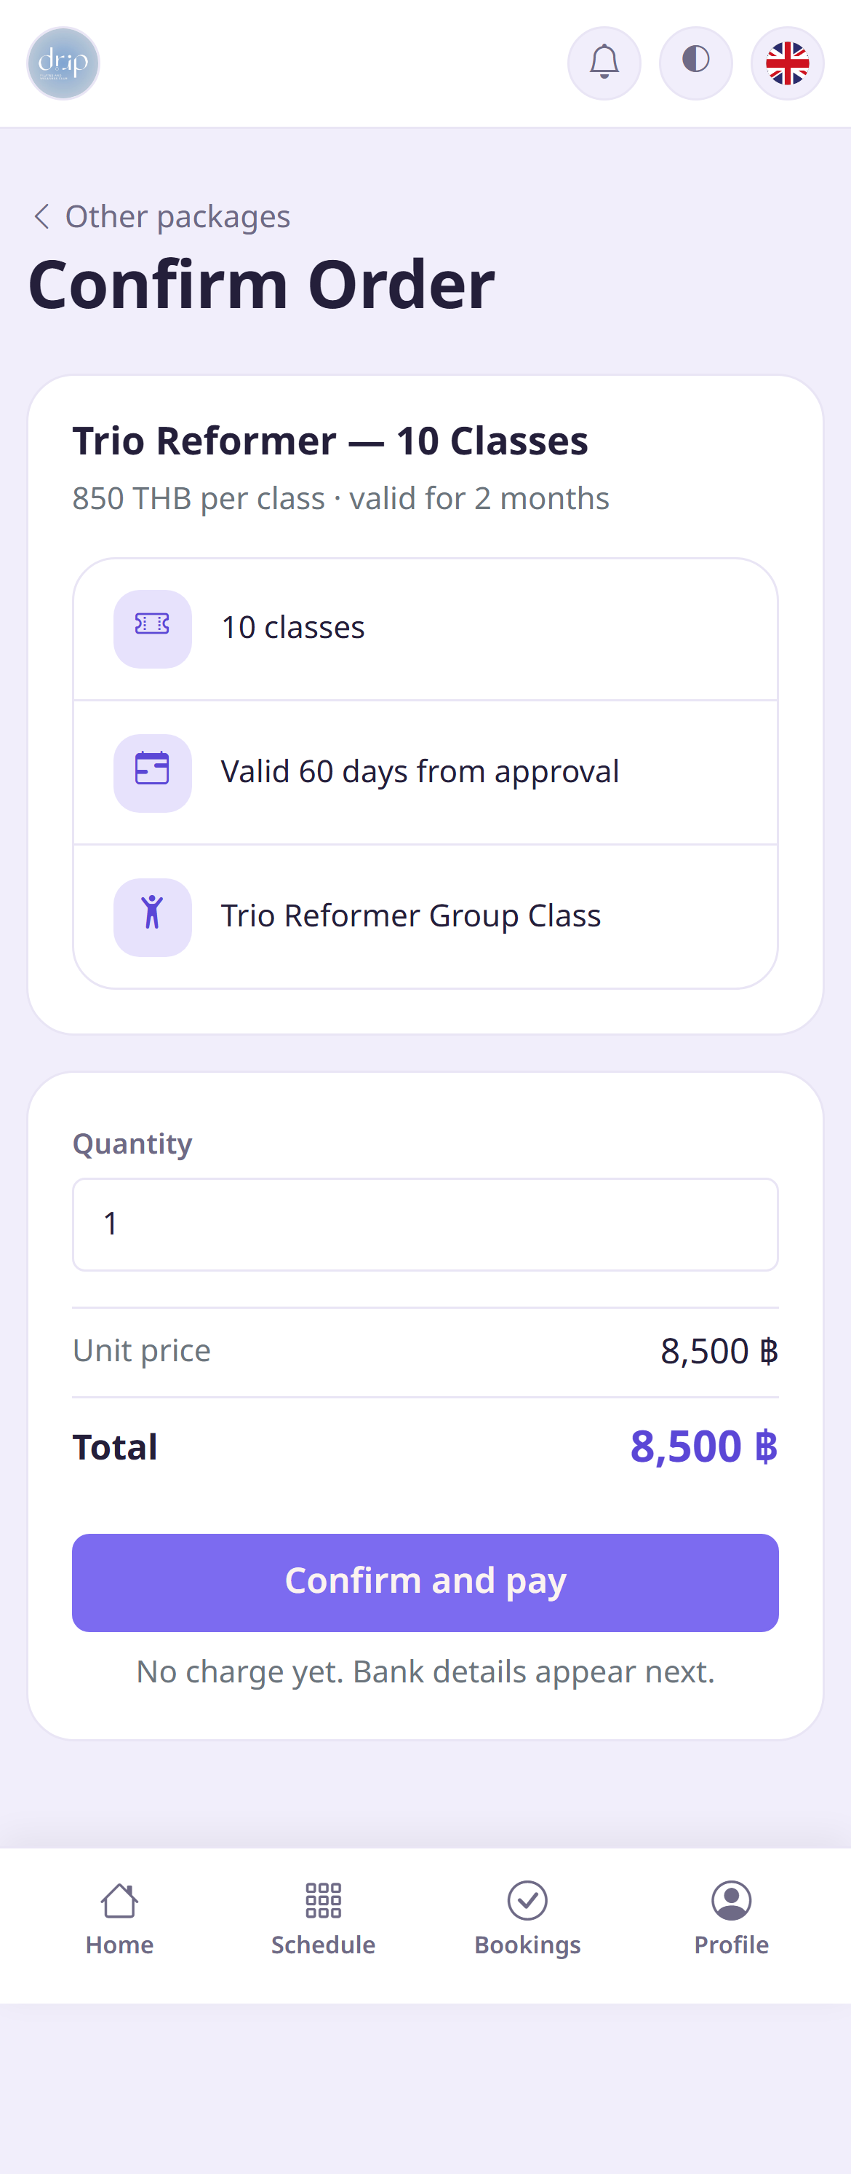
Figure 5 — Review before confirming
Step 3 Transfer and upload your slip
The app shows the bank account to transfer to — tap copy to paste it straight into your banking app. Once you have paid, come back and upload a photo of your slip.
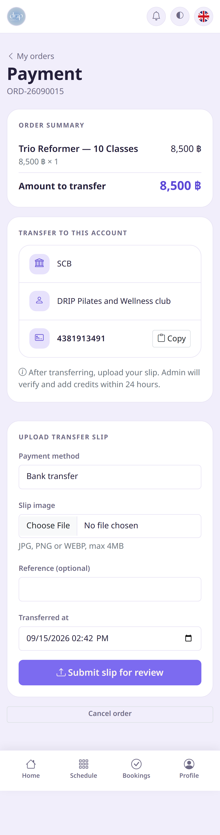
Figure 6 — Transfer to the account shown, then attach your slip
⚑ Tip Our account: —

⚠ Caution Credits do not arrive the moment you transfer — our team checks your slip first, usually within 24 hours. You will get a notification once it is approved and your credits are added automatically.

Step 4 Track your order
Check Profile → My Orders. If you have not uploaded a slip yet, or uploaded the wrong image, you can fix it here.
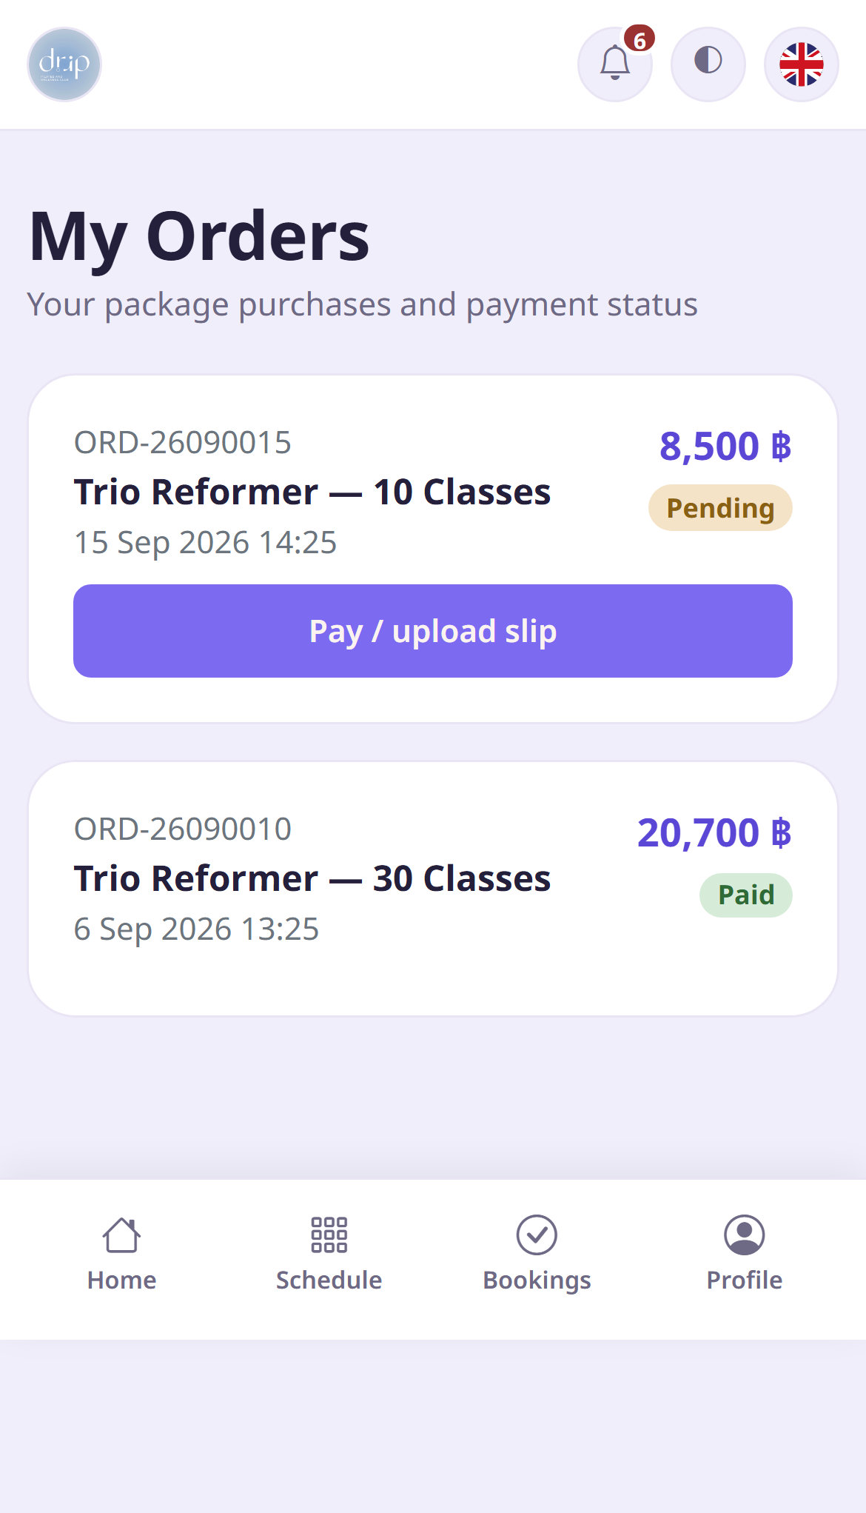
Figure 7 — Your orders and their status

3. Book a class

Step 1 Pick a studio and a day
Tap the Schedule tab, choose the studio you want to visit, then swipe the date strip to see each day's classes.
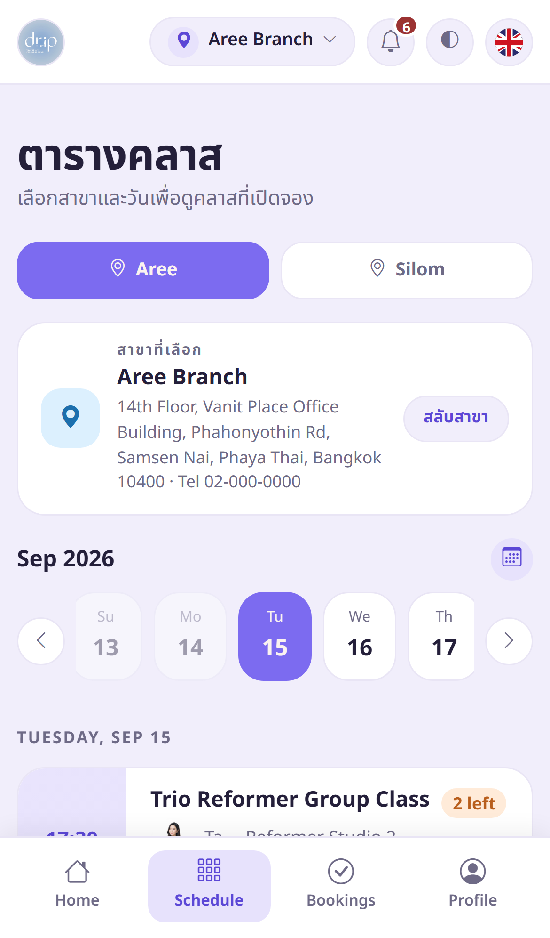
Figure 8 — Choose your studio and date
Each class card shows the time, class name, instructor, room, and how many spots are left.
Step 2 Tap to book
Tap the book button on the class card. A credit is deducted right away and your spot is confirmed. Booked classes appear under the Bookings tab.
✔ Good to know We always use credits from the package expiring soonest, so you get the most out of what you have paid for — no need to choose.

⚑ Tip If a class is full you can join the waitlist. No credit is taken while you wait. If someone cancels we move you up automatically, deduct the credit then, and send you a notification.

⚠ Caution Booking closes minutes before the class starts, and you can book up to days ahead. If booking has closed but you still want to join, contact the studio directly.

4. Manage your bookings

Step 1 See what you have booked
The Bookings tab has two parts — your upcoming classes, and your past history.
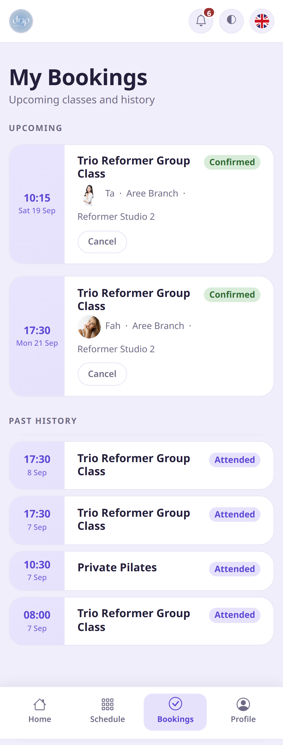
Figure 9 — Upcoming classes and history
What each status means:
Confirmed | Your spot is secured — just turn up on time.
Waitlisted | The class is full and you are in the queue. No credit taken yet.
Attended | You checked in and attended.
Cancelled | Cancelled in time — your credit was refunded.
Late cancel | Cancelled too close to the class time.
No-show | You did not attend and did not cancel.

Step 2 Cancel a class
Tap Cancel on the class card in the Bookings tab. Before you confirm, the app tells you whether you will get your credit back.
✔ Good to know Cancel more than hours before the class and you get your credit back in full.

⛔ Warning Cancel later than that and the credit is not refunded — the spot was held for you and nobody else could take it in time.

⛔ Warning Not turning up without cancelling also costs the credit. If you cannot make it, always cancel — even at the last minute.

Step 3 On the day
Arrive about 10 minutes early and give your name or phone number at the front desk — our staff will check you in. You do not need to show anything in the app.
⚑ Tip We send a reminder before your class. Tap the bell at the top right to see all your notifications.

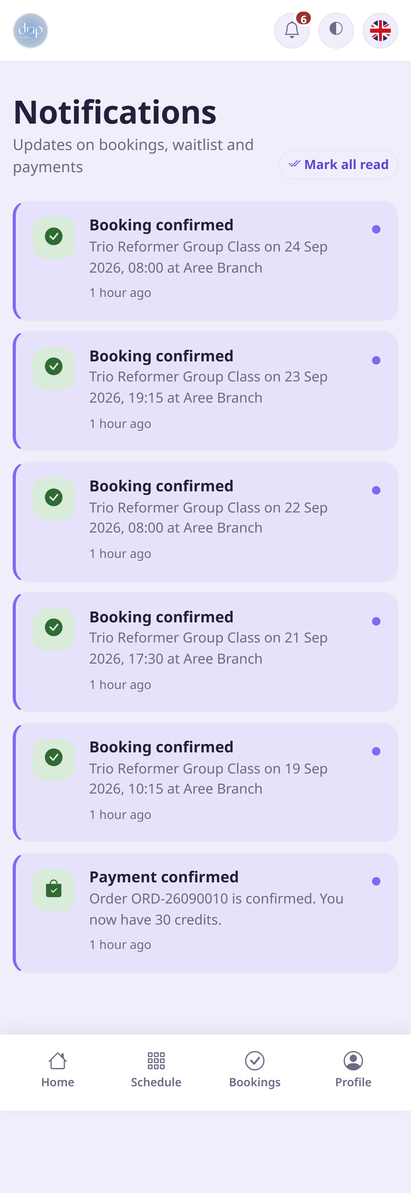
Figure 10 — Notification centre

5. My account

Step 1 Check credits and packages
The Profile tab shows how many classes you have taken, your remaining credits, and every package you hold with its expiry date.
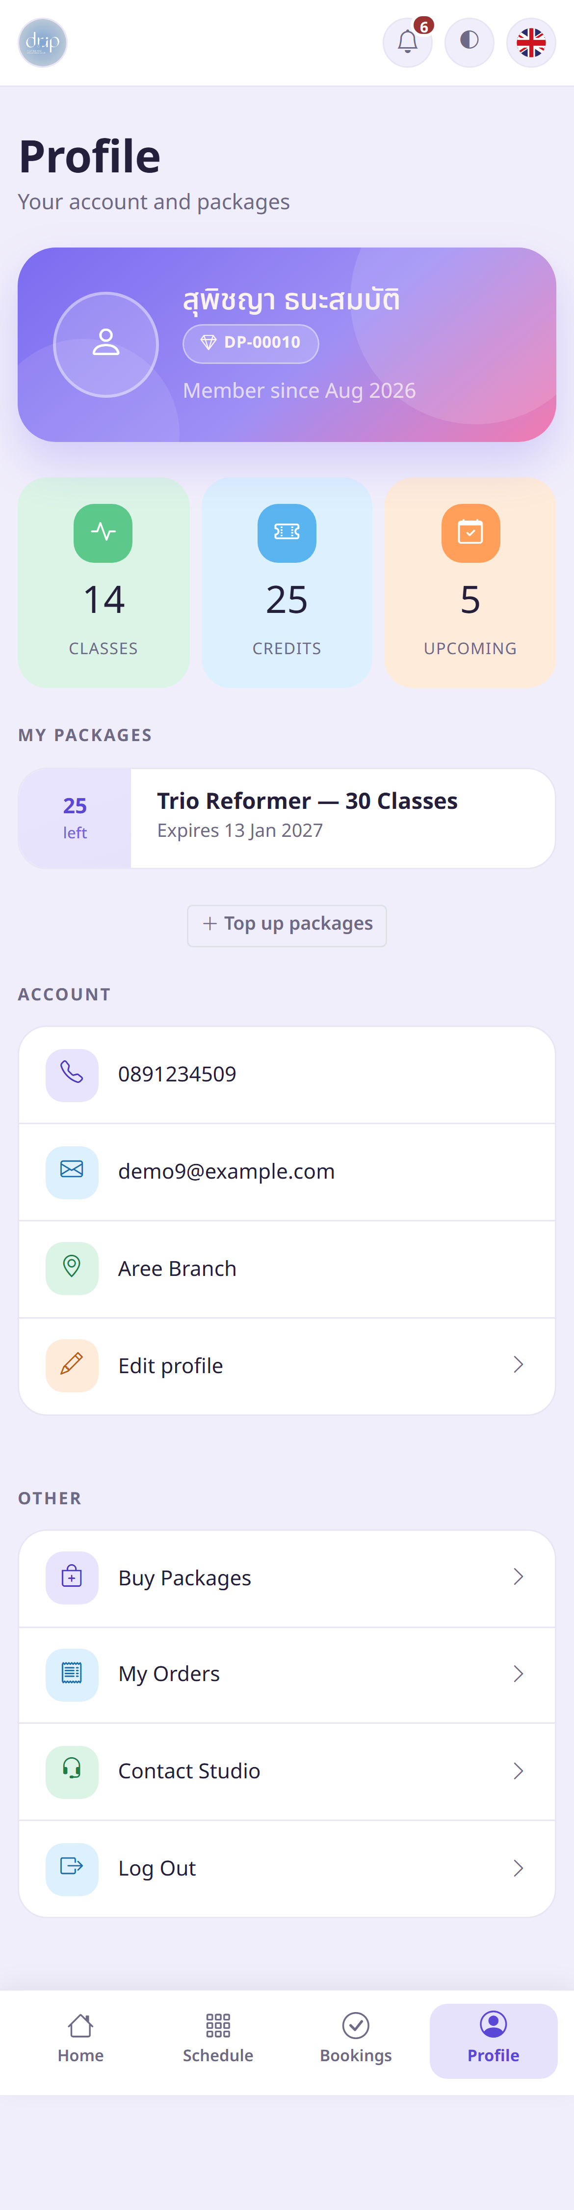
Figure 11 — Your profile and packages
⚠ Caution Credits expire. Once past the expiry date they cannot be used and are not refundable, so keep an eye on the date and plan ahead.

Step 2 Update your details
Go to Profile → Edit profile to change your name, email, home studio and password.
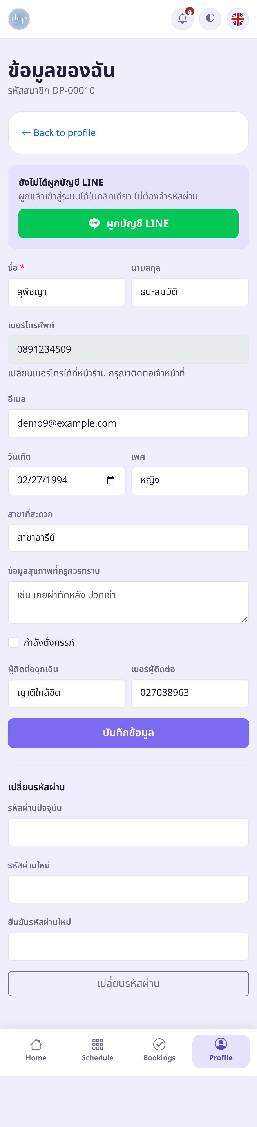
Figure 12 — Edit your profile
⛔ Warning Important: if you have an injury, a medical condition, past surgery, or you are pregnant, please tell the studio. Your instructor will adapt the exercises to keep you safe.

6. Key rules at a glance

Free cancellation | More than hours before class
Booking closes | minutes before class starts
Book ahead | Up to days in advance
Late cancel
No-show
Which package is used | Always the one expiring soonest
Trial package | One per member, once only
Slip approval | Usually within 24 hours

7. Frequently asked questions

I cannot book a class — what should I check?
Check these in order: do you still have credits, has your package expired, is the class full, and has booking already closed? If everything looks fine and it still will not book, contact the studio.
I transferred the money but my credits have not arrived
Credits are added after our team checks your slip, usually within 24 hours. First make sure the slip was actually uploaded — see Profile → My Orders. If it is there and more than 24 hours have passed, please contact the studio.
Will I get my credit back if I cancel?
Yes, in full, if you cancel more than hours before the class. Later than that and it is not refunded. The app always tells you which applies before you confirm.
How does the waitlist work?
If a class is full you can join the queue — no credit is taken at that point. When someone cancels, the first person in the queue is moved up automatically, the credit is taken then, and we notify you. If you no longer want the spot you can leave the queue at any time, free of charge.
My credits expired — can they be extended?
Expired credits cannot be used and are not refundable. However, if something comes up — illness or travel — contact the studio in advance. We can freeze your package, which extends the expiry date by the number of days it was frozen.
What should I bring to class?
Wear comfortable activewear you can move in, and bring grip socks and water. Arrive about 10 minutes early to check in and get ready.
Where do I change the language or dark mode?
The flag at the top right switches between Thai and English, and the half-circle icon beside it switches between light and dark mode. Your choice is remembered.
I forgot my password
If you have linked LINE, just sign in with LINE — no password needed. If you have not linked it, contact the studio and we will reset your password for you.
⚑ Tip Still stuck? Message us on LINE — Open chat

