Cloud Infrastructure And Services – PCS221
Lab Assignment 5
Name – Panvir Singh
Subgroup – CS3
Roll No. – 8025320067

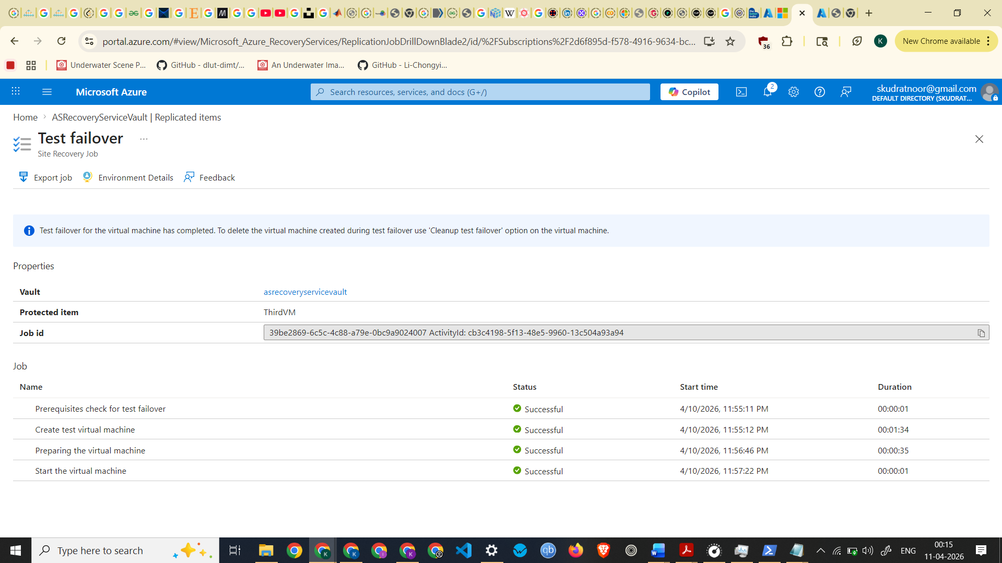
Test Failover Completed

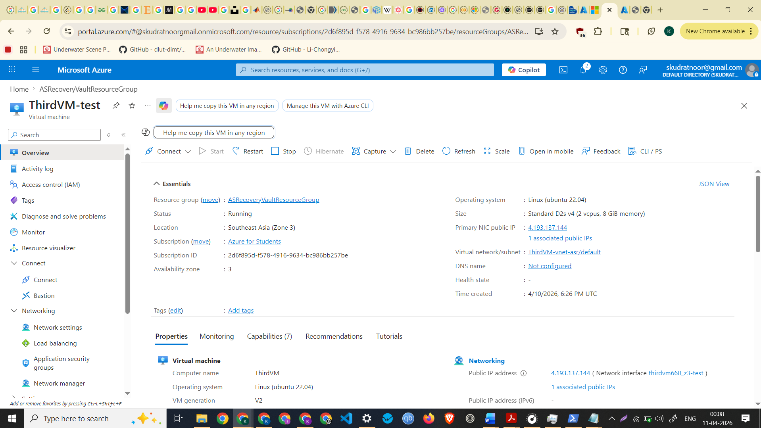
Screenshot of Test Failover VM

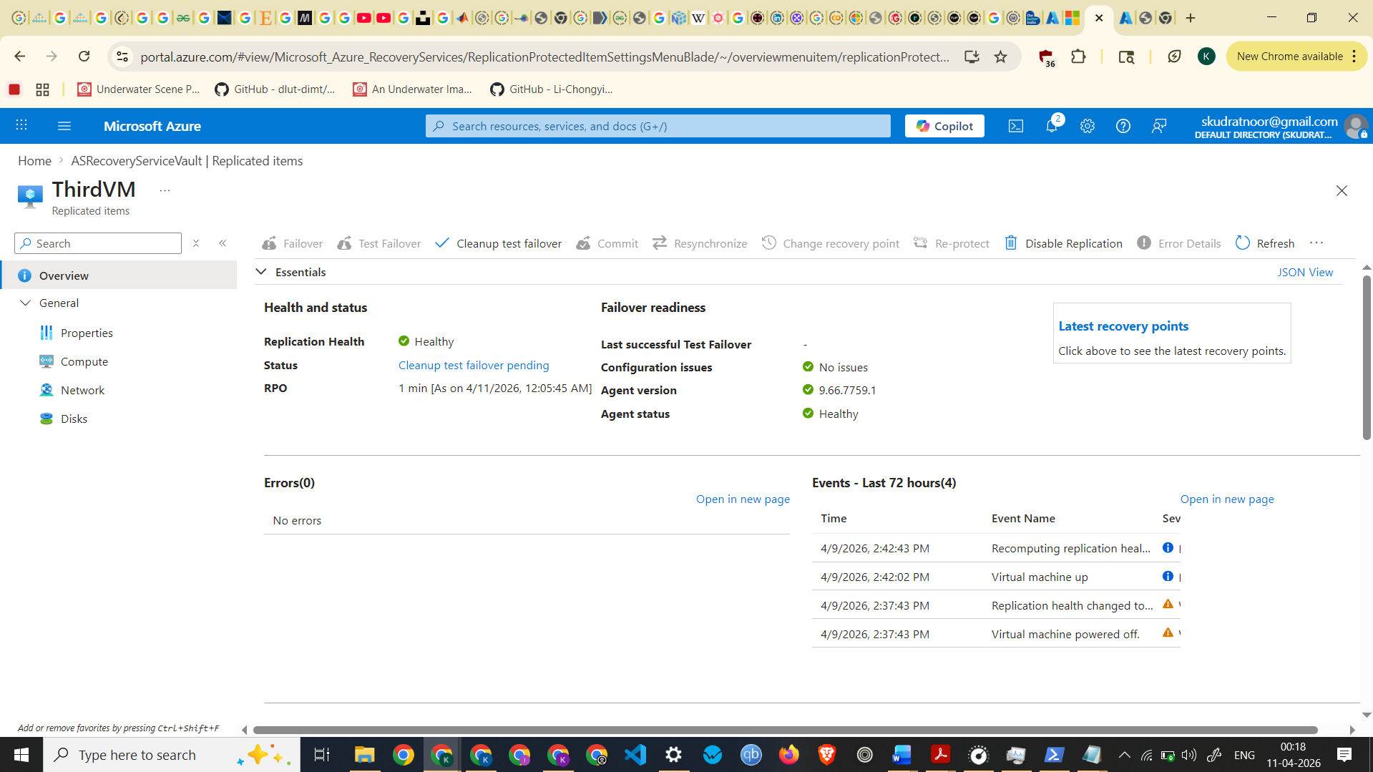

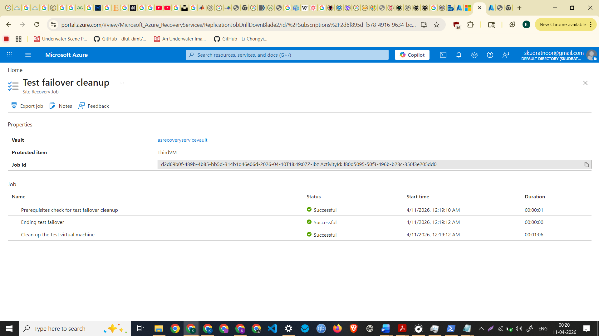
Test failover cleanup completed
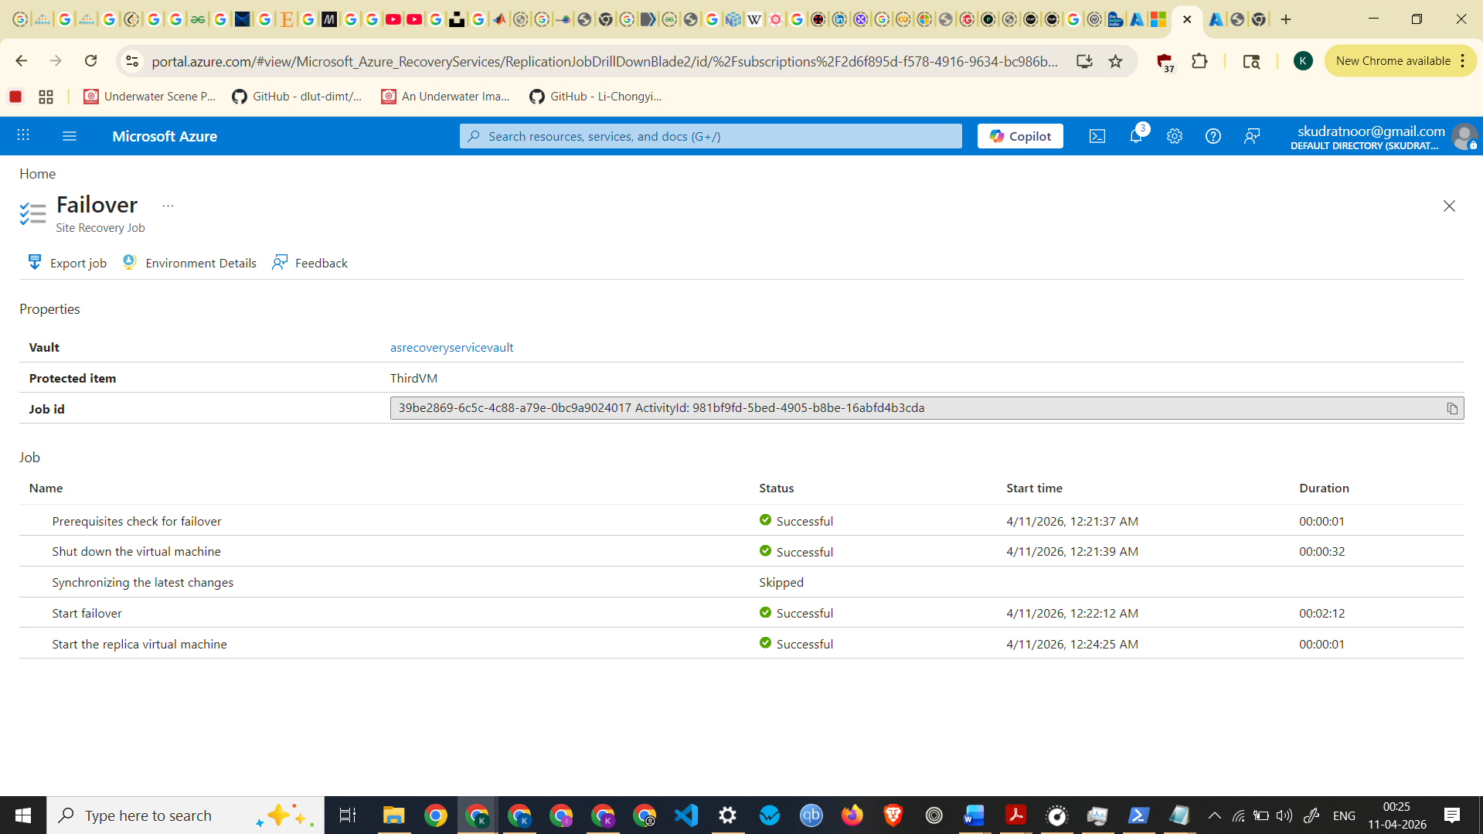
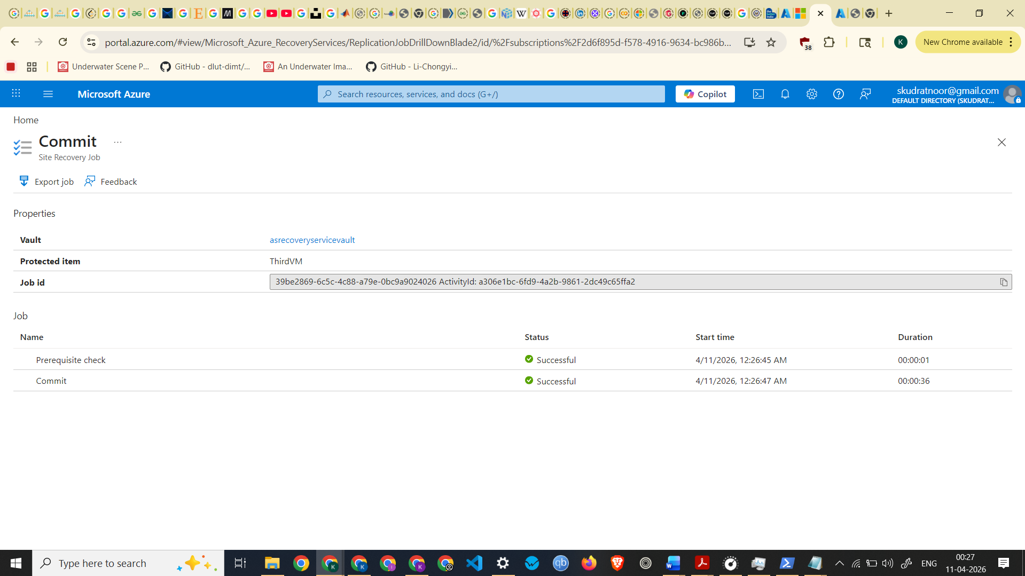
Screenshot of Failover Committed
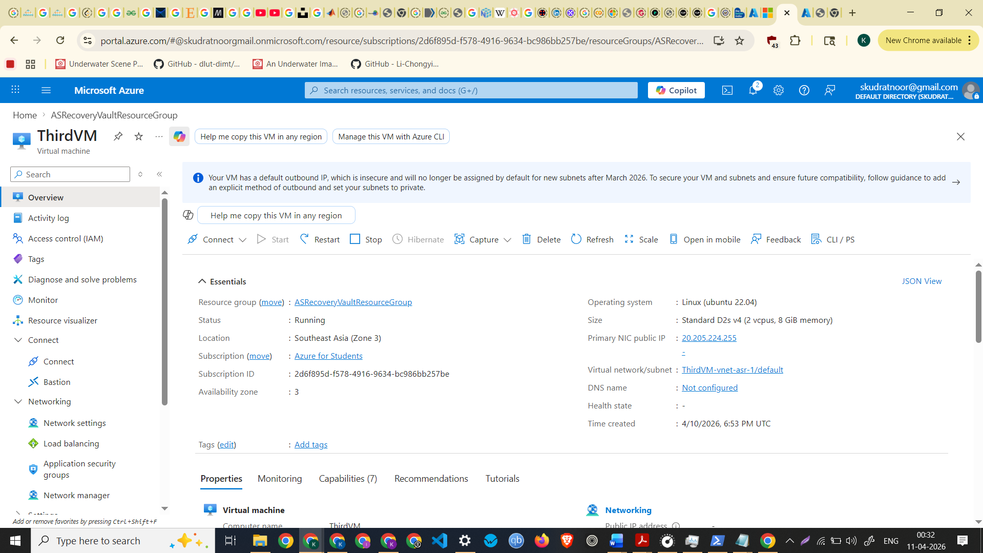
Screenshot of Migrated VM

