**From Gamers to Programmers: How Gaming Influences Decision-Making in Selecting the IT Program for BSIT 2-1 Web and Mobile Application Development Students at ISU-E**

Mhyiel Kyle C. Villanueva  
Jamby Villarta  
Runielle Raven U. Zamora

Allysa B. Reyes

Joaquin G. Vinarao

Mark Vincent L. Rama

Janelle Valdez  
Raymond B. Kenneth

Liam Karl Ali. Valdez

Isabela State University - Echague

February 25, 2025

**CHAPTER I**

**INTRODUCTION**

In today's digital era, many gamers develop problem-solving skills, creativity, and logical thinking as they immerse themselves in virtual worlds. Gamers often arrange competitive events for the games they play, helping them acquire various skills, including meeting new people, learning English, improving communication, understanding historical moments, and gaining knowledge about military affairs and myths and legends from different cultures (Khanmurzina et al., 2020). Gaming in education may be viewed as an interference to learning but its role in education is to increase students’ motivation and engagement to enhance visual skills, to improve students’ interaction and collaboration abilities with their peers and to enable them to apply gaming values in a real- world situation (Zirawaga et al., 2017). Programming education also provides foundational knowledge and fosters higher-order thinking skills essential for generating and converging ideas to solve problems (Lee & Lee, 2024). The ability to strategize, analyze patterns, and adapt to challenges in games closely mirrors the skills required in programming and other IT-related fields. For some students, gaming becomes more than just entertainment—it is an influential factor in their academic and career paths. The continuous growth of video game production has

significantly impacted various aspects of human lives, especially among the younger generation (Ebadi & Ahmadi, 2024). Studies have revealed that entertainment video games can be effective educational tools, beneficial in almost all academic disciplines, particularly in foreign languages and science (Martinez et al., 2022). The demand for skilled IT professionals is rising. In December 2023, the US experienced nearly 364,000 active tech job postings, with 142,295 new additions, and technology job gains in four out of five sector categories (CompTIA Tech Jobs Report, 2024). Despite this demand, many students face challenges in choosing the right career path within the IT field, such as selecting their major and future job roles. As the digital age unfolds, the IT sector has emerged as one of the most dynamic and influential domains in the contemporary workforce landscape (Ndovela & Mutanga, 2024). While various factors influence career decisions, the role of gaming in motivating students to pursue IT careers remains underexplored.

Since some IT students have a background in gaming, it is crucial to understand how their gaming experiences may influence their decision to choose IT as their field of study. Gaming is very common in today's generation; additionally, the effect of COVID-19 on students who were stuck at home and entertained themselves through gaming is significant. A study by Kapoor and Subida aimed to assess young adults' gaming addiction and perceived psychological distress during the COVID-19 pandemic, focusing on Filipinos aged 18-24. It identified factors contributing to their frequent engagement in online games, aiming to inform a preventive intervention program. According to our classmates, one of their reasons for choosing WMAD as their major is because they want to be game developers. Additionally, one classmate mentioned that even when they were still a child, they really loved to play video games. It is safe to assume that gaming has a significant influence on their choice of an IT program and their major.

We also observed that most of our classmates really love to play games; when the subject is vacant, they spend their free time playing video and online games. Given their passion for gaming, the researchers wonder how gaming influences their decision-making when choosing an IT program and their major. This research will specifically focus on BSIT 2-1 Web and Mobile Application Development (WMAD) students at ISU-E, investigating how gaming has shaped their interest in IT programs and how it fosters curiosity about technology, inspiring them to choose IT as their academic and professional future. This curiosity about game mechanics, programming, and systems can influence their decision to choose IT as their academic path. This research aims to explore how gaming experiences shape students' interest in IT and inspire them to pursue an IT program. By investigating how gaming fosters a deeper understanding of technology and sparks career interests in IT, this study will offer valuable insights into how gaming serves as a gateway for students to pursue careers in the technology field.

**STATEMENT OF THE PROBLEM**

The objective of this study is to examine how gaming influences the decision-making process of selecting the IT program for BSIT 2-1 Web and Mobile Application Development students at ISU-E. Specifically, this study seeks to answer the following questions:

1. How do gaming experiences develop skills that inform students' IT specialization choices?
2. How significant is gaming in influencing students' choice of IT program?
3. How do gaming experiences shape students' interest in technology and programming?

**Hypothesis**

The underlying declarative hypothesis study, How Gaming Influences Decision-Making in Selecting the IT Program, were:

1. Students who engage more in gaming are more likely to choose the Web-Mobile Application Development track in the IT Program.
2. Students who have gaming experience have an effect on choosing the IT program.

**Research Objectives** This research seeks the following objectives**:**

1. **To evaluate** the various factors in gaming that affect the decision-making process of BSIT 2-1 WMAD students.
2. **To examine** the experiences of BSIT 2-1 WMAD students at Isabela State University-Echague in selecting their IT program as a gamer.
3. **To determine** how gaming fosters creativity, critical thinking, and motivation in web and mobile application development.

**Scope and Delimitation**

The primary objective of this research is to determine how gaming influences the decision-making process of selecting an IT program. The study will be conducted at Isabela State University—Echague Main Campus, and the respondents will be selected from the BSIT 2-1 Web and Mobile Application Development (WMAD) class within the same institution. Specifically, this investigation aims to examine the types of games that impact the decision-making process in selecting an IT program. Additionally, the study seeks to explore how gaming experiences shape students' interest in technology and programming and to assess the significance of gaming when choosing the IT program. The focus will be on the current semester and may not account for changes or trends over time. The study will primarily investigate the influence of gaming on academic decision-making, excluding other potential influences such as socioeconomic factors, peer influence, or familial expectations.

**Significance of the Study**

The findings of the study will provide insight and information regarding how gaming influences decision-making in selecting the IT program. Specifically, this study will benefit the following individuals.

**For the Researcher:** The study may help the researcher understand more about how gaming influences choosing an IT program.

**For Concern Individual:** This study will help concerned individuals to better understand how gaming affects the choice of an IT program. It will also assist those with a gaming background in selecting an IT program, making decision-making easier and helping them find their interests.

**For Organization and Agencies:** This study will help organizations/agencies in selecting their personnel based on the specific experience or background of the individual.

**For Future Researchers:** The study presented could be an important source of information that could be used as a starting point for further investigation into this area. Additionally, the study will offer objective, verifiable data regarding the impact of gaming on IT program selection, which may be utilized in subsequent research projects.

**DEFINITION OF TERMS**

The following terms were defined in accordance with how they are used during the course of the study:

**IT program** - Information technology (IT) refers to a broad professional category that encompasses functions such as building communications networks, safeguarding data and information, and troubleshooting computer problems. (What Is IT? Understanding Information Technology Today, 2024)

**Gaming** - Gaming is playing an electronic video game, which is often done on a dedicated gaming console, PC or smartphone. (Wright, 2022)

**Programming.** It entails the use of logic to enable particular computing functionality and processes for a computer program (Rouse, 2020).

**WMAD** - refers to one of the majors in the Information Technology program. Students will design, employ, and deploy information resources to support an organization. By specializing in Web and Mobile Applications, they will gain a broad foundation in user interaction, global communication, and digital technologies, using state-of-the-art computer systems focused on the development of mobile web applications. (FEU Institute of Technology, n.d.)

**Technology -** It is the application of scientific knowledge to the practical aims of human life or, as it is sometimes phrased, to the change and manipulation of the human environment. (The Editors of Encyclopaedia Britannica, 2025)

**Decision-making** - it refers to the process of making choices by identifying a decision, gathering information, and assessing alternative resolutions. (University of Massachusetts Dartmouth, 2022)

**CHAPTER II**

**REVIEW OF RELATED LITERATURE AND STUDIES**

This chapter contains the concept, the findings from the investigation, generalizations or conclusions, techniques, and other information that is relevant to the proposed study and acts as a foundation and direction for the researchers.

**Theoretical Framework**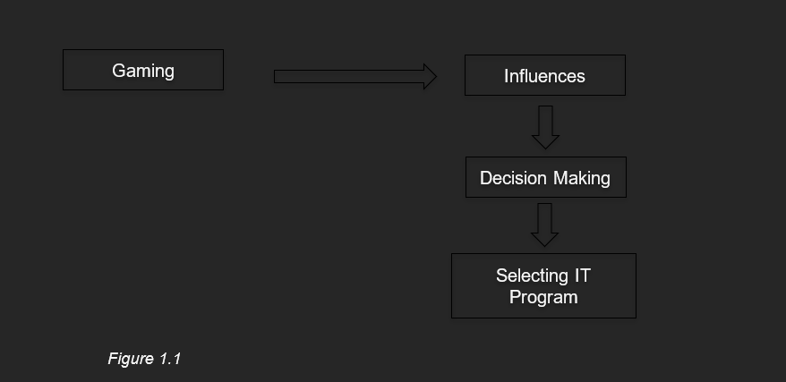

As illustrated in the figure 1.1, it contains how gaming affects their decision in selecting an IT program, how gaming influences the BSIT 2-1 students to decide on choosing an IT program, and how decision-making shapes students in choosing an IT program. The model illustrates the process of gaming influencing the decision making, it also shows how gaming influences that will lead to decision making and will end up in selecting IT Program. After the study and analyzing the studies, the researchers hoped that the study would help the concerned individual, along with the future researcher, organizations, and agency, to give them knowledge and insight on the experience of students on how gaming influences their decision-making in choosing the IT strand.

**Local Literature**

In the study by Aranda et al. (2022), the researchers examined the perceived effects of online gaming on the academic performance and social behavior of Grade 12 students during the Covid-19 pandemic. Using a correlational quantitative research method, they surveyed 100 students from De La Salle Medical and Health Sciences Institute - Special Health Sciences Senior High School using Google Forms. The study revealed that 12 out of 18 responses were favorable, indicating that online gaming had a positive impact on students' academic performance. Similarly, while 6 responses were less favorable, the majority of students agreed that online gaming positively influenced their social behavior.

Academic performance of the respondents in this study (IRCHE 2017) shows that from the 126 responses, most of the students that plays on-line games obtain a grade ranging from 86-90 interpreted as “Good” that got 68 or 53.97%. Followed by a grade ranging from 81-85 with a description of “satisfactory” got 49 from the respondents or 38.89%. Next is the grade ranging from 91-95 which means “Very Good” got the second to least, which is 7 of the respondents or 5.56%, and lastly, the remaining number which is 2 or 1.59% is the grade ranging from 75-80.

Sadjail, Sansawi, and Matolo (2022) explored the factors influencing students’ choice of college course, focusing on influences such as parental expectations, societal pressures, personal interests, and financial considerations. The study highlights how these factors shape students’ decision-making processes and emphasizes the role of self-determination in overcoming challenges. This research contributes to understanding the complex dynamics involved in students’ academic choices.

**Foreign Literature**

According to Reynaldo, M. D., McCaffrey, A., & D. C. Brown. (2020). The cognitive and social benefits of video games in learning. Procedia Computer Science, 171, 108-115.This review explores how video games improve cognitive skills such as attention control, problem-solving, and decision-making, all of which play a role in choosing IT career paths.

As stated by Barr, M. D. (2019). From playing to programming: The impact of video games on computer science interest. Journal of Computer Science Education, 15(4), 234-245. Barr’s research focuses on how playing video games can inspire students, particularly adolescents, to pursue computer science careers. The study shows a clear connection between gaming interest and career interests in IT.

As explained by Holbert, S., Berland, M., & Kafai, Y. B. (2020). Educational game-based learning in computer science. International Journal of Educational Technology, 32(3), 95-102. This study emphasizes the effectiveness of educational video games in engaging students and enhancing learning in computer science and IT subjects. It shows that game-based learning motivates students to pursue further studies in IT fields.

In accordance with Rutgers Education and Employment Research Center. (2021). Gaming and IT careers: Connecting passion to profession. Rutgers University Press. This study looks at the link between hobbies like video gaming and the pursuit of IT careers. It suggests that the skills developed in gaming, such as problem-solving and technical skills, can contribute to career choices in the IT sector.

As explained by Shute, V. J., Ventura, M., & Ke, F. (2015). Video game preferences and career interests. Psychology of Popular Media Culture, 4(3), 251-262. This article explores the relationship between video game preferences and career interests. It highlights how video game genres correlate with aspirations in technology and IT-related fields.

In a study by Atreya (2022), video games were explored in terms of their impact on human cognitive abilities. While many studies have traditionally focused on the negative effects of gaming, such as aggression and poor academic performance, recent research highlights the positive effects, particularly in cognitive functions. The study found that video games enhance abilities such as multitasking, self-control, and quick decision-making, which are crucial for mental agility. Atreya (2022) compared the cognitive abilities of gamers and non-gamers, noting that gamers perform better in tasks involving response speed, task completion under time constraints, and multitasking.

Reynaldo et al. (2021) reviewed the effects of video games on cognitive abilities and decision-making. The results showed that playing video games, especially first-person shooter (FPS) and real-time strategy (RTS) games, enhances cognitive skills like perception, attentional control, and decision-making. While FPS games were linked to increased decision-making speed and efficiency, RTS games were found to improve cognitive flexibility. The study also discovered that serious simulation games enhanced risk assessment and decision-making, suggesting that video games could be helpful in professional contexts, such as for doctors and nurses.

According to the study of Mark Frydenberg (2016), teaching game development has become an accepted methodology for introducing programming concepts and capturing the interest of beginning computer science and information technology (IT) students. This study, conducted over three consecutive semesters, explores game development using a gaming engine, rather than a traditional programming language, as a means not only to introduce programming concepts, but also to promote the development of information and communications technology (ICT) literacy skills among first-year business students. The paper argues that in addition to learning programming concepts, completing the steps involved to develop and publish an original game requires students to demonstrate a variety of ICT skills. To be successful, they must be proficient at creating and editing multimedia, interacting with multiple operating systems and mobile devices, performing research online, transferring files from one machine to another, and uploading the files for their games to an app store and the web.

Teaching technology literacy to non-technical students has changed greatly since John Kemeny and Thomas Kurtz, creators of the BASIC programing language at Dartmouth College, introduced the notion of computer literacy in 1964. Kemeny recognized that that "someday computer literacy will be a condition for employment, possibly for survival, because the computer illiterate will be cut off from most sources of information." (Kemeny, 1983)

Computer literacy then was achieved by using time-shared teletype terminals connected to a college mainframe to create simple BASIC programs as a way to develop algorithmic thinking. "By making the BASIC environment so friendly, [Kemeny and Kurtz] created a safe place for people to play and explore. The computer game movement came from BASIC. People shared their games, long before there were networks, by printing the programs [in computer magazines] for others to enter in and enjoy." (Claburn, 2014)

**Local Studies**

As stated by Dumrique and Castillo (2018) conducted a research to analyze the influence of online gaming on academic performance and social behavior among high school students at the Polytechnic University of the Philippines Laboratory High School. According to the data, internet gaming did not have a substantial impact on students' academic performance or social relationships. The study stressed the significance of discipline and time management for students in balancing gaming and academic duties.

According to Gabrito, Ibañez Jr., and Velza (2021) investigated the effects of online gaming on the academic performance of students at DEBESMSCAT-Cawayan Campus. The study revealed that the majority of students believed that their gaming activities did not significantly hinder their ability to perform academic tasks. In fact, some respondents perceived positive effects on aspects such as test scores, grades, and participation in learning activities.

Ax explained by Cañares (2023) conducted a quasi-experimental study to determine the effects of online games on the academic performance of Grade 9 students at Pasian National High School. The research aimed to assess whether exposure to online games influenced students' academic outcomes, utilizing a two-group pretest-posttest design to measure performance changes.

According to Cabrillos et al. (2022) explored the relationship between online gaming and academic performance among Bachelor of Physical Education students at Sultan Kudarat State University. The study assessed the impact of online games on health, social, intellectual aspects, and academic performance, highlighting the need for balanced engagement in gaming activities to maintain academic success.

As stated by Valdez et al. (2020) examined how online gaming affects the academic performance of General Academic Strand students at Bestlink College of the Philippines. The study concluded that while online gaming can be beneficial in reducing stress and enhancing teamwork, excessive gaming may lead to addiction and negatively impact academic performance.

As stated by Palackal and Guarino (2015) explored the experience of Internet Gaming Disorder (IGD) among adolescents in Metro Manila using a multiple case study approach. Their findings highlighted the cognitive, affective, physiological, and behavioral impact of gaming, as well as risk factors such as escapism and peer recognition. They also identified warning signs, including preoccupation with gaming and deception, as well as consequences like academic decline and relational conflicts. Additionally, the study emphasized the role of parental control as a protective factor against IGD. These findings contribute to the understanding of gaming addiction and its implications for adolescent well-being.

According to Llabore Jr. et al. (2023) examined the effects of digital gaming on adolescents’ mental health and behavior in the Philippines. Their study, which involved 59 junior and senior high school students, found a significant correlation between the number of gaming hours and both mental health (r = 0.539, p < 0.05) and behavioral status (r = 0.460, p < 0.05). The findings suggest that violent digital gaming can serve as a coping mechanism for stress and loneliness, but it may also lead to aggressive behavior when gameplay is interrupted. These results highlight the dual effects of gaming, supporting further research on its psychological and behavioral impacts on adolescents.

A research conducted at Leyte Normal University to investigate the impact of online gaming on students' academic achievement (2018). In a descriptive survey research that made use of questionnaires, interviews, and observational methods, the research used a sample of 139 students. The research indicated that a majority of the respondents (49.61%) reported that online gaming had adverse effects on their academic performance, especially in the area of their concentration on studies. This corroborates the contention by parents and stakeholders of the excessive use of online gaming, which would lead to addiction and distraction. The research concluded that even though online games are a big technological advancement, their negative impacts on academic performance call for policy interventions aimed at reducing this risk in schools. The findings of the study are meant to inform future education policies at Leyte Normal University to ensure that the impact of gaming on academic performance is perfectly managed.

The study by Quijano-Pagutayao (2024) explores the factors influencing career degree choices among senior high school students in Bukidnon. It identifies key influences, including family background, particularly parental involvement in farming, financial constraints, and the distance from home to educational institutions. The study also highlights the role of students’ preferences for career success, such as pursuing degrees that could provide higher income or prestige. These findings are relevant in understanding the factors shaping career decisions among youth in rural settings.

As stated by Vicpher D. Garnada (2020) aimed to assess the influence of online computer game addiction on the academic attitudes of college students in Salug Valley, Zamboanga del Sur, Philippines. The research involved 365 students and used a descriptive-survey method, including questionnaires on online gaming addiction and academic attitudes. The findings indicated that most respondents experienced a moderate level of online gaming addiction, and their academic attitudes were moderately affected. While there was no significant relationship between gaming addiction and students’ study habits, goal achievement, or academic responsibility, a significant relationship was found between online game addiction and students' participation in extra-academic activities. The study suggests that school administrators should provide more engaging activities to redirect students’ focus, while guidance counselors and parents should work together to monitor and help students balance gaming with academic responsibilities.

**Foreign Studies**

Manero et al. (2017) examined the influence of players' age, gender, and gaming preferences on the effectiveness of a videogame designed to increase teenagers' interest in classical theater. Participants were divided into four groups: Well-rounded gamers, Hardcore players, Casual players, and Non-gamers. The study found that only gaming preferences significantly influenced students' interest in theater-going, while age and gender had no effect. Casual and Well-rounded gamers showed more interest than Non-gamers and Hardcore players. The study also explored the impact of gaming profiles on traditional educational approaches, finding that traditional education worked better for Non-gamers. This suggests that understanding students' gaming preferences can help educators choose the most effective educational approach.

According to Hartmann & Gommer (2021), the increasing use of games as educational tools is largely attributed to their motivational appeal. Their research delves into how different motivational factors and the context of both the game and teaching environment influence students' willingness to engage in gameplay. By utilizing self-determination theory and a mixed-method case study, the study analyzed seven educational games used in a postgraduate engineering course over two years. Their findings indicate that various motivational forms can coexist during gameplay and that the combination of game attractiveness, learning, and operability helps explain these motivational dynamics.

According to Flynn et al. (2018), youth in the United States have low levels of cardiorespiratory fitness, which is a risk factor for childhood obesity, particularly among black and Hispanic youth. This feasibility study explored the use of active video games (AVGs) to improve fitness and attitudes toward physical activity among adolescents. The 6-week AVG program was conducted in a youth development program in a high-poverty neighborhood in New York City, involving youth aged 10 to 15 years, with 50% being overweight or obese. Participants underwent fitness tests and completed surveys assessing barriers to physical activity before and after the intervention. Each week, they played Wii Fit games for 30 minutes. The results showed that participants improved their sit-up and step-up counts, and increased their self-efficacy, intention to exercise, and perceived social support for exercise. Additionally, participants enjoyed the program and viewed Wii Fit as a way to enhance fitness and physical activity. The study concludes that AVGs may be a viable exercise option for black and Hispanic youth in poverty-impacted areas.

As noted by Scholes et al. (2024), engagement with video games can enhance student digital competence, though a digital skills gap often emerges by adolescence. Their research investigates how elementary students' digital self-efficacy, influenced by video game experiences, relates to perceptions of digital competence. The study examines the roles of sex, self-efficacy, and socioeconomic status (SES) in the digital skills and gaming perceptions of 7-10-year-olds (N = 613). Surprisingly, SES was inversely related to enjoyment of gaming and digital technology, with lower-SES students responding more positively than their higher-SES counterparts. Consistent with expectations, boys reported higher digital skills than girls across all SES categories. The authors advocate for using gaming pedagogies in classrooms to address the nuances of students' digital self-efficacy, which are influenced by gender and SES.

According to Kapoor and Subida (2017), their study investigated how players' age, gender, and gaming preferences (defined as their gaming habits and interests) impact the effectiveness of a specifically designed videogame aimed at increasing teenagers' interest in classical theater. Using a validated instrument, participants were categorized into four groups based on their gaming preferences: (1) Well-rounded (WR) gamers, who regularly engage with all types of games; (2) Hardcore players, who predominantly play first-person shooter (FPS) and sports games; (3) Casual players, who moderately play games such as music, social, and puzzle games; and (4) Non-gamers, who rarely engage with videogames. The study revealed that among the personal factors measured—age, gender, and type of player—only gaming preferences had a statistically significant (p<0.05) positive effect on students' interest in attending theater. Age and gender showed no substantial impact on the results. Both Casual and Well-rounded gamers performed better in the game compared to Non-gamers and Hardcore players. Interestingly, traditional teaching methods outperformed videogames only for students who do not typically play games. These findings suggest that gaming preferences could play a crucial role in determining the success of various educational approaches. Consequently, understanding students' gaming profiles beforehand could assist educators in selecting the most effective educational strategies for their needs.

Aziz et al. (2025) studied how video games affected players' cognitive capacities and ability to make decisions. The researchers collected data from children in Rawalpindi, Pakistan, between the ages of 16 and 30, using a quantitative research approach (survey), in order to examine the ways in which video games affect cognitive abilities like multitasking, problem-solving, critical thinking, teamwork, and decision-making speed. According to the findings, playing video games greatly improves cognitive capacities. Participants reported increases in their capacity for multitasking, problem-solving, critical thinking, and quick decision-making. According to the study's findings, playing video games can improve cognitive function in addition to providing amusement. These results point to the potential of video games to increase mental acuity and call for more investigation into their positive effects on education and psychology.

According to Oscarido et al. (2023) their study assessed the impact of video games on human behavior and judgment. After playing video games from a certain genre, the researchers used a direct testing method to examine the performance of 22 respondents, ages 17 to 25. Based on their post-game decision-making skills, participants received scores. The findings showed that playing competitive First-Person Shooter (FPS) games improves players' capacity for decisive action. Numerous participants indicated that playing first-person shooter games improved their cognitive abilities, enabling them to quickly evaluate available options and choose the best course of action. The notion that gaming might promote mental agility is supported by these findings, which imply that video games, especially competitive first-person shooter games, may enhance cognitive processing and decision-making skills.

According to *Adams, David M., et al 2016,* thatresearch on the effects of playing video games has been limited by a preoccupation with possible negative repercussions. Nevertheless, research has shown that video games can have positive effects on young players' social lives. The existing body of research, however, has largely ignored the more computer-related aspects of video game play and its effects. This study provides empirical evidence to support theoretical arguments about the relationship between playing video games and computers. The type of scientific thinking encouraged by video games and the technological abilities needed to play video games is suggested to result in an increase in players' confidence with computers and interest in computer science. These potential relationships are examined using data from over 1,000 undergraduate students to empirically assess the relationship between video game play and: 1) confidence with computers, and 2) interest in computer science. The results indicate that game play is statistically significant as a predictor of confidence and interest. In comparison to the other predictors in the model, the strength of the effect from playing video games is relatively very strong. The findings suggest that exposure to video games as a recreational technology help inform players' abilities with nonrecreational technology and build an interest in technology in general.

Shin, S. Y., et al. (2020) conducted a study involving 1,200 Korean teenagers and found that gaming was a favored leisure activity among the majority of the participants. Additionally, the study revealed that the more frequently adolescents played games, the more they enjoyed and engaged with the activity

According to Capinpin et al. (2022), this study aims to determine the impact of gaming on mental well-being and academic performance among teenage students. A survey was conducted among 34 senior high school students to gather data on whether gaming can affect their academic performance and mental well-being. The survey consists of questions regarding the students’ studying habits, gaming habits, and overall academic performance. Results have shown that students who play video games frequently tend to score lower in terms of academic performance, particularly on academic competence, test competence, and strategic studying.

**Gaps in the Literature**

This research seeks to explore how gaming influences the decision-making process of BSIT 2-1 WMAD students at ISU-E when selecting an IT program. While existing literature primarily examines gaming’s impact on activities, age, gender, and its role as an educational tool, this study aims to delve deeper into how gaming shapes students' interest in IT programs. The researchers also aim to identify the types of games that have the most influence on decision-making and assess the significance of gaming in choosing an IT program. The study will evaluate various gaming-related factors that affect decision-making and analyze students’ experiences in selecting an IT program as gamers. By focusing on BSIT 2-1 students, the researchers hope to gain valuable insights into their perspectives, helping to identify any gaps in knowledge or confidence at the beginning of their academic journey. Additionally, the research aims to provide useful feedback to professors in the CCSICT department, enhancing their understanding of how gaming impacts students' choices in IT programs.

**CHAPTER III**

**RESEARCH METHODOLOGY**

This chapter provides the details of the procedures involved in examining how gaming influences the decision-making process of selecting the IT program. It aims to evaluate the various factors in gaming that affect the decision-making process of BSIT 2-1 WMAD students, examine their experiences as gamers at Isabela State University-Echague in selecting their IT program, and determine the types of games that have influenced their choices. Furthermore, this chapter outlines the research design and various methods used for data collection and the conduct and development of the study.

**RESEARCH DESIGN**

The research design utilized in this study is a quantitative research design, which systematically involves collecting and analyzing numerical data. This approach helps researchers identify patterns, calculate averages, develop hypotheses, examine relationships, and generalize findings to larger populations (Bhandari, 2023). This method is highly suitable for the study’s objectives, as it focuses on collecting measurable feedback and opinions from BSIT 2-1 WMAD students. Data will be gathered using structured tools such as questionnaires and surveys, which are specifically designed to capture respondents' attitudes, experiences, and opinions reliably and efficiently. While primarily quantitative, these tools can also incorporate qualitative elements to provide additional context (Bhandari, 2023). By employing these instruments, the study aims to derive critical insights that are essential for achieving its objectives and making data-driven conclusions.

**POPULATION AND SAMPLING**

The respondents of the study are selected BSIT class, specifically the BSIT 2-1 WMAD students from the Isabela State University -Echague, College of Computing Studies, Information and Communication Technology department. The researcher will employ a non-probability sampling method, specifically a convenience sampling technique. Non-probability sampling is a sampling technique that involves taking into account factors other than randomness, such as availability, closeness to the study subject's location, or subject matter knowledge. (Nikolopoulou, 2022). Convenience sampling is a non-probability sampling technique where respondents are chosen for the sample based on their accessibility to the researcher. Nikolopoulou, K. (2022a) The Survey King sample size calculator is employed to calculate the population's sample size, enabling the researchers to determine the required sample size for their study.

**RESEARCH INSTRUMENTS**

In this study, the researchers will utilize a survey to collect data on how gaming influences students' decision-making processes in selecting an IT program. The survey draft has been developed based on the researchers' thorough review of relevant literature, past investigations, and published and unpublished dissertations. The survey is divided into two sections. The first section focuses on influences, examining how students decide on selecting an IT program and identifying the factors that shape their decisions. The second section explores the decision-making process, shedding light on the specific factors and challenges students experience while choosing an IT program. To complement the survey, the researchers will employ an observation checklist during interviews. This checklist will help capture insights into the influences and decision-making processes faced by the respondents when selecting an IT program. Through this design, the researchers aim to analyze the impact of gaming on students' decision-making and the specific factors influencing their choices, providing valuable data to inform future studies.

**DATA COLLECTION PROCEDURES**

In this study, the researchers will obtain informed consent from the respondents before conducting the survey. The targeted respondents will be from the BSIT 2-1 WMAD section at Isabela State University Echague, selected based on criteria prepared by the researchers. Once consent has been received from all respondents, the survey process will commence. The researchers will coordinate with the respondents to schedule the survey at the respondents’ earliest convenience and preferred location. Upon arrival, the researchers and respondents will briefly discuss and settle down before starting the survey. During the survey, the respondents will complete an observation checklist provided by the researchers. The researchers will remain on-site until all respondents have finished answering the checklist. After completing the survey, the researchers will explain to the respondents how the collected data will be used and provide their contact details for any follow-up inquiries. After the survey process, the researchers will compile and organize all transcripts and, if available, video recordings for further analysis.

**LOCALE OF THE STUDY**

*Figure 2.1 - locale of the Survey*

TheCollege of Computing Studies, Information and Communication Technology department located at San Fabian Echague, Isabela, was the location where the survey took place.

**DATA ANALYSIS**

The researchers will employ quantitative analysis to interpret the data collected in this study. Quantitative analysis utilizes computational and statistical methods to describe and analyze information using statistics and numerical data. This approach will involve both descriptive statistics, which summarize the characteristics of the data set, and inferential statistics, which enable the researchers to draw meaningful conclusions from the data. The data collected from the respondents will be analyzed systematically. Initially, the researchers will transcribe and organize the responses from the observation checklists and surveys to ensure the data is accurate and comprehensible. The responses will then be assessed for consistency and completeness. To process the data, the researchers will apply the weighted mean to quantify and interpret the responses. This statistical measure will help summarize the influences and decision-making factors experienced by the respondents in relation to gaming and their selection of an IT program. The analysis will provide evidence to support the researchers' evaluation of the relationships between gaming, decision-making, and program selection. By employing this method, the researchers aim to draw legitimate and reliable conclusions, address the research objectives, and identify patterns or trends in the data. Furthermore, the findings will inform future studies, highlight areas for improvement, and suggest potential directions for further research.

**STATISTICAL TREATMENT OF THE DATA**

1. **Sample Size Calculation**

The sample size of the population of the BSIT 2-1 WMAD class is determine using the Survey King Sample Size Calculator 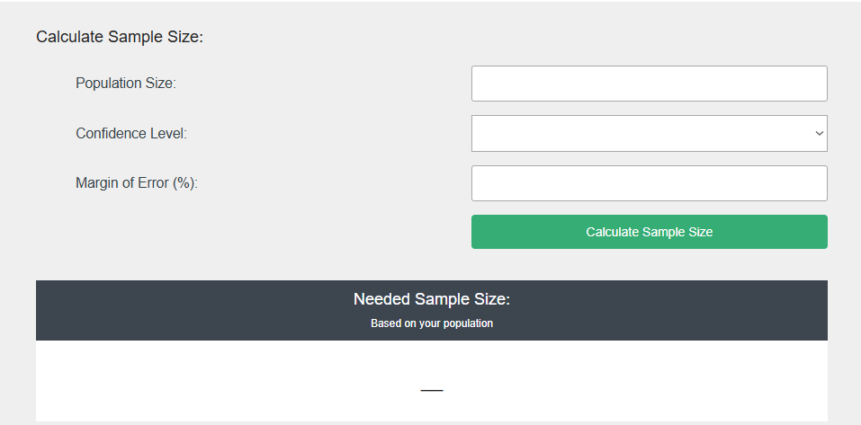

*Figure 2.2 - Calculation of the sample size – Survey King Sample Size Calculator*

Where:

Population size = 40

Confidence level = 90%

Margin of error = 10%

**B.**  **Weighted Mean**

The weighted mean will be utilized to determine the respondents' average assessment of how gaming influences decision-making in selecting the IT program for BSIT 2-1 Web and Mobile Application Development students at ISU-E. To ensure that the qualitative data collected by the researcher is free from bias, the weighted mean will also serve as supplementary support.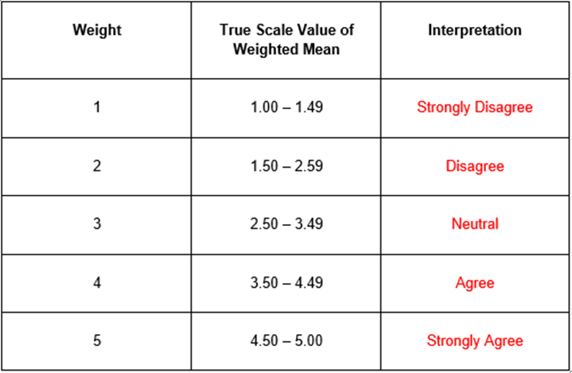

*Figure 2.3 – True Scale Value of Weighted Mean*

Wherein:

w = weight mean

f = frequency

N = total population

**CHAPTER IV**

**RESULTS AND DISCUSSION**

The following section presents the data interpretation and analysis based on responses collected from the BSIT 2-1 WMAD students of ISU-E in the study From Gamers to Programmers: How Gaming Affects Selecting IT Program. The implementation phase involved researchers guiding participants through the survey process, ensuring they understood the context of each question and the relevance of their responses. Additionally, participants were encouraged to ask questions to clarify concepts related to gaming and IT program selection. The responses recorded in the tables below will aid the researcher in forming a well-supported conclusion regarding the impact of gaming on students' selection of an IT program. This analysis will determine whether the study effectively meets its objectives in identifying correlations between gaming experiences and academic paths in IT. Furthermore, to maintain validity and avoid bias, the research findings from participants serve as supporting evidence in establishing credible insights into the study’s conclusions.

**INTERPRETATION OF DATA**

**Table 1.1** - Weighted Mean, Inferential Statistical Analysis, and Descriptive Interpretation of How Gaming Introduced Students to Selecting an IT Program.

| **Introducing Gaming** | **Weighted Mean** | **Descriptive Interpretation** |
| --- | --- | --- |
| 1. Gaming introduced me to the idea of pursuing a career in IT. | 2.8 | Neutral |
| 2. My interest in programming or web development stems from gaming experiences. | 3.68 | Agree |
| **Grand Mean and Interpretation** | 3.24 | Neutral |

Table 1.1 displays the results of how gaming is introduced to students. The students are neutral regarding the statements, "Gaming introduced me to the idea of pursuing a career in IT," which has a weighted mean of 2.8, and "My interest in programming or web development stems from gaming experiences," which has a weighted mean of 3.68. The students remained completely neutral in agreement with both claims, as reflected by the grand mean of 3.24, indicating a neutral implementation.

**Table 1.2 -** Weighted Mean, Inferential Statistical Analysis, and Descriptive Interpretation of How Gaming Influences Students to Selecting an IT program.

| **Gaming Influence** | **Weighted Mean** | **Descriptive Interpretation** |
| --- | --- | --- |
| 3. Gaming introduced me to the idea of pursuing a career in IT. | 2.8 | Neutral |
| 4. My interest in programming or web development stems from gaming experiences. | 3.68 | Agree |
| 5. Playing games exposed me to the idea of creating apps and websites. | 3.84 | Agree |
| 6. Skills developed in gaming (e.g., teamwork, logic) are applicable to IT programming. | 3.92 | Agree |
| 7.Games that involve problem-solving have shaped how I approach technical tasks. | 3.96 | Agree |
| 8. Playing games with strategic elements motivates me to learn programming and development skills. | 3.92 | Agree |
| 9. Gaming challenges improve my ability to solve complex tasks. | 4 | Agree |
| 10. Logical thinking developed through gaming has enhanced my approach to coding. | 4 | Agree |
| **Grand Mean and Interpretation** | 3.76 | Agree |

Table 1.2 presents the results of research participants' assessments of how gaming influences their selection of an IT program. The students remained neutral regarding the statement, "Gaming introduced me to the idea of pursuing a career in IT," which received a weighted mean of 2.8. However, a stronger agreement was observed in responses that indicate gaming's influence on technical skills and motivation for programming. "My interest in programming or web development stems from gaming experiences" had a weighted mean of 3.68, while "Playing games exposed me to the idea of creating apps and websites" had a weighted mean of 3.84, both interpreted as Agree. Participants agreed that gaming-related skills are applicable in IT programming, as reflected in statements such as "Skills developed in gaming, such as teamwork and logic, are applicable to IT programming," with a weighted mean of 3.92, and "Games that involve problem-solving have shaped how I approach technical tasks," with a weighted mean of 3.96. A strong positive influence was observed in "Playing games with strategic elements motivates me to learn programming and development skills," with a weighted mean of 3.92, "Gaming challenges improve my ability to solve complex tasks," with a weighted mean of 4.0, and "Logical thinking developed through gaming has enhanced my approach to coding," with a weighted mean of 4.0, all interpreted as Agree. The grand mean of 3.76, also interpreted as Agree, suggests that students generally recognize the significant role gaming plays in fostering interest in programming and shaping problem-solving abilities. These findings reinforce the relevance of gaming experiences in IT education, showing that gaming can serve as an entry point for students considering an IT-related academic and career path.

Table 2.1: Weighted Mean, Inferential Statistical Analysis, and Descriptive Interpretation of How Gaming Affects Decision-Making in Students Selecting an IT Program.

| **Gaming** | **Weighted Mean** | **Descriptive Interpretation** |
| --- | --- | --- |
| 1. Gaming experiences contributed to my decision to pursue a career in IT. | 3.68 | Agree |
| **Grand Mean and Interpretation** | 3.68 | Agree |

Table 2.1 presents the results of research participants' assessments of how gaming experiences contributed to their decision to pursue a career in IT. The statement "Gaming experiences contributed to my decision to pursue a career in IT" received a weighted mean of 3.68, indicating that participants agree with this claim. The grand mean of 3.68, also interpreted as Agree

Table 2.2: Weighted Mean, Inferential Statistical Analysis, and Descriptive Interpretation of How Gaming Experience Affects Decision-Making in Students Selecting an IT Program

| **Gaming Experience** | **Weighted Mean** | **Descriptive Interpretation** |
| --- | --- | --- |
| 2. Problem-solving mechanics in games influenced how I evaluate technical challenges in IT-related tasks. | 4.08 | Agree |
| 3. Playing strategy-based games strengthened my motivation to learn programming and IT development skills. | 4 | Agree |
| 4. Overcoming gaming challenges enhanced my problem-solving skills, which impacted my approach to IT decision-making. | 3.92 | Agree |
| 5. I am inspired by the technological aspects of video games, including coding and game mechanics | 3.96 | Agree |
| 6.Gaming has strengthened my interest in app and web development as a career path. | 4 | Agree |
| 7. Skills developed through gaming (e.g., teamwork, logic) are directly applicable to IT programming. | 3.88 | Agree |
| 8. Gaming experiences played a role in my decision to pursue an IT-related profession. | 3.72 | Agree |
| 9. Overcoming gaming challenges has improved my ability to solve complex programming tasks. | 3.96 | Agree |
| 10. Multiplayer gaming has helped me develop collaboration skills essential for group coding projects. | 3.96 | Agree |
| **Grand Mean and Interpretation** | 3.94 | Agree |

Table 2.1 presents the results of research participants' assessments of how gaming experiences influenced their decision-making in selecting an IT program. Participants agreed that gaming plays a significant role in shaping their approach to technical challenges, as reflected in "Problem-solving mechanics in games influenced how I evaluate technical challenges in IT-related tasks" with a weighted mean of 4.08. Similarly, "Playing strategy-based games strengthened my motivation to learn programming and IT development skills" and "Gaming has strengthened my interest in app and web development as a career path" both received a weighted mean of 4.0, suggesting gaming serves as an encouraging factor in IT learning and career aspirations.

Gaming’s impact on skill development was further highlighted in statements such as "Overcoming gaming challenges enhanced my problem-solving skills, which impacted my approach to IT decision-making" with a weighted mean of 3.92, and "I am inspired by the technological aspects of video games, including coding and game mechanics" with a weighted mean of 3.96. Additionally, "Skills developed through gaming, such as teamwork and logic, are directly applicable to IT programming" received a weighted mean of 3.88, and "Gaming experiences played a role in my decision to pursue an IT-related profession" scored 3.72, reinforcing the idea that gaming cultivates essential technical and analytical skills relevant to IT disciplines.

Students also recognized gaming’s role in collaboration and problem-solving, with "Overcoming gaming challenges has improved my ability to solve complex programming tasks" and "Multiplayer gaming has helped me develop collaboration skills essential for group coding projects," both receiving a weighted mean of 3.96. The grand mean of 3.94, interpreted as Agree, indicates that students generally acknowledge gaming as a valuable influence on decision-making related to IT program selection, supporting its relevance in shaping technical skills, problem-solving strategies, and career interests.

**Table 1. Respondents of the BSIT 2-1 WMAD**

| Profile | Frequency (n=25) | Percentage (100%) |
| --- | --- | --- |
| Age | | |
| 19 | 13 | 52% |
| 20 | 9 | 36% |
| 21 | 2 | 8% |
| 22 | 1 | 4% |
| Total: | 25 | 100% |
| Sex | | |
| Male | 12 | 48% |
| Female | 8 | 32% |
| Rather not say | 5 | 20% |
| Total: | 25 | 100% |

**Table 1 shows the profile of the respondents.**

Based on the data collected from 25 respondents, the majority are 19 years old, accounting for 52% of the sample, followed by 20-year-olds at 36%. Only a small portion are aged 21 and 22, representing 8% and 4% respectively. This suggests that the participants are predominantly in their late teens.

In terms of sex, 48% identified as male and 32% as female, while 20% preferred not to disclose their sex. The notable percentage of non-disclosure may reflect a desire for privacy or sensitivity regarding gender identity. Overall, the demographic profile indicates a youthful group with a nearly balanced representation of sexes, though with a significant portion opting for anonymity.For the year level, there were only 4 respondents who were 1st year students, which is 8% of the study’s population. There were also 84% of the population made up by 2nd year students, which is 42 in total. As for the 3rd year students, they made up the remaining 8% or 4 respondents.

**Table2. Computed mean of the IT program of BSIT 2-1 WMAD of ISU-E**

| Statement | Mean | Descriptive Equivalent |
| --- | --- | --- |
| 1. Gaming introduced me to the idea of pursuing a career in IT. | 3.7600 | A |
| 2. My interest in programming or web development stems from gaming experiences. | 3.8400 | A |
| 3. Gaming has influenced my interest in app and web development as a career. | 3.9600 | A |
| 4. I am inspired by the technological aspects of video games, such as coding and game mechanics. | 4.0000 | A |
| 5. Playing games exposed me to the idea of creating apps and websites. | 3.8800 | A |
| 6. Skills developed in gaming (e.g., teamwork, logic) are applicable to IT programming. | 4.0400 | A |
| 7. Games that involve problem-solving have shaped how I approach technical tasks. | 4.0800 | A |
| 8. Playing games with strategic elements motivates me to learn programming and development skills. | 4.0800 | A |
| 9. Gaming challenges improve my ability to solve complex tasks. | 4.1600 | A |
| 10. Logical thinking developed through gaming has enhanced my approach to coding. | 4.1600 | A |
| 11. Gaming experiences contributed to my decision to pursue a career in IT. | 3.8400 | A |
| 12. Problem-solving mechanics in games influenced how I evaluate technical challenges in IT-related tasks. | 4.0800 | A |
| 13. Playing strategy-based games strengthened my motivation to learn programming and IT development skills. | 4.1600 | A |
| 14. Overcoming gaming challenges enhanced my problem-solving skills, which impacted my approach to IT decision-making. | 4.2400 | SA |
| 15. I am inspired by the technological aspects of video games, including coding and game mechanics. | 4.2800 | SA |
| 16. Gaming has strengthened my interest in app and web development as a career path. | 4.1200 | A |
| 17. Skills developed through gaming (e.g., teamwork, logic) are directly applicable to IT programming. | 3.8800 | A |
| 18. Gaming experiences played a role in my decision to pursue an IT-related profession. | 4.0000 | A |
| 19. Overcoming gaming challenges has improved my ability to solve complex programming tasks. | 4.0800 | A |
| 20. Multiplayer gaming has helped me develop collaboration skills essential for group coding projects. | 4.0400 | A |
| Grand Mean | 4.0340 | A |

**Table 2 presents the influence of gaming on IT career choices among BSIT students.**

Based on data collected from respondents, the computed grand mean of 4.034 (Agree) indicates that gaming significantly impacts students' career decisions. The highest-rated statement (mean of 4.28) reveals that students are particularly inspired by the technological aspects of gaming, such as coding and game mechanics. Other notable influences include enhanced problem-solving skills (means ranging from 4.04-4.24) and improved teamwork abilities from multiplayer gaming (mean of 4.04). These findings suggest that gaming serves as both a motivational factor and skill-building platform for IT students.

The results further demonstrate gaming's educational value for IT programs. Students reported that gaming experiences strengthened their logical thinking, programming interest, and approach to technical challenges. With consistent agreement across all measured statements (means all above 3.76), the data strongly supports integrating game-based learning strategies into IT curricula. This approach could effectively leverage students' gaming experiences to enhance engagement and skill development in programming and web development courses. According to Manero et al. (2017), understanding students' gaming preferences can help educators choose the most effective educational approach.

**Table3a. Difference between the IT program of BSIT 2-1 WMAD of ISU-E when grouped according to Age.**

| Statements | 19 | | 20 | | 21 | | 22 | | Corr. | Sig. |
| --- | --- | --- | --- | --- | --- | --- | --- | --- | --- | --- |
| Mean | Desc. | Mean | Desc. | Mean | Desc. | Mean | Desc. |
| 1. Gaming introduced me to the idea of pursuing a career in IT. | 3.6923 | A | 3.8889 | A | 3.0000 | A | 3.0000 | N | 0.291 | 0.831 |
| 2. My interest in programming or web development stems from gaming experiences. | 3.7692 | A | 4.0000 | A | 3.7600 | A | 3.0000 | N | 0.291 | 0.831 |
| 3. Gaming has influenced my interest in app and web development as a career. | 3.9231 | A | 4.1111 | A | 3.7692 | A | 3.0000 | N | 0.291 | 0.831 |
| 4. I am inspired by the technological aspects of video games, such as coding and game mechanics. | 4.0000 | A | 4.0000 | A | 4.0000 | A | 4.0000 | A | 0.291 | 0.831 |
| 5. Playing games exposed me to the idea of creating apps and websites. | 3.7692 | A | 4.0000 | A | 4.0000 | A | 4.0000 | A | 0.291 | 0.831 |
| 6. Skills developed in gaming (e.g., teamwork, logic) are applicable to IT programming. | 4.0769 | A | 3.8889 | A | 3.0000 | A | 4.0000 | A | 0.291 | 0.831 |
| 7. Games that involve problem-solving have shaped how I approach technical tasks. | 4.0769 | A | 4.0000 | A | 3.8400 | A | 4.0000 | A | 0.291 | 0.831 |
| 8. Playing games with strategic elements motivates me to learn programming and development skills. | 4.0000 | A | 4.0000 | A | 3.9231 | A | 5.0000 | SA | 0.291 | 0.831 |
| 9. Gaming challenges improve my ability to solve complex tasks. | 4.0769 | A | 4.2222 | SA | 4.1111 | A | 4.0000 | A | 0.291 | 0.831 |
| 10. Logical thinking developed through gaming has enhanced my approach to coding. | 4.0769 | A | 4.1111 | A | 4.0000 | A | 5.0000 | SA | 0.291 | 0.831 |
| 11. Gaming experiences contributed to my decision to pursue a career in IT. | 3.8462 | A | 4.0000 | A | 3.0000 | A | 3.0000 | N | 0.291 | 0.831 |
| 12. Problem-solving mechanics in games influenced how I evaluate technical challenges in IT-related tasks. | 4.0769 | A | 4.2222 | SA | 3.9600 | A | 3.0000 | N | 0.291 | 0.831 |
| 13. Playing strategy-based games strengthened my motivation to learn programming and IT development skills. | 4.3077 | SA | 4.1111 | A | 4.0000 | A | 4.0000 | A | 0.291 | 0.831 |
| 14. Overcoming gaming challenges enhanced my problem-solving skills, which impacted my approach to IT decision-making. | 4.1538 | A | 4.4444 | SA | 4.0000 | A | 4.0000 | A | 0.291 | 0.831 |
| 15. I am inspired by the technological aspects of video games, including coding and game mechanics. | 4.3077 | SA | 4.2222 | SA | 4.0000 | A | 5.0000 | SA | 0.291 | 0.831 |
| 16. Gaming has strengthened my interest in app and web development as a career path. | 4.2308 | SA | 4.0000 | A | 4.0000 | A | 4.0000 | A | 0.291 | 0.831 |
| 17. Skills developed through gaming (e.g., teamwork, logic) are directly applicable to IT programming. | 4.1538 | A | 3.5556 | A | 4.0000 | A | 4.0000 | A | 0.291 | 0.831 |
| 18. Gaming experiences played a role in my decision to pursue an IT-related profession. | 4.0000 | A | 4.0000 | A | 3.7692 | A | 4.0000 | A | 0.291 | 0.831 |
| 19. Overcoming gaming challenges has improved my ability to solve complex programming tasks. | 4.0769 | A | 4.0000 | A | 4.0000 | A | 4.0000 | A | 0.291 | 0.831 |
| 20. Multiplayer gaming has helped me develop collaboration skills essential for group coding projects. | 4.1538 | A | 3.7778 | A | 4.0000 | A | 4.0000 | A | 0.291 | 0.831 |

**Interpretation of Table 3a: Age-Based Differences in Gaming's Influence on IT Career Choices**

The data reveals minimal variation in gaming's influence across different age groups, with all statements showing non-significant correlations (Sig. = 0.831). While 19-year-olds showed slightly lower agreement (Mean=3.69-4.31) compared to 20-year-olds (Mean=3.56-4.44), both groups consistently rated gaming as influential (mostly "Agree" to "Strongly Agree"). Notably, 22-year-olds showed more polarized responses, with some statements rated neutral (Mean=3.00) while others reached "Strongly Agree" (Mean=5.00), though the small sample size (4%) limits generalizability. The strongest agreement across all ages was for technological inspiration (Statement 15) and problem-solving enhancement (Statement 14), suggesting these are universal impacts of gaming regardless of age.

The consistent positive ratings across age groups (despite non-significant differences) reinforce gaming's universal role in IT career motivation. The highest means appeared in skill development areas (problem-solving, logical thinking, collaboration), supporting game-based pedagogy for all undergraduate IT students. The outlier neutral responses from older students (21-22 years) may reflect different gaming experiences or career maturity, warranting further study with larger samples. According to a study by Manero et al. (2017), the study found that only gaming preferences significantly influenced students' interest in theater-going, while age and gender had no effect.

These findings suggest that while age doesn't statistically moderate gaming's influence, its motivational and skill-building benefits appear most pronounced in younger undergraduates (19-20 years), supporting early integration of gaming elements in foundational IT courses.

**Table3b. Difference between the IT program of BSIT 2-1 WMAD of ISU-E when grouped according to Sex.**

| Statements | Male | | Female | | Prefer not to say | | Corr. | Sig. |
| --- | --- | --- | --- | --- | --- | --- | --- | --- |
| Mean | Desc. | Mean | Desc. | Mean | Desc. |
| 1. Gaming introduced me to the idea of pursuing a career in IT. | 4.5833 | SA | 2.7500 | N | 3.4000 | N | 33.183 | 0.000 |
| 2. My interest in programming or web development stems from gaming experiences. | 4.5833 | SA | 2.7500 | N | 3.8000 | A | 15.832 | 0.000 |
| 3. Gaming has influenced my interest in app and web development as a career. | 4.7500 | SA | 2.8750 | N | 3.8000 | A | 31.626 | 0.000 |
| 4. I am inspired by the technological aspects of video games, such as coding and game mechanics. | 4.6667 | SA | 3.1250 | N | 3.8000 | A | 15.374 | 0.000 |
| 5. Playing games exposed me to the idea of creating apps and websites. | 4.5833 | SA | 2.8750 | N | 3.8000 | A | 17.986 | 0.000 |
| 6. Skills developed in gaming (e.g., teamwork, logic) are applicable to IT programming. | 4.4167 | SA | 3.3750 | N | 4.2000 | A | 2.735 | 0.087 |
| 7. Games that involve problem-solving have shaped how I approach technical tasks. | 4.6667 | SA | 3.0000 | N | 4.4000 | SA | 11.085 | 0.000 |
| 8. Playing games with strategic elements motivates me to learn programming and development skills. | 4.5833 | SA | 3.2500 | N | 4.2000 | A | 6.234 | 0.007 |
| 9. Gaming challenges improve my ability to solve complex tasks. | 4.6667 | SA | 3.3750 | N | 4.2000 | A | 9.442 | 0.001 |
| 10. Logical thinking developed through gaming has enhanced my approach to coding. | 4.7500 | SA | 3.5000 | A | 3.8000 | A | 8.272 | 0.002 |
| 11. Gaming experiences contributed to my decision to pursue a career in IT. | 4.5000 | SA | 3.1250 | N | 3.4000 | A | 8.653 | 0.002 |
| 12. Problem-solving mechanics in games influenced how I evaluate technical challenges in IT-related tasks. | 4.7500 | SA | 3.1250 | N | 4.0000 | A | 19.630 | 0.000 |
| 13. Playing strategy-based games strengthened my motivation to learn programming and IT development skills. | 4.5833 | SA | 3.2500 | A | 4.6000 | SA | 14.071 | 0.000 |
| 14. Overcoming gaming challenges enhanced my problem-solving skills, which impacted my approach to IT decision-making. | 4.7500 | SA | 3.5000 | A | 4.2000 | A | 16.358 | 0.000 |
| 15. I am inspired by the technological aspects of video games, including coding and game mechanics. | 4.6667 | SA | 3.7500 | A | 4.2000 | A | 6.432 | 0.006 |
| 16. Gaming has strengthened my interest in app and web development as a career path. | 4.8333 | SA | 3.2500 | A | 3.8000 | A | 35.145 | 0.000 |
| 17. Skills developed through gaming (e.g., teamwork, logic) are directly applicable to IT programming. | 4.3333 | SA | 3.1250 | N | 4.0000 | A | 4.451 | 0.024 |
| 18. Gaming experiences played a role in my decision to pursue an IT-related profession. | 4.5000 | SA | 3.3750 | A | 3.8000 | A | 7.191 | 0.004 |
| 19. Overcoming gaming challenges has improved my ability to solve complex programming tasks. | 4.4167 | SA | 3.3750 | A | 4.4000 | SA | 8.050 | 0.002 |
| 20. Multiplayer gaming has helped me develop collaboration skills essential for group coding projects. | 4.4167 | SA | 3.3750 | A | 4.2000 | A | 7.778 | 0.003 |

**Table 3b reveals significant gender-based differences in how gaming influences IT career motivation among BSIT students.**

Male respondents consistently showed stronger agreement (means ranging from 4.33-4.83, "Strongly Agree") across nearly all statements, particularly regarding gaming's role in inspiring their IT career choice (Statements 1-3, 16) and developing technical skills like problem-solving (Statements 7,12,14). In contrast, female respondents were more neutral (means 2.75-3.75), with statistically significant differences (p<0.05) for 19 of 20 items. The only exception was Statement 6 about teamwork skills from gaming (p=0.087), which showed comparable agreement across genders, suggesting this may be a universally valued aspect.

These findings highlight important implications for IT education strategies. The strong gender disparity suggests gaming-centric approaches may disproportionately engage male students, potentially requiring alternative methods to inspire female students, such as project-based or collaborative learning. However, certain gaming-derived benefits like problem-solving and teamwork (evident in Statements 6,19) appear universally applicable and could serve as common ground for curriculum design. Educators should consider these differences when developing inclusive programs that leverage gaming's strengths while addressing varied student motivations.

**Table 4a. Significant relationship of the IT program of BSIT 2-1 WMAD of ISU-E when grouped according to Age**.

| Statements | 19 | | 20 | | 21 | | 22 | | Corr. | Sig. |
| --- | --- | --- | --- | --- | --- | --- | --- | --- | --- | --- |
| 3.6923 | A | 3.8889 | A | 3.0000 | A | 3.0000 | N |
| 1. Gaming introduced me to the idea of pursuing a career in IT. | 3.6923 | A | 3.8889 | A | 3.0000 | A | 3.0000 | N | -0.008 | 0.968 |
| 2. My interest in programming or web development stems from gaming experiences. | 3.7692 | A | 4.0000 | A | 3.7600 | A | 3.0000 | N | -0.021 | 0.920 |
| 3. Gaming has influenced my interest in app and web development as a career. | 3.9231 | A | 4.1111 | A | 3.7692 | A | 3.0000 | N | -0.071 | 0.734 |
| 4. I am inspired by the technological aspects of video games, such as coding and game mechanics. | 4.0000 | A | 4.0000 | A | 4.0000 | A | 4.0000 | A | 0.000 | 1.000 |
| 5. Playing games exposed me to the idea of creating apps and websites. | 3.7692 | A | 4.0000 | A | 4.0000 | A | 4.0000 | A | 0.102 | 0.629 |
| 6. Skills developed in gaming (e.g., teamwork, logic) are applicable to IT programming. | 4.0769 | A | 3.8889 | A | 3.0000 | A | 4.0000 | A | 0.017 | 0.934 |
| 7. Games that involve problem-solving have shaped how I approach technical tasks. | 4.0769 | A | 4.0000 | A | 3.8400 | A | 4.0000 | A | 0.034 | 0.870 |
| 8. Playing games with strategic elements motivates me to learn programming and development skills. | 4.0000 | A | 4.0000 | A | 3.9231 | A | 5.0000 | SA | 0.192 | 0.358 |
| 9. Gaming challenges improve my ability to solve complex tasks. | 4.0769 | A | 4.2222 | SA | 4.1111 | A | 4.0000 | A | 0.087 | 0.679 |
| 10. Logical thinking developed through gaming has enhanced my approach to coding. | 4.0769 | A | 4.1111 | A | 4.0000 | A | 5.0000 | SA | 0.197 | 0.345 |
| 11. Gaming experiences contributed to my decision to pursue a career in IT. | 3.8462 | A | 4.0000 | A | 3.0000 | A | 3.0000 | N | -0.127 | 0.545 |
| 12. Problem-solving mechanics in games influenced how I evaluate technical challenges in IT-related tasks. | 4.0769 | A | 4.2222 | SA | 3.9600 | A | 3.0000 | N | -0.129 | 0.539 |
| 13. Playing strategy-based games strengthened my motivation to learn programming and IT development skills. | 4.3077 | SA | 4.1111 | A | 4.0000 | A | 4.0000 | A | -0.215 | 0.302 |
| 14. Overcoming gaming challenges enhanced my problem-solving skills, which impacted my approach to IT decision-making. | 4.1538 | A | 4.4444 | SA | 4.0000 | A | 4.0000 | A | 0.011 | 0.957 |
| 15. I am inspired by the technological aspects of video games, including coding and game mechanics. | 4.3077 | SA | 4.2222 | SA | 4.0000 | A | 5.0000 | SA | 0.039 | 0.852 |
| 16. Gaming has strengthened my interest in app and web development as a career path. | 4.2308 | SA | 4.0000 | A | 4.0000 | A | 4.0000 | A | -0.119 | 0.572 |
| 17. Skills developed through gaming (e.g., teamwork, logic) are directly applicable to IT programming. | 4.1538 | A | 3.5556 | A | 4.0000 | A | 4.0000 | A | -0.207 | 0.321 |
| 18. Gaming experiences played a role in my decision to pursue an IT-related profession. | 4.0000 | A | 4.0000 | A | 3.7692 | A | 4.0000 | A | 0.000 | 1.000 |
| 19. Overcoming gaming challenges has improved my ability to solve complex programming tasks. | 4.0769 | A | 4.0000 | A | 4.0000 | A | 4.0000 | A | 0.049 | 0.817 |
| 20. Multiplayer gaming has helped me develop collaboration skills essential for group coding projects. | 4.1538 | A | 3.7778 | A | 4.0000 | A | 4.0000 | A | -0.045 | 0.832 |

**Interpretation of Table 4a: Age-Based Relationship with Gaming's Influence on IT Career Choices**

The data shows no statistically significant relationship between age and gaming's influence on IT career motivation among BSIT students (all p-values > 0.05). While mean scores vary slightly across age groups (19-22 years), the correlation coefficients are negligible (-0.215 to 0.197) and non-significant. Notably, all age groups generally agreed (mean scores mostly 3.0-4.44) that gaming contributes to IT skills development, particularly in problem-solving (Statements 7,9,12,14) and technical inspiration (Statements 4,15). The strongest agreement appeared among 20-year-olds for overcoming gaming challenges (Statement 14: mean=4.44, "Strongly Agree"), while 22-year-olds showed more neutral responses in some areas (Statements 1-3,11-12).  
 The consistent lack of significant age-based differences suggests gaming's motivational impact on IT careers is relatively stable across the surveyed age range (19-22 years). This supports the universal application of game-based learning strategies in IT education for young adult students. However, the slightly lower agreement among older students (21-22 years) in certain areas may indicate a need for age-adaptive approaches in curriculum design. Overall, these findings reinforce that gaming experiences can be equally valuable across different undergraduate ages for developing IT-relevant skills and career interests.

**Table 4b. Significant relationship between Classroom Environment and Student Motivation in Information Technology when grouped according to Sex.**

| Statements | Male | | Female | | Prefer not to say | | Corr. | Sig. |
| --- | --- | --- | --- | --- | --- | --- | --- | --- |
| Mean | Desc. | Mean | Desc. | Mean | Desc. |
| 1. Gaming introduced me to the idea of pursuing a career in IT. | 4.5833 | SA | 2.7500 | N | 3.4000 | N | -.718** | 0.000 |
| 2. My interest in programming or web development stems from gaming experiences. | 4.5833 | SA | 2.7500 | N | 3.8000 | A | -.535** | 0.006 |
| 3. Gaming has influenced my interest in app and web development as a career. | 4.7500 | SA | 2.8750 | N | 3.8000 | A | -.671** | 0.000 |
| 4. I am inspired by the technological aspects of video games, such as coding and game mechanics. | 4.6667 | SA | 3.1250 | N | 3.8000 | A | -.642** | 0.001 |
| 5. Playing games exposed me to the idea of creating apps and websites. | 4.5833 | SA | 2.8750 | N | 3.8000 | A | -.601** | 0.001 |
| 6. Skills developed in gaming (e.g., teamwork, logic) are applicable to IT programming. | 4.4167 | SA | 3.3750 | N | 4.2000 | A | -0.358 | 0.079 |
| 7. Games that involve problem-solving have shaped how I approach technical tasks. | 4.6667 | SA | 3.0000 | N | 4.4000 | SA | -0.356 | 0.081 |
| 8. Playing games with strategic elements motivates me to learn programming and development skills. | 4.5833 | SA | 3.2500 | N | 4.2000 | A | -0.361 | 0.076 |
| 9. Gaming challenges improve my ability to solve complex tasks. | 4.6667 | SA | 3.3750 | N | 4.2000 | A | -.445* | 0.026 |
| 10. Logical thinking developed through gaming has enhanced my approach to coding. | 4.7500 | SA | 3.5000 | A | 3.8000 | A | -.588** | 0.002 |
| 11. Gaming experiences contributed to my decision to pursue a career in IT. | 4.5000 | SA | 3.1250 | N | 3.4000 | A | -.597** | 0.002 |
| 12. Problem-solving mechanics in games influenced how I evaluate technical challenges in IT-related tasks. | 4.7500 | SA | 3.1250 | N | 4.0000 | A | -.650** | 0.000 |
| 13. Playing strategy-based games strengthened my motivation to learn programming and IT development skills. | 4.5833 | SA | 3.2500 | A | 4.6000 | SA | -0.256 | 0.216 |
| 14. Overcoming gaming challenges enhanced my problem-solving skills, which impacted my approach to IT decision-making. | 4.7500 | SA | 3.5000 | A | 4.2000 | A | -.557** | 0.004 |
| 15. I am inspired by the technological aspects of video games, including coding and game mechanics. | 4.6667 | SA | 3.7500 | A | 4.2000 | A | -.461* | 0.020 |
| 16. Gaming has strengthened my interest in app and web development as a career path. | 4.8333 | SA | 3.2500 | A | 3.8000 | A | -.726** | 0.000 |
| 17. Skills developed through gaming (e.g., teamwork, logic) are directly applicable to IT programming. | 4.3333 | SA | 3.1250 | N | 4.0000 | A | -.452* | 0.023 |
| 18. Gaming experiences played a role in my decision to pursue an IT-related profession. | 4.5000 | SA | 3.3750 | A | 3.8000 | A | -.532** | 0.006 |
| 19. Overcoming gaming challenges has improved my ability to solve complex programming tasks. | 4.4167 | SA | 3.3750 | A | 4.4000 | SA | -0.245 | 0.238 |
| 20. Multiplayer gaming has helped me develop collaboration skills essential for group coding projects. | 4.4167 | SA | 3.3750 | A | 4.2000 | A | -0.338 | 0.099 |

### Interpretation of Table 4b: Gender Differences in the Relationship Between Gaming and IT Career Motivation

The data reveals significant gender disparities in how gaming influences IT career motivation, with male students showing much stronger agreement (Mean: 4.33-4.83, "Strongly Agree") compared to female students (Mean: 2.75-3.75, mostly "Neutral"). Strong negative correlations (r=-.718 to -.445*) indicate gaming is a far more powerful motivator for males across nearly all aspects, particularly in sparking initial IT interest (Statements 1-3,16) and developing technical skills like problem-solving (Statements 9,12,14). Only teamwork-related skills (Statements 6,20) showed no significant gender differences, suggesting these gaming benefits are universally valued.**

These findings have important implications for IT education. While gaming-based approaches effectively engage male students, alternative strategies may be needed to motivate female students equally. Educators should leverage universally relevant gaming aspects (problem-solving, collaboration) while incorporating additional methods like project-based learning to create more inclusive IT programs. The results highlight the need for gender-sensitive pedagogical approaches in computing education to ensure all students are effectively supported in their career development.

**CHAPTER V**

**SUMMARY, CONCLUSIONS AND RECOMMENDATION**

This chapter presents the summary of findings from the acquired and treated data, and conclusions and recommendations.

**Summary of Findings**

1. How do gaming experiences develop skills that inform students' IT specialization choices?

Based on the accumulated results, gaming experiences play a significant role in developing essential skills that inform students’ IT specialization choices. Problem-solving games enhance analytical thinking, which is crucial for debugging and troubleshooting in programming. Survey responses show strong agreement (mean = 4.0) that logical thinking developed through gaming improves students’ approach to coding, indicating that gaming fosters structured problem-solving skills needed in software development. Additionally, strategy-based games train individuals to make logical decisions and adapt to challenges, with a mean agreement of 3.92, highlighting their positive impact on coding efficiency. Beyond problem-solving, team-based games foster collaboration and communication, which are necessary for group coding projects where teamwork is essential. Responses indicate a mean score of 3.96, showing that gaming environments help students develop interpersonal skills crucial for IT professions. Moreover, puzzle and logic-based games refine cognitive abilities that improve understanding of code structure and algorithm design. With a mean score of 4.08, students strongly agree that problem-solving mechanics in games influence how they evaluate technical challenges in IT-related tasks. This suggests that gaming can enhance algorithmic thinking and sequential reasoning, aligning with programming logic. The survey findings indicate that gaming experiences contribute to the development of problem-solving, strategic thinking, teamwork, and logical reasoning, all of which are highly applicable in IT programming and specialization choices. The high agreement scores (ranging from 3.92 to 4.08) confirm that gaming serves as an informal yet effective training ground for IT-related skills, reinforcing its role in shaping students’ academic and career pathways in the field of information technology

2. How significant is gaming in influencing students' choice of IT program?  
 According to the gathered data, gaming plays a significant role in influencing students’ choice of IT program. While gaming alone may not directly determine career decisions (mean = 2.8, Neutral), it serves as an entry point for IT exploration (mean = 3.84, Agree). Additionally, gaming strengthens career motivation (mean = 4.0, Agree) and reinforces problem-solving skills essential for IT professions (mean = 4.08, Agree). The survey findings suggest that gaming serves as an indirect but meaningful influence in IT program selection by fostering curiosity, logical thinking, and career interest in programming and development

3. How do gaming experiences shape students' interest in technology and programming?  
 As indicated by the collected responses, playing games can expose you to the idea of creating apps and websites, with a mean of 3.84 (Agree), suggesting that games fuel curiosity in programming. Additionally, gaming influences interest in how apps and websites are built, with a mean of 3.8 (Agree). Since games incorporate various design elements and functionalities, they naturally capture students’ interest in technology. Gaming experiences also foster an interest in programming, with a mean of 3.68 (Agree), as games often involve logic, problem-solving, and strategy-based mechanics that engage and challenge the mind. Furthermore, gaming can strengthen interest in app and web development as a career path, reflected in the high agreement (mean = 4.0) that gaming encourages creativity and technical skills needed in IT. Lastly, playing strategy games can motivate students to learn programming and IT development skills (mean = 4.0, Agree), as these games enhance cognitive functions, problem-solving abilities, and logical thinking, which are essential in coding and software development.

**Conclusion**

The evidence above shows that gaming has a significant effect on people’s interest in skill development, decision making regarding a career in information Technology. The survey shows that people who play games have developed interest and the skills that are related to IT and programming, whether it's the love of gaming on how it works, Or the skills developed through gaming by enhancing their reasoning skills and critical thinking skills. It is clear above that gaming has a significant impact on IT-related pathways because almost all mean scores fall within the "Agree" range, and only one statement was interpreted as "Neutral." Participants frequently stated in the survey that they learned concepts related to coding, web and app development, and strategic problem-solving through gaming.Particularly strategy based games and competitive games that require the critical thinking skills and the development of ways to approach the root of certain problems in order to be solved just like in refactoring codes in programming. Additionally emphasized as being directly applicable to IT environments was the development of transferable skills like reasoning, cooperation, and teamwork particularly through multiplayer gaming.

**Recommendations**

Research Study Recommendations  
1. Plan the study earlier  
2. Consult with additional experts in this field of study for assistance  
3. Time Management  
4. Acquire a vast amount of knowledge about Research  
5. Weekly meeting with members

**References**

*Lee, D., & Lee, Y. (2024). Productive Failure-Based Programming course to develop computational thinking and creative Problem-Solving skills in a Korean elementary school.* [*https://eric.ed.gov/?q=gamers+develop+problem+solving+skills&ff1=dtySince_2016&id=EJ1428777*](https://eric.ed.gov/?q=gamers+develop+problem+solving+skills&ff1=dtySince_2016&id=EJ1428777)

*Ebadi, S., & Ahmadi, R. (2024). A Native Video Gamer’s Journey toward Multi-Literacy Development: A Narrative Inquiry.* [*https://eric.ed.gov/?q=Ebadi+%26+Ahmadi%2c&id=EJ1437733*](https://eric.ed.gov/?q=Ebadi+%26+Ahmadi%2c&id=EJ1437733)

*Martinez, L., Gimenes, M., & Lambert, E. (2022). Entertainment Video Games for Academic Learning: A Systematic Review. https://eric.ed.gov/?q=gaming+as+an+effective+tool+and+are+beneficial+in+almost+all+academic+disciplines&id=EJ1349122*

*Khanmurzina, R. R., Cherdymova, E., I., Guryanova, T. Y., Toriia, R. A., Sukhodolova, E. M., & Tararina, L., I. (2020). Computer games influence on everyday social practices of Students-Gamers.* [*https://eric.ed.gov/?q=gamers+interest+in+coding&ff1=dtySince_2016&id=EJ1234829*](https://eric.ed.gov/?q=gamers+interest+in+coding&ff1=dtySince_2016&id=EJ1234829)

*Top IT skills in demand in 2024. (2024, February 12). CompTIA. https://www.comptia.org/blog/top-it-skills-in-demand*

*Ndovela, S., & Mutanga, B. (2024). Academic Factors Influencing Students Career Choices in the IT Field: Insights from South African IT Students. Indonesian Journal of Information Systems, 6(2), 107–116. https://doi.org/10.24002/ijis.v6i2.8293*

*Kapoor, S. K., & Subida, M. (2023). Assessment of Gaming Addiction and Perceived Psychological Distress among Filipino Young Adults during COVID-19 Pandemic. https://eric.ed.gov/?q=gamers+in+gaming+development&ff1=dtySince_2016&id=EJ1378583*

*Rouse, M. (2020). What is Programming? – Definition. Technopedia*

[*https://www.techopedia.com/definition/13128/programming*](https://www.techopedia.com/definition/13128/programming)

*What is IT? Understanding Information Technology Today. (2024, July 25). https://www.snhu.edu/about-us/newsroom/stem/what-is-information-technology#:~:text=Information%20technology%20(IT)%20is%20a,information%2C%20and%20troubleshooting%20computer%20problems.*

*Wright, G. (2022, November 16). gaming. WhatIs. https://www.techtarget.com/whatis/definition/gaming*

*FEU Institute of Technology. (n.d.).* [*https://feutech.edu.ph/academics/bsitwma*](https://feutech.edu.ph/academics/bsitwma)

*The Editors of Encyclopaedia Britannica. (2025, February 22). Technology | Definition, Examples, Types, & Facts. Encyclopedia Britannica.* [*https://www.britannica.com/technology/technology*](https://www.britannica.com/technology/technology)

Bhandari, P. (2022, November 24). *What Is Quantitative Research? | Definition, Uses & Methods.* Scribbr.

<https://www.scribbr.com/methodology/quantitative-research/>

Nikolopoulou, K. (2022b). *What Is Non-Probability Sampling? | Types & Examples.* Scribbr.

<https://www.scribbr.com/methodology/non-probability-sampling/>

Nikolopoulou, K. (2022a). *What Is Convenience Sampling? | Definition & Examples.* Scribbr.

<https://www.scribbr.com/methodology/convenience-sampling/#:~:text=Convenience%20sampling%20is%20a%20non,to%20participate%20in%20the%20research>.

*Reynaldo, M. D., McCaffrey, A., & D. C. Brown. (2020).*

*https://www.sciencedirect.com/science/article/pii/S1877050920324698*

*Barr, M. D. (2019)*

[*https://www.researchgate.net/publication/307554876_From_Playing_to_Programming_The_Effect_of_Video_Game_Play_on_Confidence_with_Computers_and_an_Interest_in_Computer_Science*](https://www.researchgate.net/publication/307554876_From_Playing_to_Programming_The_Effect_of_Video_Game_Play_on_Confidence_with_Computers_and_an_Interest_in_Computer_Science)

*Holbert, S., Berland, M., & Kafai, Y. B. (2020)*

*https://www.scup.com/doi/10.18261/ISSN1891-943X-2006-03-03*

*Rutgers Education and Employment Research Center. (2021).*

[*https://www.rutgers.edu/news/all-time-your-kids-play-video-games-could-lead-car*](https://www.rutgers.edu/news/all-time-your-kids-play-video-games-could-lead-car)*eer-study-finds*

*Shute, V. J., Ventura, M., & Ke, F. (2015).*

[*https://www.apa.org/news/press/releases/2013/11/video-games*](https://www.apa.org/news/press/releases/2013/11/video-games)

*Atreya, S. (2022). The impact of video games on cognitive development. Neuroquantology, 20(5), 5338–5343.* [*https://doi.org/10.48047/nq.2022.20.5.nq22816*](https://doi.org/10.48047/nq.2022.20.5.nq22816)

*Reynaldo, C., Christian, R., Hosea, H., & Gunawan, A. A. (2021). Using video games to improve capabilities in decision making and cognitive skill: A literature review. Procedia Computer Science, 179, 211-221.* [*https://doi.org/10.1016/j.procs.2021.01.034*](https://doi.org/10.1016/j.procs.2021.01.034)

Mark Frydenberg (2016). Game Development as a Pathway to Information Technology Literacy  
<https://files.eric.ed.gov/fulltext/EJ1135343.pdf>

Kemeny, J. G. (1983). *An introduction to computers for everyone*. Scientific American Books.

<https://files.eric.ed.gov/fulltext/EJ1135343.pdf>

Claburn, T. (2014, May 1). The birth of BASIC. *InformationWeek*. https://www.informationweek.com/software/information-management/the-birth-of-basic

*Aranda, N. T. F., Barrion, R. A. P., Brutas, A. M., Daraido, N. Y. P., & Turno, J. V. M. (2022). Perceived effects of online gaming on the academic performance and social behavior of Grade 12 students during the Covid-19 pandemic.*

[*https://greenprints.dlshsi.edu.ph/grade_12/426/*](https://greenprints.dlshsi.edu.ph/grade_12/426/)

Dumrique, D. O., & Castillo, J. G. (2018). Online Gaming: Impact on the academic performance and social behavior of the students in Polytechnic University of the Philippines Laboratory High School. *KnE Social Sciences*, *3*(6), 1205.

<https://doi.org/10.18502/kss.v3i6.2447>

Sadjail, S., Sansawi, D., & Matolo, M.-A. L. (2022). Factors influencing students in choosing their college course. Psychology and Education: A Multidisciplinary Journal, 3(8) [htt*ps://ejournals.ph/article.php?id=20782*](https://ejournals.ph/article.php?id=20782)

Dumrique, D. O., & Castillo, J. G. (2018). Online Gaming: Impact on the Academic Performance and Social Behavior of the Students in Polytechnic University of the Philippines Laboratory High School. KnE Social Sciences, 3(6), 1205–1210.

<https://knepublishing.com/index.php/Kne-Social/article/view/2447/5372>

Gabrito, R. C., Ibañez Jr., R. Y., & Velza, J. F. P. (2021). Impact of Online Gaming on the Academic Performance of DEBESMSCAT-Cawayan Campus Students. Scientific Journal of Informatics, 8(1).

<https://journal.unnes.ac.id/nju/sji/article/view/45007/0>

Cañares, N. C. (2023). The Effects of Online Games on the Academic Performance of Pasian National High School Grade 9 Students. AIDE Interdisciplinary Research Journal, 6(1), 172–189.

<https://journal.aide-inc.net/index.php/aide-irj/article/view/97>

Cabrillos, L. E., Gapasin, J. D., Marfil, J. A., & Calixtro Jr., V. L. (2022). Examining the Effects of Online Games on The Academic Performance of BPEd Students of Sultan Kudarat State University, Philippines. International Journal of Multidisciplinary: Applied Business and Education Research, 3(1), 13–22.

<https://www.researchgate.net/publication/377703457_Examining_the_Effects_of_Online_Games_on_The_Academic_Performance_of_BPEd_Students_of_Sultan_Kudarat_State_University_Philippines>

Valdez, F., Baylen, R., Bustamante, A., Cabiles, G., Vallente, A. M., & Ablen, D. A. (2020). Effects of Online Gaming on Academic Performance of GAS Students at Bestlink College of the Philippines. Ascendens Asia Singapore – Bestlink College of the Philippines Journal of Multidisciplinary Research, 2(1). <https://ojs.aaresearchindex.com/index.php/aasgbcpjmra/article/view/1585>

Palackal, G., & Guarino, A. T. (2015). Internet gaming experience among adolescents in Metro Manila: A case study. Philippine Journal of Counseling Psychology, 17(1).<https://ejournals.ph/article.php?id=17279>

Llabore Jr., M., Delos Reyes, L. A., Garcia, R. A., Pero, R. A., Parajas, P. J., Dela Merced, J. J., Lopez, M. A. E., Nicolas, J. J., Marquez, R., & Lim, M. C. (2023). Effects of digital gaming in the mental health and behavioral status among adolescents. Psychology and Education: A Multidisciplinary Journal, 12(7),<https://ejournals.ph/article.php?id=21787>

Verecio, R. L. (2018). Online gaming addiction among BSIT students of Leyte Normal University Philippines its implication towards academic performance. Indian Journal of Science and Technology, 1(4). <https://www.researchgate.net/publication/329884770_Online_Gaming_Addiction_among_BSIT_Students_of_Leyte_Normal_University_Philippines_its_Implication_towards_Academic_Performance>

Quijano-Pagutayao, A. S. (2024). Factors influencing youth career degree choices in Bukidnon: A study of senior high school students’ preferences and motivations. International Journal of Academic and Practical Research, 3(1).<https://ejournals.ph/article.php?id=24185>

Garnada, V. D. (2020). Online Gaming Addiction and Academic Attitudes: The case of college students in the Philippines. International Review of Humanities and Scientific Research, 417, 426. <https://www.researchgate.net/publication/339687790_ONLINE_GAMING_ADDICTION_AND_ACADEMIC_ATTITUDES_THE_CASE_OF_COLLEGE_STUDENTS_IN_THE_PHILIPPINES>

**APPENDICES**

l. Questionnaire (Google Form)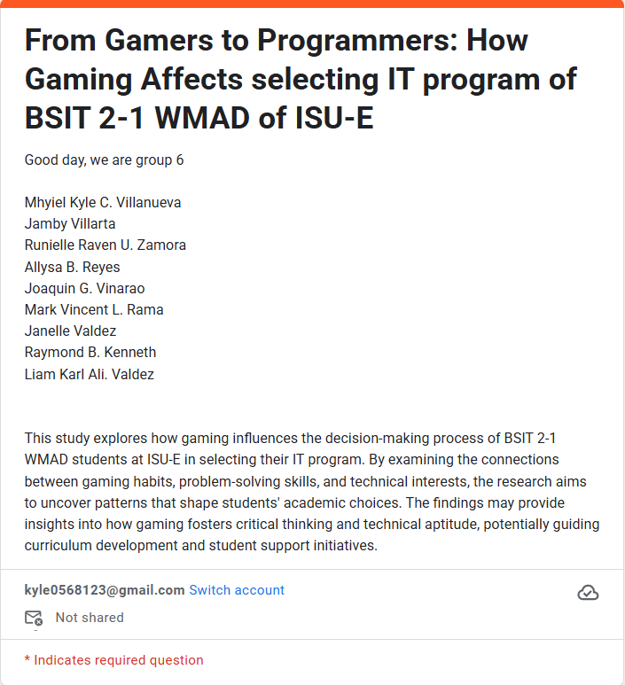

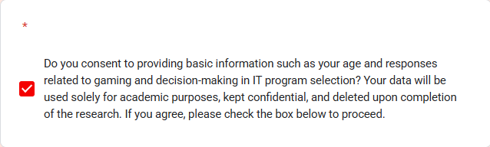

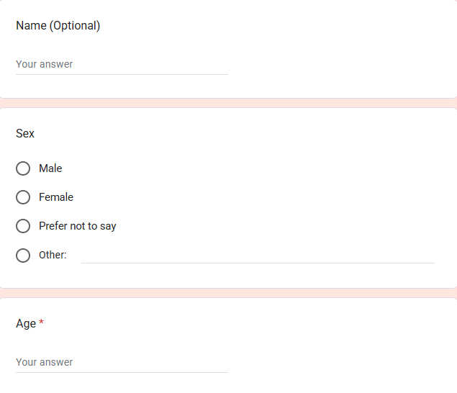

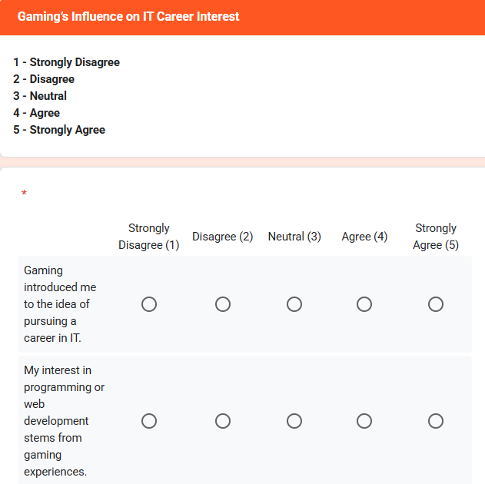

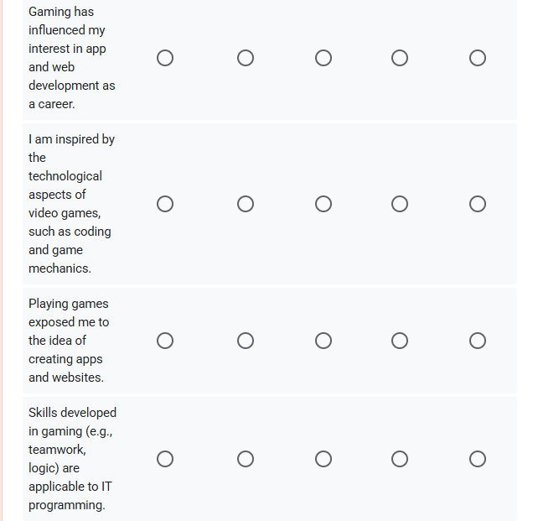

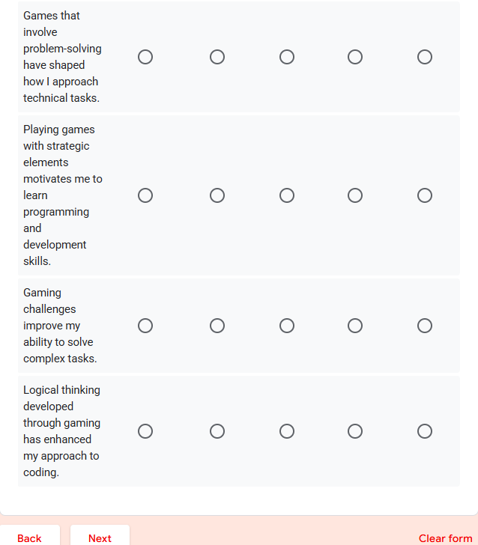

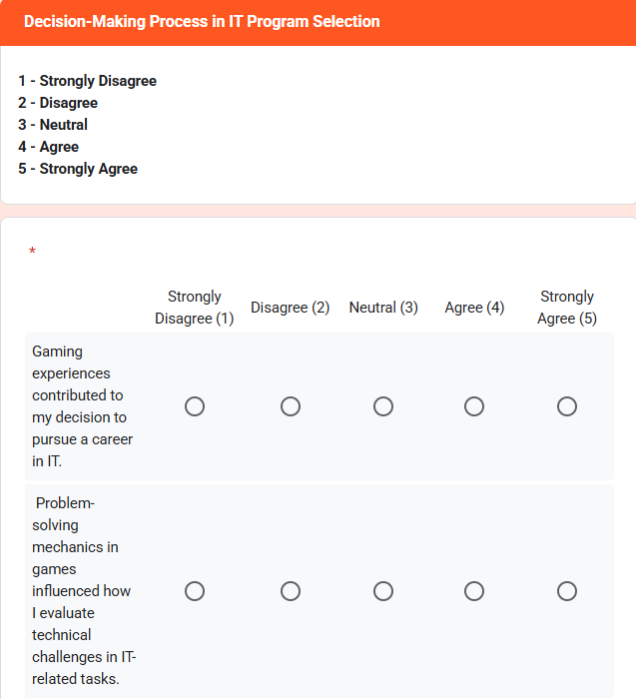

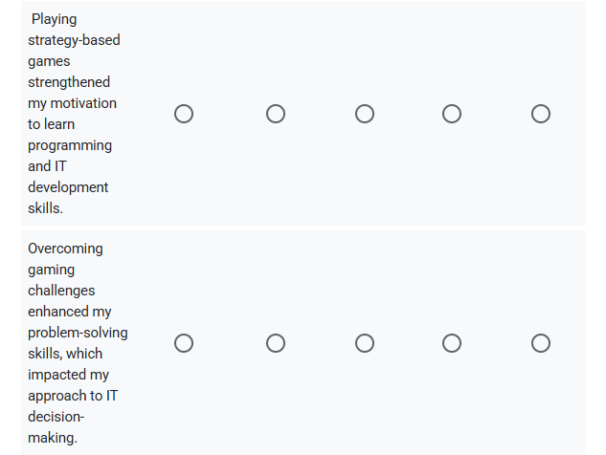

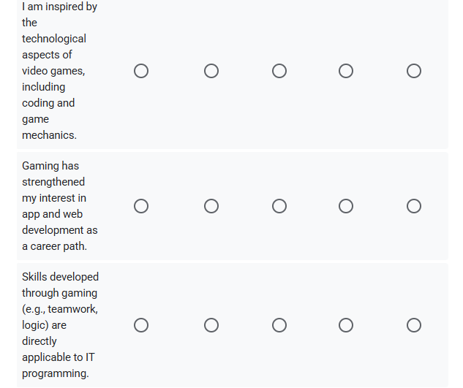

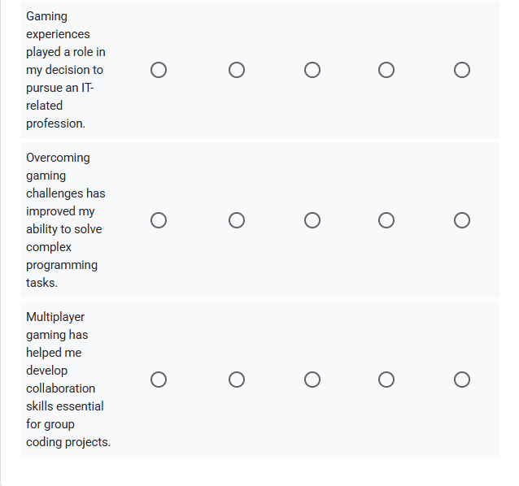

**ETHICAL CONSIDERATION**

Numerous ethical considerations were carefully addressed during the research process. To ensure that the respondents fully understood the study and could make an informed decision about their participation, the researchers provided them with detailed information about the study's purpose, its potential benefits, any associated risks, and the overall rationale behind the research. Informed consent was obtained from all respondents prior to their involvement. The researchers prioritized treating the respondents with respect, acknowledging them as individuals rather than mere subjects of study. Measures were taken to ensure the respondents' privacy and anonymity throughout the research. The findings of the study will be presented transparently, without bias, and will include all relevant facts to uphold academic integrity. Additionally, all sources utilized in the study will be properly cited and referenced to give due credit to the original authors and maintain respect for intellectual property. To safeguard the confidentiality of the respondents, their information will be securely destroyed once it is no longer needed or upon the study's completion. This ensures that no personal data can be reconstructed or misused.