# Image Separation

Download the datasets from Moodle. Each of the three datasets contain 26 examples named a-z. The images numbered 0 are the ones which you need to decompose. It contains the summation of 11 binary images (values 0-1, image type uint8). 10 out of 11 Images are present in the set of 20 given images, while the 11th is not. Find the 11th image and present it. Also, find which of the 20 images are blended in the ‘0’ image.

Example of Images you receive in a set:

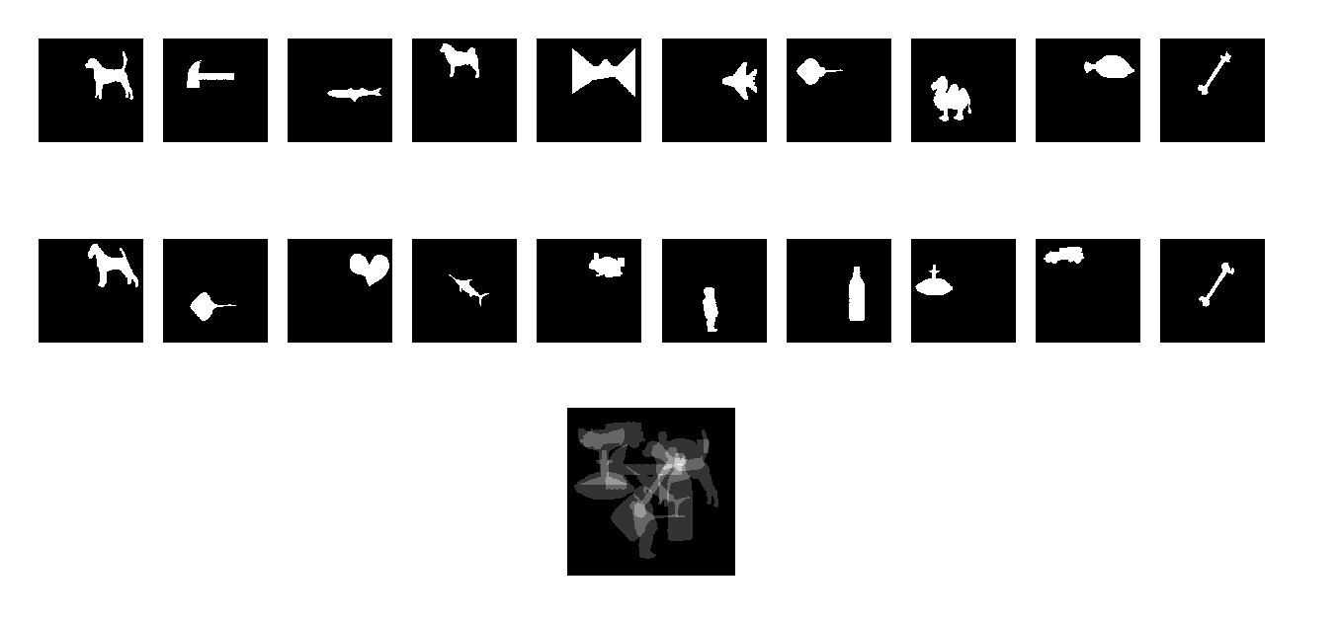

Example of what your algorithm should provide as a result:

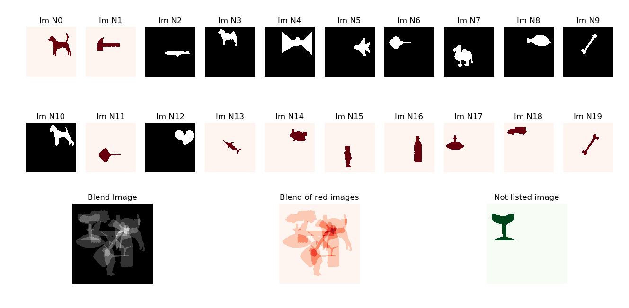

Red ones are the images which were blended in the ‘0’ image. The green one is the 11th blended image which is not present in the set of 20.