Consultancy Assessment Report

# Methodology and Assumptions

The consultancy assessment was conducted through a structured data pipeline designed to process, clean, merge, analyze, and visualize global health indicators, specifically related to Under-5 Mortality Rate (U5MR) status and population data. Below is a breakdown of the methodology followed, along with key assumptions and caveats:

- **Data Loading:** Three key datasets were used:  
 - U5MR status classification (on-track/off-track).  
 - World population prospects including birth projections.  
 - Global indicator estimates from the global data flow.  
 These files are expected to follow specific structural conventions, which are implicitly assumed during parsing.

- **Data Cleaning:**  
 - U5MR status labels were standardized (e.g., 'achieved', 'on track') and grouped under unified labels ('On-track' or 'Off-track').  
 - The global data flow required reformatting due to inconsistent headers and missing data entries. Rows with incomplete 'Geographic area' or 'Indicator' values were removed.  
 - Yearly data columns (e.g., 2022, 2021, etc.) were converted to numeric, treating '-' as missing (NaN).

- **Assumptions Made:**  
 - The most recent available estimate across years (2022–2018) is a valid proxy for current coverage.  
 - Population weight was based solely on the number of projected births, assuming it's a valid proxy for health service need.  
 - Country matching across datasets was assumed to be reliable using ISO3 codes and country names (e.g., 'ISO3Code' vs. 'OfficialName').

- **Merging Datasets:**  
 - Datasets were merged on country codes and names. Any mismatch or missing alignment (e.g., differing spellings) may lead to data loss.

- **Analysis and Visualization:**  
 - A population-weighted average coverage was computed for each combination of U5MR status and indicator.  
 - Visualization was done using a seaborn barplot with color-coded indicators and status categories.

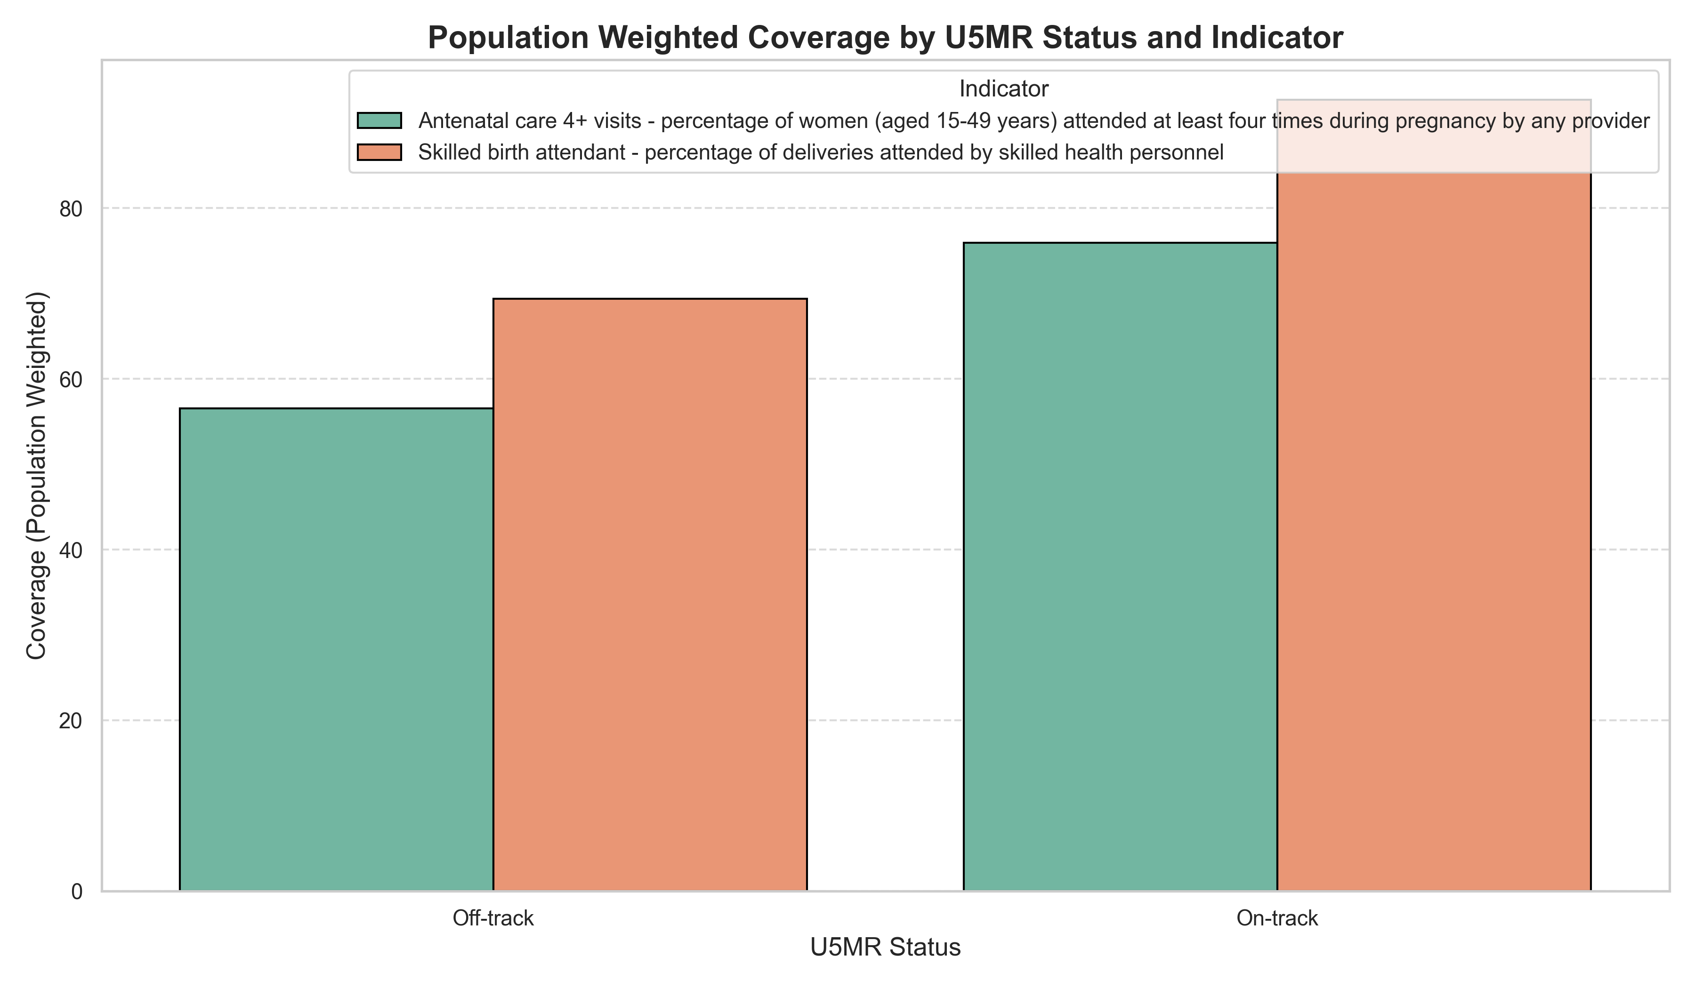

# Results Table

|  |  |  |
| --- | --- | --- |
| Status.U5MR | Indicator | PopulationWeightedCoverage |
| Off-track | Antenatal care 4+ visits - percentage of women (aged 15-49 years) attended at least four times during pregnancy by any provider | 56.52 |
| Off-track | Skilled birth attendant - percentage of deliveries attended by skilled health personnel | 69.38 |
| On-track | Antenatal care 4+ visits - percentage of women (aged 15-49 years) attended at least four times during pregnancy by any provider | 75.92 |
| On-track | Skilled birth attendant - percentage of deliveries attended by skilled health personnel | 92.72 |

The data indicates a clear improvement in maternal healthcare coverage from the off-track to on-track status. Specifically, the percentage of women receiving at least four antenatal care visits increased from 56.52% to 75.92%, while the proportion of deliveries attended by skilled health personnel rose from 69.38% to 92.72%. These improvements suggest significant progress in access to and utilization of essential maternal health services, which are critical for reducing maternal and newborn mortality rates.

Position I applied for: Household Survey Data Analyst Consultant - Req. #581656