CISP 41 Programming in C#

Project Evaluation Sheet
Student Name: __ Paola Socorro, Zixing Qiao, Qianqun Xu_______ Project Number: _____4__________
Project Name: ___Payroll Program 4_______ Visual Studio Version: _____2010______
Date Due: _______June 6, 2013________ Date Turned In: ________June 6th___
Above to be completed by student
Points ( ____ Possible)
Correctness/Efficiency:

Output is accurate ____________

Meets all requirements ____________

Provide appropriate user interface ____________

Logic is efficient ____________

Documentation/Coding Style:
Project can be open from the submitted zip file ____________

Folder is present and contains all necessary project files (no extra files) ____________

Use required coding template ____________

Use proper naming and spacing ____________

Submit all requested information ____________

Test Cases:

List all required test cases ____________

Provide output forms for important test cases ____________

Other issues: ____________

Extra Credit: ____________

Timeliness: ____________

Project Score:

CISP 41 Programming in C#

Project specification

***
- Database - made by Zixing Qiao.

- ReportClass, Paystub report, and w_report derived class - made by Qianqun Xu.

- Payroll Class, User Interface, Forms, Payroll_Form code, splashcreen, graphics - made by Paola Socorro.

- Note(s): Small changes made to Database to correct spelling errors, Originally also made code to read and gather data from datafiles, code was replaced by the use of a database. - both by PSocorro.
- Project database located: Payroll_Project04\Project4\Resources
***

This program should calculate the salary per month of a company's employees. It calculates both for employees paid per hour, and for those with a fixed salary regardless of hours.

The program deducts the cost for medical and dental benefits, life insurance, 401k account, and FSA.

It also takes into account taxes like, social security tax (10%), federal income tax(15%) and state income tax (5%).

for each employee the program also creates monthly pay stubs. as well as w-2's at the end of the year.

a database is used to keep record of the employees and their individual information like id number, name, pay per hour or salary and benefits. Etc.

The database has a master table for employee data, and a separate table to keep monthly data of hours worked.

Hours worked by salaried employees are for record keeping only. Their net pay is calculated, based on the gross monthly salary.

medical and dental benefits are deducted first, before tax deductions. Tax is based on the subsequent amount.

All commits available at GitHub
https://github.com/ZenRumi/Payroll_Project04

Limitations:
Program cannot place reports in a separate window for user view before printing.
All forms go to print preview at once.
program cannot create paystub per employee, one at a time. All are created at once, one after the other.
Program cannot update, change database in anyway.
cannot add employee, remove employee
cannot create reports for quarters.
program does not take into account the occasional switch of idnumber's position in month files. (possible error noticed but had no time to implement a solution. My idea was to search the array first and place values in the proper place according to id number position.)

CISP 41 Programming in C#

Project status

**Project processes all 12 months, produces pay stubs and w-2's for each employee. **

Updates from GitHub uploads:

May 20th

ZenRumi authored

May 21st
Testform is for my use not the final UI. Included data files.

May 30th
Changed UI,
Created standardForm
created payrollclass
added master file and monthly files to resources.
fixed flashscreen.
updated payroll form code: now reads master file and splits lines into
arrays for later use.

May 31st (database .mdf file and log file emailed to psocorro )
Jun02

ZenRumi authored
must attach database to SQL SERVER 2008 or above.
connection name should be: project4dataConnectionString.
database located in resources folder.

June 03
Program now processes each month selected in the combobox.

June 04 (reports code emailed to PSocorro Monday June 3rd)
W-2 and Paystub reports done by Joe added in.

June 5th (9th commit)
reports implement. User will now be able to print pay stubs and w-2s at
the end of the year.

CISP 41 Programming in C#

Sketch of user interface

Splash Screen.
Graphic: Designed by Paola Socorro. Hexaform Inc.


Main form

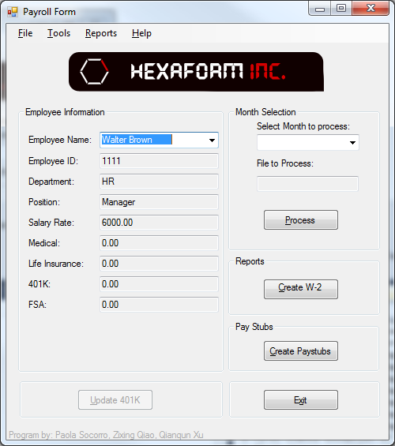

About Form.
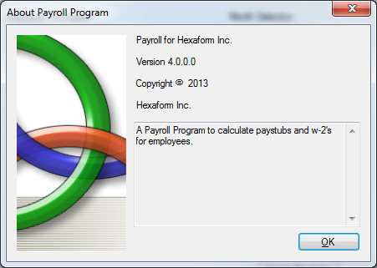

CISP 41 Programming in C#

Objects and Properties Plan for ___________Form
Object | Property | Setting
pictureBox1 | InitialImage | Project4.Properties.Resources.hexaformLogo
label1 | Text | Program by: Paola Socorro, Zixing Qiao, Qianqun Xu
StandardForm | Size  StartPosition  Text | 500, 385  CenterScreen  StandardForm
menuStrip1 | Size  Text | 484,24  menuStrip1
Payroll_Form: StandardForm | MainMenuStrip  Size | menuStrip1  500,565
employee_NameLabel1 | Name | Employee Name
employeeIDLabel | Name | Employee ID
departmentLabel | Name | Department
positionLabel | Name | Position
salary_RateLabel | Name | Salary Rate
medicalLabel | Name | Medical
life_InsuranceLabel | Name | Life Insurance
_401KLabel | Name | 401K
fSALabel | Name | FSA
employee_NameComboBox | DataSource  DisplayMember | master_TransactionsBindingSource  Employee Name
EmployeeIDTextBox | ReadOnly | True
DepartmentTextBox | ReadOnly | True
PositionTextBox | ReadOnly | True
salary_RateTextBox | ReadOnly | True
MedicalTextBox | ReadOnly | True
life_InsuranceTextBox | ReadOnly | True
_401KTextBox | ReadOnly | True
fSATextBox | ReadOnly | True
monthsComboBox | Name | monthsComboBox
processingTextBox | Name  ReadOnly | processingTextBox  True
processButton | Name  Text | processButton  &Process
reportButton | Name  Text | reportButton  &Create W-2
checksButton | Name  Text | ChecksButton  &Create Paystubs
EXITbutton | Name  Text | EXITbutton  E&xit
update401kButton | Name  Text  Enabled | update401kButton  &Update 401K  False
masterTransactionsBindingSource | DataMember  DataSource | Master_Transactions  project4dataDataSetBindingSource
master_TransactionsTableAdapter | ClearBeforeFill | True
jan_TransactionsBindingSource (through dec) | DataMember  DataSource | Jan_Transactions (through Dec)  project4dataDataSet
jan_TransactionsTableAdapter (through dec) | ClearBeforeFill | True
project4dataDataSet | DataSetName  SchemaSerialization | project4dataDataSet  IncludeSchema
printDocument1 | Name | printDocument1
printPreviewDialog1 | Name | printPreviewDialog1

CISP 41 Programming in C#

Event Plan for ___________Form
Object | Event | Action - Pseudocode
processButton | processButton_Click | Try: dataRowReaderMonth()  Catch: IndexOutOfRangeException
reportButton  w2ReportToolStripMenuItem_Click | w2ReportToolStripMenuItem_Click | checkForMonthProcess();  if allMonthsProcessBool==true  for loop go through employeeID array  if index in employeeID array is not null  create w-2 to print preview  else  break;
checksButton  monthlyPayStubsToolStripMenuItem_Click | monthlyPayStubsToolStripMenuItem_Click | Same as report button  Creat paystub report instead.
EXITbutton | EXITbutton_Click | Close the form
update401kButton | None | none
aboutToolStripMenuItem | aboutToolStripMenuItem_Click | Open about form
PayrollClass |  | Business class that does the payroll calculations and deductions.
Report |  | Report class that handles creating different reports(base class)
PaystubReport |  | Handles creating paystubs to print preview
W_2Report:Report |  | Inherits from Report. Handles creating w-2 to print preview

Class diagram

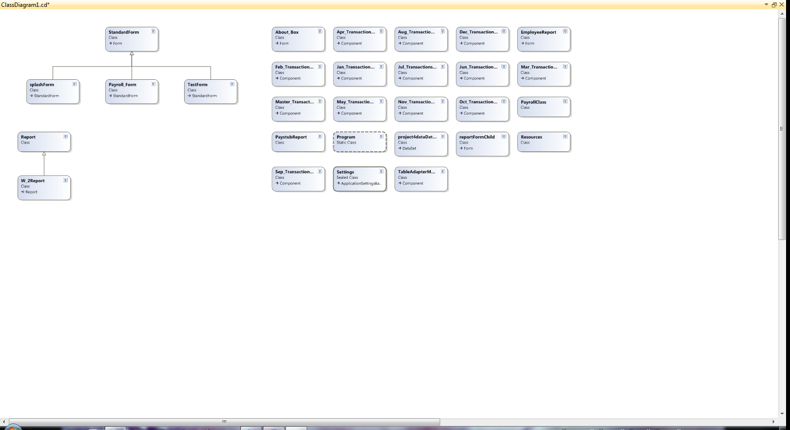

Sample of database created

by Zixing Qiao

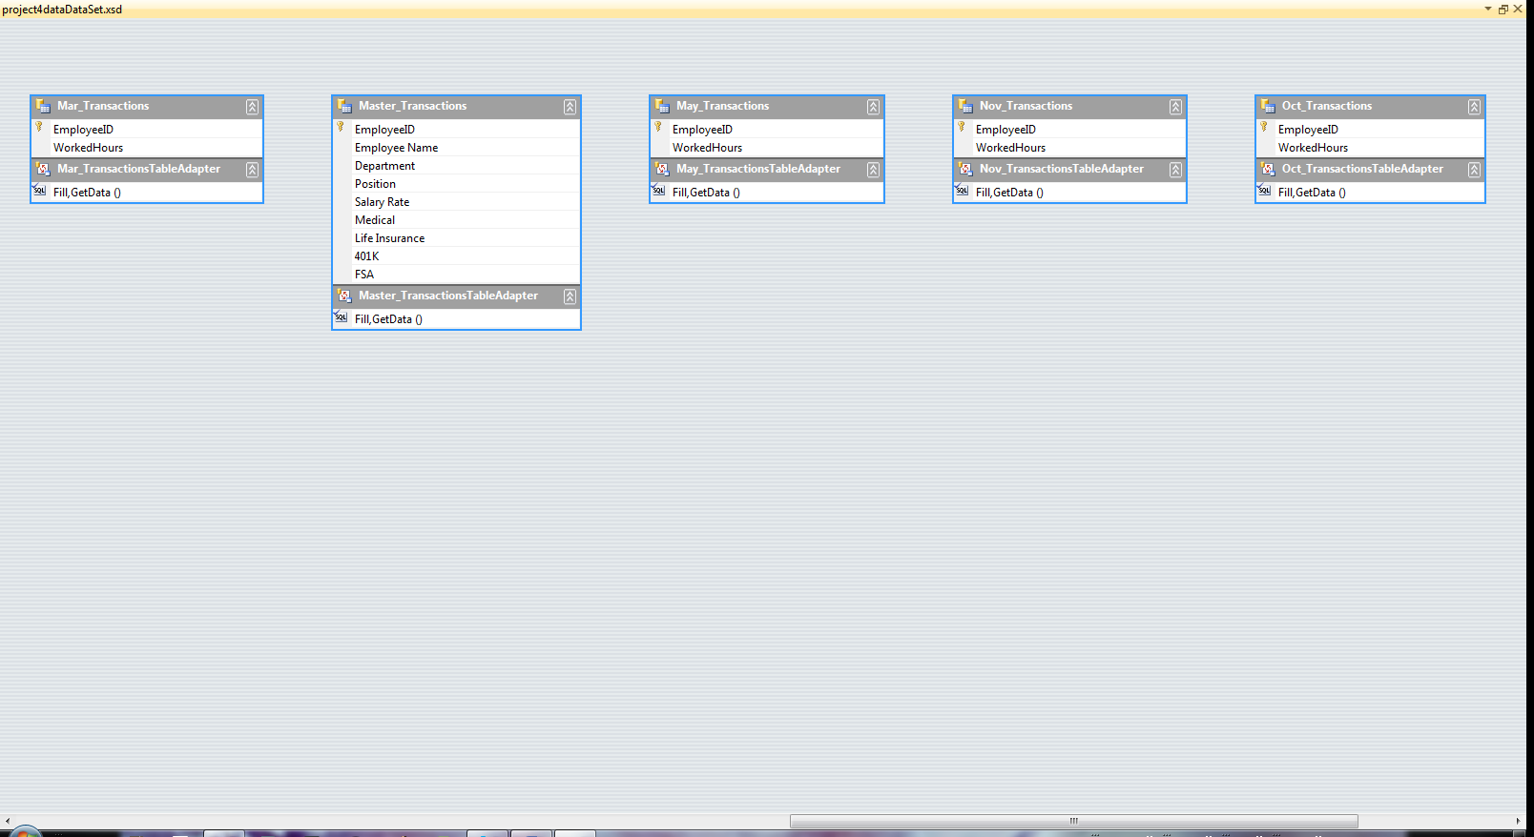

CISP 41 Programming in C#

Test cases and captured screens

Payroll Form:
Contains employee information for individual viewing.
(originally intended to update 401k, add and remove employee. features not implemented yet)

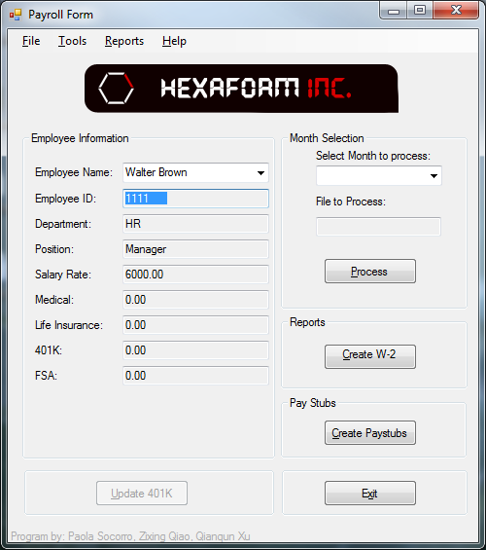

Select Month to process from drop down menu.
Process month desired to create paystubs for.

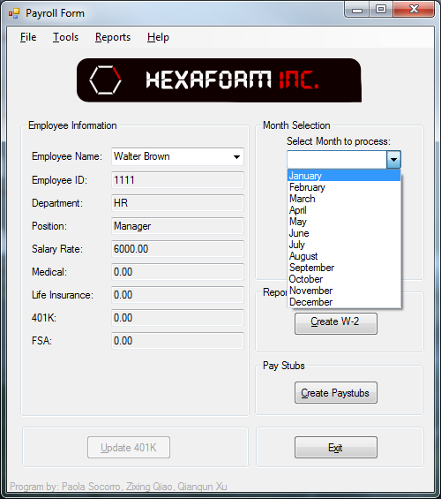

no month selected brings up message box
no processing takes place until month is selected.
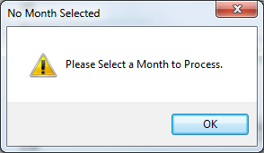

Time to create paystubs for the month processed.
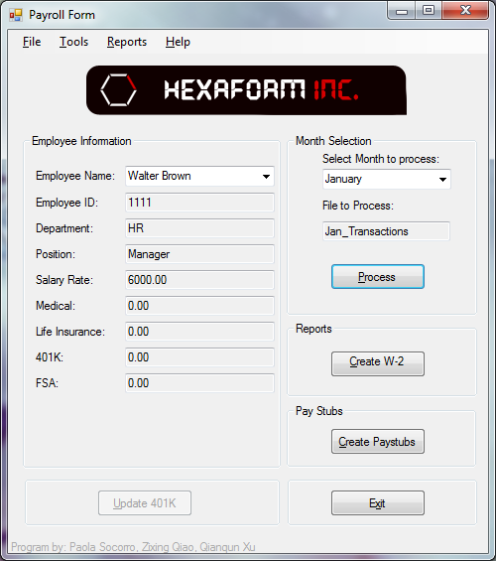
if no month has been processed yet
message box appears.
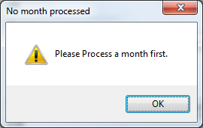

Paystubs are created and go directly to print preview
one print preview per paystub.
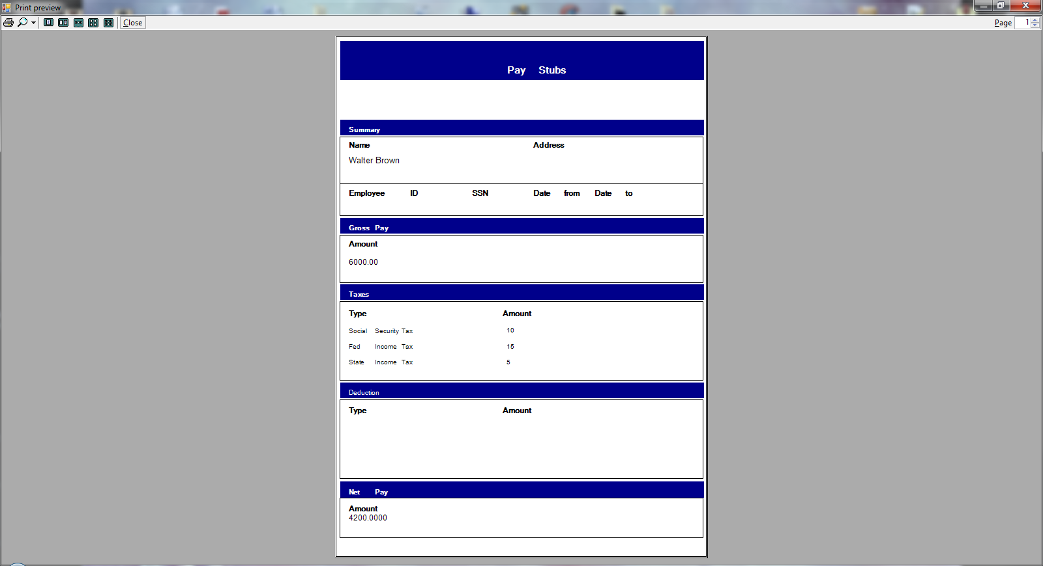

If user attempts to create w-2 now an error message comes up
message comes up as long as there is a month not processed.
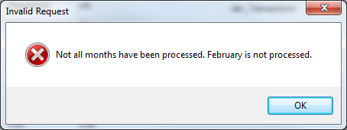
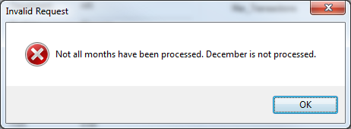

Once all months are processed
w-2 is created to the print preview.
one per employee.

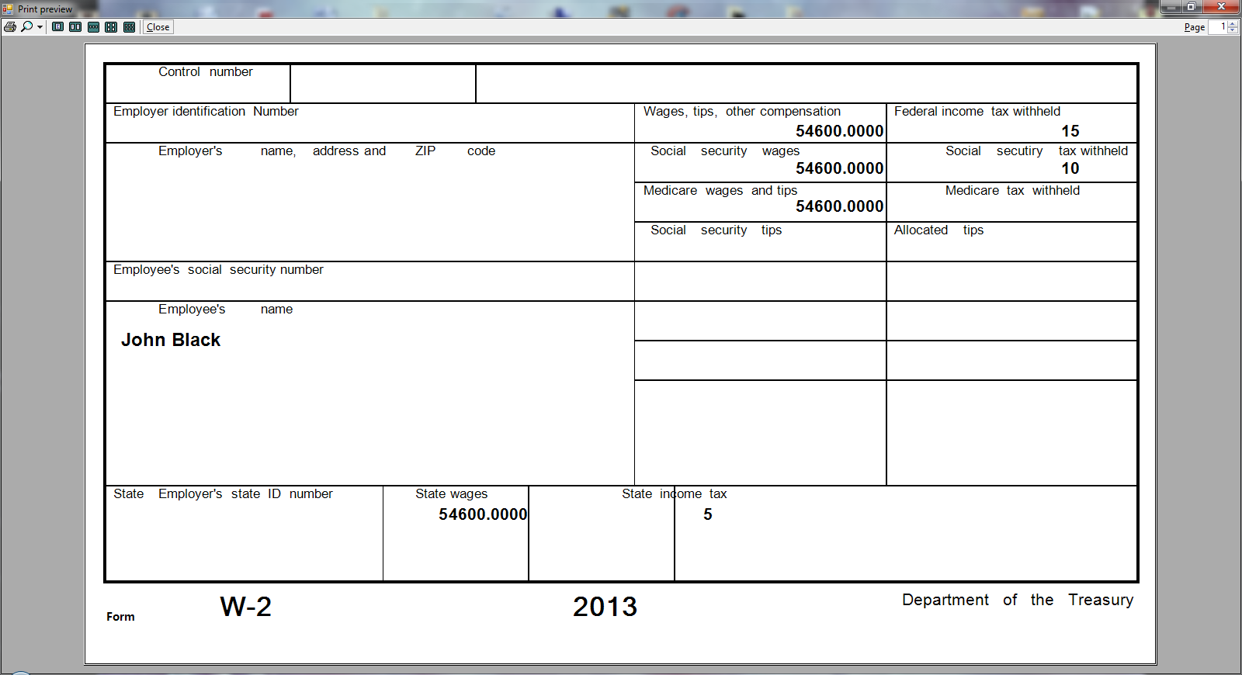

Both reports can be accessed through the menu.

our about form

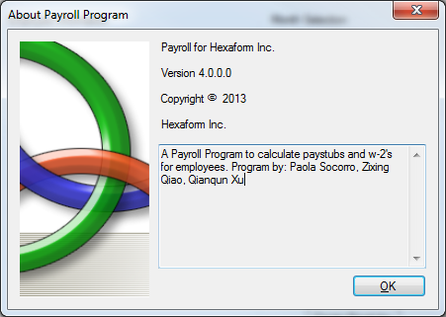

CISP 41 Programming in C#

Source code

Main Form - by Paola Socorro
/* Program: Payroll Project 4
Author: Paola Socorro (for this PayrollClass)
Class: CISP 41
Date: May 18 2013
Description: The business part of the payroll program that handles user input, as well as calculations.

I certify that the code below is my own work.

Exception(s): Database - made by Zixing Qiao. ReportClass, Paystub report, and w_report derived class - made by Qianqun Xu.
* Payroll Class, User Interface, Forms, Payroll_Form code, splashcreen, graphics - made by Paola Socorro.
*
* Note(s): Small changes made to Database to correct spelling errors,
* Originally also made code to read and gather data from datafiles, code was replaced by the use of a database. - both by PSocorro.

*/

using System;
using System.Collections.Generic;
using System.ComponentModel;
using System.Data;
using System.Drawing;
using System.Linq;
using System.Text;
using System.Windows.Forms;
using System.IO;

namespace Project4
{
public partial class Payroll_Form : StandardForm
{
//
//CODE by Paola Socorro
//

PayrollClass aPayroll = new PayrollClass();

const int MAXIMUM_EMPLOYEEINT =20;

string[] months = { "January", "February", "March", "April", "May", "June", "July", "August", "September", "October", "November", "December" };
string[] monthlyData = { "Jan_Transactions", "Feb_Transactions", "Mar_Transactions", "Apr_Transactions", "May_Transactions", "Jun_Transactions", "Jul_Transactions", "Aug_Transactions", "Sep_Transactions", "Oct_Transactions", "Nov_Transactions", "Dec_Transactions" };
string[] isMonthProcess = { "no", "no", "no", "no", "no", "no", "no", "no", "no", "no", "no", "no" };
string monthToProcess;
bool allMonthsProcessedBool=false;
string[] employeeIdArray= new string[MAXIMUM_EMPLOYEEINT];
decimal[] eNetPay = new decimal[MAXIMUM_EMPLOYEEINT];
decimal[] eGrossPay = new decimal[MAXIMUM_EMPLOYEEINT];
decimal[] eDeductedTax = new decimal[MAXIMUM_EMPLOYEEINT];
decimal[] w2TotalPay = new decimal[MAXIMUM_EMPLOYEEINT];

decimal socialSecurityTaxDec = 10;
decimal fedIncomeTaxDec = 15;
decimal stateIncomeTaxDec = 5;

string idNumber;
string nameLastname;
string departmentString;
string positionString;
decimal rateDec;
decimal monthlySalaryDec; //just for salary employees
decimal benefitsDec; //medical and dental benefits both into one.
decimal lifeInsur;
decimal savings401K; // not to be confused with FSA
decimal fsa;

decimal hoursWorked;

public Payroll_Form()
{
InitializeComponent();
}

private void EXITbutton_Click(object sender, EventArgs e)
{
this.Close();
}
//
//Loads the months array into the combobox.
//
private void Payroll_Form_Load(object sender, EventArgs e)
{
// TODO: This line of code loads data into the 'project4dataDataSet1.Dec_Transactions' table. You can move, or remove it, as needed.
this.dec_TransactionsTableAdapter.Fill(this.project4dataDataSet.Dec_Transactions);
// TODO: This line of code loads data into the 'project4dataDataSet1.Nov_Transactions' table. You can move, or remove it, as needed.
this.nov_TransactionsTableAdapter.Fill(this.project4dataDataSet.Nov_Transactions);
// TODO: This line of code loads data into the 'project4dataDataSet1.Oct_Transactions' table. You can move, or remove it, as needed.
this.oct_TransactionsTableAdapter.Fill(this.project4dataDataSet.Oct_Transactions);
// TODO: This line of code loads data into the 'project4dataDataSet1.Sep_Transactions' table. You can move, or remove it, as needed.
this.sep_TransactionsTableAdapter.Fill(this.project4dataDataSet.Sep_Transactions);
// TODO: This line of code loads data into the 'project4dataDataSet1.Aug_Transactions' table. You can move, or remove it, as needed.
this.aug_TransactionsTableAdapter.Fill(this.project4dataDataSet.Aug_Transactions);
// TODO: This line of code loads data into the 'project4dataDataSet1.Jul_Transactions' table. You can move, or remove it, as needed.
this.jul_TransactionsTableAdapter.Fill(this.project4dataDataSet.Jul_Transactions);
// TODO: This line of code loads data into the 'project4dataDataSet1.Jun_Transactions' table. You can move, or remove it, as needed.
this.jun_TransactionsTableAdapter.Fill(this.project4dataDataSet.Jun_Transactions);
// TODO: This line of code loads data into the 'project4dataDataSet1.May_Transactions' table. You can move, or remove it, as needed.
this.may_TransactionsTableAdapter.Fill(this.project4dataDataSet.May_Transactions);
// TODO: This line of code loads data into the 'project4dataDataSet1.Apr_Transactions' table. You can move, or remove it, as needed.
this.apr_TransactionsTableAdapter.Fill(this.project4dataDataSet.Apr_Transactions);
// TODO: This line of code loads data into the 'project4dataDataSet1.Mar_Transactions' table. You can move, or remove it, as needed.
this.mar_TransactionsTableAdapter.Fill(this.project4dataDataSet.Mar_Transactions);
// TODO: This line of code loads data into the 'project4dataDataSet1.Feb_Transactions' table. You can move, or remove it, as needed.
this.feb_TransactionsTableAdapter.Fill(this.project4dataDataSet.Feb_Transactions);
// TODO: This line of code loads data into the 'project4dataDataSet.Master_Transactions' table. You can move, or remove it, as needed.
this.master_TransactionsTableAdapter.Fill(this.project4dataDataSet.Master_Transactions);
// TODO: This line of code loads data into the 'project4dataDataSet.Master_Transactions' table. You can move, or remove it, as needed.
this.master_TransactionsTableAdapter.Fill(this.project4dataDataSet.Master_Transactions);

this.jan_TransactionsTableAdapter.Fill(this.project4dataDataSet.Jan_Transactions);
//
//FILL employeeIdArray at runtime.
//
populateIdArray();
Console.WriteLine("array filled");
for (int i = 0; i < months.Length; i++)
{
monthsComboBox.Items.Add(months[i]);
}

}
//
//DISPLAYS file to be processed to the user. Assigns selected index to variable.
//
private void monthsComboBox_SelectedIndexChanged(object sender, EventArgs e)
{
processingTextBox.Text = monthlyData[monthsComboBox.SelectedIndex];
monthToProcess = monthlyData[monthsComboBox.SelectedIndex];
//Console.WriteLine("To process: " + monthlyData[monthsComboBox.SelectedIndex].ToString());
}
//
//READ DATA FROM MASTER TABLE.
//Places each row of data into variables.
//
private void populateIdArray()
{
int counter =0;
foreach (DataRow row in project4dataDataSet.Master_Transactions.Rows)
{
string idNum = row["EmployeeID"].ToString();
idNum = idNum.Replace(" ", null);//removing spaces in string
employeeIdArray[counter] = idNum;
counter++;
}
}
//
//Reads employee information from Master_transactions.
//Places data in apropriate variables.
//
private void dataRowReaderMaster()
{
foreach (DataRow row in project4dataDataSet.Master_Transactions.Rows)
{
string idNum = row["EmployeeID"].ToString();
idNum = idNum.Replace(" ", null);//removing spaces in string
if (idNum == idNumber)
{
nameLastname = row["Employee Name"].ToString();
//nameLastname = nameLastname.Replace(" ", null);
departmentString = row["Department"].ToString();
positionString = row["Position"].ToString();
positionString = positionString.Replace(" ", null);//removing spaces in string
rateDec = decimal.Parse(row["Salary Rate"].ToString());
benefitsDec = decimal.Parse(row["Medical"].ToString());
lifeInsur = decimal.Parse(row["Life Insurance"].ToString());
savings401K = decimal.Parse(row["401k"].ToString());
fsa = decimal.Parse(row["FSA"].ToString());
}
}

//
//Compares position to check if its Manager or Engineer.
//Manger is used, due to error in database values for one employee. Cindy Red.
//
if (positionString == "Manager" || positionString == "Engineer" || positionString == "Manger")
{
monthlySalaryDec = rateDec;
rateDec = 0;
// Console.WriteLine("done" + monthlySalaryDec.ToString() + " set");
}

}

private void dataRowReaderMonth()
{

//processingTextBox.Text = monthlyData[monthsComboBox.SelectedIndex];
//monthToProcess = monthlyData[monthsComboBox.SelectedIndex];

int counter =0;
//int monthCounter = 0;
string tName; // name of the stable.
//string month = monthlyData[counter];
int tableCount= monthsComboBox.SelectedIndex;

foreach (DataTable table in project4dataDataSet.Tables)
{
if (table.TableName.ToString() == monthlyData[tableCount])
{
tName = table.TableName;
Console.WriteLine(monthlyData[tableCount].ToString() + "\n");
foreach (DataRow row in table.Rows)
{
idNumber = row["EmployeeID"].ToString();
idNumber = idNumber.Replace(" ", null);//removing spaces in string
hoursWorked = decimal.Parse(row["WorkedHours"].ToString());
dataRowReaderMaster();
calcEmployeePay(counter);
//Console.WriteLine("Data Read for month of "+ months[counter].ToString());
Console.WriteLine("One Employee done: " + nameLastname.ToString() + " id: " + idNumber.ToString() + " hours worked: " + hoursWorked.ToString());
counter++;

}
isMonthProcess[tableCount] = "yes";
}

}

}

private void findEmployeeInData()
{
int counter = 0;
string tName; // name of the stable.
int tableCount = monthsComboBox.SelectedIndex;

foreach (DataTable table in project4dataDataSet.Tables)
{
if (table.TableName.ToString() == monthlyData[tableCount])
{
tName = table.TableName;
Console.WriteLine(monthlyData[tableCount].ToString() + "\n");
foreach (DataRow row in table.Rows)
{
idNumber = row["EmployeeID"].ToString();
idNumber = idNumber.Replace(" ", null);//removing spaces in string
dataRowReaderMaster();
counter++;

}

}

}
}//Not used ran out of time. It was supposed to find an employee in the database, to output w-2 and paystubs correctly, and per person.

private void calcEmployeePay(int step)
{
if (positionString == "Manager" || positionString == "Engineer" || positionString == "Manger")
{

eGrossPay[step] = aPayroll.grossPaySalary(monthlySalaryDec);

}
else
{
eGrossPay[step] = aPayroll.grossPay(rateDec, hoursWorked);

}
aPayroll.deductionPay(benefitsDec, lifeInsur, savings401K, fsa);
eDeductedTax[step] = aPayroll.mandatoryTaxDeductions();
eNetPay[step] = aPayroll.netPayCalc();
w2TotalPay[step] += eNetPay[step];
//Console.WriteLine("inside calcEmployeePay");
}

private void processButton_Click(object sender, EventArgs e)
{
//dataRowReaderMaster();
//dataRowReaderMonth();
try
{
dataRowReaderMonth();
Console.WriteLine("done");
}
catch (IndexOutOfRangeException)
{
MessageBox.Show("Please Select a Month to Process.","No Month Selected",MessageBoxButtons.OK,MessageBoxIcon.Exclamation);

}

}

private void testFormToolStripMenuItem_Click(object sender, EventArgs e)
{
TestForm myTestForm = new TestForm();
myTestForm.ShowDialog();
}

private void aboutToolStripMenuItem_Click(object sender, EventArgs e)
{
About_Box myAboutForm = new About_Box();
myAboutForm.ShowDialog();
}

private void w2ReportToolStripMenuItem_Click(object sender, EventArgs e)
{
checkForMonthProcess();
if (allMonthsProcessedBool == true)
{
for (int i = 0; i < employeeIdArray.Length; i++)
{
if (employeeIdArray[i] != null)
{
W_2Report aW_2 = new W_2Report(nameLastname,w2TotalPay[i], socialSecurityTaxDec, fedIncomeTaxDec, stateIncomeTaxDec);
}
else
{
break;
}
}
}

}

private void monthlyPayStubsToolStripMenuItem_Click(object sender, EventArgs e)
{
if (monthsComboBox.SelectedIndex > -1)
{
for (int i = 0; i < employeeIdArray.Length; i++)
{
if (employeeIdArray[i] != null)
{
idNumber = employeeIdArray[i];
dataRowReaderMaster();
PaystubReport aPSReport = new PaystubReport(nameLastname, eGrossPay[i], socialSecurityTaxDec, fedIncomeTaxDec, stateIncomeTaxDec, eNetPay[i]);
}
else
{
break;
}
}
}
else
{
MessageBox.Show("Please Process a month first.", "No month processed", MessageBoxButtons.OK, MessageBoxIcon.Exclamation);
}

}

private void checkForMonthProcess()
{
for (int step = 0; step < isMonthProcess.Length; step++)
{
allMonthsProcessedBool = true;
if (isMonthProcess[step] == "no")
{
allMonthsProcessedBool = false;
MessageBox.Show("Not all months have been processed. " + months[step].ToString() + " is not processed.", "Invalid Request", MessageBoxButtons.OK, MessageBoxIcon.Error);
break;

}
}

}

}
}

Payroll Class - Paola Socorro
/* Program: Payroll Project 4
Author: Paola Socorro (for this PayrollClass)
Class: CISP 41
Date: May 18 2013
Description: This Class is will calculate payroll for salaried employees and hourly employees.

I certify that the code below is my own work.

Exception(s): N/A

*/

using System;
using System.Collections.Generic;
using System.Linq;
using System.Text;

namespace Project4
{
class PayrollClass
{
//MANDATORY
public const decimal SOCIAL_SECURITY_TAX = .10M;
public const decimal FEDERAL_INCOME_TAX = .15M;
public const decimal STATE_INCOME_TAX = .05M;

//GROSS AND NET PAY
protected decimal grossPayDecimal;
protected decimal netPayDecimal;
protected decimal deductedTaxes;

public PayrollClass()
{

}

public decimal grossPay(decimal rate, decimal hours)
{
grossPayDecimal = rate * hours;
return grossPayDecimal;
}

public decimal grossPaySalary(decimal salary)
{
grossPayDecimal = salary;
return grossPayDecimal;
}

//TO BE CALCULATED BEFORE TAXES.
public decimal deductionPay(decimal benefitsMedDen, decimal lifeInsurance, decimal save401K, decimal fsa)
{
netPayDecimal = grossPayDecimal - (benefitsMedDen+ lifeInsurance + save401K + fsa);
return netPayDecimal;
}

//TO BE CALCULATED AFTER deductionPay()
public decimal mandatoryTaxDeductions()
{
deductedTaxes= netPayDecimal * (SOCIAL_SECURITY_TAX + FEDERAL_INCOME_TAX + STATE_INCOME_TAX);
return deductedTaxes;
}

public decimal netPayCalc()
{
netPayDecimal = netPayDecimal - deductedTaxes;
return netPayDecimal;
}

//Stop contribution of 401k to 15,000
public decimal stop401k(decimal contribution401k)
{
return contribution401k;
}

}
}

Report Class by Qianqun Xu
/* Program: Report Class
Author: Qianqun Xu
Class: CISP 41
Date:
Description: Handles reports program

I certify that the code below is my own work.

Exception(s): N/A

*/

using System;
using System.Collections.Generic;
using System.Linq;
using System.Text;
using System.Windows.Forms;

namespace Project4
{
class Report
{

protected string nameString;
protected decimal wagesDecimal, socialSecurityTaxDecimal, fedIncomeTaxDecimal, stateIncomeTaxDecimal;

public string Name
{
get { return nameString; }
set { nameString = value; }
}
public decimal Wages
{
get { return wagesDecimal; }
set { wagesDecimal = value; }
}
public decimal SocialSecurityTax
{
get { return socialSecurityTaxDecimal; }
set { socialSecurityTaxDecimal = value; }
}
public decimal FedIncomeTax
{
get { return fedIncomeTaxDecimal; }
set { fedIncomeTaxDecimal = value; }
}
public decimal StateIncomeTax
{
get { return stateIncomeTaxDecimal; }
set { stateIncomeTaxDecimal = value; }
}

public Report(string nameString, decimal wagesDecimal, decimal socialSecurityTaxDecimal,decimal fedIncomeTaxDecimal, decimal stateIncomeTaxDecimal)
{
Name = nameString; Wages = wagesDecimal;
SocialSecurityTax = socialSecurityTaxDecimal;
FedIncomeTax = fedIncomeTaxDecimal;
StateIncomeTax = stateIncomeTaxDecimal;
printReport();
}

public virtual void printReport()
{

}

}
}

/* Program: Paystub Report Class
Author: Qianqun Xu
Class: CISP 41
Date:
Description: Handles reports pay stubs in derived classess.

I certify that the code below is my own work.

Exception(s): N/A

*/

using System;
using System.Collections.Generic;
using System.Linq;
using System.Text;
using System.Drawing;
using System.Drawing.Printing;
using System.Windows.Forms;
using System.ComponentModel;

namespace Project4
{
class PaystubReport
{
private string nameString;
private int monthInterger;
private decimal grossPayDecimal, socialSecurityTaxDecimal, fedIncomeTaxDecimal, stateIncomeTaxDecimal, netPayDecimal;

public string Name
{
get { return nameString; }
set { nameString = value; }
}
public int Month
{
get { return monthInterger; }
set { monthInterger = value; }
}
public decimal GrossPay
{
get { return grossPayDecimal; }
set { grossPayDecimal = value; }
}
public decimal SocialSecurityTax
{
get { return socialSecurityTaxDecimal; }
set { socialSecurityTaxDecimal = value; }
}
public decimal FedIncomeTax
{
get { return fedIncomeTaxDecimal; }
set { fedIncomeTaxDecimal = value; }
}
public decimal StateIncomeTax
{
get { return stateIncomeTaxDecimal; }
set { stateIncomeTaxDecimal = value; }
}
public decimal NetPay
{
get { return netPayDecimal; }
set { netPayDecimal = value; }
}

public PaystubReport(string nameString, decimal grossPayDecimal, decimal socialSecurityTaxDecimal,decimal fedIncomeTaxDecimal, decimal stateIncomeTaxDecimal, decimal netPayDecimal)
{

Name = nameString;
GrossPay = grossPayDecimal;
SocialSecurityTax = socialSecurityTaxDecimal;
FedIncomeTax = fedIncomeTaxDecimal;
StateIncomeTax = stateIncomeTaxDecimal;
NetPay = netPayDecimal;
printReport();
}

public void printReport()
{

PrintPreviewDialog PrintPreviewDialog1 = new PrintPreviewDialog();
PaperSize paperSize = new PaperSize("DataOrder", 470, 660);
PrintDocument Report = new PrintDocument();
Report.DefaultPageSettings.PaperSize = paperSize;
PrintPreviewDialog1.Document = Report;
Report.PrintPage += new PrintPageEventHandler(Report_PrintPage);
PrintPreviewDialog1.FormBorderStyle = FormBorderStyle.Fixed3D;
PrintPreviewDialog1.ShowDialog();
}

public void Report_PrintPage(object sender,System.Drawing.Printing.PrintPageEventArgs e)
{

float hozPosFloat = 15.0f;
float verPosFoat = 15.0f;
float leftbianJu = 5;
float topbianJu = 5;

Pen line = new Pen(Color.Black, 1.0f);

//Draw frame and blue patches
e.Graphics.FillRectangle(Brushes.DarkBlue, leftbianJu, topbianJu, 461, 50);
e.Graphics.FillRectangle(Brushes.DarkBlue, leftbianJu, topbianJu + 100, 461,20);

e.Graphics.DrawRectangle(line, leftbianJu, topbianJu + 122, 460, 60);
e.Graphics.DrawRectangle(line, leftbianJu, topbianJu + 122, 460, 100);
e.Graphics.FillRectangle(Brushes.DarkBlue, leftbianJu, topbianJu + 225, 461,20);

e.Graphics.DrawRectangle(line, leftbianJu, topbianJu + 247, 460, 60);
e.Graphics.FillRectangle(Brushes.DarkBlue, leftbianJu, topbianJu + 309, 461,20);

e.Graphics.DrawRectangle(line, leftbianJu, topbianJu + 331, 460, 100);
e.Graphics.FillRectangle(Brushes.DarkBlue, leftbianJu, topbianJu + 434, 461,20);

e.Graphics.DrawRectangle(line, leftbianJu, topbianJu + 456, 460, 100);
e.Graphics.FillRectangle(Brushes.DarkBlue, leftbianJu, topbianJu + 560, 461,20);

e.Graphics.DrawRectangle(line, leftbianJu, topbianJu + 581, 460, 50);

//Paystubs, 2013,Fill the form with instructions
e.Graphics.DrawString("Pay Stubs", new Font("Kozuka Mincho Pro B", 9, FontStyle.Bold),
Brushes.White, hozPosFloat + 200, verPosFoat + 20);
e.Graphics.DrawString("Summary", new Font("Kozuka Mincho Pro B", 6, FontStyle.Bold),
Brushes.White, hozPosFloat, 112);

e.Graphics.DrawString("Name\t\t\t\t\t\tAddress", new Font("Kozuka Mincho Pro B", 7, FontStyle.Bold),
Brushes.Black, hozPosFloat, 131);
e.Graphics.DrawString("Employee ID\t\tSSN\t\tDate from\tDate to", new
Font("Kozuka Mincho Pro B", 7, FontStyle.Bold), Brushes.Black, hozPosFloat, 192);
e.Graphics.DrawString("Gross Pay", new Font("Kozuka Mincho Pro B", 6, FontStyle.Bold),
Brushes.White, hozPosFloat, 237);
e.Graphics.DrawString("Amount", new Font("Kozuka Mincho Pro B", 7, FontStyle.Bold),
Brushes.Black, hozPosFloat, 256);
e.Graphics.DrawString("Taxes", new Font("Kozuka Mincho Pro B", 6, FontStyle.Bold),
Brushes.White, hozPosFloat, 321);
e.Graphics.DrawString("Type\t\t\t\t\tAmount", new Font("Kozuka Mincho Pro B",
7, FontStyle.Bold),
Brushes.Black, hozPosFloat, 345);
e.Graphics.DrawString("Social Security Tax", new Font("Arial", 6, FontStyle.Regular),
Brushes.Black, hozPosFloat, 368);
e.Graphics.DrawString("Fed Income Tax", new Font("Arial", 6, FontStyle.Regular),
Brushes.Black, hozPosFloat, 388);
e.Graphics.DrawString("State Income Tax", new Font("Arial", 6, FontStyle.Regular),
Brushes.Black, hozPosFloat, 408);
e.Graphics.DrawString("Deduction", new Font("Kozuka Mincho Pro B", 6, FontStyle.Regular),
Brushes.White, hozPosFloat, 446);
e.Graphics.DrawString("Type\t\t\t\t\tAmount", new Font("Kozuka Mincho Pro B",
7, FontStyle.Bold),
Brushes.Black, hozPosFloat, 468);
e.Graphics.DrawString("Net Pay", new Font("Kozuka Mincho Pro B", 6, FontStyle.Bold),
Brushes.White, hozPosFloat, 572);
e.Graphics.DrawString("Amount", new Font("Kozuka Mincho Pro B", 7, FontStyle.Bold),
Brushes.Black, hozPosFloat, 592);

//Fill the blank with data
e.Graphics.DrawString(nameString, new Font("Arial", 8, FontStyle.Regular), Brushes.Black, hozPosFloat, 150);

e.Graphics.DrawString(grossPayDecimal.ToString(),new Font("Arial", 7, FontStyle.Regular), Brushes.Black, hozPosFloat, 280);

e.Graphics.DrawString(socialSecurityTaxDecimal.ToString() ,new Font("Arial", 6, FontStyle.Regular), Brushes.Black, hozPosFloat + 200,368);

e.Graphics.DrawString(fedIncomeTaxDecimal.ToString(),new Font("Arial", 6, FontStyle.Regular), Brushes.Black, hozPosFloat + 200,388);

e.Graphics.DrawString(stateIncomeTaxDecimal.ToString(),new Font("Arial", 6, FontStyle.Regular), Brushes.Black, hozPosFloat + 200,408);

e.Graphics.DrawString(netPayDecimal.ToString(),new Font("Arial", 7, FontStyle.Regular), Brushes.Black, hozPosFloat, 605);
}

}
}

/* Program: Derived W-2:Report Class
Author: Qianqun Xu
Class: CISP 41
Date:
Description: Handles reports for W-2 in derived classess.

I certify that the code below is my own work.

Exception(s): N/A

*/

using System;
using System.Collections.Generic;
using System.Linq;
using System.Text;
using System.Drawing;
using System.Drawing.Printing;
using System.Windows.Forms;
using System.ComponentModel;

namespace Project4
{
class W_2Report:Report
{

public W_2Report(string nameString, decimal wagesDecimal, decimal socialSecurityTaxDecimal,decimal fedIncomeTaxDecimal, decimal stateIncomeTaxDecimal)
:
base(nameString, wagesDecimal, socialSecurityTaxDecimal, fedIncomeTaxDecimal, stateIncomeTaxDecimal)
{
}

public override void printReport()
{

PrintPreviewDialog PrintPreviewDialog1 = new PrintPreviewDialog();
PaperSize paperSize = new PaperSize("DataOrder", 810, 470);
PrintDocument Report = new PrintDocument();
Report.DefaultPageSettings.PaperSize = paperSize;
PrintPreviewDialog1.Document = Report;
Report.PrintPage += new PrintPageEventHandler(Report_PrintPage);
PrintPreviewDialog1.FormBorderStyle = FormBorderStyle.Fixed3D;
PrintPreviewDialog1.ShowDialog();
}

public void Report_PrintPage(object sender,System.Drawing.Printing.PrintPageEventArgs e)
{

//draw a form

float hozPosFloat = 15.0f; float verPosFoat = 15.0f; float leftbianJu = 15; float topbianJu = 15;
float tableWidth = 780;
float tableHeight = 393;

Pen line = new Pen(Color.Black, 1.0f);
Pen wideLine = new Pen(Color.Black, 2.0f);

//Draw a Rectangle, the frame of the form

e.Graphics.DrawRectangle(wideLine, leftbianJu, topbianJu, tableWidth, tableHeight);

//Draw horizontal lines inside the table
e.Graphics.DrawLine(line, leftbianJu, topbianJu + 30, leftbianJu + tableWidth, topbianJu + 30);
e.Graphics.DrawLine(line, leftbianJu, topbianJu + 60, leftbianJu + tableWidth, topbianJu + 60);
e.Graphics.DrawLine(line, leftbianJu, topbianJu + 150, leftbianJu + tableWidth, topbianJu + 150);
e.Graphics.DrawLine(line, leftbianJu, topbianJu + 180, leftbianJu + tableWidth, topbianJu + 180);
e.Graphics.DrawLine(line, leftbianJu, topbianJu + 320, leftbianJu + tableWidth, topbianJu + 320);
e.Graphics.DrawLine(line, leftbianJu + 400, topbianJu + 90, leftbianJu +
tableWidth, topbianJu + 90);
e.Graphics.DrawLine(line, leftbianJu + 400, topbianJu + 120, leftbianJu +
tableWidth, topbianJu + 120);
e.Graphics.DrawLine(line, leftbianJu + 400, topbianJu + 210, leftbianJu +
tableWidth, topbianJu + 210);
e.Graphics.DrawLine(line, leftbianJu + 400, topbianJu + 240, leftbianJu +
tableWidth, topbianJu + 240);

//Draw vertical lines inside the table
e.Graphics.DrawLine(line, leftbianJu + 140, topbianJu, leftbianJu + 140, topbianJu + 30);
e.Graphics.DrawLine(line, leftbianJu + 280, topbianJu, leftbianJu + 280, topbianJu + 30);
e.Graphics.DrawLine(line, leftbianJu + 400, topbianJu + 30, leftbianJu + 400,

topbianJu + 320);
e.Graphics.DrawLine(line, leftbianJu + 590, topbianJu + 30, leftbianJu + 590, topbianJu + 320);
e.Graphics.DrawLine(line, leftbianJu + 210, topbianJu + 320, leftbianJu + 210, topbianJu + tableHeight);
e.Graphics.DrawLine(line, leftbianJu + 320, topbianJu + 320, leftbianJu + 320, topbianJu + tableHeight);
e.Graphics.DrawLine(line, leftbianJu + 430, topbianJu + 320, leftbianJu + 430, topbianJu + tableHeight);

//W-2, 2013
e.Graphics.DrawString("Form", new Font("Microsoft YaHei", 6, FontStyle.Bold), Brushes.Black, hozPosFloat, verPosFoat + 414);
e.Graphics.DrawString(" W-2", new Font("Microsoft YaHei", 15, FontStyle.Bold),
Brushes.Black, hozPosFloat, verPosFoat + 400);
e.Graphics.DrawString("2013", new Font("Kozuka Mincho Pro B", 15, FontStyle.Bold),
Brushes.Black, hozPosFloat + 350, verPosFoat + 400);
e.Graphics.DrawString("Department of the Treasury", new Font("Arial", 9, FontStyle.Regular),
Brushes.Black, hozPosFloat + 600, verPosFoat + 400);

//Fill the form with instructions
e.Graphics.DrawString(" Control number", new Font("Arial", 7, FontStyle.Regular),
Brushes.Black, hozPosFloat, verPosFoat + 1);
e.Graphics.DrawString(" Employer identification Number", new Font("Arial", 7, FontStyle.Regular),
Brushes.Black, hozPosFloat, verPosFoat + 31);
e.Graphics.DrawString(" Employer's name, address and ZIP code", new
Font("Arial", 7, FontStyle.Regular),
Brushes.Black, hozPosFloat, verPosFoat + 61);
e.Graphics.DrawString(" Employee's social security number", new Font("Arial",
7, FontStyle.Regular),
Brushes.Black, hozPosFloat, verPosFoat + 151);
e.Graphics.DrawString(" Employee's name", new Font("Arial", 7, FontStyle.Regular),
Brushes.Black, hozPosFloat, verPosFoat + 181);
e.Graphics.DrawString(" Wages, tips, other compensation\t\tFederal income tax withheld", new Font("Arial", 7, FontStyle.Regular),
Brushes.Black, hozPosFloat + 400, verPosFoat + 31);
e.Graphics.DrawString(" Social security wages\t\t\tSocial secutiry tax withheld", new Font("Arial", 7, FontStyle.Regular),

Brushes.Black, hozPosFloat + 400, verPosFoat + 61);
e.Graphics.DrawString(" Medicare wages and tips\t\t\tMedicare tax withheld", new Font("Arial", 7, FontStyle.Regular),
Brushes.Black, hozPosFloat + 400, verPosFoat + 91);
e.Graphics.DrawString(" Social security tips\t\t\tAllocated tips", new
Font("Arial", 7, FontStyle.Regular),
Brushes.Black, hozPosFloat + 400, verPosFoat + 121);
e.Graphics.DrawString(" State Employer's state ID number\t State wages\t\t State income tax", new Font("Arial", 7, FontStyle.Regular),
Brushes.Black, hozPosFloat, verPosFoat + 321);

//Fill the blank with data
e.Graphics.DrawString(Name, new Font("Arial", 10, FontStyle.Bold), Brushes.Black, hozPosFloat + 10, verPosFoat + 201); e.Graphics.DrawString(Wages.ToString() + "\n\n" + Wages.ToString() + "\n\n" +
Wages.ToString(),
new Font("Arial", 9, FontStyle.Bold),Brushes.Black, hozPosFloat + 520, verPosFoat + 44);
e.Graphics.DrawString(FedIncomeTax.ToString() + "\n\n" + SocialSecurityTax.ToString(),
new Font("Arial", 9, FontStyle.Bold), Brushes.Black, hozPosFloat + 720, verPosFoat + 44);
e.Graphics.DrawString(Wages.ToString() + "\t\t " + StateIncomeTax.ToString(),
new Font("Arial", 9, FontStyle.Bold), Brushes.Black, hozPosFloat + 250, verPosFoat + 335);

}

}
}

---
Program.cs
using System;
using System.Collections.Generic;
using System.Linq;
using System.Windows.Forms;

namespace Project4
{
static class Program
{
/// <summary>
/// The main entry point for the application.
/// </summary>
[STAThread]
static void Main()
{
Application.EnableVisualStyles();
Application.SetCompatibleTextRenderingDefault(false);
Application.Run(new splashForm());//psocorro
Application.Run(new Payroll_Form());
}
}
}

