KNXnet/IP Parser for Microsoft Network Monitor 3.3
Version 1.00.00

Author: Kent Filek
Rev: May 30, 2009

General
The KNXnet/IP parser is a script for the Microsoft Network Monitor Version 3.3 to parse and display network frames carrying KNXnet/IP and EMI messages.
The nice thing about NetMon is the possibility to modify or add parsers by editing simple script files using a text editor or directly within NetMon. No compiler needed.
The parser file contains two protocol parsers:
- EIBnetIP, based on UDP and active for frames with UPD port 3671.
Note: the parser named EIBnetIP largely represents the protocol KNXnet/IP but is not strictly bound it. KNXnet/IP is the IP protocol wrapper for the EIB bus messages.
Future versions may have different naming to better visualize the relation to KNXnet/IP.
- cEMI, based on EIBnetIP. Parses Link Layer Messages (L_...), Transport Layer Messages (T_...) and Application Layer Messages (A_...). Many Application Layer Messages are identified and displayed by name but corresponding parameters are not. cEMI (or EMI) is the protocol used by devices at the EIB bus to communicate with each other.
Further parameter parsing for Application Layer Messages will be implemented in a future version.
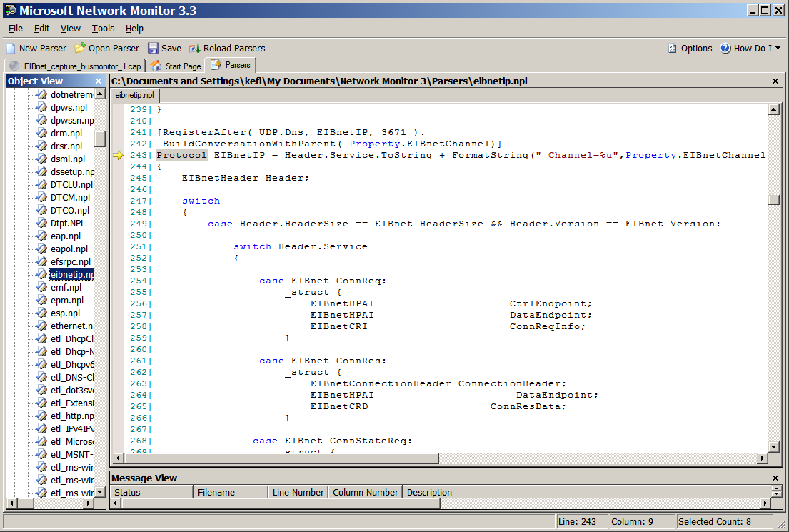

Installation
To install the parser simply copy the file eibnetip.npl into the directory
My Documents\Network Monitor 3\Parsers
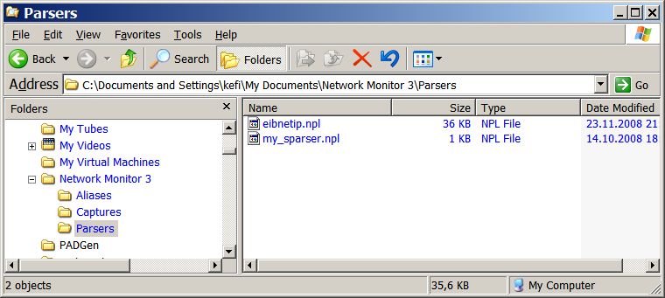
If there is no such directory create one.
There should also be a file my_sparser.npl located within this directory. If there is none, copy the file provided or create a new one. In any case assure the file my_sparser.npl contains an ‘include’ statement as shown in the screenshot below.
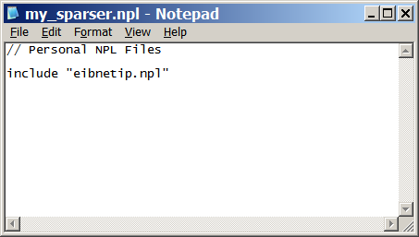

Example

