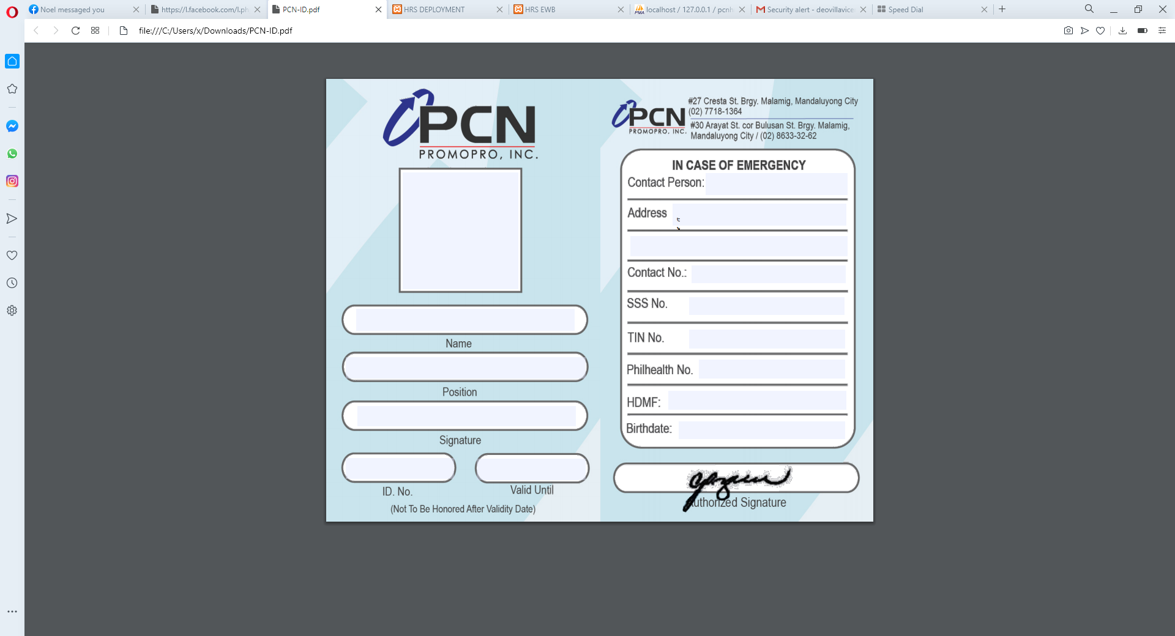${AreaImg}

**${foto}**

**324 e, Nanirahan st., brgy. Poblacion , Mandaluyong city**

**1979-05-11**

**pagibig**

**phealth**

**tin**

**sss**

**e num**

**e person**

**158, A DE GUZMAN**

**Warehouse / Traffic Coordinator (Warehouse Champion for BD1)**

**10/31/2020**

**123456**