Processor – GIS



**Export to XLSX User Guide**

Welcome to the Python XLSX geoprocessing tool project for ArcGIS. This is an open source project started by Processor-GIS to help geoprocessing workflows easily write data to .xlsx (Excel 2010) format. This document serves as a guide for using the tool. Please note that the tool requires an additional 3rd party library for Python called openpyxl. This library is not installed with ArcGIS or Python by default and must be installed separately. Please see our document titled openpyxl_Installation to accomplish this task.

**System Requirements**

ArcGIS 10.4+

Microsoft Excel 2010+

Python 2.7.12

openpyxl (Python library)

Python setuptools (Python library)

**Installation**

1. Download the ExportToXLSX.tbx file and the ExportToXLSX.py file. These files may be downloaded from the ArcGIS Code Sharing site or GitHub. The .tbx file is an ArcGIS Toolbox file and the .py file is the Python script file containing the Python code. It is recommended to store these two files in the same folder location because the ArcGIS Toolbox file is set to read the corresponding Python file in the same folder location. The following screenshot shows the downloaded files as they appear in File Explorer:

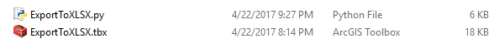

**Running the Tool**

1. In ArcCatalog or the Catalog window of ArcMap, navigate to the location of the downloaded .tbx and .py files. Please note that the .py file will not be visible in Catalog but the .tbx file will be expandable showing the interface of the tool. The Catalog view of the tool is shown below:



1. Open the Export to XLSX tool (under the .tbx file) by either double clicking or right-clicking the tool and choosing Open. The main user interface should open allowing input of tool parameters. If the user interface does not open, the path to the .py file will need to be set to its correct location. This can be accomplished by right-clicking the tool in Catalog and selecting Properties. Choose the Source tab and enter the correct path to the ExportToXLSX.py file as shown in the below screenshot.

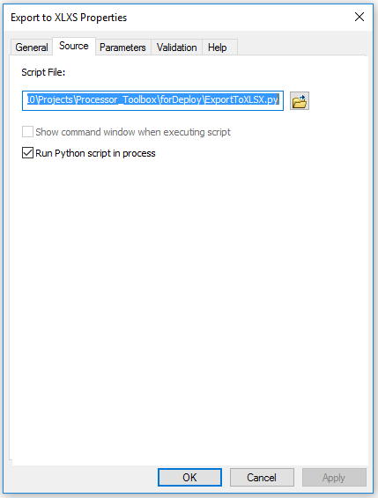

1. Enter required tool parameters as shown in the following screenshot.

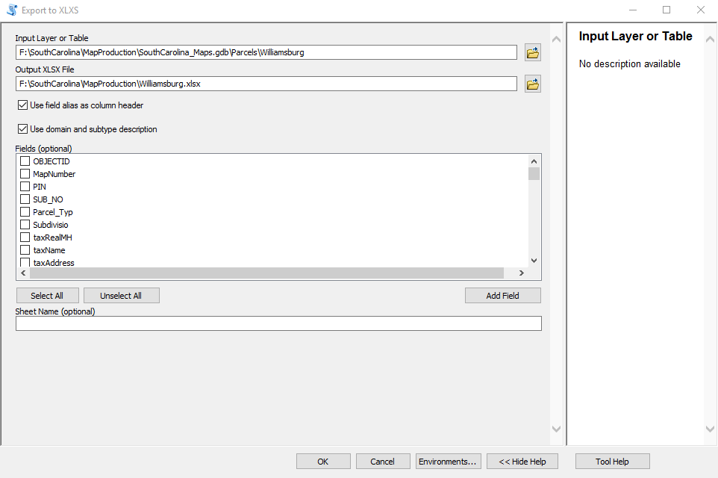

**Parameter Descriptions**

**Input Layer or Table:** Almost any data type that can display an attribute table in ArcMap or ArcCatalog may be used as input into the tool.

**Output XLSX File:** The name and location of the output XLSX file to be created. This parameter will automatically populate to the same folder location as the Input Layer or Table parameter above. The name of the XLSX file will be the same name as the Input Layer or Table by default. Both the output folder location and the XLSX file name may be modified as necessary.

**Use field alias as column header:** If field aliases are included in the input Layer or Table, the output XLSX file will use those values as column headers when checked.

**Use domain and subtype description:** If domains and or subtypes are included in Input Layer or Table, the output XLSX file will include the corresponding descriptions. If this box left unchecked, the codes will be written instead.

**Fields (optional):** If no fields are checked within the Fields box, the output XLSX file will include all fields contained in the Input Layer or Table. If a field(s) is checked, only those field checked will be written to the output XLSX file. Please note that if you are using this tool in ArcMap and have fields turned off in the layer properties, only those visible fields will be shown in the Fields box.

**Sheet Name (optional):** The name of the sheet containing the data in the output XLSX file. If no name is specified, the name of the Input Layer or Table will be used by default.

**Contact**

We would love to hear from you. Please contact us anytime.

[justin@processor-gis.com](mailto:justin@processor-gis.com)

<https://twitter.com/Processor_GIS>

<https://github.com/processor-gis>

785-979-8554 (cell)

913-725-0021 (fiber line)