Processor – GIS



**openpyxl Installation**

**Last Revision: 04/20/2017**

This document explains how to install the openpyxl library for Python, which allows Python developers to work with Microsoft Excel 2010 (.xlsx) file format. The document was written for installation on Windows 7 operating system and Python version 2.7.5. However, Windows 8 and Windows 10 are very similar in process. Therefore, this document may suffice for those operating systems as well. Documentation for openpyxl Python library may be found here:

<https://openpyxl.readthedocs.io/en/default/>

1. **Verify openpyxl installed**
   1. Open IDLE (Python GUI)
      1. click Start >> All Programs >> ArcGIS >> Python 2.7 >> IDLE (Python)
   2. Enter the following command in IDLE: import openpyxl
   3. If no error occurs, openpyxl is installed and no further action is required in this document. If an error occurs as shown in the below screenshot, proceed to the next step (2).

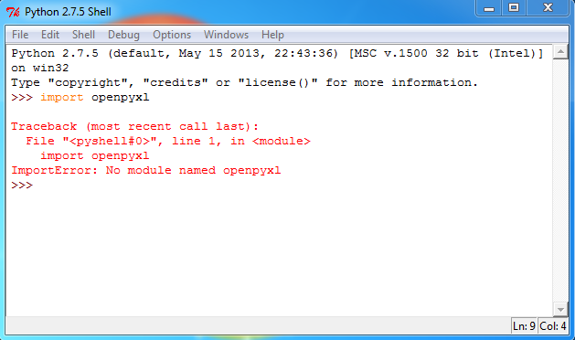

1. **Verify Python can be started from the Command Prompt (cmd)** – installation of openpyxl is performed through the Windows Command Prompt. Python must be able to be started from there.
   1. Open the Windows Command Prompt – click Start >> type cmd in the search box and press Enter.
   2. Enter the following command: python
   3. If the Python Interpreter starts inside the Command Prompt as shown below, proceed to step 3. If an error occurs, proceed with the next step (d).

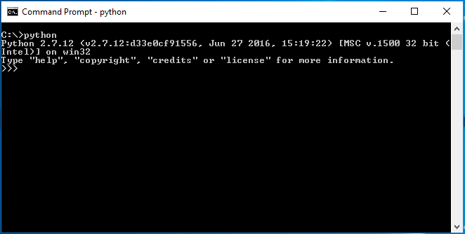

* 1. Add python.exe to PATH environmental variable. This allows you to start the Python Interpreter from the command prompt.
     1. Click Start >> right click Computer >> choose Properties (in Windows 8 or 10, open the File Explorer and right click on ‘This PC’, and choose Properties)
     2. Click Advanced system settings in the upper left portion of the screen. The System Properties dialog box Advanced tab appear as shown in the below screenshot.

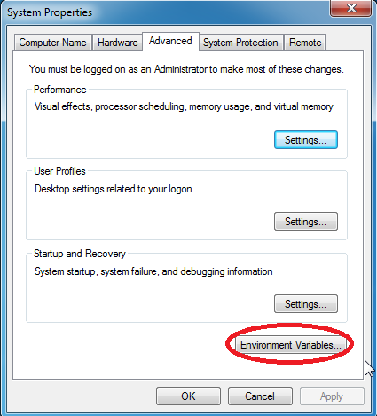

* + 1. Click the Environment Variables button
    2. In the Environment Variables dialog box, select Path and click the Edit button to open the Edit User Variable dialog box as shown in the below screenshot.

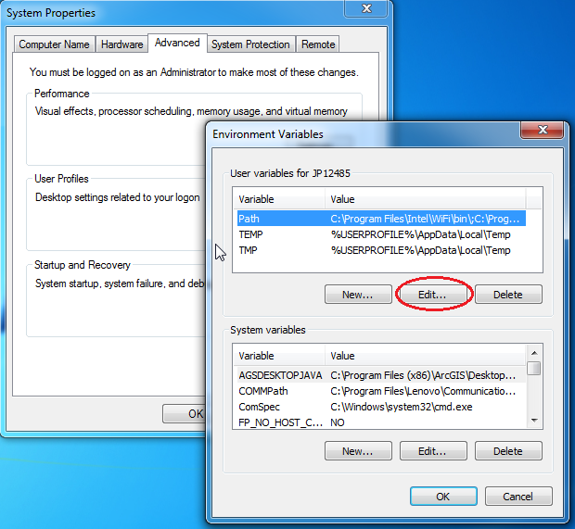

* + 1. Edit the Variable value in the Edit User Variable dialog box:

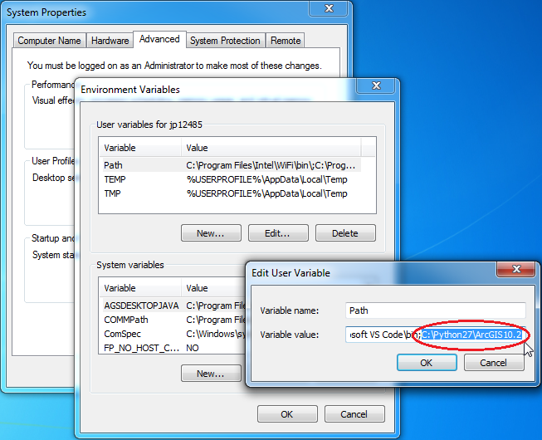

In the Variable value text, enter the path (only the path) to the python.exe file after the last semi-column (;). Depending on your version of ArcGIS and Python, this path could be somewhat different. In most cases, Python is installed when you install ArcGIS and will be in a folder path similar to the above screenshot (C:\Python27\ArcGIS10.2). Verify on your PC that there is a python.exe in the folder path you enter into the Variable value text box.

* + 1. Click OK on the Edit User Variable dialog and all preceding dialog boxes.
    2. Open the Windows Command Prompt again and enter python. The Python interpreter should open as shown in the following screenshot:

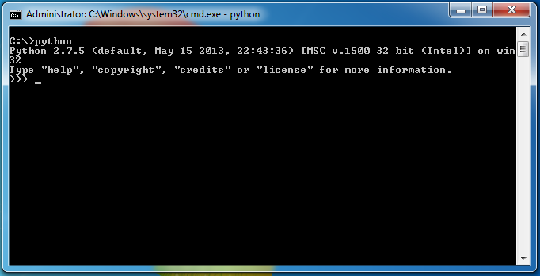

**3. Verify Python Setup Tools are installed (prerequisite for openpyxl installation)**

1. In Python IDLE, enter the following command: import setuptools
2. If no Error occurs, Python setuptools are installed and you may proceed to the final step 5. Otherwise proceed to step 4 below.
3. **Install Python Setup Tools** – Python setup tools are a required prerequisite to install the openpyxl library as well as other 3rd party Python libraries.
   1. Access the following URL: <https://pypi.python.org/pypi/setuptools>
      1. Scroll to the bottom of the page till you see the download files (right below Code of Conduct). Click on setuptools-26.0.0.zip to begin downloading.
      2. The zip file may be downloaded to any location. However, placing it on your Desktop can make things more convenient.
      3. Right click the zip file and extract it (choose Extract Here option). A new folder will appear containing installation files and folders.
      4. Open the Windows Command Prompt (cmd) and change the directory to the location of the unzipped file. Use the ‘cd’ command as shown in the following screenshot:

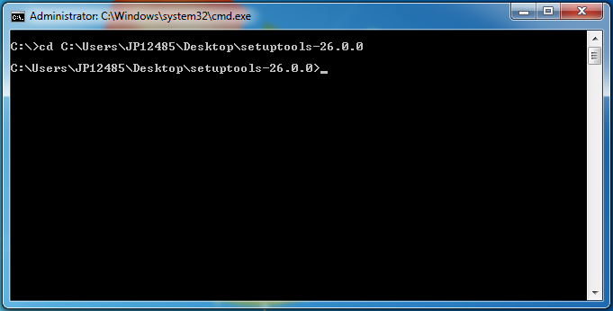

* + 1. Enter following command: python setup.py install
    2. The following screenshot shows the result of a successful installation:

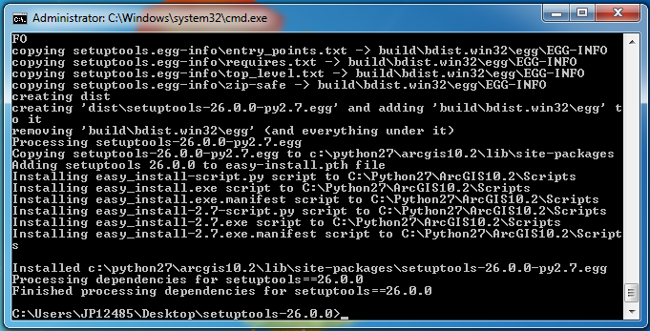

The downloaded installation files for Python setuptools may be deleted after a successful installation.

1. **Install openpyxl**
   1. Access the following URL: <https://pypi.python.org/pypi/openpyxl>
   2. Download openpyxl-2.4.0-b1.tar.gz file
   3. Extract the downloaded file to a location on your PC
      1. If prompted to decompress to a temporary folder and open it, choose Yes.
   4. Open the Windows Command Prompt (cmd) by clicking Start, and typing cmd into the Search box.
   5. Change the directory in the Command Prompt using the ‘cd’ command to the location of the openpyxl-2.4.0-b1 folder that was extracted from the downloaded zip file.

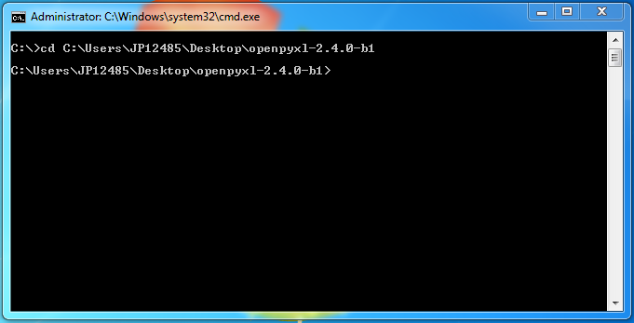

* 1. Enter the following command: python setup.py install

The following screenshot shows the result of a successful installation:

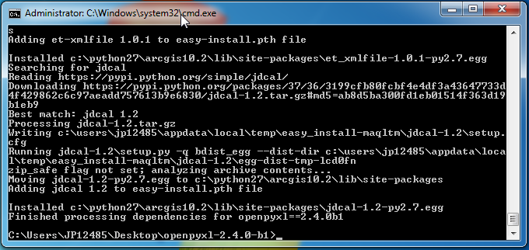

Installation may be verified by entering ‘import openpyxl’ in the Python Interpreter (IDLE). If no error occurs, openpyxl has been successfully installed.

The downloaded zip file and extracted files for openpyxl may be deleted after a successful installation.

**Contact**

We would love to hear from you. Please contact us anytime.

[justin@processor-gis.com](mailto:justin@processor-gis.com)

<https://twitter.com/Processor_GIS>

<https://github.com/processor-gis>

785-979-8554 (cell)

913-725-0021 (fiber line)