Online Auction Haray

**Online Auction & Auction Style**

Online auctions are auctions held over the internet. There are several types of formats for these online auctions such as:

* English auctions
  + Most common type of auction
  + Bids are announced by the bidders and the winners pay what they bid
  + It is usually an ascending bid auction (Starts from small bids and gets higher till a winner is established)
  + Bids are open for everyone to see
  + The winner is the highest bidder
* Dutch auctions
  + Dutch auctions are the opposite of english auctions
  + The price begins high and then starts to lower until someone accepts the offer
* First-price sealed-bid
  + Bidders are only allowed to make one private offer
  + Highest bid wins
* Reverse auction
  + In the reverse auction, the roles are reversed in a sense where there are multiple sellers that are competing to obtain a buyers business.
* Bidding fee auction
  + Also known as the penny auction
  + It is similar to the english auction
  + Bidders must pay a fee for every bid they make
  + So bidders may spend a lot of money without winning the item.

Online auctions usually have no physical limitations and targets audiences all over the world. The auctions may include business to business (B2B), business to consumer (B2C), and consumer to consumer (C2C) auctions.

The most used and relatable online auction that people are used to and feel comfortable bidding on is the Auction-Style Listing, sellers name a starting price and you bid against other buyers. You can watch the item to see how the bidding is going. When the listing ends, the highest bidder wins the item and completes the purchase. But on the other hand there is a strong commitment to this auction type a bid is considered a binding contract. That means that when you bid on an item, you're committing to buy it if you win.

**User Experience**

User experience is how a person feels when interacting with a system. This includes a website, mobile application, desktop software and basically any form of human/device interaction. It's sure enough important because it tries to fulfill the user’s needs. It aims to provide positive experiences that keep a user loyal to the product or brand our in our case the auction website. Additionally, a meaningful user experience allows you to define customer journeys on your product that are most conducive to business success.

A Simple friendly user interface website that includes a search bar for the products in the website, Categories for the products to sort and group the different types of products, a Carting System to add products that the customer selects, check out tab to finalize the purchase, a personal information section so the customer can add his personal information including his username and password and address, The homepage will be equipped with banners for deals and advertisements,in the header of the website the logo will be a home button, the footer will be the policy, about us and FaQ , Customer supporting system with live chat for maximum instant customer care and Finally Secured connection so the customer feels safe sharing his personal information.

**Item Policy**

Online auctions tend to impose item policies to keep their businesses running legally without breaking any laws. These item policies would allow others to know the websites return policies and what types of products are banned within the website. A lot of common items that aren’t allowed to be sold in many online auctions are firearms, illegal substances, and stolen goods. Item policies can also make sure a buyer has received their product within a certain time frame.

**Payment Methods**

When you're selling, remember that not all payment methods will provide the same level of buyer confidence. It’s important to consider the buyer’s perspective when selecting typical payment options.

Buyers’ questions about payment methods include:

* Is it traceable and is there proof of payment?
* Is it fast and convenient?
* How secure is it?
* What is the liability coverage in case something goes wrong?

**Types of payments and their description:**

1. **Wire Transfers**

Also known as bank transfer, buyers deposit payment directly into the seller's bank account either online or at most banks. Harray recommends using this option as a safe method of payment for domestic transactions.

1. **PayPal**

Harray recommends using this option as a fast, secure and convenient method of payment for all of your international transactions. When you list your item with PayPal, your buyers can securely pay you online without ever sharing their financial information.

1. **Cash On Delivery (C.O.D)**

Payment of the item is received at the time of delivery. The buyer can choose to pay by cash, depending on what form of payment the delivery service accepts, or if the seller personally delivers the item. This option is also applicable for meetups between buyer and seller.

**Revenue Model**

Online auctions may get their revenue from insertion fees, commissions, advertisement, and membership plans. For a customer to put his product up for sale, an insertion fee must be paid. The price of this fee can depend on the product’s type and priority level chosen within the website (e.g. front page) As for the commission fee, many online auctions take a small percentage of the sale when a product is sold and use that as their main type of income. Online auctions is also a great place for advertisements, they usually have slots open for advertisements within their website (e.g. banners). Lastly, online auctions may have membership plans that give their subscribers certain benefits like discounts or the ability to put their products up for sale without an insertion fee.

**Accounting**

When it comes to accounting and bookkeeping auction websites usually keep track of these things in a database like there annual profits/losses including a per account/user sales recording. Companies also have monthly, quarterly, and annual reports of their financial reports. And there are many types of accounting here are some:

* Financial Accounting
  + Involves recording and classifying business transactions, and preparing and presenting financial statements to be used by internal and external users
* Managerial Accounting
  + Focuses on providing information for use by internal users, the management
  + This branch deals with the needs of the management rather than strict compliance with generally accepted accounting principles
* Cost Accounting
  + Cost accounting refers to the recording, presentation, and analysis of manufacturing costs
  + Very useful in manufacturing businesses since they have the most complicated costing process
* Auditing
  + Refers to the examination of financial statements by an independent party with the purpose of expressing an opinion as to fairness of presentation and compliance with GAAP
  + Focuses on evaluating the adequacy of a company's internal control structure by testing segregation of duties, policies and procedures, degrees of authorization, and other controls implemented by management
* Accounting Information Systems
  + (AIS) involves the development, installation, implementation, and monitoring of accounting procedures and systems used in the accounting process
  + Includes the employment of business forms, accounting personnel direction, and software management
* Fiduciary Accounting
  + Involves handling of accounts managed by a person entrusted with the custody and management of property of or for the benefit of another person
  + Examples include trust accounting, receivership, and estate accounting

**Customer Database**

In the customer database of online auctions, the information stored includes all the necessary information that would allow a user to purchase and sell products. Information such as: name, phone number, email address, mailing address, username, password, and lastly the option to save credit card information.

if we gather information about specific traits or attributes of our customers, then we can look for similarities and satisfy the needs of large groups of customers. Such information should be gathered at every touch point between customer and business, And with this type of information Harray can take strategic actions regarding the services and the products to show or provide to each customer based on their preference and [appreciat](https://www.thesaurus.com/browse/appreciate)ion.

The data contained in the Harray database will build a pattern of how customers purchase. By understanding purchasing habits, Harray can increase sales of products and services upon these patterns.

**Analytics**

As for analysing data the employees (managers) will have a dashboard like (Klipfolio, geckoboard, databox) are all websites that gives you analytics about your page that are filled with statistics about our page views, new and unique or old viewer also page views per visitor and from where our visitors are coming from. That's for the website but auctions sites have a lot of other analytics data that depend on the user/account of those signs in the website like percentage of genders, ages, countries and most/least/average sales per bidders or auctioneers. These analytical reports that consist of descriptive, predictive and prescriptive analysis will help the managers with decision making.

**Recommendation System**

Online Auction websites will keep track of a customer’s viewing and purchase history. Then the system will recommend related and relevant products based on the customer’s history. And some websites even ask you to join or subscribe using your email to receive news about new or related products, Recommendation engines are basically data filtering tools that make use of algorithms and data to recommend the most relevant items to a particular user. There are two major types of recommendation systems.

Type Of Recommendation Systems:

* **Content-based recommendation systems**: they recommend based on product attributes.

Content-based recommendation systems are recommendation systems that use their knowledge of each product to recommend new products.

* **Collaborative filtering**: they recommend based on similar users

Collaborative filtering systems make recommendations only based on how users rated products in the past, not based on anything about the products themselves.

Recommendation systems play an important role in helping users find products and content they care about.

**Requirements Determination**

Haray.com is an online auction that allows people to create a free account and sell or buy products. It uses an English style based auction where the bids are announced by the bidders and winners pay what they bid for. The auction is also an ascending bid where bids are open for everyone to see. The auction also includes business to business (B2B), business to consumer (B2C), and consumer to consumer (C2C) auctions.

**User Registration (New Users)**

In Haray.com, a user should be able to access the website and create an account. Within the account creation, the user will be asked to enter his:

* Name
* Username
* Password
* Phone
* Email
* Address
* Date of birth

*A unique user ID will be assigned to the user by the system upon registration.*

**Existing User**

If a user already has an existing account in Haray.com, he will be able to sign in. When signing in, he will be asked to enter:

* Username
* Password

Existing Users may also:

* Edit their personal information
* View all of their bid history
* View their purchase history
* View and manage their products as well as accept bids

**Searching Products**

Users in Haray.com may search for products using the search bar. Users may also filter the searches by:

* Product name
* Price range
* Product type
* Condition

**Selling Products**

Any user can put an item up for auction. When putting an item up for auction, the user will be asked to enter information about the item. Information such as:

* Product Name
* Type
* Description
* Condition (New or used)
* Starting Price
* Quantity
* Photo
* Accepted Payment Methods
* Shipping Locations
* Target Price (Optional)
* Size (Optional)
* Weight (Optional)
* Color (Optional)
* Time limit (Optional)

*A unique product ID will be assigned to the product by the system upon adding a product.*

**Buying Products**

Any registered user may also bid on products. When placing a bid, the system will take note of:

* Price
* Feedback / comment / rate the product after you win the bid

*A unique bidding ID will be assigned to the product by the system upon placing a bid.*

**Administrator Privileges**

Haray also has a number of administrators that have special privileges to monitor and maintain the website such as:

* Lock a user’s account incase of rule violations
* Lock an auction incase of rule violations
* View analytical data about the website and the accounting

**Rating System**

After purchasing an item, the user who purchased it may rate the product. When rating the seller, the system will:

* Rating (Out of 5)
* The User’s username

**User History & Recommendation System**

Haray.com will log all of a users purchase, selling history, and users ratings in three separate pages. The website will then recommend items based on a user’s purchase history.

**User Interface**

Our users can enjoy many features that will make it easier for them to shop at Haray.com like the search bar that will be available at all pages that will help you search for any of the available products through the product name, seller, price range or type. As well as view all the bids placed on products that are being viewed. Also the whole interface will be easy and simple to navigate by seeing any available products details by clicking on it. And if you scroll down from any products page you can see related products we recommend that you may like.

**Website Policies**

To keep our website safe for use we'd like to put some policies to protect our website users and to keep everything in order and legal. These policies are included in these categories:

**Prohibited and restricted items**

* Adult films or any 18+ rated movies, tv shows, magazines, anime, comics, books or any of them that show nudity
* Underwear clothes
* Alcoholic drinks
* Living creatures
* Credit or debit cards
* Any drug or drug like substances (i.e. vitamins)
* Firearms,weapons and knives
* Government documents, IDs and licences
* Hazardous, restricted, or regulated materials and substances
* Human remains and body parts
* Personal information
* Currency
* Stolen property

**Policies for buyers**

* You can't use Haray if your account contains false contact information
* You can't bid on your own item/s
* If you know the seller, you can't bid on the item with the intent to increase its price
* You can't offer to buy items outside of Haray

**Feedback Policies**

* You can leave a feedback only after you won the bid for the product from Haray
* It is strictly prohibited to engage in threats of bodily or physical harm or any kind of harassment using feedback comments

**Threats and offensive language policy**

* Hateful, obscene, offensive, profane, racist, sexual, defamatory, or violent language cannot be used in profiles, user IDs, feedback, product pages, in emails between users and in any other areas of the site

**Haray employees policies**

* Haray employees as administrators are not allowed to sell or bid on any product
* Haray employees are allowed to sell or bid on any product only on their personal non-administrator accounts

**Search manipulation policy**

* Using keywords that are not directly related to the item for sale is not allowed
* Listings that make comparisons with other products are not allowed
* Listings can't include keywords with question marks, as this can be misleading for buyers. If any item details are unclear or unknown, they should be left out of the listing
* Selling the exact same product multiple times to gain more screen space in the search results is not allowed

**Warranty policy**

* If a product contains any sort of warranty it has to be written clearly in full text in the description of the product
* If a product contains any sort of warranty it has to be included in the selling

**False or missing contact information policy**

* Users must provide their correct name, address, and phone number
* Users must keep their contact information up-to-date
* Users are not allowed to use a fax number as a telephone number
* Users are not allowed to use a disconnected telephone number

**Username policy**

* Can't be obscene or profane
* Can't contain an email address or web address (URL), or the word Haray
* Can't contain a phone number
* Can't contain a third party's trademark or brand

Online auctions tend to impose item policies to keep their businesses running legally without breaking any laws. These item policies would allow others to know the websites return policies and what types of products are banned within the website. A lot of common items that aren’t allowed to be sold in many online auctions are firearms, illegal substances, and stolen goods. Item policies can also make sure a buyer has received their product within a certain time frame.

**Limitations**

With our time working on this project, we have had to overcome numerous limitations that we struggled with. The majority of them are related to programming. Many companies decide to outsource parts of the website development or other aspects of their projects. Since this was not an option for us we had to deal with many things that we had to get familiarized with quickly. Some of these things include:

* Website Design
  + We are not very familiar with CSS and javascript but we did our best to overcome this obstacle and make Haray look as clean as we can.
* Not an actual business
  + Since we are not an actual company that is registered somewhere, there are a few things that we were not able to implement. For example, we were not able to implement proper payment methods like Knet and Paypal both of which require business accounts.
* Server to run our database
  + At first we struggled with getting a server to run our database, however we were later aided by the faculty of Kuwait University who provided us a server and a database.
* Time Management
  + Building a website from scratch requires a lot of time and effort so one thing we struggled with was completing it in time without any bugs.

**Business Process and Functional Modeling**

Use case diagram:

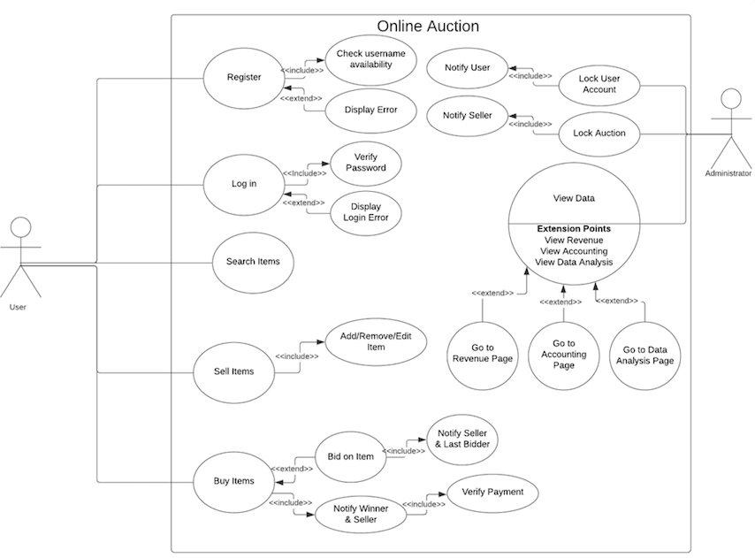

Activity diagram:

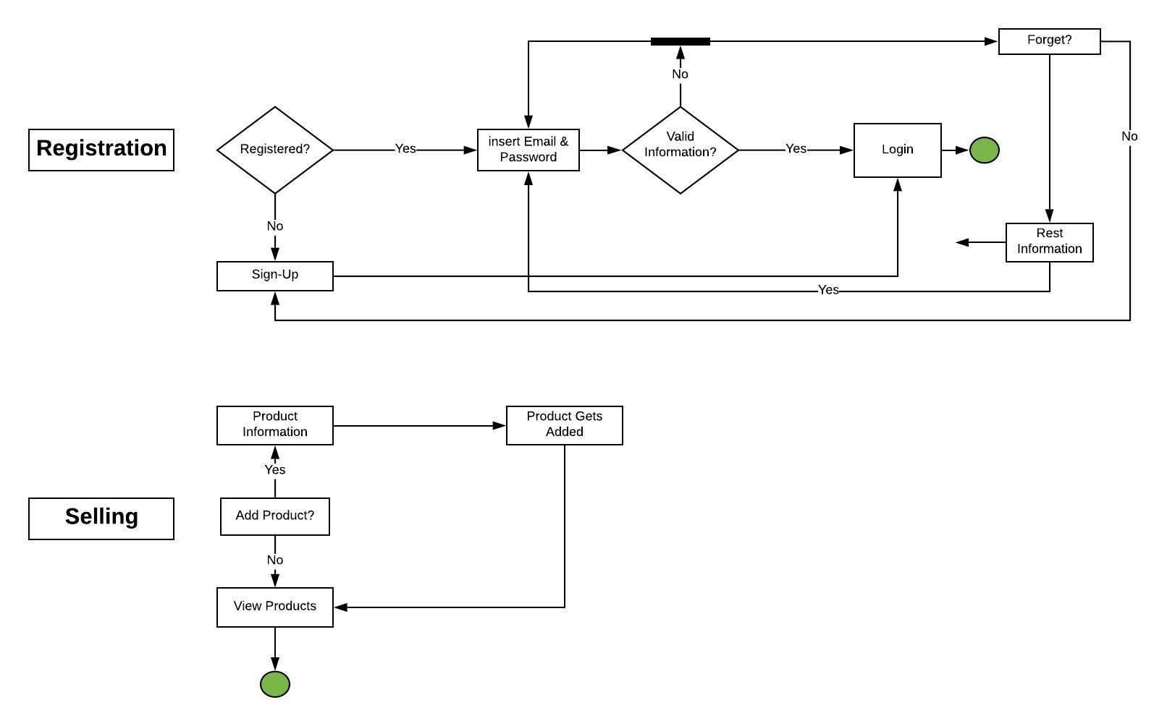

**Structural modeling:**

Class diagram:

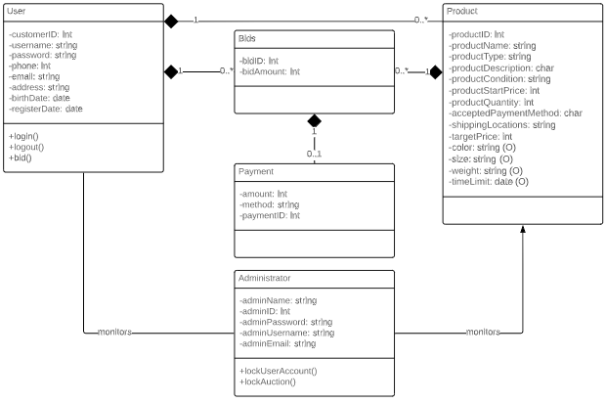

**Behavioral modeling:**

Sequence diagram:

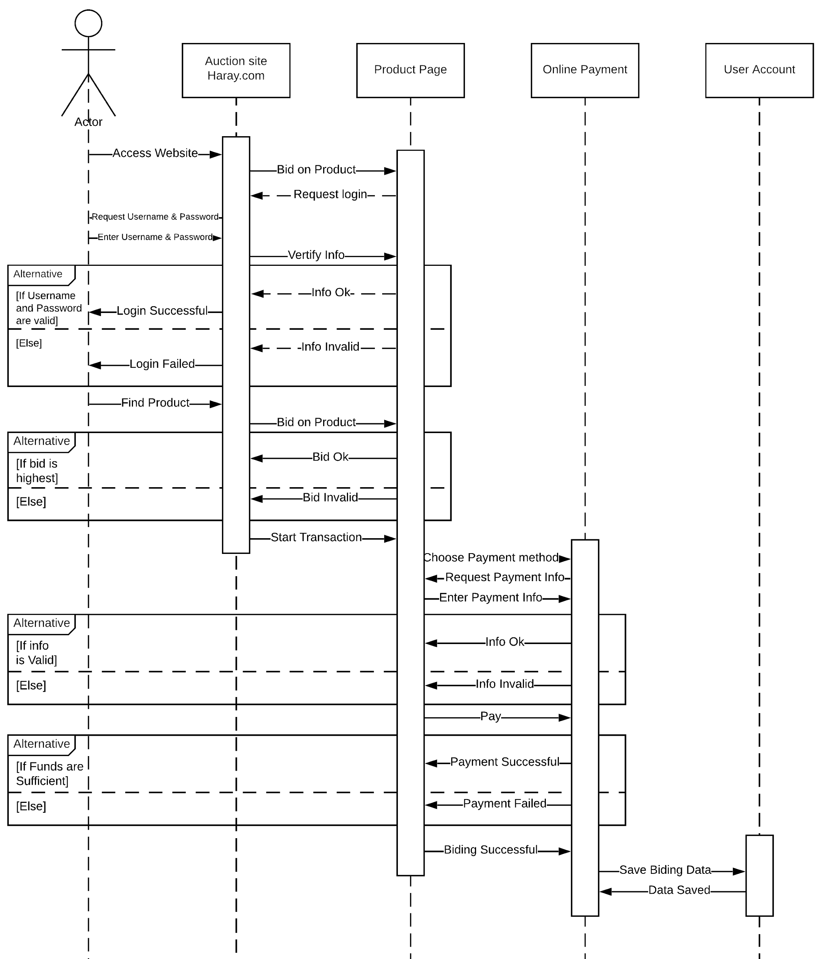

**Communication Diagram:**

sign-up/in:

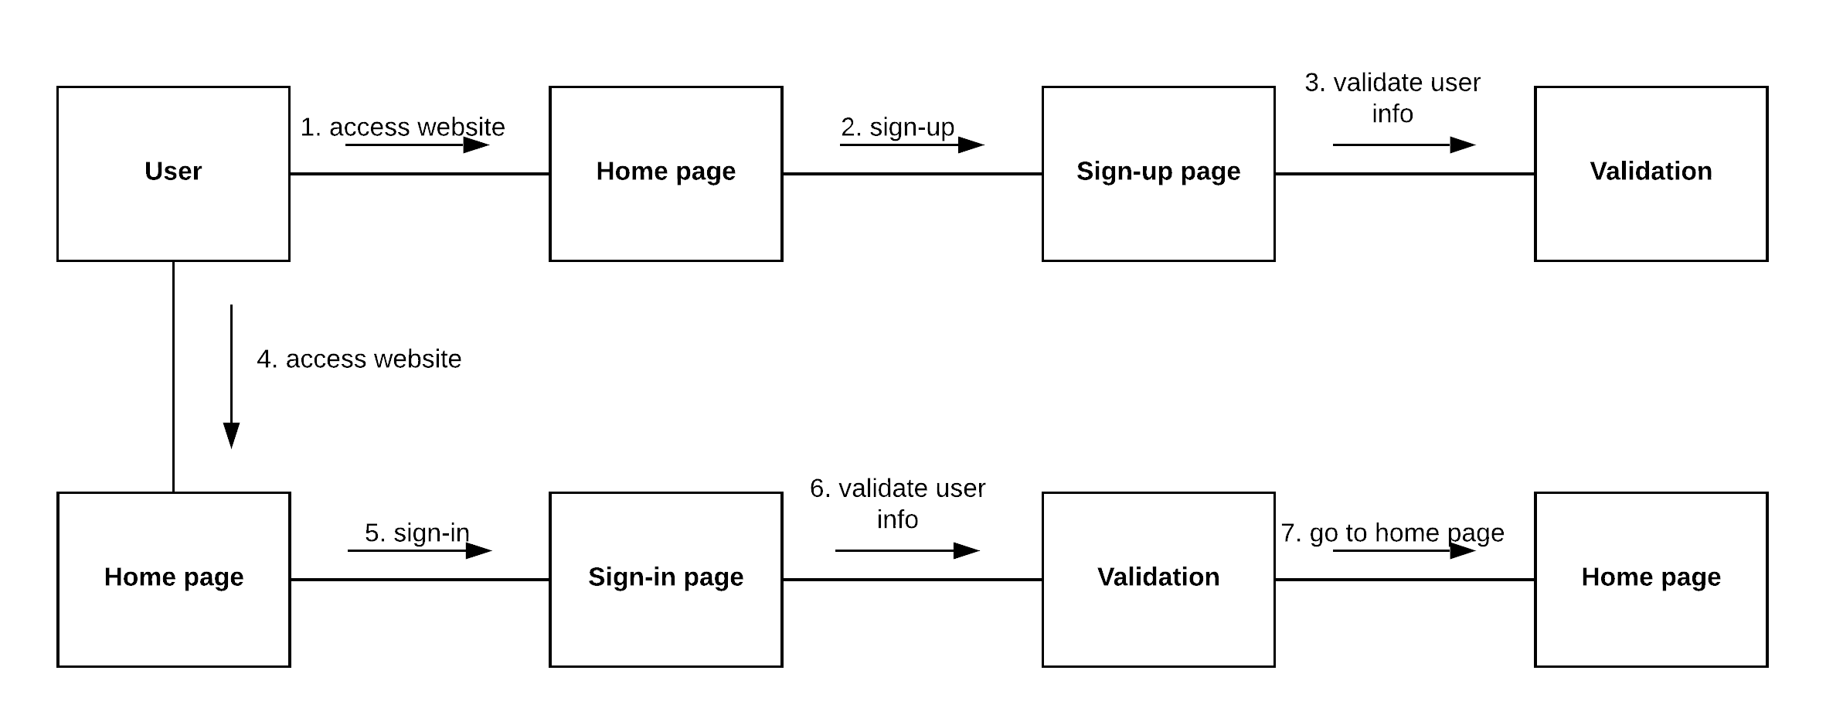

Buyer:

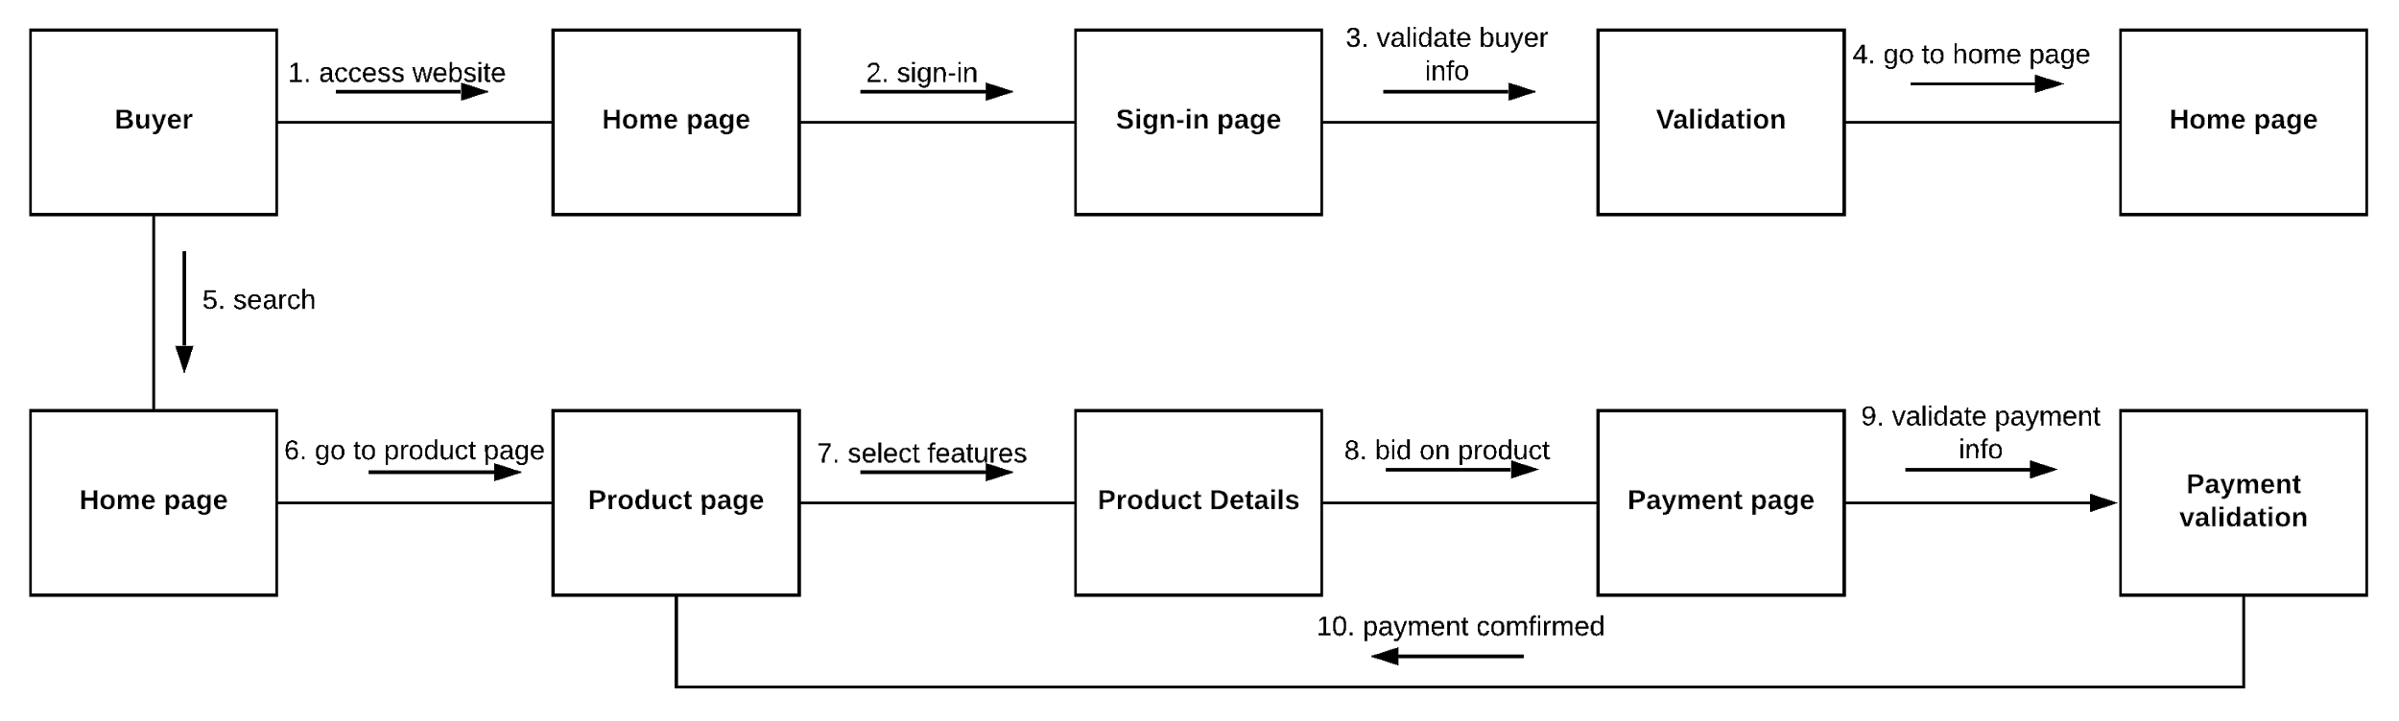

Seller:

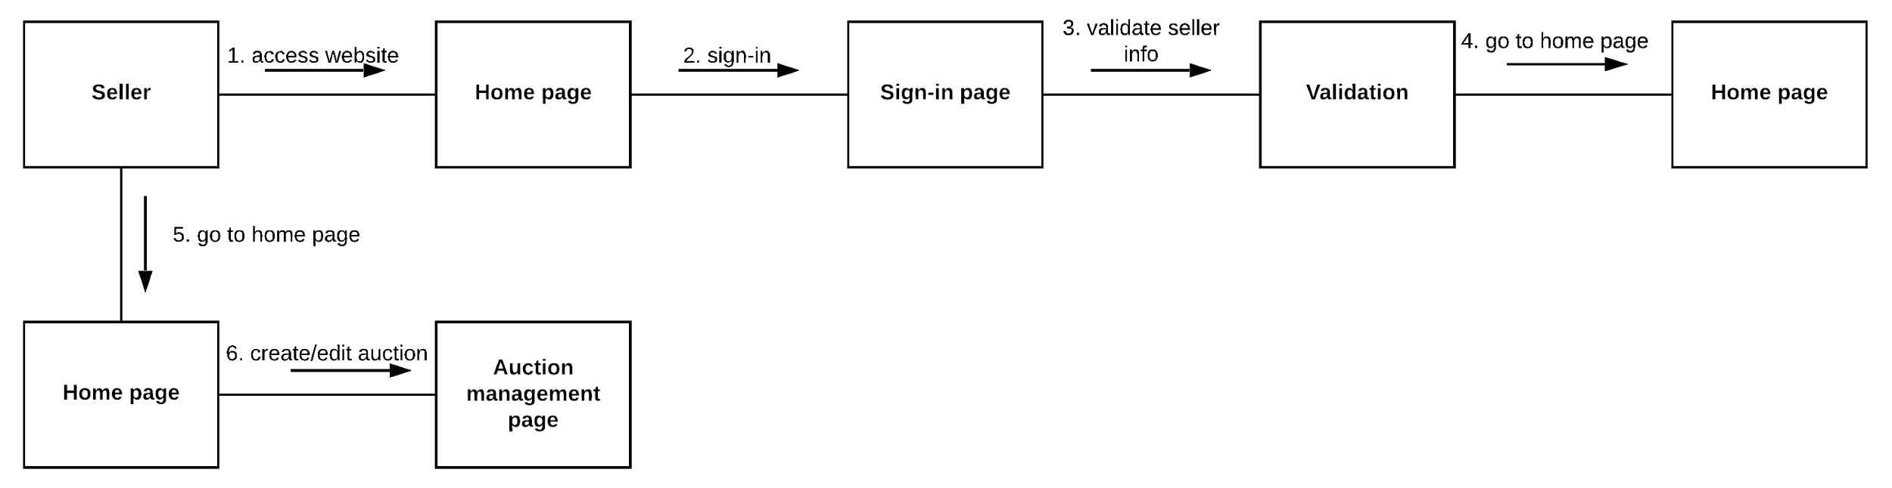

Admin: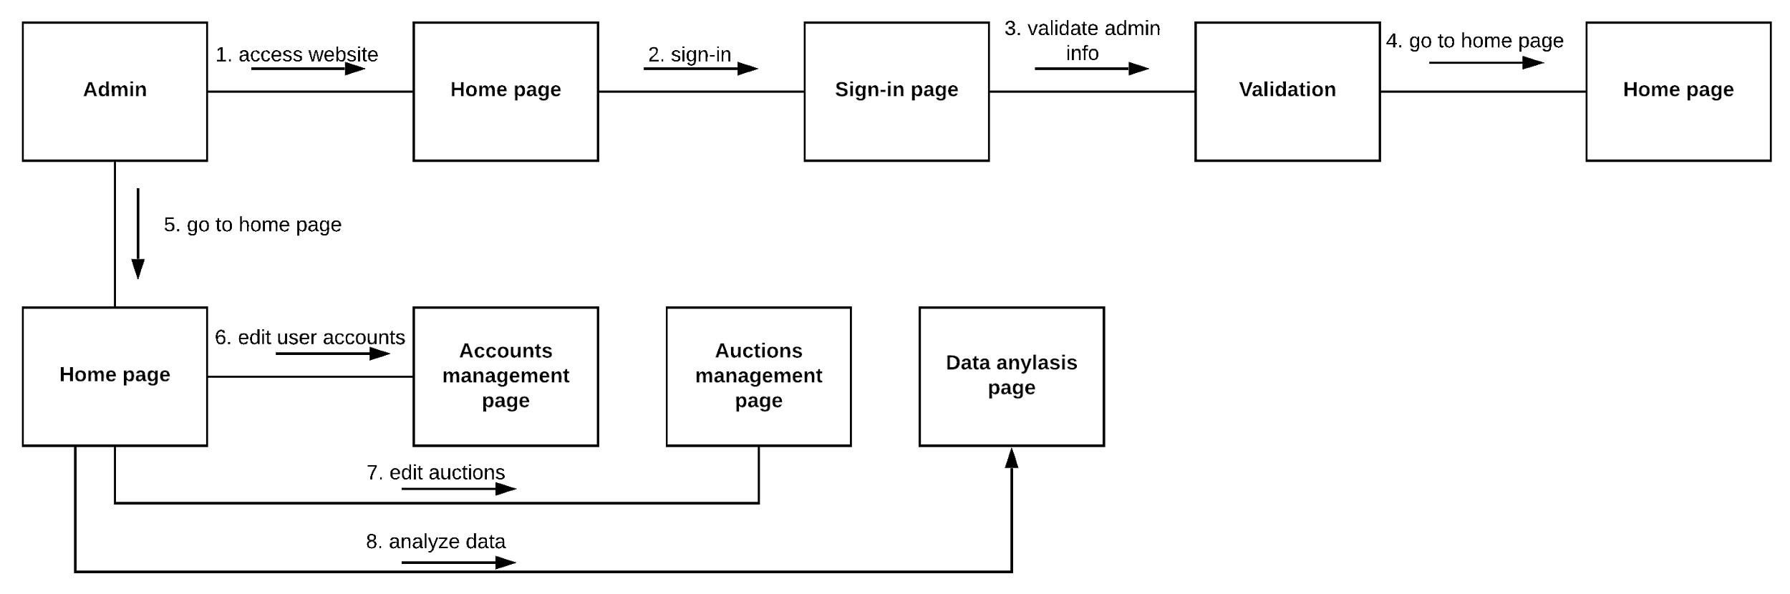

State machine diagram:

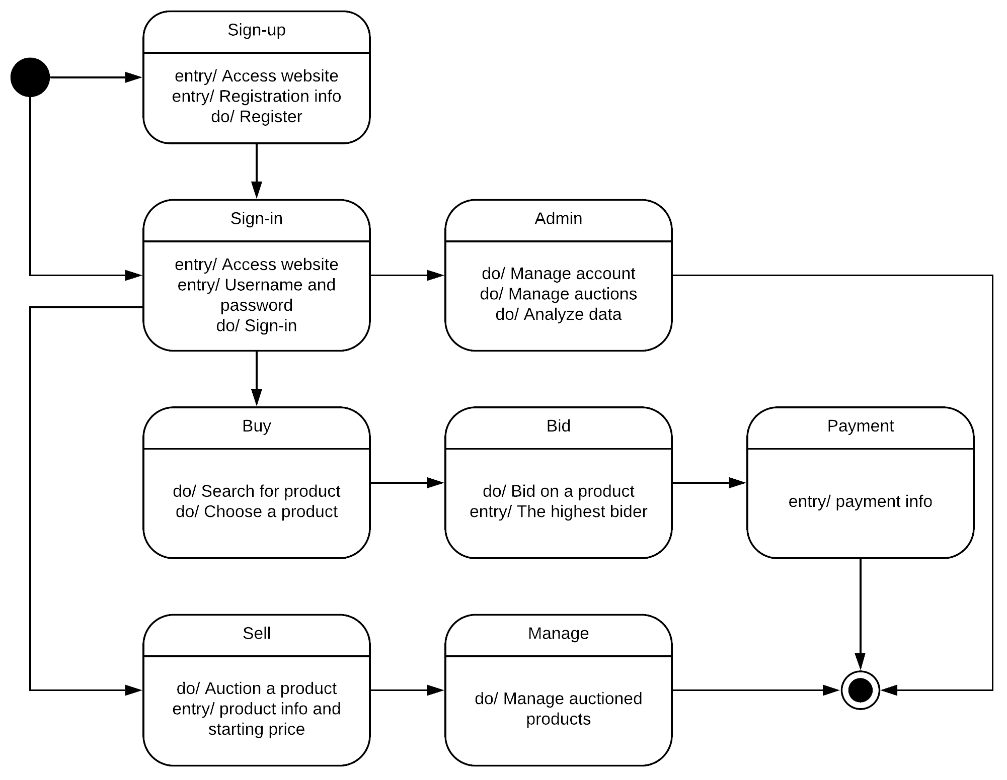

**Overall System Design and Architecture:**

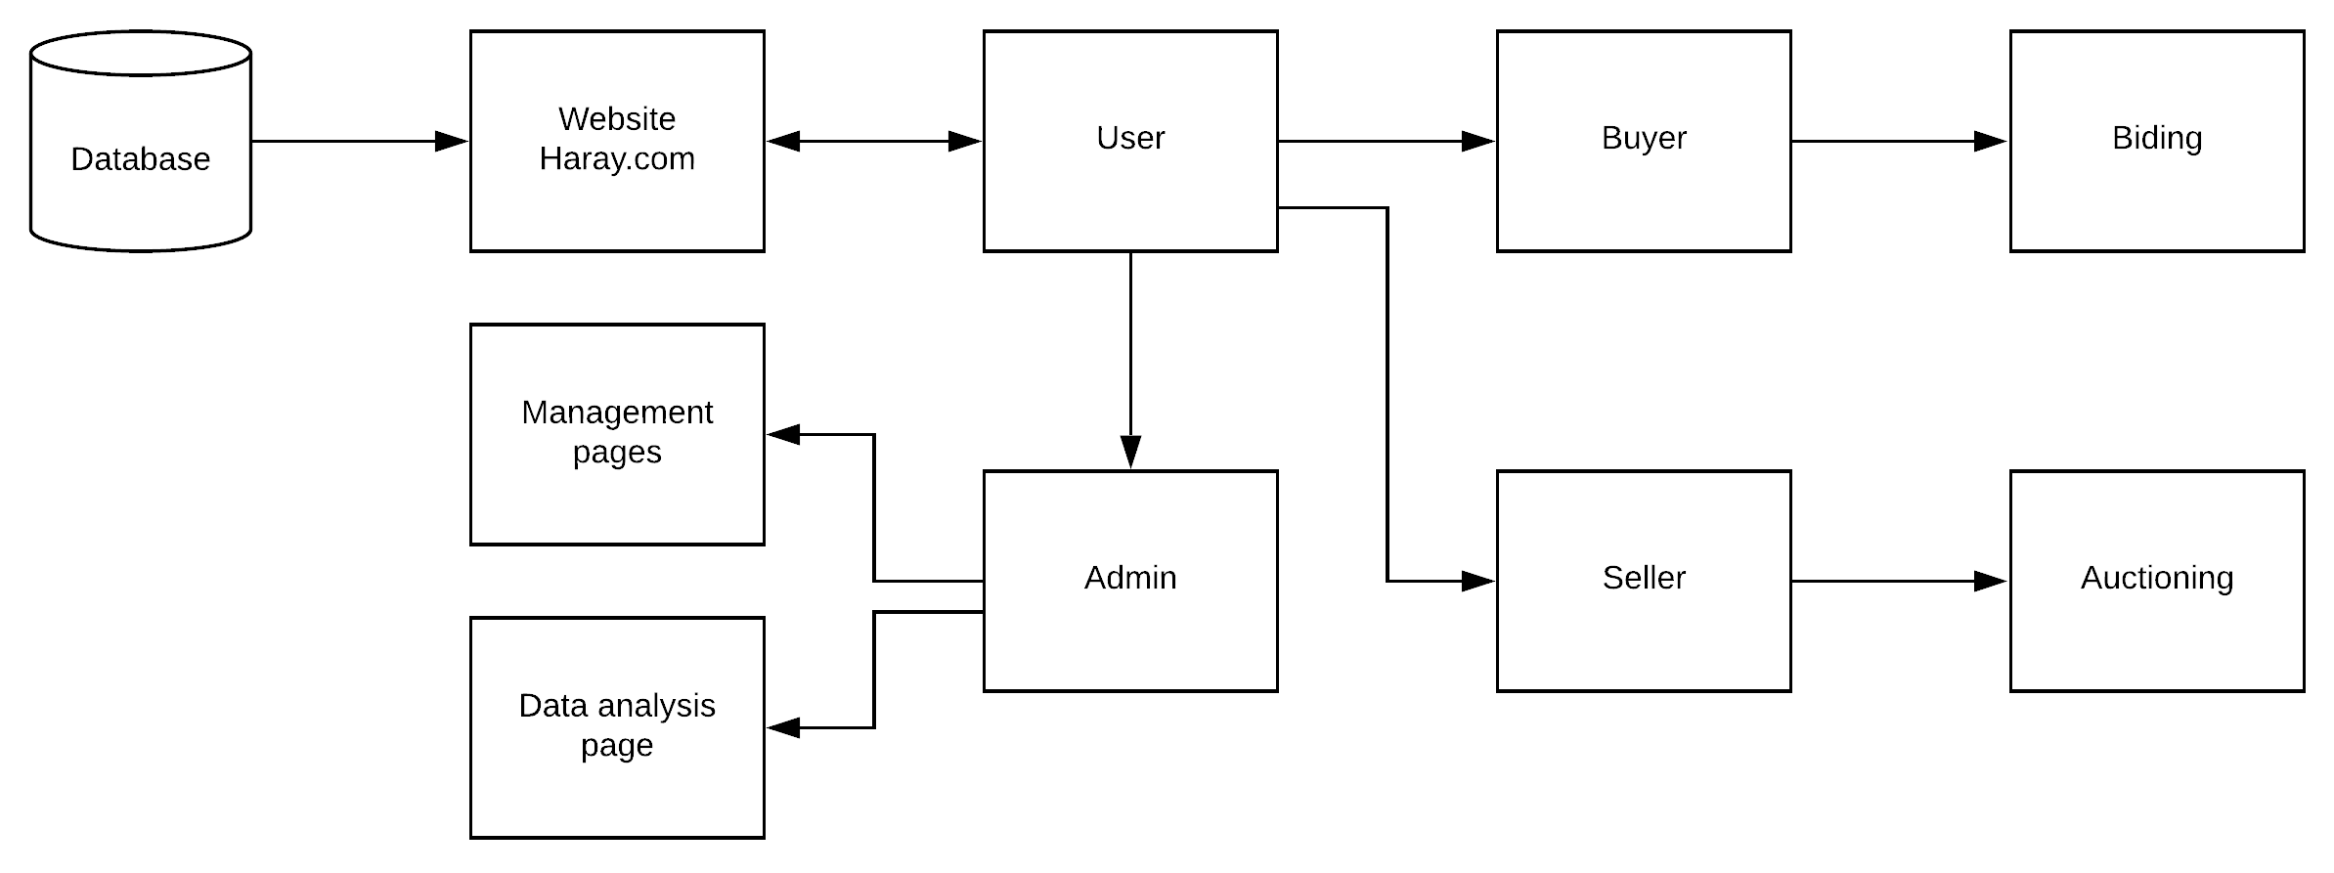

**Class and Method Design:**

|  |  |
| --- | --- |
| **Method Name:** | Creating an account |
| **Client:** | User (including Buyer and Seller) |
| **Programming Language:** | Visual Basic |
| **Description:** | User Enters their information including ( First name, last name, E-mail, Birthdate , Gender , Address and their phone number) To create an account. |
| **Description Details:** | User must enter all the necessary fields, if he misses a field or entered wrong info a message box will appear with error message for the field, else if there was any duplication in the unique fields, an error message will appear for that field, else account will be created, and the info will be saved in database. |

|  |  |
| --- | --- |
| **Method Name:** | Log-in |
| **Client:** | User (including Buyer, Seller and Administrator) |
| **Programming Language:** | Visual Basic |
| **Description:** | User Enters his username and password to access the page. |
| **Description Details:** | User Enters his username and password, If the entered login credentials were false an access denied message will appear, else if they missed a field an error message will appear, else they will be directed to their homepage. |

|  |  |
| --- | --- |
| **Method Name:** | Create an Auction |
| **Client:** | User (Seller) |
| **Programming Language:** | Visual Basic |
| **Description:** | Seller enters a product with a product description and a starting price for the bid to create an auction. |
| **Description Details:** | seller enters product with its description , if they miss a field an error message will appear, else an auction will be created |

|  |  |
| --- | --- |
| **Method Name:** | Bid |
| **Client:** | User (Buyer) |
| **Programming Language:** | Visual Basic |
| **Description:** | Buyer will start bidding for the products that they want. |
| **Description Details:** | Buyer offer a bid, if the bid is lower than current bid or equal to the current bid error message will appear. |

|  |  |
| --- | --- |
| **Method Name:** | Payment |
| **Client:** | User (Buyer) |
| **Programming Language:** | Visual Basic |
| **Description:** | Buyer will be directed to the payment page to make his payment. |
| **Description Details:** | Buyer will enter his payment method and card information, if they entered wrong information an error message will appear, else if they miss a field an error message will appear, if all the information is correct the payment will process. |

|  |  |
| --- | --- |
| **Method Name:** | Search |
| **Client:** | User (including Buyer, Seller and Administrator) |
| **Programming Language:** | Visual Basic |
| **Description:** | User can use the search feature to go-over products and categories. |
| **Description Details:** | The User can type in the search box for what their looking for and with the entered information a list will show up. |

**Database Design**

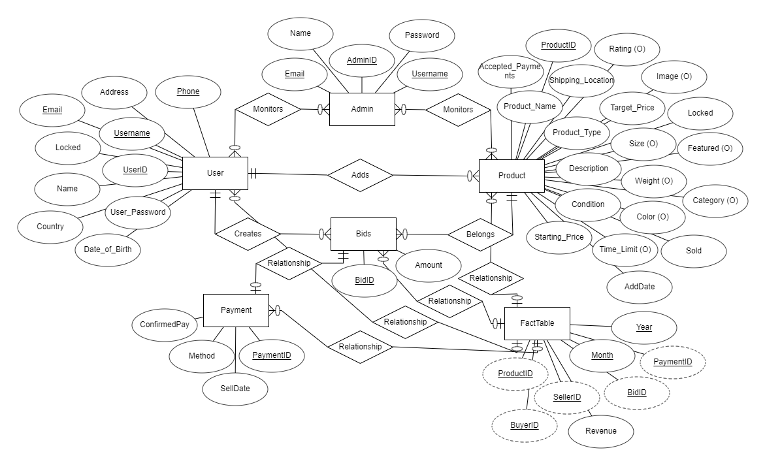

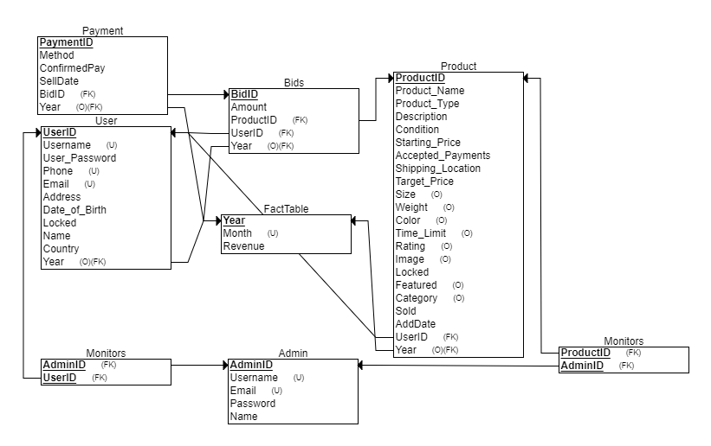

**User Interface**

