**Global warming. Are Greenhouse gases its most important contributor?**

A sample size of 29 years for the entire world

**Introduction:**

Urbanization and industrialization worldwide have skyrocketed over the past years. An equally important side-effect of these advancements is a growing concern to curb the effects these advancements have on the earth. One prominent issue that is of great concern to humanity is the abnormal increase in the earth’s surface temperature otherwise known as Global warming. This research paper will study the relationships between Greenhouse Gas concentrations, Surface Temperature changes, and Land cover changes in the entire world from the year 1992 to 2020. The aim of this research is to obtain and use the possible correlation between these factors to weigh the importance of Greenhouse Gas concentrations to global warming. This research would provide viable information to aid guide government policy making and the daily living by the public, towards effectively stopping Climate change and Global warming.

**Background:**

Global warming refers to the overall rise in average the surface temperature of the earth owing to human activities. This human-induced phenomenon falls under a larger problem which is climate change. This is the long-term shift or alteration in global or regional climatic patterns also owing to more than just a natural shift in nature but human activities. Global warming is a highly contentious topic since it holds within it the answer to a threat against humankind’s continued survival. Aside from global warming’s stake in our survival as a species, it is a strong determinant for worldwide economic and political decisions which affect daily living. So, what actually causes Global warming and if it is such a national threat why is it so difficult to combat? The layman’s understanding of the cause of global warming is attributed to Greenhouse Gas emissions, primarily, Carbon dioxide (CO2). But after extensive peer reviews and research, I now believe the answer is not as clear cut. During my research, I encountered almost an equal number of scientific articles that attributed Global warming to Greenhouse Gas emissions and others that claim the effect of one of the major greenhouse gases is not as pronounced as many thinks (Zhao, 2011). In addition to the effect of greenhouse gases, certain papers studying land cover also found some evidence to suggest changes in land cover (Deforestation) have some effect on changing surface temperature (Zhihui, 2013).

But regardless of the disparity in what exactly causes Global warming, the fact has been proven that the earth is indeed warming at an alarming rate. A generally accepted cause-and-effect relationship is what this field currently lacks. Due to the far-reaching effects of this problem, a definitive description of the problem is necessary for effective policy planning and public living. Also, papers on the topic of global warming show that people often tend to be lethargic or totally irresponsive to the threat being posed by this man-made phenomenon. People tend to be committed to their current beliefs which have proven to aid them function normally and thus tend to dismiss the ideas like climate change due to their unknown nature (Weber, 2020, p. 142). It is evident that there exists a lot of uncertainty and inaction when it comes to this topic.

The aim of this research paper is to identify a possible relationship between Greenhouse Gas concentrations, Surface Temperature changes, and Land cover changes in the entire world from the year 1992 to 2020. The existence of this possible correlation would serve as proof to support the notion of Greenhouse gases are partially responsible for global warming and verify the possible involvement of man-induced changes in land cover as a contributor to Global warming. Furthermore, the nature of this possible correlation would serve as a measure of the effectiveness of policies made through the years 1992 to 2020 to curb Global 92warming.

**Materials and methods**

Research Question: Global warming. Are Greenhouse gases its most important contributor?

**Associations Tested**

1. “Is change in land cover associated with Annual Surface Temperature Change”
2. “Is change in Green House Gas Concentrations associated with Annual Surface Temperature Change?”

**Sample Description**

The sample space for this research is 29 years of climate and land records. This data represents the climatic conditions, land cover states, and atmospheric gas concentrations for the entire world for over 29 years (1992 - 2020). The indicators (variables) used in this research were developed by the IMF Climate Change Dashboard in collaboration with international organizations and other agencies including the Organisation for Economic Co-operation and Development (OECD), the World Bank Group (WBG), the United Nations (UN), the European Commission, the European Statistical Office (Eurostat), the Food and Agriculture Organization (FAO), the International Energy Agency (IEA) and the National Oceanic and Atmospheric Administration (NOAA).

**Variables**

Green House Gas concentrations: This variable is a measure of the Greenhouse Emissions produced by the energy industry worldwide for the years 1970-2021. Estimates of emissions are in million metric tons of CO2 equivalent.

Land Cover Index: This variable is a measure of the changes in land cover that are climate-altering over time. Climate Altering Land Cover Index (CALCI) reflects the changes in the share of climate-altering land cover as compared to the base year, 2015. The climate Altering Land Cover Index is unitless.

Average Surface Temperature Change: This variable is a measure of mean surface temperature change with respect to the baseline climatology globally, corresponding to the period 1951-1980. But for the purpose of this research the, the years 1992 to 2020 will be used. This data is based on data provided by the Global Surface Temperature Change data distributed by the National Aeronautics and Space Administration Goddard Institute for Space Studies (NASA-GISS).

**Statistical Methods**

Pearson's correlation coefficient.

Conditions that allow us to safely use Pearson's correlation coefficient.

Normality of Variables: The Samples size for my research is 29 years which represents the climatic conditions for the years 1992 to 2020. Though the sample size is less than 30 which is the accepted benchmark for a sample to be considered fairly large, the lack of data on climate for the world has restricted me to 29 days. Since 29 days is a close estimate to 30, I will assume the sample is fairly large enough to assume normality.

Linear nature of Bivariate distributions: From the Scatter plot of all explanatory and response variables, there is an Observed linear relationship between Surface Temperature change, Land Cover Index, and Green House Gas concentration.

Independence of variables: The Observations which are Surface Temperature change, Green House Gas Concentration, and Land Cover index are independent of each other.

For the association, “Is change in land cover associated with Annual Surface Temperature Change” A Pearson correlation test was conducted to determine if there is a linear relationship between Land Cover Index and Average Annual Surface Temperature Change.

Ho = There exists no linear correlation between Land Cover Index and the surface temperature change for the years 1992 to 2020, r = 0.

Ha = There exists a linear correlation between Land Cover Index and the surface temperature change for the years 1992 to 2020. r $≠$ 0

For the association, “Is change in Green House Gas Concentrations associated with Annual Surface Temperature Change?” A Pearson correlation test was conducted to determine if there is a linear relationship between Green House Gas Concentrations and Average Annual Surface Temperature Change.

Ho`= There exists no linear correlation between Green House Gas Concentrations and the Surface Temperature change for the years 1992 to 2020. r = 0.

Ha` = There exists a linear correlation between Green House Gas Concentrations and the Surface Temperature change for the years 1992 to 2020. r $≠$ 0

**Analysis and Results**

Univariate distributions

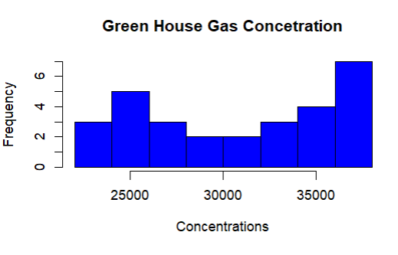

The variable Greenhouse Gas concentration has a mean of 30776.59 and a standard deviation of 5155.887. Also, there is an observe incline of the variable as the years progress.

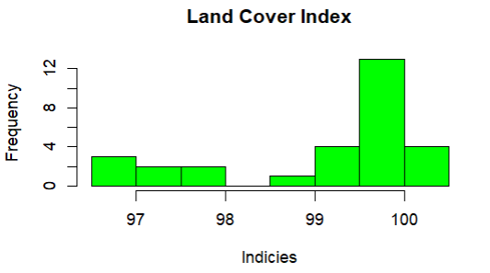

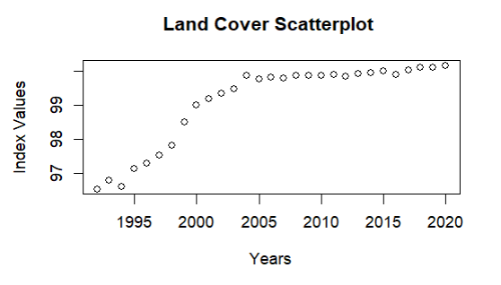

The variable Land Cover Index has a mean of 99.10347 and standard deviation of 1.221718 Also, there is an observe incline of the variable as the years progress.

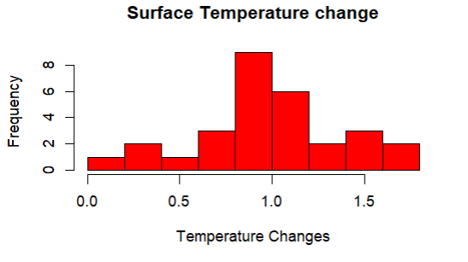

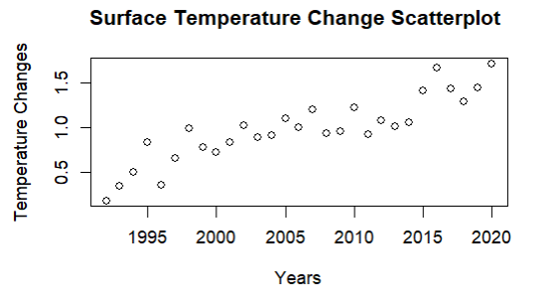

The variable Surface Temperature Change has a mean 0.9813448 of and standard deviation of 0.3657503. Also, there is an observe incline of the variable as the years progress.

All three variables show a incline in their values from the year 1992 to 2020. The are also no observed outliers within any of the variables. The variable Surface Temperature Change is shown to be normally distributed which allows us to proceed with our Pearson's correlation coefficient test. Although the other two variables do not visibly show outright normality, we can assume normality based on the number of values they have. There are 28 total values for these variables, which is close to 30 data points, the accepted benchmark of observations to assure normality.

For the assumed relationship between Green House Gas Concentration and Surface Temperature change the Coefficient of correlation equals 0.8219796 and r^2 = 0.6756504

**Conclusion of Hypothesis Test**

Given a significance level 𝛼 = 0.05 and a p-value of 4.562e-08, For the assumed relationship between Green House Gas Concentration and Surface Temperature change for the years 1992 to 2020 we have strong evidence to reject H0. The evidence establishes a strong positive linear relationship between Green House Gas Concentration and Surface Temperature change for the years 1992 to 2020. The evidence further suggests the Green House Gas Concentration accounts for 67.57% (r^2 = 0.67565046) of the variation in surface temperature change

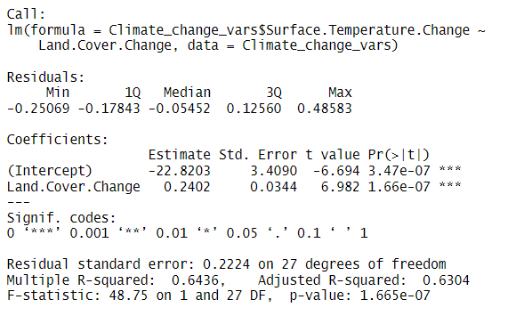

For the assumed relationship between the Land Cover Index and the Surface Temperature change the Coefficient of correlation “r” equals 0.8022386 and r^2 = 0.64358677

**Conclusion of Hypothesis Test**

Given a significance level 𝛼 = 0.05 and a p-value of 1.665e-07, For the assumed relationship between Land Cover index and Surface Temperature change for the years 1992 to 2020 we have strong evidence to reject H0. The evidence establishes a strong positive linear relationship between the Land Cover index and Surface Temperature change for the years 1992 to 2020. The evidence further suggests the Land cover index accounts for 64.36% (r^2 = 0.64358677) of the variation in surface temperature change

**Discussion**

The results of this research show that there exists some valid relationship between Greenhouse Gas concentrations, Surface Temperature changes, and Land cover changes in the entire world from the year 1992 to 2020. Many existing literature asserts the ambiguities that exist when attempting to find a singular cause of global warming and the vast body of inaccurate data the public has and operates on. A popular assertion observed in my research is the understatement of the stake of C02, a very large component of Greenhouse gases, in global warming. The general understanding and many people and governments when trying to mitigate global warming is that cutbacks on carbon emissions would significantly do so, but from my research and peer reviews, such thinking is false. The correlation between Land cover change and surface temperature change in my research was almost as strong as that of Greenhouse gas concentrations and surface temperature change. This implies that though Greenhouse emissions do play a role in global warming, their importance has been overstated. Also, based on the continued increase observed in the univariate distribution of the world’s annual surface temperature change, it can be assumed that measures, most of which are directed at curbing greenhouse gas production, have been less effective than hoped for. This research brings to light the partial involvement of Greenhouse gas emissions in global warming and states another of possibly many contributors to this problem. To formulate better policies to curb global warming, more research must be done to fully understand the conjoined factors that cause global warming. Only then can effective policies and living styles be made that are sustainable.

Limitations

-One pertinent limitation of this study is that it was done over a sample space of only 29 years Climatic conditions and landcover changes require large sample sizes for accurate predictions. The lack of available data was the main cause of this, but with the growing popularity of climate change accessing such data soon will no longer be a hindrance.

**Conclusion**

The threat of Global Warming (climate change) is very real and fast approaching. The efforts made to curb this canker have been ineffective due to the lack of a definitive cause. Campaigns meant to exaggerate the causes of global warming have resulted in a sea of partially true information that is insufficient to properly combat the problem. The causes of global warming far exceed the bounds of Greenhouse Gas Concentrations, realizing this fact and conducting further research to identify a more reliable account of the causes of Global Warming causes will go a long way to aid build a sustainable solution to it.

*References*

Weber, E. U. (2020). Seeing Is Believing: Understanding & Aiding Human Responses toGlobal Climate Change. *Daedalus*, *149*(4), 139–150. <https://www.jstor.org/stable/48592033>

Zhihui Li, Xiangzheng Deng, Qingling Shi, Xinli Ke, & Yingcheng Liu. (2013). Modeling the Impacts of Boreal Deforestation on the Near-Surface Temperature in European Russia. *Advances in Meteorology*, 1–9. <https://doi.org/10.1155/2013/486962>

Zhao, X. (2011). Is Global Warming Mainly Due to Anthropogenic Greenhouse Gas Emissions? *Energy Sources, Part A: Recovery, Utilization, and Environmental Effects*, *33*(21), 1985–1992. <https://doi.org/10.1080/15567030903515013>