Demonstration
Present workflow via screenshots and description.

Equal division of the contested sum
Below, we demonstrate how our application works for the following scenario. There is an estate of 1000 money units and 5 creditors A, B, C, D and E with claims 50, 150, 200, 300 and 450 money units, respectively. The award eac creditor must receive according to the algorithm by Aumann and Maschler can be computed as depicted in Table 2. First, creditors are ordered from lowest to highest claims. Then, the estate is equally devided among all persons until the lowest creditor A receives half of what A claims (Round 1 in Table 2). Then, the remaing estate is equally devided among all persons except the creditor with the lowest claim A until the next lowest creditor B receives half of what B claims (Round 2 in Table 2). Then, the remaing estate is equally devided among all persons except the creditors with the 2 lowest claims A and B until the next lowest creditor C receives half of what C claims (Round 3 in Table 2). Then, the remaing estate is equally devided among all persons except the creditors with the 3 lowest claims A, B and C until the next lowest creditor D receives half of what C claims (Round 4 in Table 2). Then, the remaing estate is equally devided among all persons except the creditors with the 4 lowest claims A, B, C and D until the last creditor E receives half of what E claims (Round 5 in Table 2). Now, the algorithms proceeds the other way round. The person with the highest claim E receives money units from the estate until E’s loss, i.e., the difference between the claim and already received money units, equals the loss for the next highest creditor D (Round 6 in Table 2). Then, the remaing estate is equally devided among the highest creditors E and D until the loss of the highest creditors equals the loss of the next highest creditor C (Round 7 in Table 2). Then, the remaing estate is equally divided among the highest creditors E, D and C until the loss of the highest creditors equals the loss of the next highest creditor B (Round 8 in Table 2). At this point, the remaing estate is 175 money units. These units are not enough for being equally divided among the highest creditors E, D, C and B until the loss of the highest creditors equals the loss of the last creditor A. Thus, the remaining estate is just equally divided to the 4 highest creditors E, D, C and B (Round 9 in Table 2). Since the there is no estate left, the algorithm terminates assigning each creditor A, B, C, D and E the money units shown at the last row of Table 2.
Table 2. Fair division of an estate of 1000 money units to 5 creditors according to the algorithm suggested by Aumann and Maschler.
 | Creditor A | Creditor B | Creditor C | Creditor D | Creditor E | Available estate
Claims | 50 | 150 | 200 | 300 | 450 | 1000
Round 1 | 25 | 25 | 25 | 25 | 25 | 875
Round 2 | - | 50 | 50 | 50 | 50 | 675
Round 3 | - | - | 25 | 25 | 25 | 600
Round 4 | - | - | - | 50 | 50 | 500
Round 5 | - | - | - | - | 75 | 425
Round 6 | - | - | - | - | 75 | 350
Round 7 | - | - | - | 50 | 50 | 250
Round 8 | - | - | 25 | 25 | 25 | 175
Round 9 | - | 43.75 | 43.75 | 43.75 | 43.75 | 0
Final outcome | 25 | 118.75 | 168.75 | 268.75 | 418.75
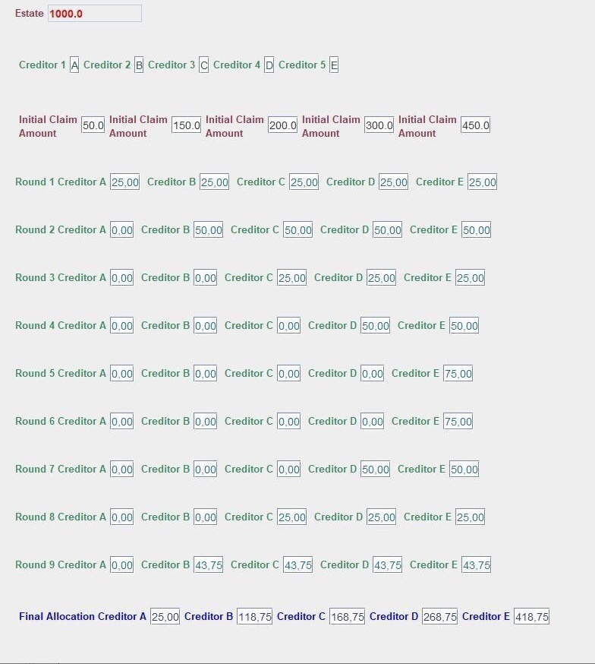
Figure 1. Indicative execution of the algorithm by Aumann and Mascher for the fair division of en estate to five creditors.

The method of sealed bids
Below, we demonstrate how our application works for the following scenario. Five persons A, B, C, D and E must divide fairly among them three discrete, indivisble items, which these persons valuate differently. The method of sealed bids is used for the division. Each person privately and independently bids on each object. The bid of each of the five persons is shown in rows 2, 3 and 4 of Table 3 expressed via numerical values indicating the amount each player thinks the object is worth. For each object, the person with the highest bid wins the object. Thus, person A gets object 2 and person B receives objects 1 and 3. Then, the fair share for each player is calculated by dividing the sum of the bids by 4, i.e., by the number of persons participating in the process (row 6 in Table 3). Then, for each player the difference [fair share] – [total value of received objects] is calculated (row 7 in Table 3). When this difference is negative, the person must pay back to the estate the corresponding amount of money. As shown in row 7 in Table 3, person B – who got two of the objects of total value of 270 money units according to B’ s individual valuation - must pay back 195 money units. Then, the surplus is determined by calculating the difference [total amount of money units owed to the estate] – [total amount of money units the estate owes]. The calculated surplus – 60 money units - is then equally divided to the four persons participating in the process resulting in each person receiving a surplus of 15 money units (row 8 in Table 3). The final settlement for this scenario is then calculated by adding the share of surplus to either the amount owed to the estate or the amount the estate owes, including allocated objects and any cash owed in the final settlement. This gives the final settlement depicted in the last row of Table 3 according to wcich person A receives object 2 and 29 money units, person B receives object 1 and 3 and must pay back 180 money units, person C receives 71 money units and person D receives 89 money units. It can be easily observed that the money units remaining unallocated in the final settlement is indeed 0.
Table 3. The method of sealed bids for the fair division of objects 1, 2 and 3 to persons A, B, C and D.
 | Person A | Person B | Person C | Person D
Object 1 | 200 | 250 | 180 | 210
Object 2 | 50 | 30 | 40 | 40
Object 3 | 6 | 20 | 4 | 10
Assigment of objects | Object 2 | Object 1, Object 3
Fair share | 64 | 75 | 56 | 65
1st settlement (winning bids) | 14 | -195 | 56 | 65
Surplus sharing | 15 | 15 | 15 | 15
Final settlement | 29 | -180 | 71 | 80
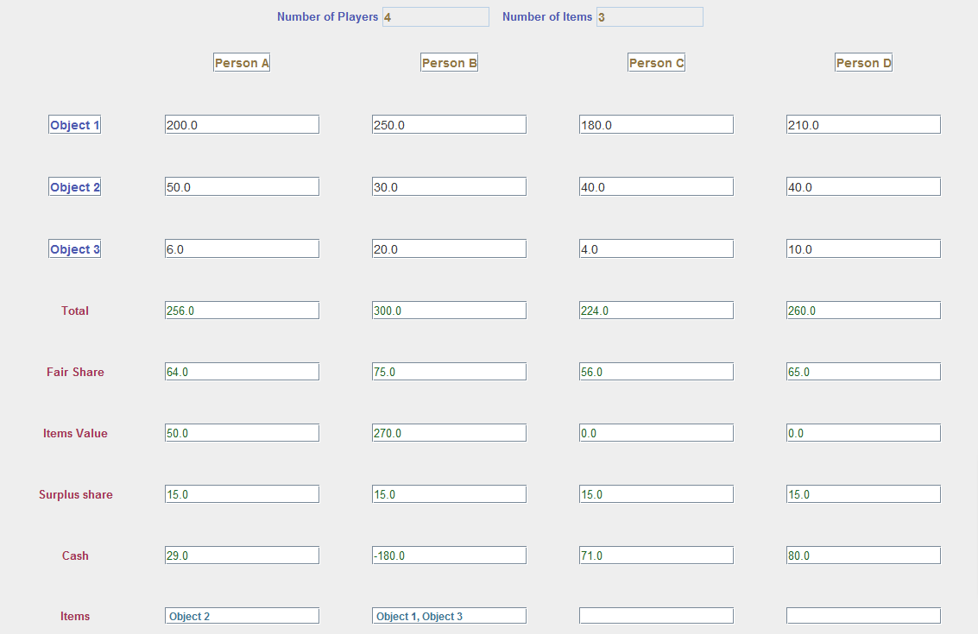
Figure 2. The method of sealed bids for the fair division of three doscrete objects 1, 2 and 3 to four persons A, B, C and D.

