AN APPLICATION FOR FAIR DIVISION
Abstract
In this work we present an application which can be used to perform fair division. In general, fair division addresses the way that sets of items can be distributed among individuals so that they all feel satisfied with the share they received. Fair division is usually considered as a game where players, i.e., individuals, valuate items differently. The division methods we selected to implement guarantee that all individuals receive a fair share. In particular, we implemented a method, first described in Talmud and later typically proved via game-theoretic arguments, for the bankruptcy problem where the objective is to divide in a fair way an insufficient amount of divisible items (e.g., money) among individuals with different claims. Furthermore, we implemented the method of sealed bids which can be used for the fair division of indivisible (i.e., discrete) items (e.g., an apartment) among individuals who valuate these items differently.
Our application could be used for educational and training purposes in order to help students familiarize with terms, concepts and techniques from algorithmic game theory. It could also be exploited in law-related real-world scenaria like for example dividing an estate among creditors when the total debts claimed exceed the existing estate or for the purposes of inheritance sharing when beneficiaries assign different values to the available items. The application has an easy-to-use interface and can run on a standard computer without requiring advanced skills on behalf of involved users.
Keywords: Application, education, training, law, fair division, game theory.

INTRODUCTION
What is just and how parties can divide among themselves in an equitable (i.e., fair) way a set of commonly claimed goods has always attracted attention and interest of societies and scientific communities. The notion of fairness in general and in particular regarding the sharing of goods has always been central to societies since fairness can imply justice and justice can imply stability [3]. Furthermore, in the presence of selfishness, the ability of developing strategic behavior, at an atomic or coalitional level, results in broader, more flexible notions of stability and justice. Several competitive and conflicting real-world situations can be seen as strategic games. In such contexts, stability is obtained as long as an equilibrium is reached; in such a case participants are happy with what they get since they can not further improve their position with unilaterally altering their behavior.
Apart from societies, fairness and strategic behavior have also concerned the scientific and research community. Fair division and game theory have emerged as two important areas of research cross-cutting various scientific disciplines [9, 12, 20].
Fair division deals with how goods can be divided in equitable ways and has a long and rich history. However, mathematical results on fair division were first stated in the 1940s, when the polish mathematician Hugo Steinhaus started a mathematical study of the question “how does one fairly divide a cake between multiple people“ [15]. The theory of fair division is concerned with finding ways to divide in a fair way an object among persons/participants. Hugo Steinhaus proved that for any group of players there is an envy-free fair division scheme according to which there is a strategy for a player to adopt in order to receive a piece at least as large as any other player’s regardless of what other players do [6, 10]. Fair division remains an open field of study in mathematics touching upon many different topics and having connections with the areas of combinatorics, mathematical induction, graph theory, algorithms, and topology [4, 7, 12, 17].
Game theory is a relatively young branch of mathematics that goes back to 1944 and the publication of the “Theory of Games and Economic Behavior” by John von Neumann and Oskar Morgenstern [21]. Game theory aims at constructing mathematical models for reaching conclusions for situations in which decision must me made by a group of people who do not necessarily share common interests. Game theory has been a branch of mathematics particularly influential in the social sciences and it has recently evolved to an essential tool for social scientists studying the strategic behavior of competing individuals, firms, and countries.
Situations calling for fair division or development of strategic behavior both arise very often in our societies even in our everyday life and receive the attention and interest of the research community. Often, it is required that an estate, a jewellery collection or land is divided fairly among claimants or rooms are assigned housemates and the rent is divided accordingly among them. Other real-world scenaria include dividing the assets of a dissolved business or even dividing cleaning chores among roommates. Furthermore, the fair allocation of indivisible goods reveals questions that apart from deeply practical are also mathematically challenging. Recently, machine learning researchers use the term "fairness" to refer to lack of bias or discrimination [12]. Also, bankruptcy situations often arise when several creditors have claims against a given estate, but the total amount of claims exceeds the value of the estate. In such situations, we are interested in determining provably and convincingly “fair” ways of dividing the estate among the claimants given that what seems fair in one case may seem less fair in another [8]. Addressing fair division problems from a game-theoretic perspective, when possible, can also provide a better insight and lead to new solutions [4, 5, 19].
Motivated by the practical and theoretical importance of fair division and its relation to game theory we focused on a bankruptcy problem, initially stated in Talmud together with a recommendation for a “fair” solution which was fully explained recently via a game-theoretic principle [2], and a method – namely he method of sealed bids – for the fair division of indivisible (i.e., discrete) items (e.g., an apartment) among individuals who valuate these items differently [10]. We developed an application which implements the fair division algorithm suggested by Aumann and Maschler, which generalizes the division recommendation from Talmud exploiting the “equal division of the contested sum” principle, and the method of sealed bids. Our application can be used by students for educational and training purposes and, also, as a tool for addressing real-world relevant situations.
The application is available at https://..... It is a lightweight application, easy-to-use and responsive. It does not require advanced computer skills on behalf of its users and can run on typical computing devices.
The rest of the paper is structured as follows. In Section 2, we first give an overview of the general research area of fair division. Then, we describe in detail the two particular problems and the corresponding algorithmic solutions, which we implemented in the context of our application. In section 3, we present the graphical user interface of our application and demonstrate corresponding examples. We conclude and outline future plans in Section 4.

Fair division
In the following, we first present an overview of the general research area addressing fair division. Then, we present details from the relevant literature regarding the two algorithms we selected to implement and include in our application.

Overview
Attempting to suggest how a group of persons can divide a cake among them so that everyone is happy with their share, it can be easily observed that there are many possible notions of fairness. An interesting notion is the one that results is envy-free divisions, i.e., one in which each person feels she received the best piece, in her own estimation [16]. How can items or collections of items be divided among two or more persons so that they all feel they received a fair share? Different persons may valuate the same item in a different way. A “fair share” to one person may not be the same as a “fair share” to another person. We are interested in methods which can guarantee that all persons receive a “fair share” even if it is not exactly the “fair share” they initially wanted. From a real-world point of view, it is worth mentioning that methods used to divide a cake can be also used to divide land or the rights of access of different countries to the ocean floor or to help merging companies to decide on issues related to administration and profile or even for deciding on the patient to receive a transplant when it becomes available.
Fair division can also be considered as a game with players and rules. There is a set of goods to be divided and players who are essentially the parties entitled to a share of the set of goods. Each player must be able to assign a value to the available set of goods or to any of its subsets. In order for the division of a set of goods to be fair, the players in the game must be willing to accept the rules of the game as binding. Furthermore, it is usually assumed that players act rationally according to their system of beliefs, mathematical rules apply when assigning values to the objects in the set of goods and the players are the only entities involved in the game, i.e., there are no external participants, like for examples lawyers or judges. If the players follow the rules the game will end after a finite number of moves by the players and result in a division of the available set of goods. Is also usually assumed that players play fair, they have no prior information about the likes or dislikes of the other players, they do not assign values in a way to manipulate the game and all players have equal rights in sharing the available set of goods, i.e., if there are five players, each player is entitled to at least 1/5 of the available set of goods. If these assumptions are not met, the division may not be totally fair.
Fair-division games can be continuous, discrete or mixed [10]. The basic idea in a continuous fair division game is that the available set of goods is divided into pieces. Each player assigns a value to each such piece. Based on these values players decide which pieces they consider a fair share. Since each player is entitled to at least a proportional share of the set of goods, it is easy to determine what is considered a fair share. In a continuous fair-division game the set of goods is divisible in an infinite number of ways, and shares can be increased or decreased by arbitrarily small amounts. Typical examples of continuous fair-division games involve the division of land, cake, etc. A fair-division game is discrete when the set of goods contains objects that are indivisible like paintings, houses, cars, boats, etc. A cake can be cut into pieces of almost any size but a painting cannot be cut into pieces. Cakes are usually used for continuous examples while collections of candies for discrete examples. In mixed fair-division games the set of goods contains both continuous and discrete components. For dividing a continuous set of goods, approaches like the Divider/Chooser method and the Lone Divider method have been proposed in the literature, which however, work well with a small number of players (two and three-four, respectively). For the fair division of discrete objects (e.g., an apartment), the method of sealed bids has been suggested for dividing a small number of objects not necessarily similar in value while for many objects similar in value (e.g., jewellery) the method of markers can be used to obtain a division such that all heirs feel like they received a fair share.

A bankruptcy problem
We focus on a bankruptcy problem which initially appeared together with a recommendation for its solution in the Talmud, an ancient document that forms the basis for Jewish religious, criminal, and civil law [2, 8, 11]. This bankruptcy problem is interesting since it is related to the various meanings that can be given to the concept of “fair division”.
The problem involves a man who dies with three debts and insufficient funds to pay them all. The question is how should an estate be divided among three creditors claiming sums of 100, 200, and 300? The Talmud offers answers through three example-cases. However the answers seem contradictory since no general rule is included in the text. The three cases are when the estate size is 100, 200, and 300 (see Table 1).
Table 1. The bankruptcy problem and the suggested solution from Talmud.
 |  | Claims
 |  | 100 | 200 | 300
Estate size | 100 | 33 1/3 | 33 1/3 | 33 1/3
Estate size | 200 | 50 | 75 | 75
Estate size | 300 | 50 | 100 | 150
In the first case when the estate size is 100, the Talmud allocates 33 1/3 to each party. The division suggests a principle of an equal division, which is easy mathematically and holds social appeal. But this is not the same idea used in the other cases. In the third case when the estate size is 300, the Talmud recommends a division of 50, 100, and 150. This is a proportional division based on the size of the debt. In modern times, proportional division is widely accepted in law and economics. In the second case when the estate size is 200, the recommendation is that the estate should be divided as 50, 75, and 75. This division seems a strange decision and does not classify as an equal division or a proportional one.
The answers defied a proper explanation for almost 2000 years and different rules of division were adopted by different scholars. Some thought that this division reflected special circumstances whose description was neglected and suggested the 200 case might be an issue of faulty transcription. A rabbinic scholar, Hai Gaon, expressed the opinion that there might be some relation between this rule and the rule for dividing a garment between two claimants; however, he did not explain the relation and eventually retracted his opinion.
In the 1980s, Robert Aumann and Michael Maschler [2] proved that there is no inconsistency in the Talmud answer demonstrating that it can be viewed as a consistent application of a game theory principle termed as “equal division of the contested sum”. This principle is essentially similar to the Talmud rule for dividing a garment between two claimants, noticed by Hai Gaon and its concept is the following.
Two persons, A and B, are arguing over a garment. A claims half of the garment while B claims the whole. A judge is asked to decide who should receive what. Instead of an even split (A: 1/2, B: 1/2) or a proportional split (A: 1/3, B: 2/3), the Talmud recommends a different answer (A: 1/4, B: 3/4), which is actually based on the equal division of the contested sum. The principle works in three steps. First, it is decided what portion of the cloth is being disputed; half of the garment is being claimed by both persons in the example. Second, the disputed portion is divided equally between A and B, with each receiving 1/4 of the cloth. Third, the remaining “undisputed” cloth is allocated entirely to the person whose claim is not disputed, i.e. to B. This logic yields an allocation of 1/4 of the garment to A who is claiming half of the cloth and the allocation of 3/4 of the garment to B who is claiming the whole cloth.
This method can be used for any division problem between two parties, following the same three previous steps: (a) determine which portion is contested by both parties, (b) split the contested portion equally, (c) assign the uncontested portion to the only person claiming it. This principle can also be applied to many situations, like when the claims are larger than the asset to be divided, as in the case of dividing an estate. In the case of a 200 estate, the Talmud division 50, 75, and 75 for the three creditors claiming debts of 100, 200, and 300, respectively, is obviously consistent with the way a disputed garment would be divided, when examined for pairs of creditors.
It is worth mentioning that a bankruptcy situation – including the one described in Talmud - is not game. However, from such a situation a cooperative game (Transferable Utility/TU game) can be derived [4, 5, 19]. This game class has been introduced by O'Neill in 1982 [11]. Aumann and Maschler showed that the numbers of the Talmud for the case when the estate size is 200 coincide with the nucleolus of the corresponding bankruptcy game. The nucleolus was invented by Schmeidler [13] in 1969. Furthermore, Sobolev [14] presented a system of axioms that characterize the nucleolus. One of these axioms, called consistency was the concept which yielded a reasonable explanation of the table in Talmud and also showed how similar problems with more creditors and various claims can be resolved [1, 2].
Aumann and Maschler noted that they reached their game theoretic understanding of the Talmud division recommendation by examining additional Talmudic passages and observing that the same principle - equal division of the contested sum – was applied in many topics and most likely formed a social custom natural for their culture. What is surely interesting is that a tool of logic and rationality - game theory - was needed to decode the Talmud solution, which primarily depended on a social custom.
Aumann and Maschler further showed the division method can be extended to arbitrarily large number of creditors and reaching the unique solution requires that the same condition needs to be met: the assets are divided up such that the amount received by any two people reflects the principle of equal division of the contested sum [2]. Aumann and Maschler showed there is in fact only one division that is consistent and suggested the following seven-step algorithm [18] for always obtaining the unique division composed of pairwise equal divisions of contested sums.
- Order the creditors from lowest to highest claims.
- Divide the estate equally among all parties until the lowest creditor receives one half of the claim.
- Divide the estate equally among all parties except the lowest creditor until the next lowest creditor receives one half of the claim.
- Proceed until each creditor has reached one-half of the original claim.
- Now, work in reverse. Start giving the highest-claim money from the estate until the loss, the difference between the claim and the award, equals the loss for the next highest creditor.
- Then divide the estate equally among the highest creditors until the loss of the highest creditors equals the loss of the next highest.
- Continue until all money has been awarded.

The method of sealed bids
The method of sealed bids is a fair division technique dealing with discrete objects. It two heirs have to split a house, the house must be kept intact and both heirs should have the feeling that they received a fair share. The method of sealed bids is used for dividing up a small number of objects not necessarily similar in value. A nice feature of this method is that every player in the game ends up with more than a fair share (in their own eyes).
In the following, we briefly state necessary assumptions and the six-step algorithm implementing the method of sealed bids (several examples can be found in [10]).
For applying the method of sealed bids, the players should be the only entities involved in the game and should be willing to accept the outcome. They should not have no prior knowledge of the other players’ preferences for not attempting to manipulate the game (if this assumption does not hold, a fair division may not be produced). Last, the players are not emotionally/irrationally attached to any of the items. The players will settle for any of the items or cash as long as it is a fair share.
The method of sealed bids consists in the following six-step algorithm. A set of persons must divide among them a set of discrete objects.
- Each player privately and independently bids on each object. A bid is the amount the player thinks the object is worth.
- For each object, the player with the highest bid wins the object.
- For each player find the sum of the bids and divide this sum by the number of players to find the fair share for that player.
- Find the difference (fair share) – (total of objects awarded) for each player. If the difference is negative, the player owes the estate that amount of money. If the difference is positive, the estate owes the player that amount of money.
- Find the surplus by finding the difference (sum of money owed to the estate) – (sum of money the estate owes). Divide the surplus by the number of players to find the fair share of surplus.
- Find the final settlement by adding the share of surplus to either the amount owed to the estate or the amount the estate owes. Include any items awarded and any cash owed in the final settlement. The sum of all the cash in the final settlement should be 0.

Our APPLICATION
Πρόκειται για δύο απλές και εύχρηστες Java και αναπτύχθηκε χρησιμοποιώντας το πρόγραμμα Apache Net Beans 11.3 σε συνδυασμό με το Java Swing, η οποία είναι μια εργαλειοθήκη γραφικών GUI για Java. Το NetBeans εκτελείται σε macOS, Windows και Linux. Εκτός από την ανάπτυξη σε γλώσσα Java, έχει επεκτάσεις και για άλλες γλώσσες όπως PHP, C, C++, JavaScript και HTML5.
Το Swing είναι ένα GUI framework για Java. Είναι μέρος του Java Foundation Classes (JFC) της Oracle - ένα API (Διεπαφή Προγραμματισμού Εφαρμογών) για την παροχή γραφικής διεπαφής χρήστη (GUI) για προγράμματα που δημιουργήθηκαν μέσω της γλώσσας προγραμματισμού Java.
Εκτός από τα κουμπιά, τις καρτέλες και τα παράθυρα, χρησιμοποιήσαμε το Swing για την δημιουργία πίνακα (συγκεκριμένα στην μέθοδο sealed bids).
Στην συνέχεια χρησιμοποιήθηκε το πρόγραμμα Launch4j 3.13 για την δημιουργία εκτελέσιμων αρχείων από τα αρχικά αρχεία .jar. Για την εκτέλεση και την δοκιμή της εφαρμογής χρησιμοποιήθηκε ένα Dell Inspiron 15 3000 series με Windows 7, καθώς και ένα Macbook Pro Mid 2012 με λογισμικό High Sierra
Για τη λειτουργία της εφαρμογής απαιτείται από το χρήστη να έχει έναν ηλεκτρονικό υπολογιστή,
χωρίς να απαιτείται από τον ηλεκτρονικό υπολογιστή εξοπλισμός υψηλών προδιαγραφών (κάρτα γραφικών, επεξεργαστής τελευταίας τεχνολογίας). Ο χρήστης και στις δύο εφαρμογές εισάγει από το πληκτρολόγιο τον αριθμό των παικτών καθώς και την περιουσία που πρόκειται να κατανεμηθεί. Στην μέθοδο Bankruptcy problem ως περιουσία εισάγεται από το πληκτρολόγιο ένα χρηματικό ποσό και οι παίκτες εισάγουν από το πληκτρολόγιο το ποσό που διεκδικούν από την περιουσία. Στην μέθοδο Sealed Bid ως περιουσία εισάγονται από το πληκτρολόγιο αντικείμενα και οι παίκτες εισάγουν το ποσό που κατά την γνώμη τους αντιστοιχεί στο κάθε αντικείμενο. Και στις δύο περιπτώσεις η έξοδος της εφαρμογής είναι ένας πίνακας που δείχνει αναλυτικά τα βήματα και των δύο αλγορίθμων, καθώς και τις τελικές κατανομές.

Graphical User Interface
Input screenshots Step by Step (Aumann & Maschler Method):

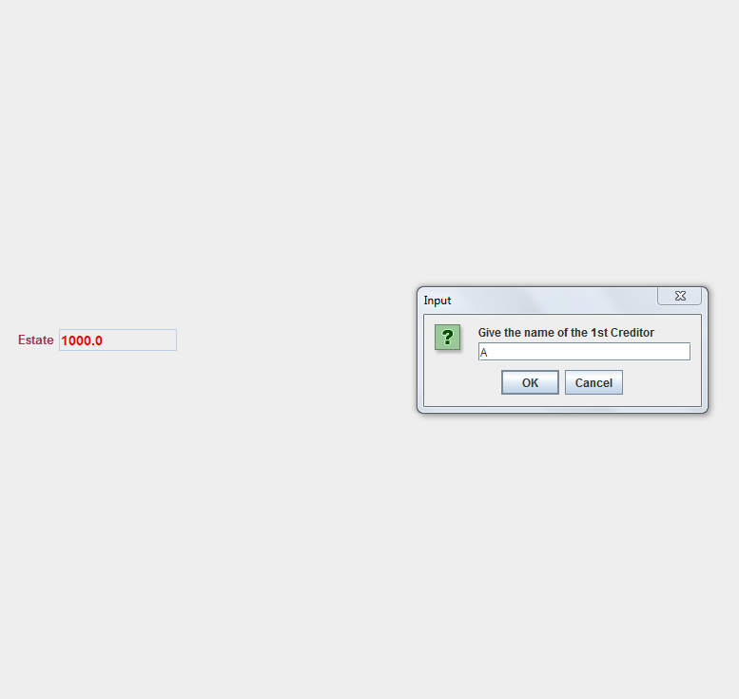
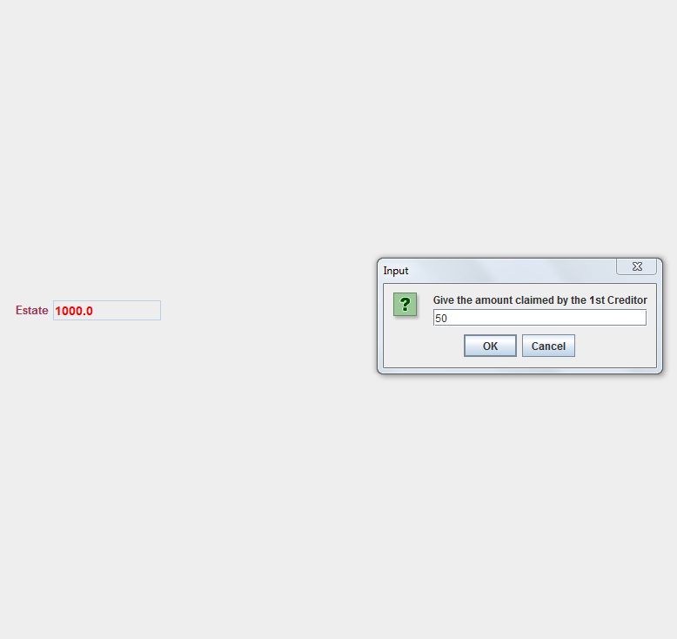
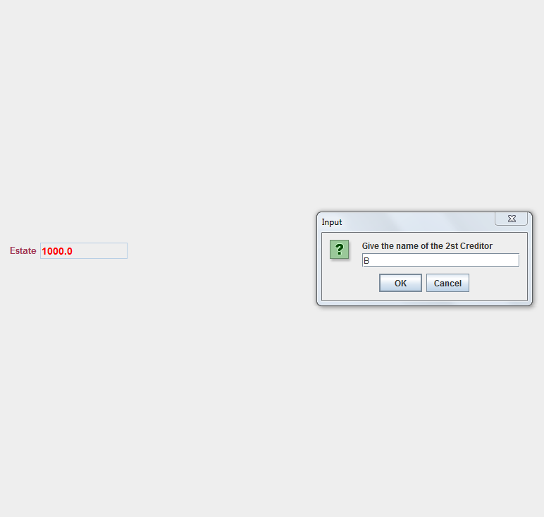
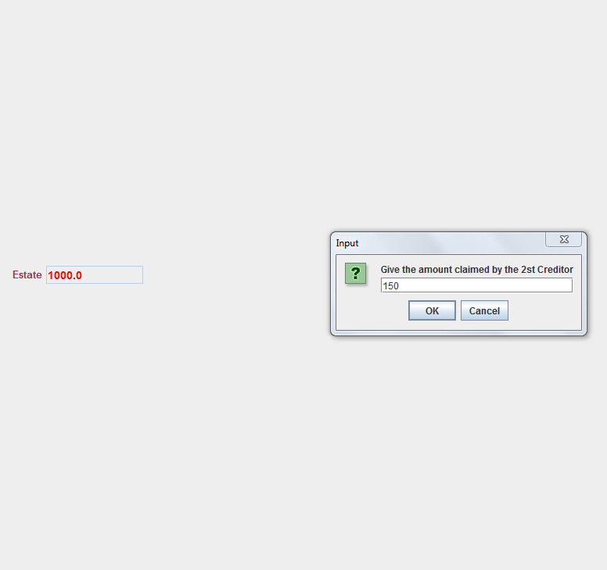
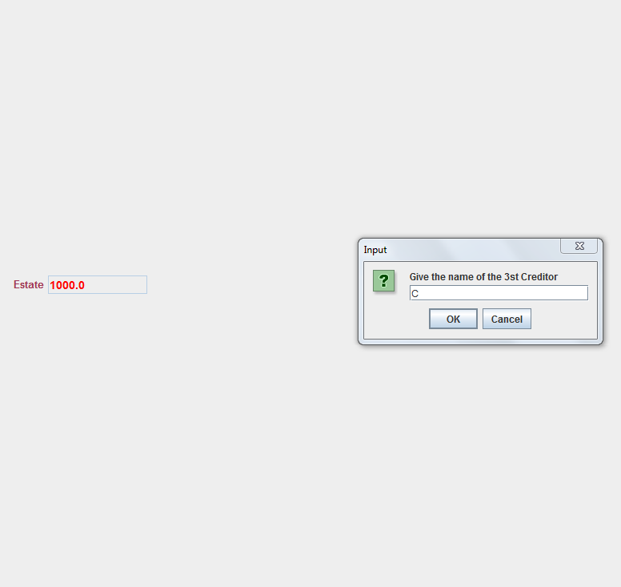
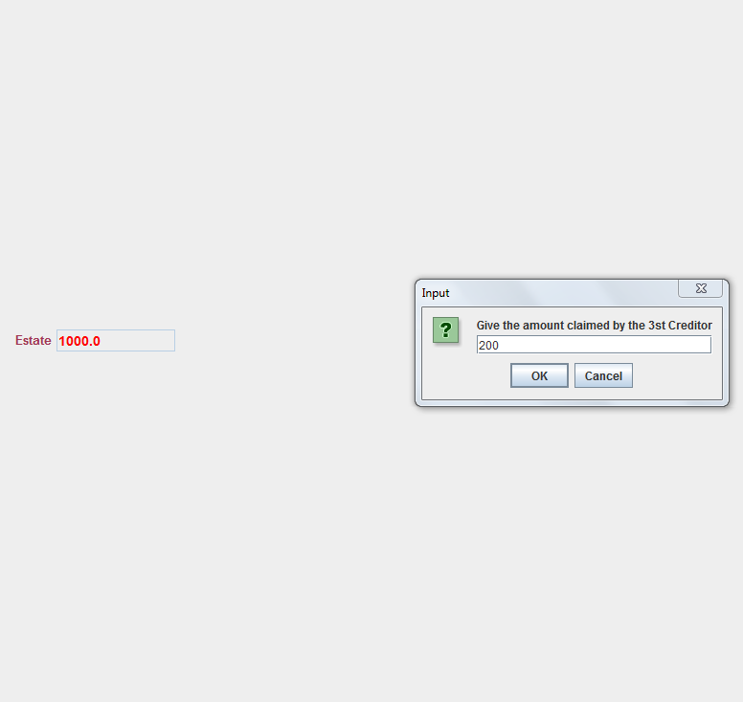
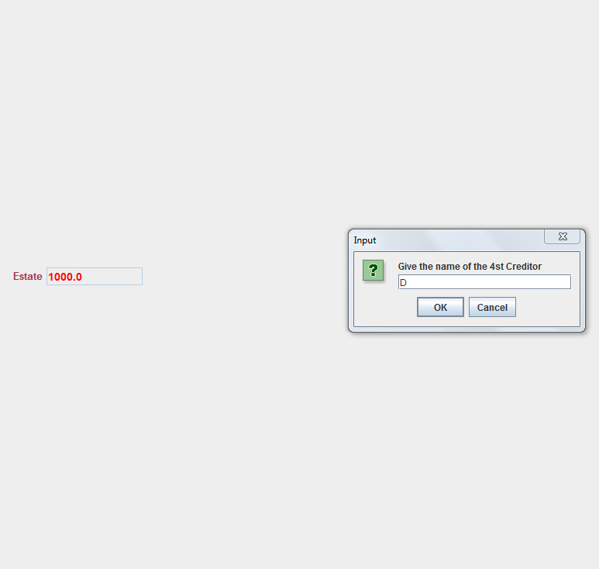
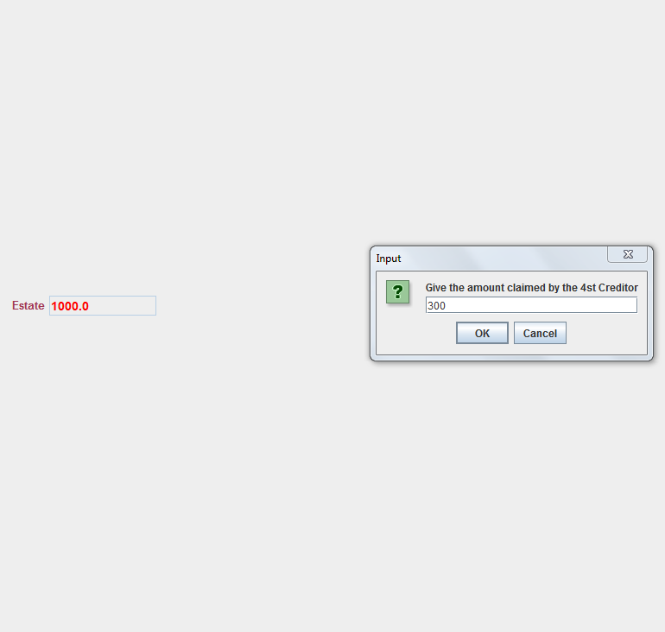
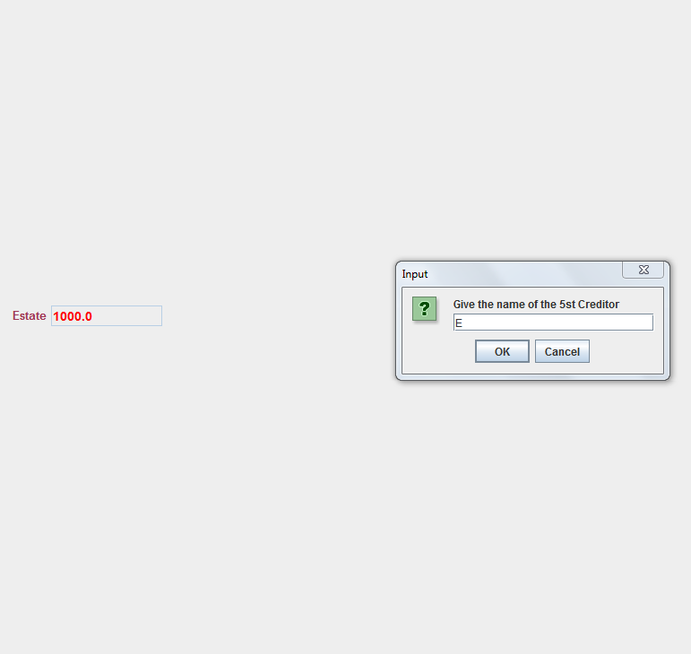
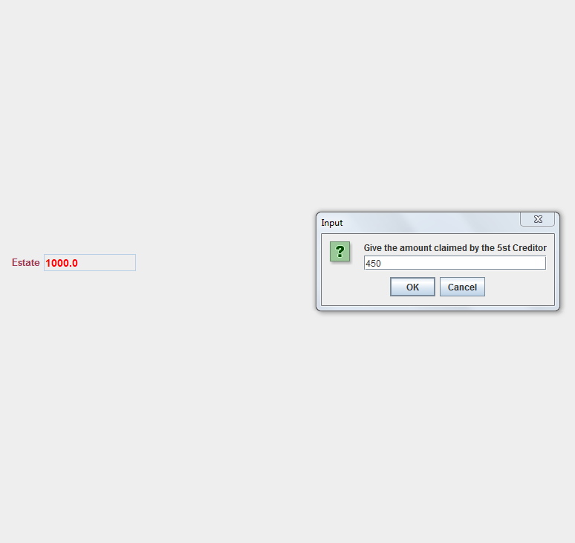

Output screenshots (Aumann Maschler):
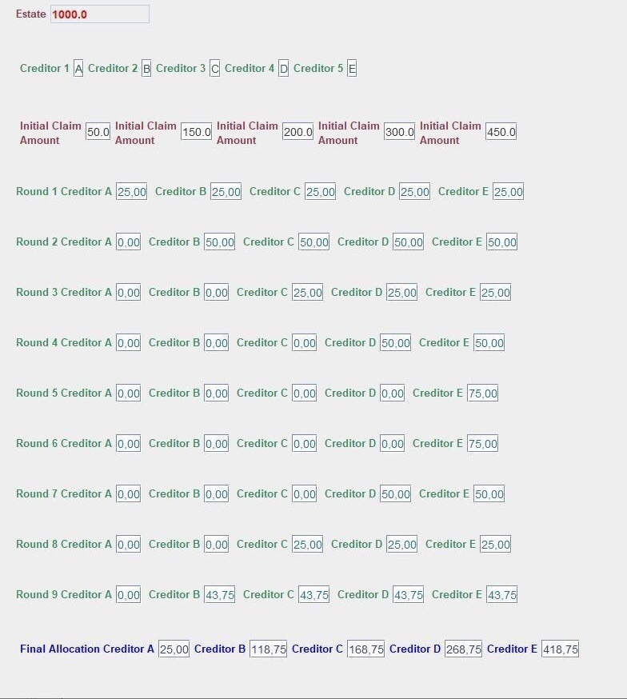

Input screenshots Step by Step(Sealed Bids):


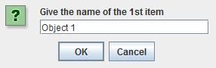
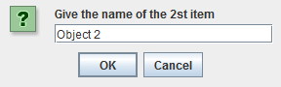
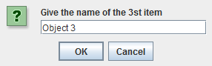




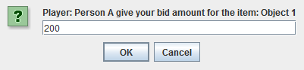
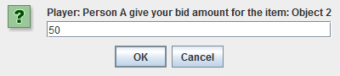
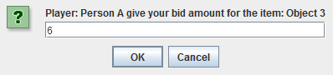
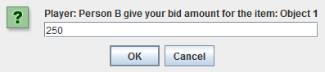
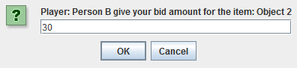
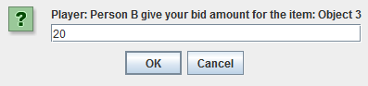
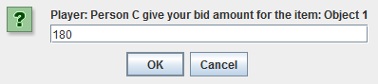
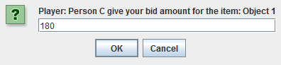
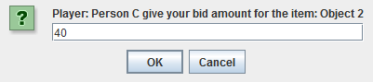
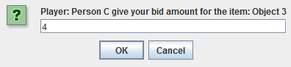
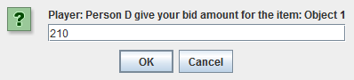
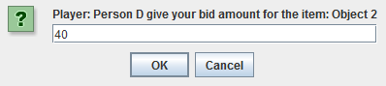
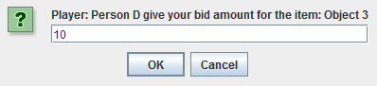
Output screenshots (Sealed Bids):

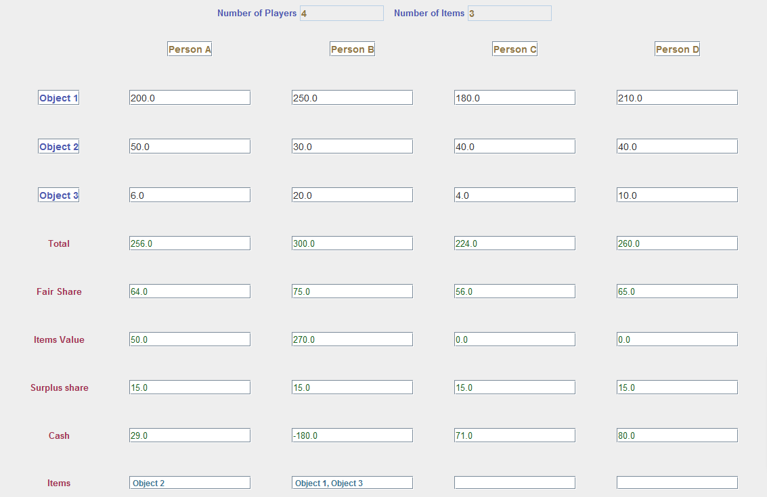

Demonstration
Present workflow via screenshots and description.

Equal division of the contested sum
Present an indicative run

The method of sealed bids
Present an indicative run

CONCLUSIONS and future plans
We focused on the area of fair division, which presents significant practical interest and raises challenging mathematical questions. In particular, we developed an application which encompasses two techniques, an algorithm for fair division suggested as a generalization of a method first described in Talmud for a bankruptcy problem and the method of sealed bids for the fair division of discrete items. Our application can be used by students for educational and training purposes and, also, as a tool in the context of real-world relevant situations.
It is within our future plans to improve and enrich the graphical environment of our application, to provide an online version and to develop a corresponding serious-game suite.
Apart from its traditionally important role in society and economics, fair division can play a significant role towards the elimination of bias or discrimination in machine learning, which has emerged as a modern trend and is likely to multilaterally affect human life and activity. Game theory has been a branch of mathematics particularly influential in the social and economic sciences. Not only scientists but also citizens must be informed and aware of the foundations, potentials and challenges regarding such important conceptual tools and their applications so that they are exploited appropriately, meting necessary ethical conditions, for the improvement of human societies.
REFERENCES
- R.J. Aumann, “Game Theory in the Talmud,” Research Bulletin Series on Jewish Law and Economics, 2002.
- R. J. Aumann and M. Maschler, “Game theoretic analysis of a bankruptcy problem from the Talmud,” Journal of Economic Theory, vol. 36, no. 2, pp. 195-213, 1985.
- M. Balinski, “What is Just?,” The American Mathematical Monthly, vol. 112, no. 6, pp. 502-511, 2005.
- S. Brams, A. Taylor, "An Envy-Free Cake Division Protocol,", The American Mathematical Monthly, vol. 102, no. 1, pp. 9–18, 1995.
- T. Driessen, “Cooperative Games, Solutions and Applications, Theory and Decision Library”. Dordrecht: Springer, 1988.
- W. H. Freeman, “For All Practical Purposes: Mathematical Literacy in Today's World (7th edition). Bedford, MA: Consortium for Mathematics and Its Applications, 2006.
- M. Gardner, "Aha! Insight". New York: W.F. Freeman and Co, 1978.
- E. Gura, and M. Maschler, “Analysis of a Bankruptcy Problem from the Talmud” in Insights into Game Theory: An Alternative Mathematical Experience (E. Gura, M. Maschler eds.), pp. 166-204, Cambridge: Cambridge University Press, 2008.
- T. P. Hill and K. E. Morrison, “Cutting Cakes Carefully,” The College Mathematics Journal, vol. 41, no 4, pp. 281-288, 2010.
- M. Inigo, J. Jameson, K. Kozak, M. Lanzetta, and K. Sonier, “College Mathematics for Everyday Life, 2nd edition”. Flagstaff, AZ: Coconino Community College, 2020.
- B. O'Neill, “A Problem of Rights Arbitration from the Talmud,” Mathematical Social Sciences, pp. 345-371, 1982.
- A. D. Procaccia, “Technical Perspective: An Answer to Fair Division's Most Enigmatic Question,” Communications of the ACM, vol. 63, no. 4, p. 118, 2020.
- D. Schmeidler, “The nucleolus of a characteristic function game,” SIAM Journal of Applied Mathematics, vol. 17, pp. 1163–70, 1969.
- A. I. Sobolev, “The characterization of optimality principles in cooperative games by functional equations,” Matematicheskie Metody v Socialnix Naukax 6. Academy of Sciences of the Lithuanian S.S.R., Vilnius (N.N. Vorobiev ed.), pp. 94-151, 1975.
- H. Steinhaus, “The problem of fair division,” Econometrica”, vol. 16, pp. 101–104, 1948.
- F. E. Su, “Mathematics for human flourishing”. New Haven, Connecticut: Yale University Press, 2020.
- F. E. Su, “Rental Harmony: Sperner’s Lemma in Fair Division,” American Mathematical Monthly, vol. 106, pp. 930–942, 1999.
- P. Talwalkar, “The Joy of Game Theory: An Introduction to Strategic Thinking,” CreateSpace Independent Publishing Platform, 2014.
- W. Thomson, “Axiomatic and Game-Theoretic Analysis of Bankruptcy and Taxation Problems: A Survey,” Mathematical Social Sciences, pp. 249.297, 2002.
- J. Veisdal, “The Envy-Free Cake-Cutting Procedure: How to Ensure Fairness as a Mechanistic Outcome,” Cantor's Paradise, 2019. Retreived from https://www.cantorsparadise.com/envy-free-cake-cutting-procedures-de3cf13c5d3d
- J. von Neumann and O. Morgenstern, Theory of games and economic behavior. Princeton, New Jersey: Princeton University Press, 1944.

