**Household Appliance Management Test specification**

This document explains how to Demo application to do the insert/update/delete and search HouseholdAppliance

Table of Contents

1. Verify Searchable list of all recorded appliances 3

2. Verify Create a new record of my appliance not found in the list 3

3. Verify Update the details of an appliance 3

4. Remove old/unused/sold appliance from the list 3

# Verify Create a new record of my appliance not found in the list

* Launch HouseholdApplianceManagement application

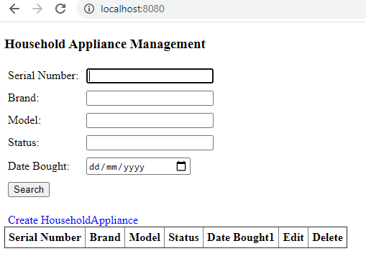

* Click on Create HouseholdAppliance application

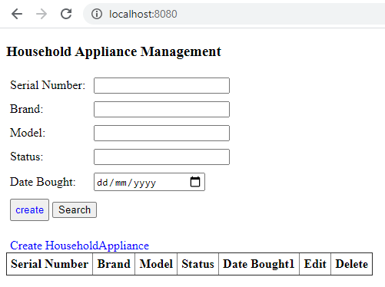

Key in values and click on the create button

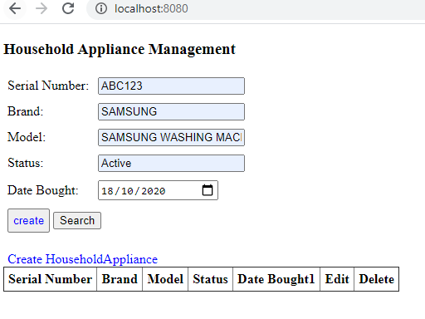

* Home Appliance is created successfully and displaying in the result.

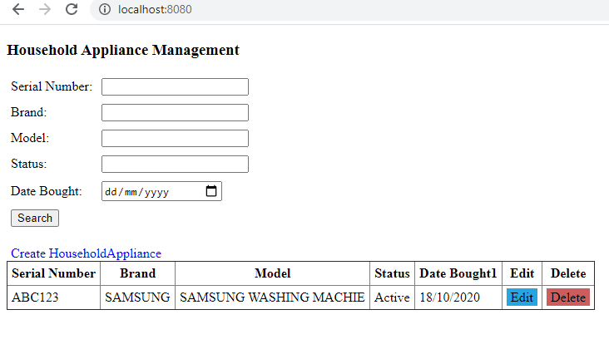

* Created some more Home Appliances

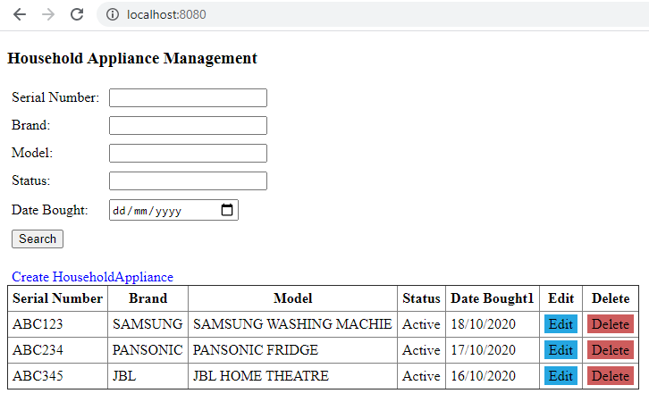

# Verify Searchable list of all recorded appliances

* Launch HouseholdApplianceManagement application

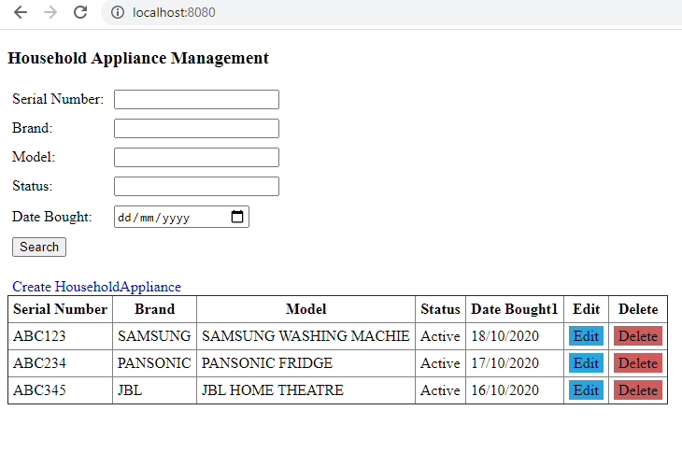

* Key in serial number ABC123 and click on search button

Home Appliance with serial number ABC123 is loaded in the screen

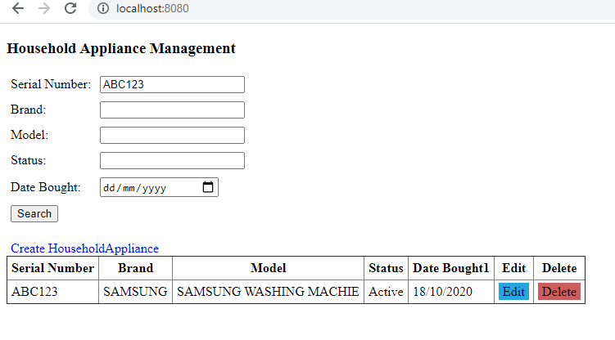

* Key in Brand as JBL and click on search button

Home Appliance with brand JBL is loaded in the screen

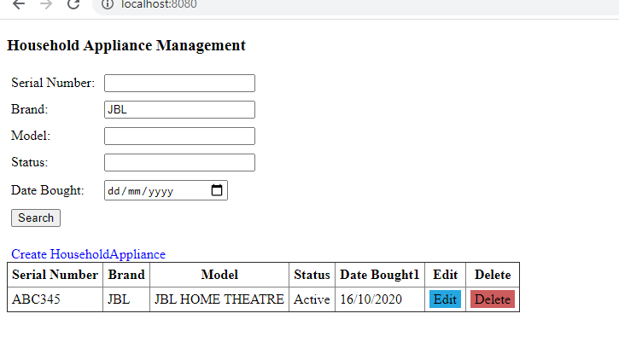

* Key in Model as “PANSONIC FRIDGE” and click on search button

Home Appliance with Model “PANSONIC FRIDGE” is loaded in the screen

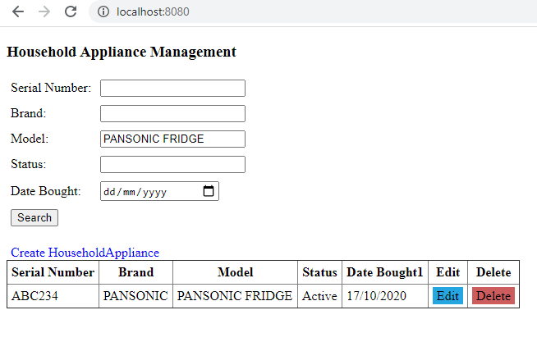

* Key in Status as “Active” and click on search button

Home Appliance with Status “Active” is loaded in the screen

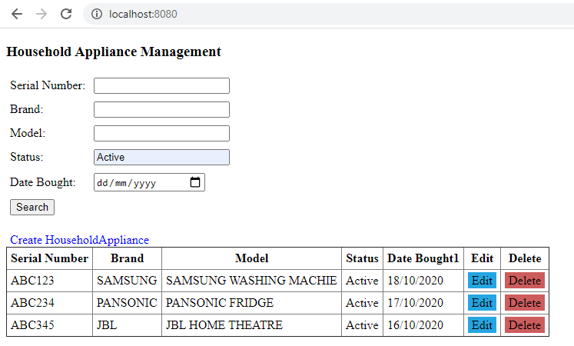

* Key in Date Bought as “17/10/2020” and click on search button

Home Appliance with Date Bought as “17/10/2020” is loaded in the screen

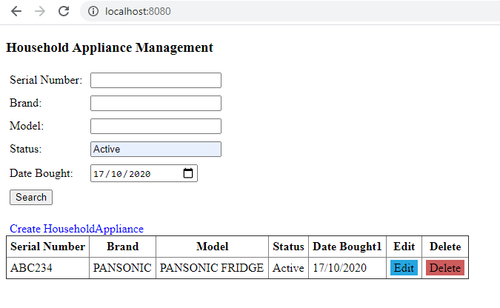

# Verify Update the details of an appliance

Update brand, model, status date bought details

Load the Home Appliance which u want to update, just edit button of corresponding Home Appliance

Load Home Appliance of serial number ABC234

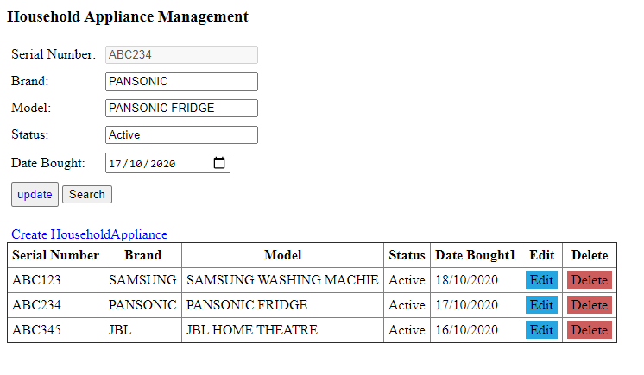

Key in the new values of brand, model, status date bought details and click on update

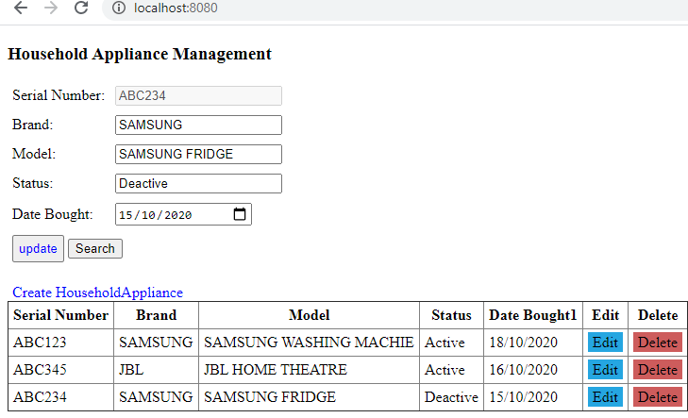

# Remove old/unused/sold appliance from the list

* Click on delete button of corresponding Home Appliance to delete

