G3_SheetsSteven

Homepage link:

* [**https://courseweb.cs.iastate.edu/~smsheets/**](https://courseweb.cs.iastate.edu/~smsheets/)
* [**https://paper-ssheets.github.io/**](https://paper-ssheets.github.io/)

Other Notes:

* Used online resources to create the site. It’s still not finished. Namely, I need more projects to fill up the “filler” links on the works.   
  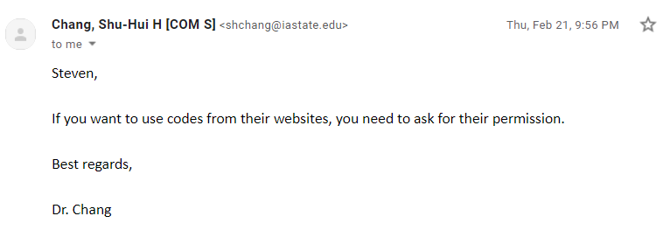
* While my *music.html* page *does* play music (must be hosted), the progress bar needs to be fixed. Will fix later.
* *gallery.html* needs a lot of work, *very* basic right now.
* Got the *contact.html* page to work properly using an online free backend. Try it out! It’ll send it to my personal email!
* Other big notable libraries used would be *amplitude.js* (for *music.html*) and *particles* (for that cool interactive background). Design built upon was by *styleshout*.
* Also, WebStorm by JetBrains is such a nice IDE to use for this course, I wish I had started using it earlier. Maybe try implementing it into the course? Because all students get a free subscription to it.
* There’s still a lot more work to be done to finishing the site, but this was a very fun and long project, and I can’t wait to finish it during the summer!

Best regards,   
Steven Sheets  
  
