Lab 02: Problem Modeling and Encapsulation

1. Assignment Submission
2. UML & Astah
3. 2. Problem Statement of AIMS Project
4. Use case diagram

1. UML Class Diagram for use cases related to cart managementDiagram

   Description automatically generated
2. Create Aims class

1. Create the DigitalVideoDisc class and its attributes

1. Create accessors and mutators for the class DigitalVideoDisc

1. Create Constructor method

1. Create the Cart class to work with DigitalVideoDisc

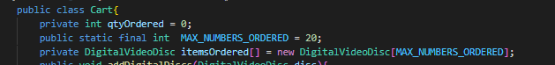

1. Create Carts of DigitalVideoDiscs

Result

11.Removing items from the cart

Result

12. References