Lab 03: Basic Object-Oriented Techniques

1.Branch your repository

2. Working with method overloading

2.1 Overloading by differing types of parameter

a) The current method has one input parameter of class DigitalVideoDisc

Result

b)

Result

2.2

Result:

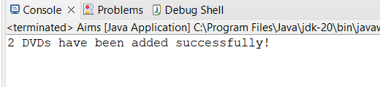

3. Passing parameter

Swap method

ChangeTitle method

A swap() method that can correctly swap the two objects.

4. 4. Use debug run

4.2

4.2.1.

4.2.3

5. Classifier Member and Instance Member

6. Open the Cart class

6.1. Video Disc List

Result:

6.2. Search by ID

Result

6.3. Search by Title

Result:

7. Implement the Store class

Result:

8. Re-organize your projects

9. String, StringBuilder and StringBuffer

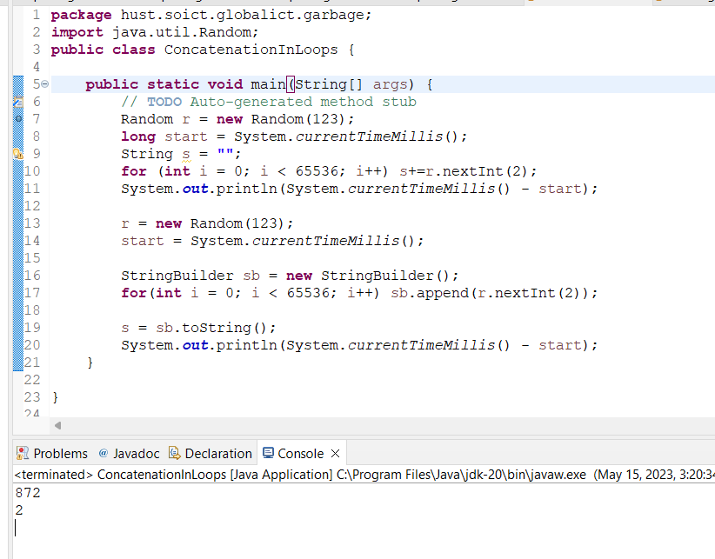

Garbagecreator

Nogarbage

10. Release flow demonstration