Homework 01

112032533 黃柏勳

Consider the reactor described in the attachment. (Note that the unit for heat transfer coefficient should be U=75/60 But/(min-ft3-°F) for the consistency of the units).

Note controller gain Kc should be negative in this case.

## Question01 & 02

1. Simulate the reactor by assuming the MV=fc (cooling water flow rate) and CV=T(reactor temperature), can be detected and manipulated by the controller (this can’t be true in the real case).

* Ans :

By the code in the attached comment, we can create the Simulink file to behave like the graph in the question02.

Please see the attached file, “HW01_Q01_Q02.slx”.

1. Get the reaction curve by a step change of cooling water flow rate from 0.8771 to 0.8 ft3/min as below:



* Ans

By the above setting, we can draw the above picture by adding (dfc = -0.0771) into variable, fc, and observe its behavior.

The following is simulation result.

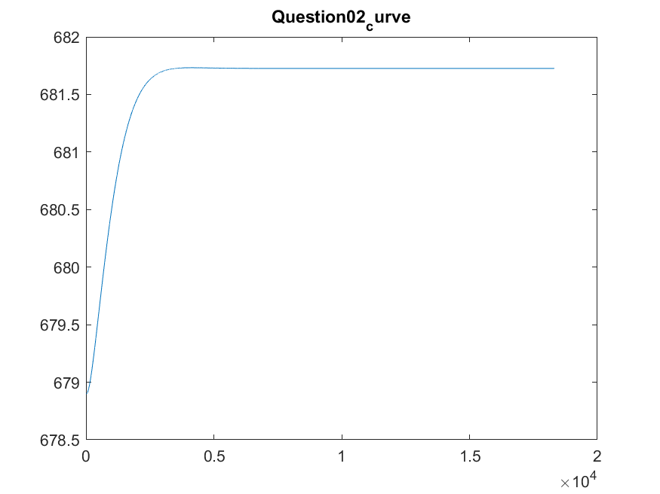

## Question03

1. Use the method of reaction curve to tune an
2. Optimal P-only controller
3. PI controller
4. PID controller

* Ans.

We can adjust

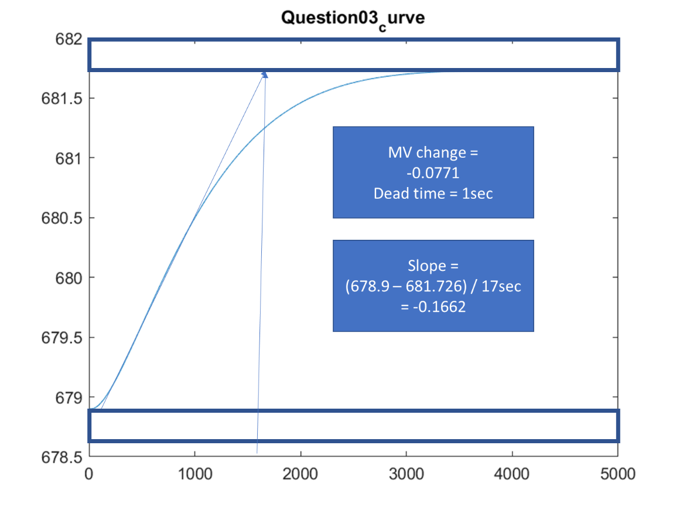

By the above curve, we can decide the following parameters.

*For P controller====================*

*Kc: -0.4638*

*For PI controller====================*

*Kc: -0.4174*

*Tau_I: 3.3333*

*For PID controller====================*

*Kc: -0.5566*

*Tau_I: 2.0000*

*Tau_D: 0.5000*

However, we need to remember that the system in the question is multi-variable system which means the variable will affect each other.

Therefore, simply a feedback controller may not be able to control the system to steady state.

* P controller:

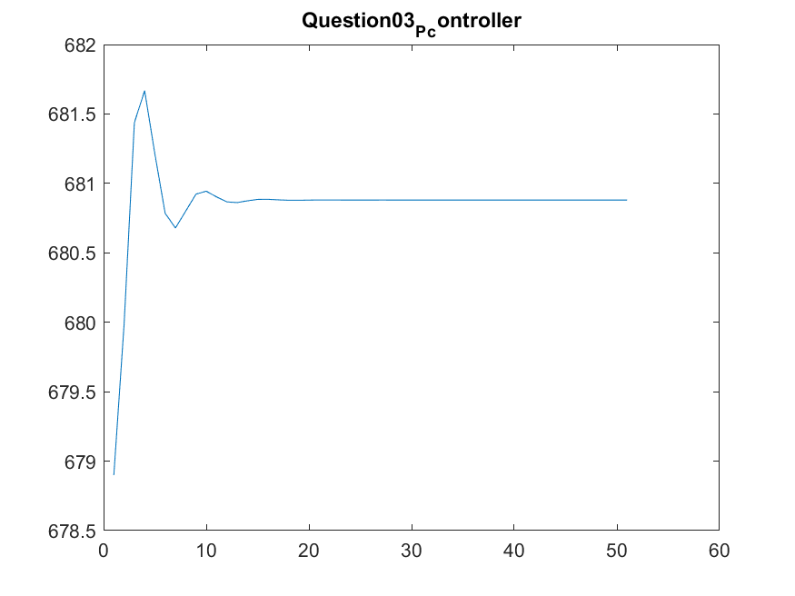

* PI controller:

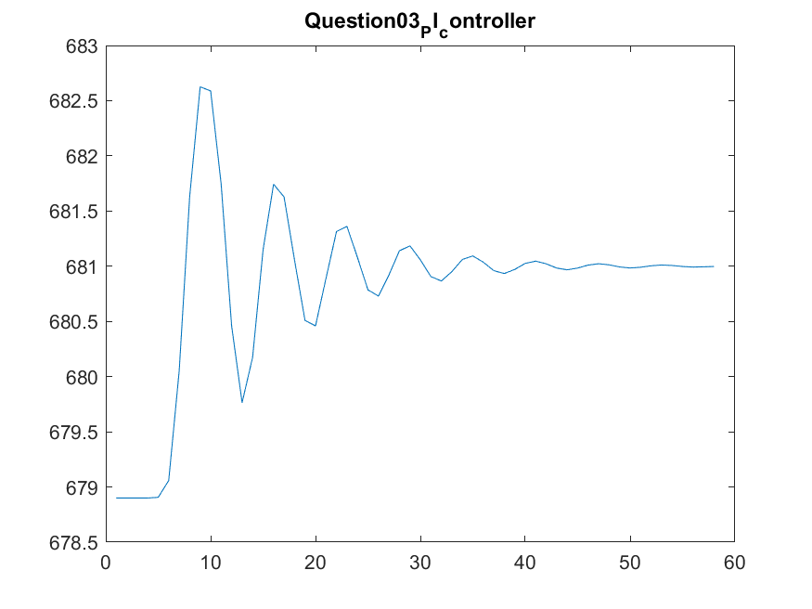

* PID controller:

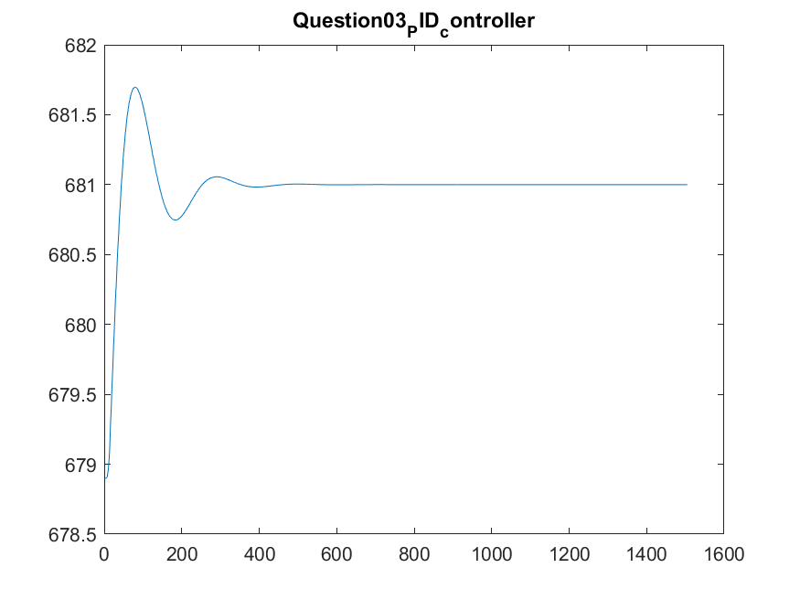

## Question04

1. Compare the performance of the above three controllers and uncontrolled case.

* No control scenario

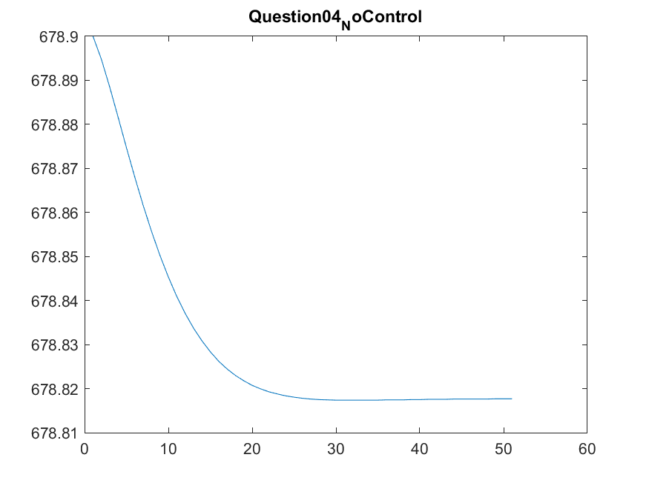

* Controlled case :
* P controller:



* PI controller:



* PID controller:

