HW02

112032533 黃柏勳

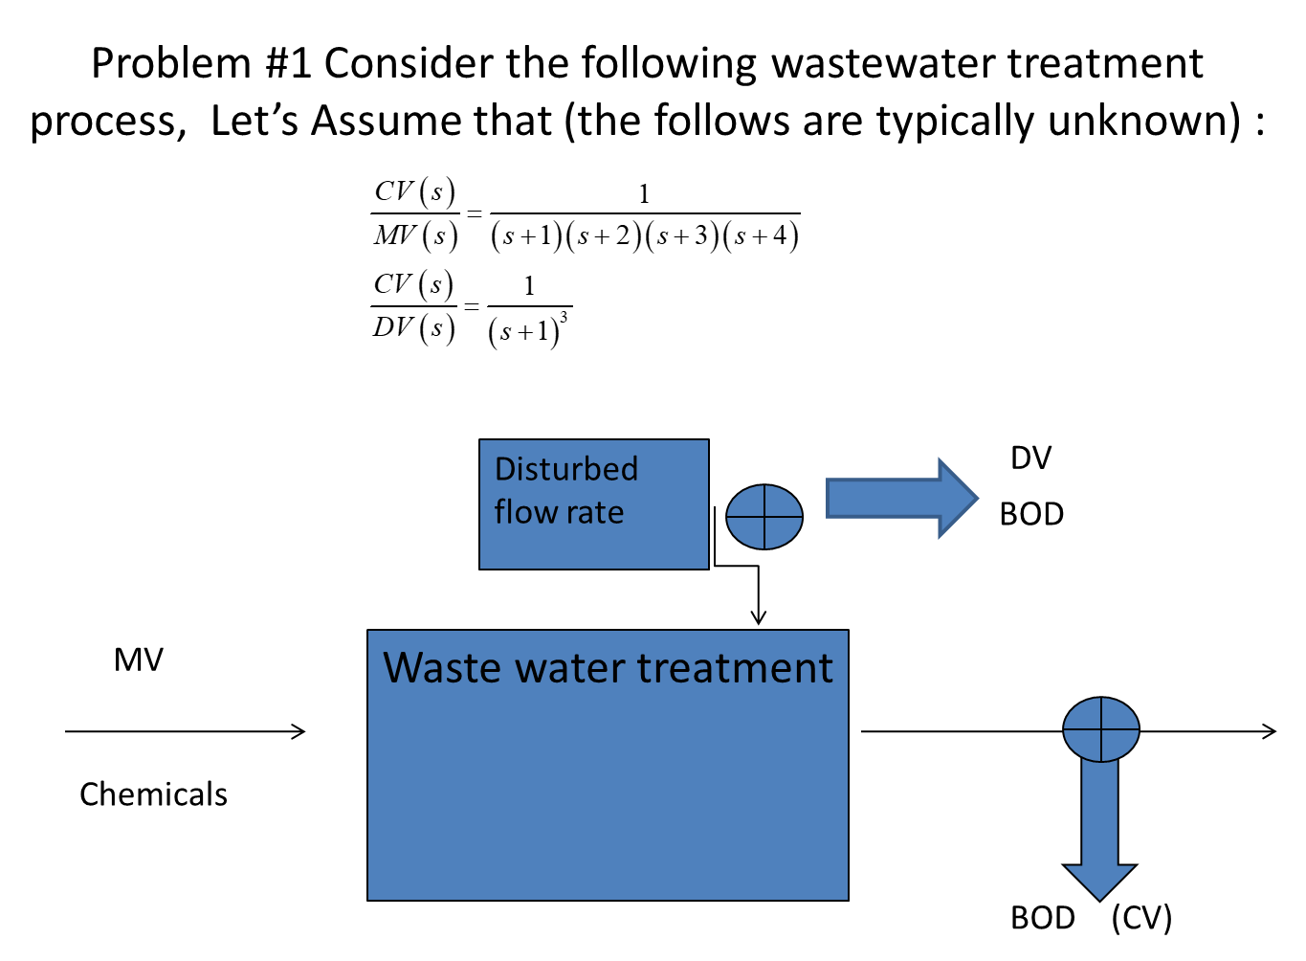

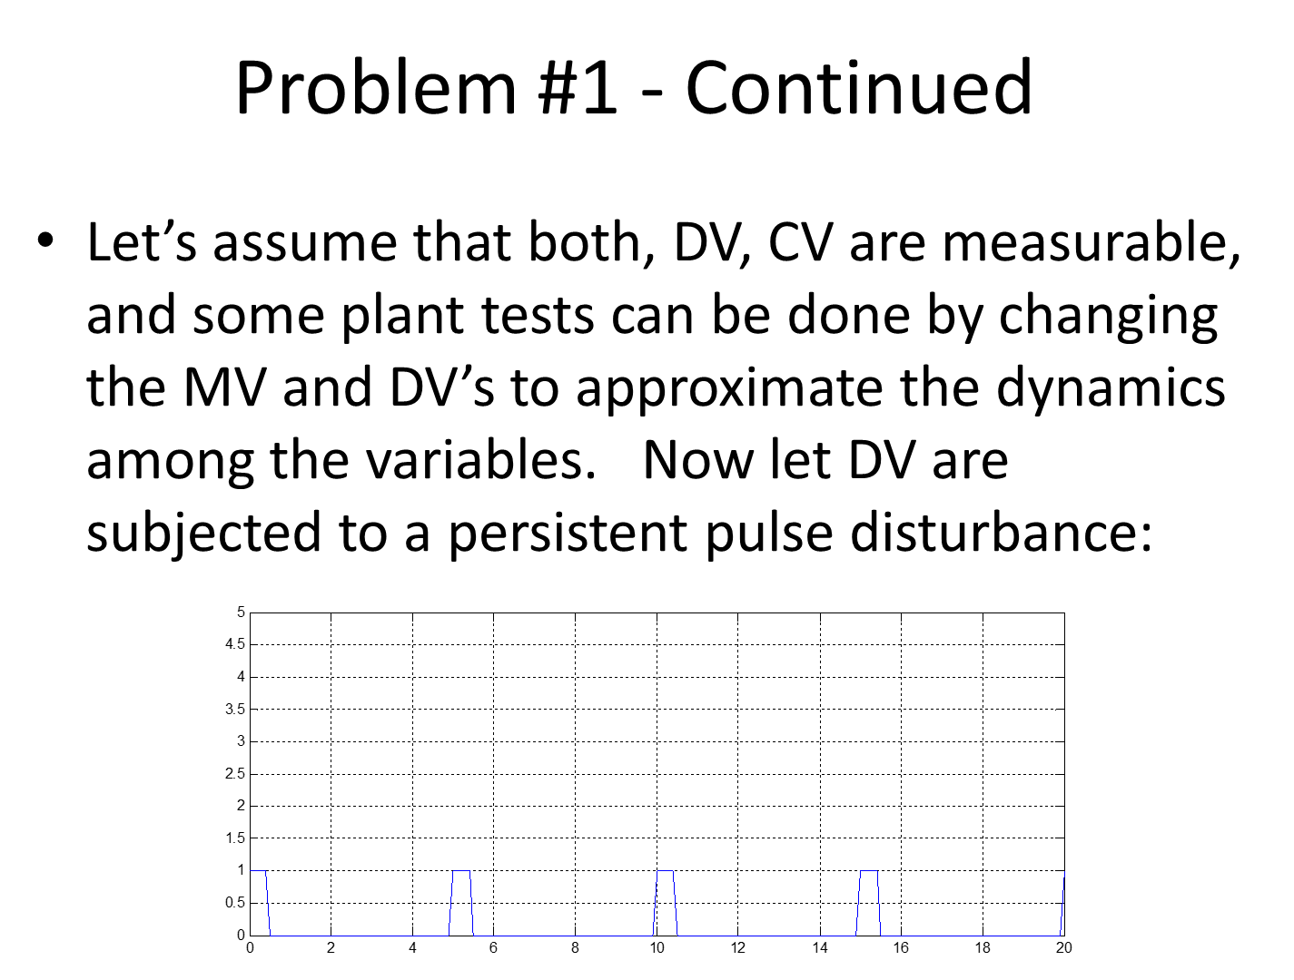

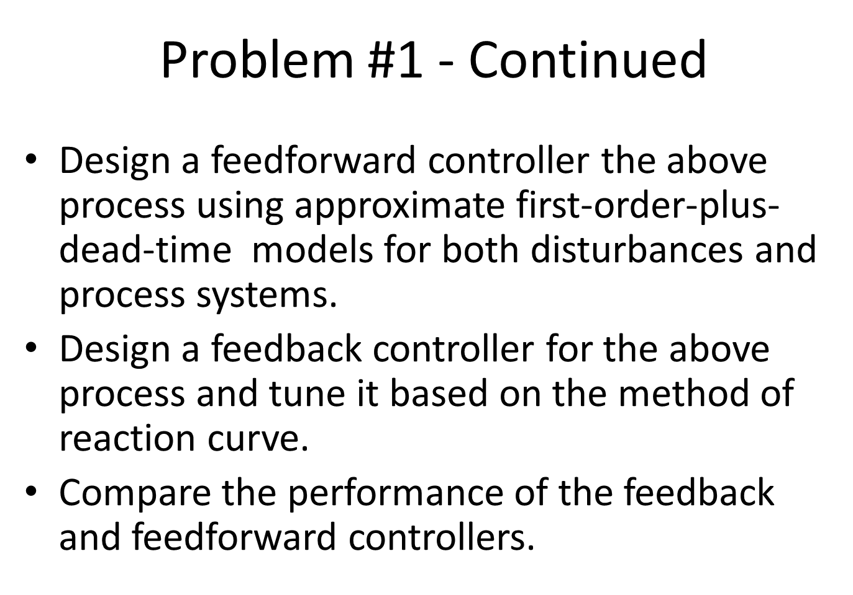

## Question01

Design a feedforward controller the above process using approximate first-order-plus-dead-time models for both disturbances and process systems.

* Ans

According the give transfer function, we can calculate the feedforward controller by

$$\frac{CV}{DV}=\frac{MV}{DV}\frac{CV}{MV}$$

$$\frac{MV}{DV}=\frac{CV}{DV}/\frac{CV}{MV}$$

The simulation result is as the following, created by the attached file, HW02_feedforward_control_2023_1106.

* No control

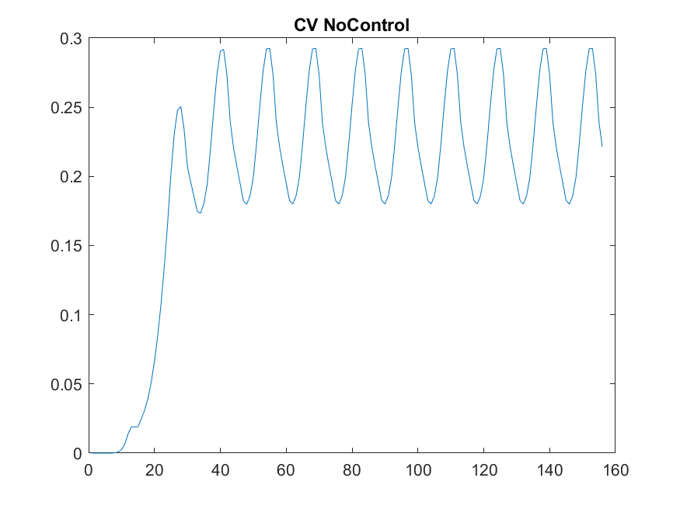.

* Control

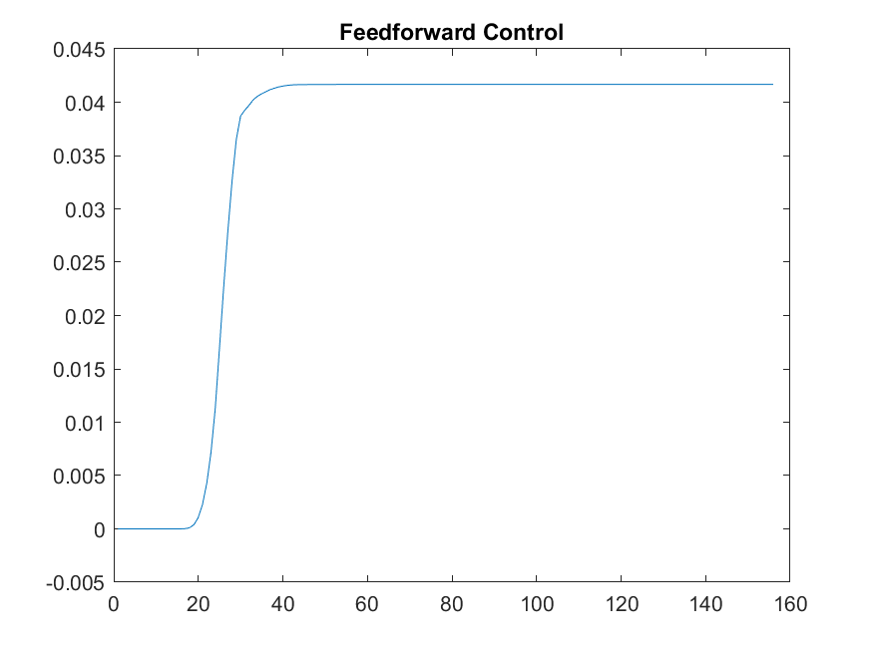

## Question02

Design a feedback controller for the above process and tune it based on the method of reaction curve.

Compare the performance of the feedback and feedforward controllers.

Simulation Please the attached file, HW02_feedforward_control_2023_1106.

* Feedforward control



* Feedback control

