HW03

112032533 黃柏勳

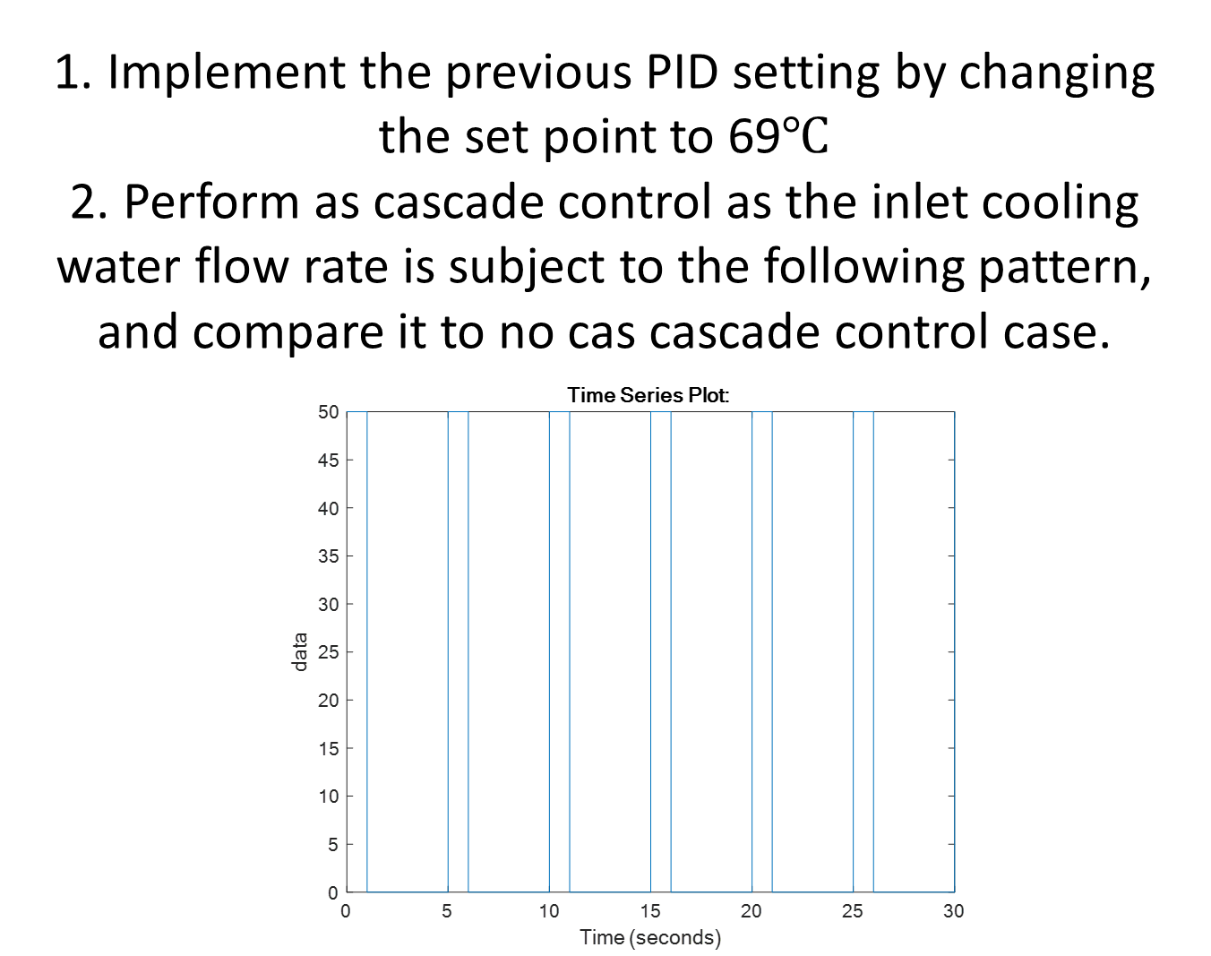

* Ans.
* If we have no control :

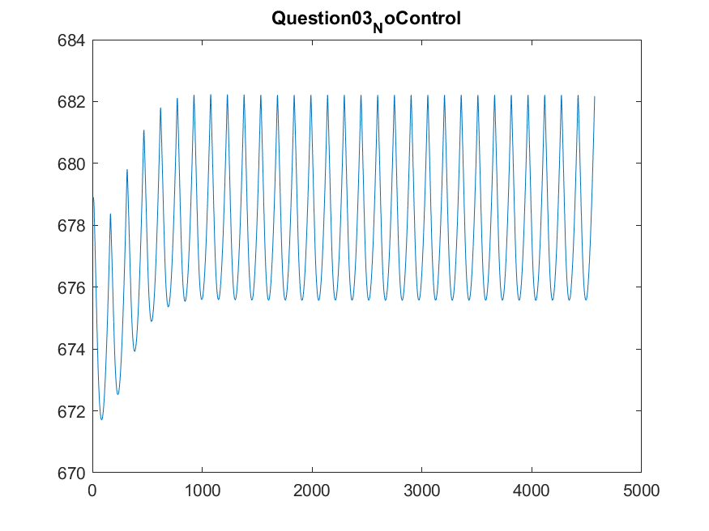

* To control, we use the same method to observe PID parameters

With step changes,

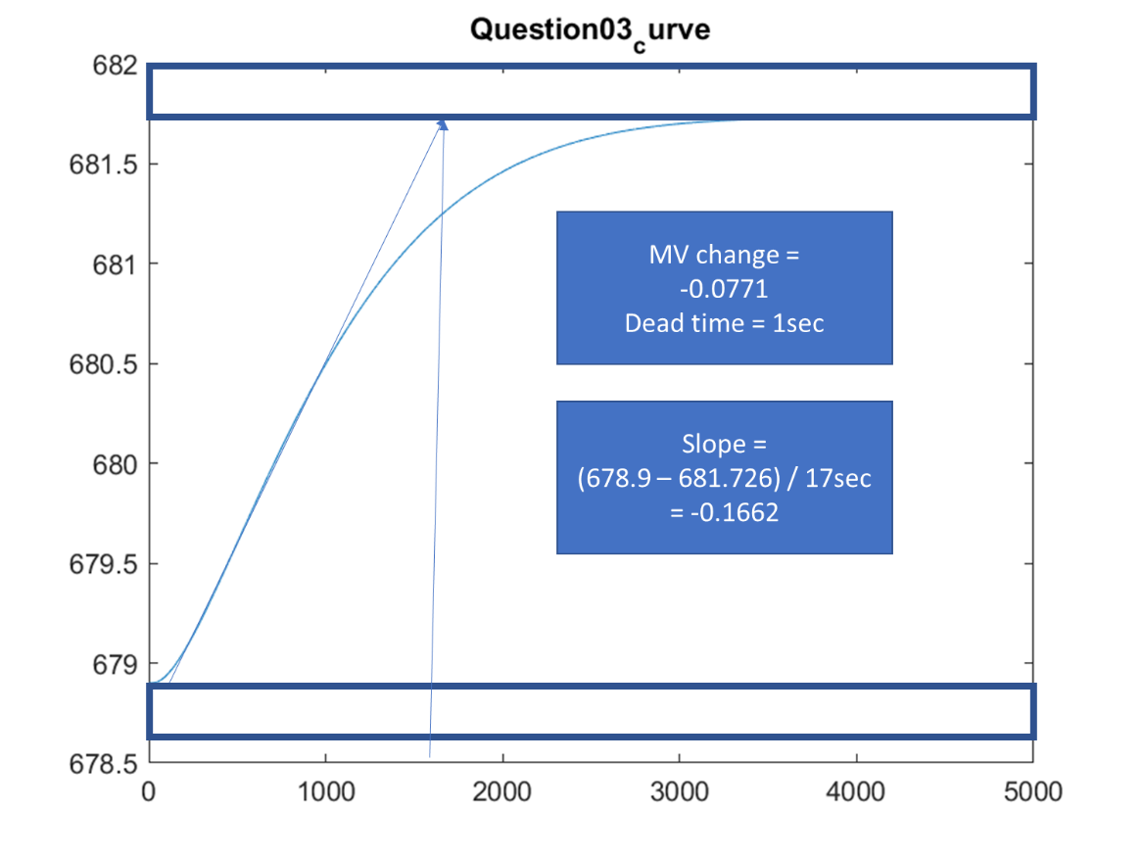

By the above curve, we can decide the following parameters.

*For P controller====================*

*Kc: -0.4638*

*For PI controller====================*

*Kc: -0.4174*

*Tau_I: 3.3333*

*For PID controller====================*

*Kc: -0.5566*

*Tau_I: 2.0000*

*Tau_D: 0.5000*

* Finally, we can get the curve of controlled plot.

Though the final steady state value doesn’t reach the target, 615 oR, the system still reaches steady state with final value 632oR.

