# Q01

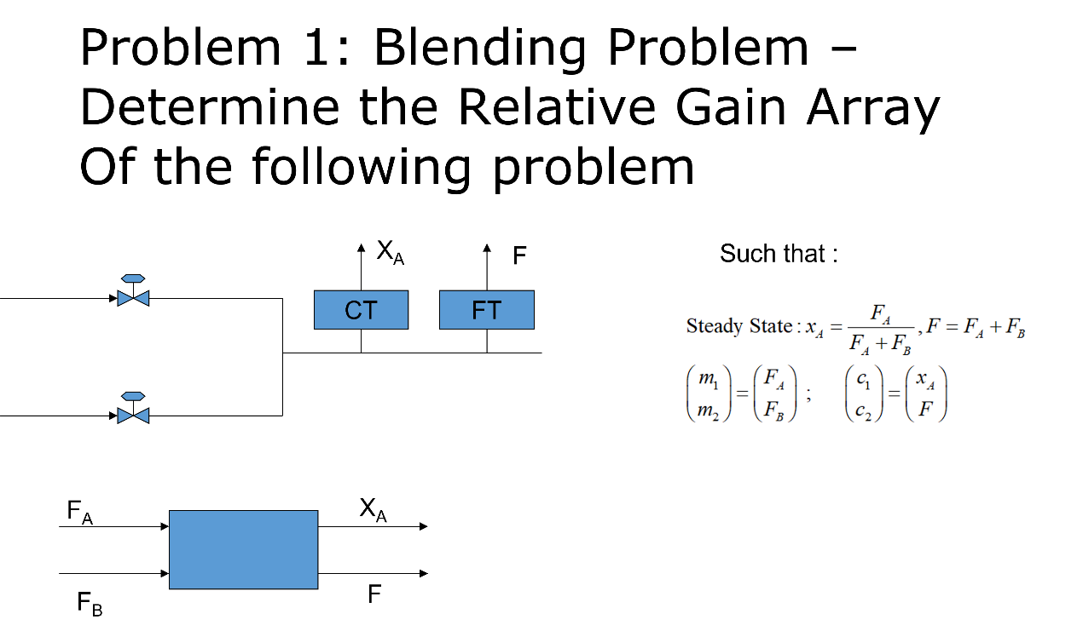

## Ans01

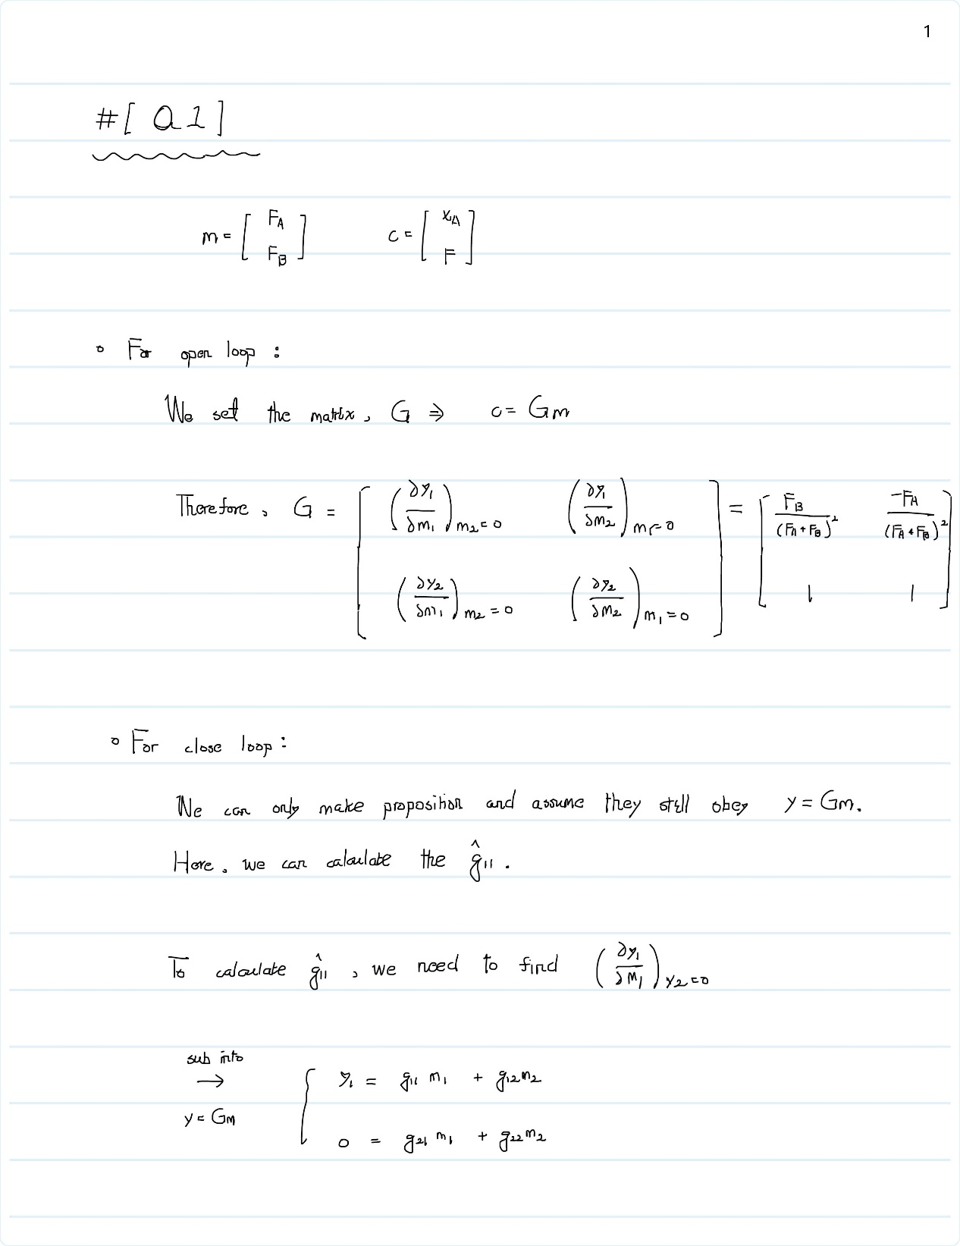

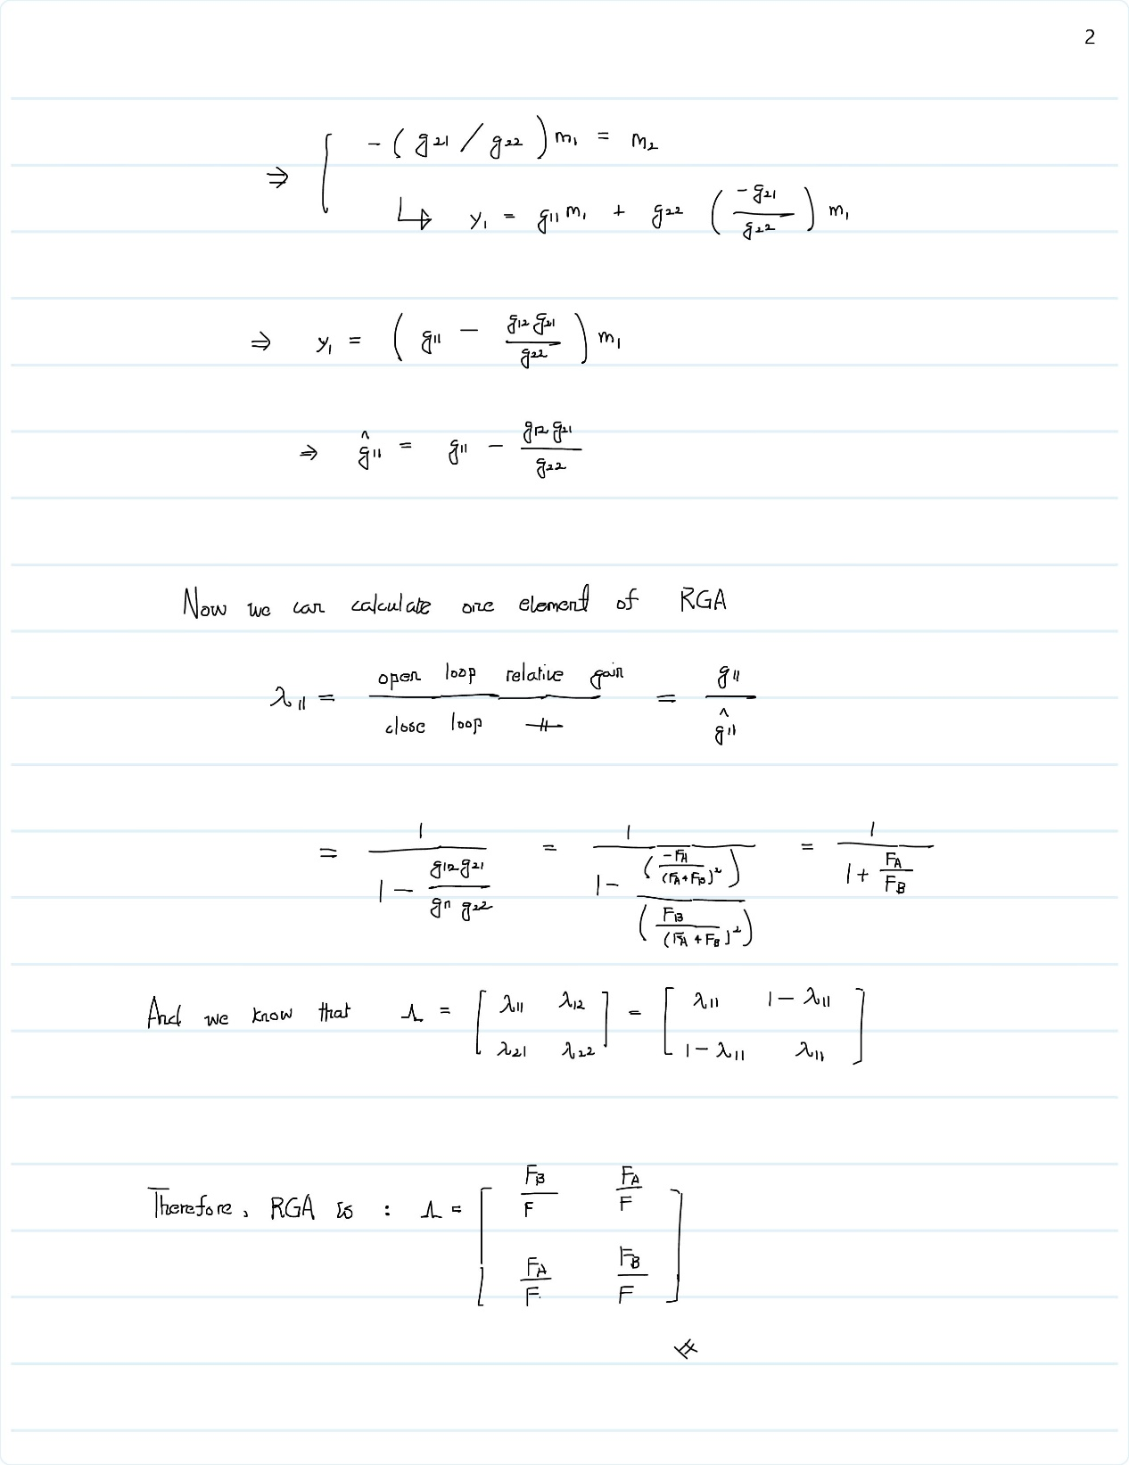

# Q02

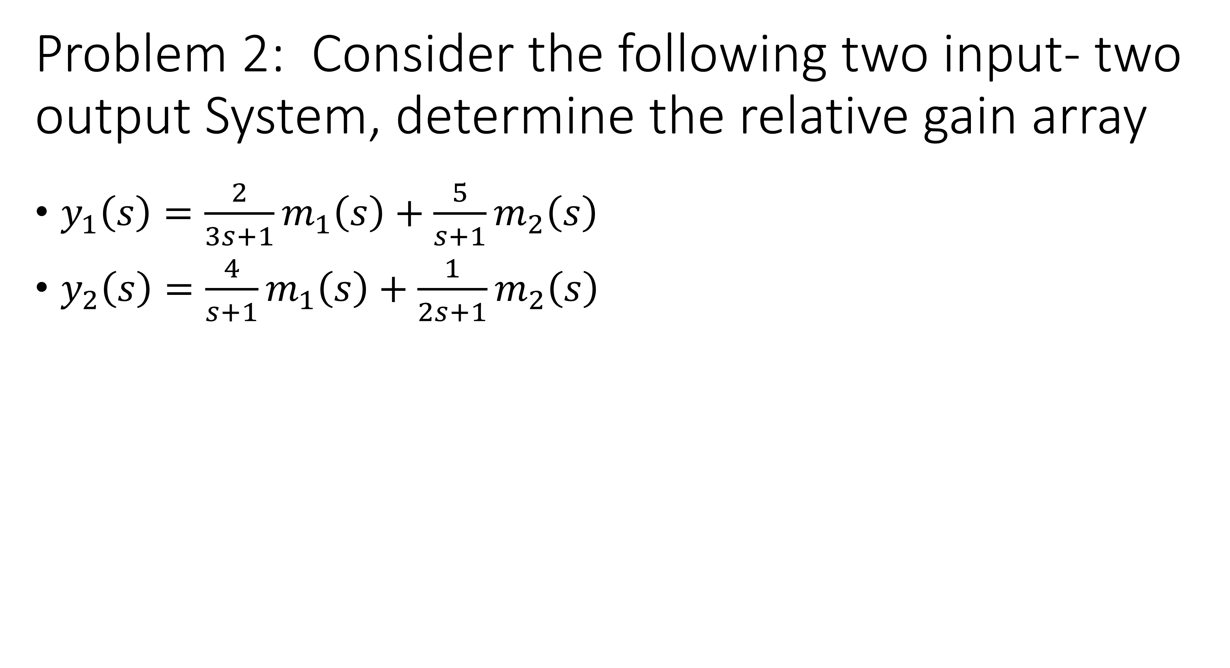

## Ans02

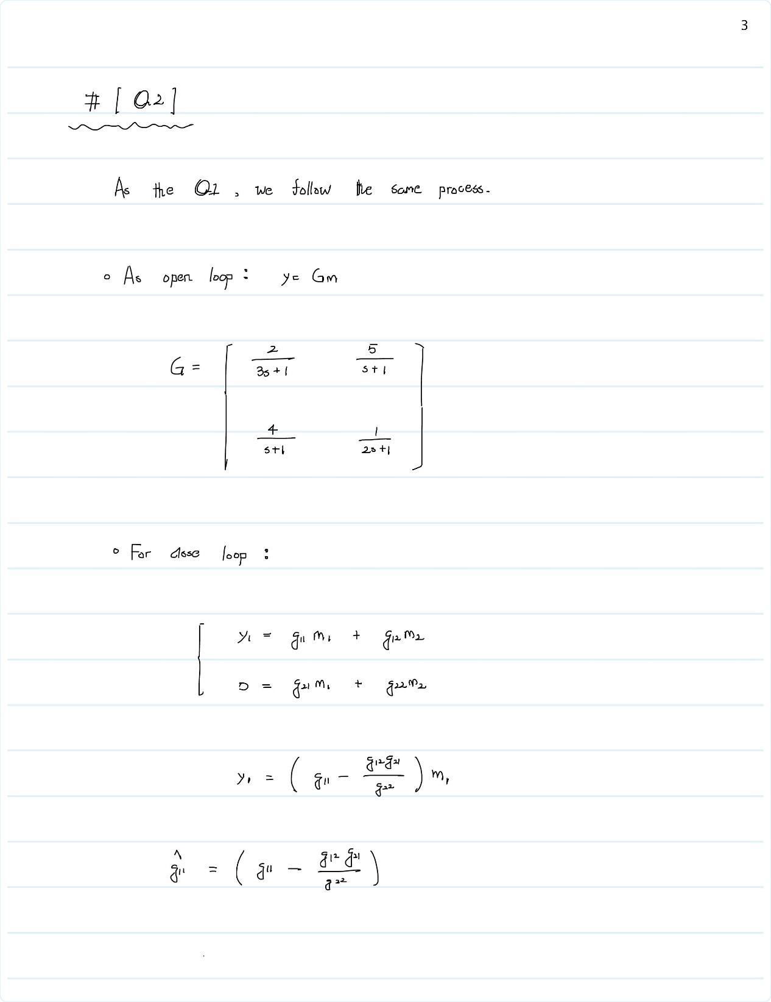

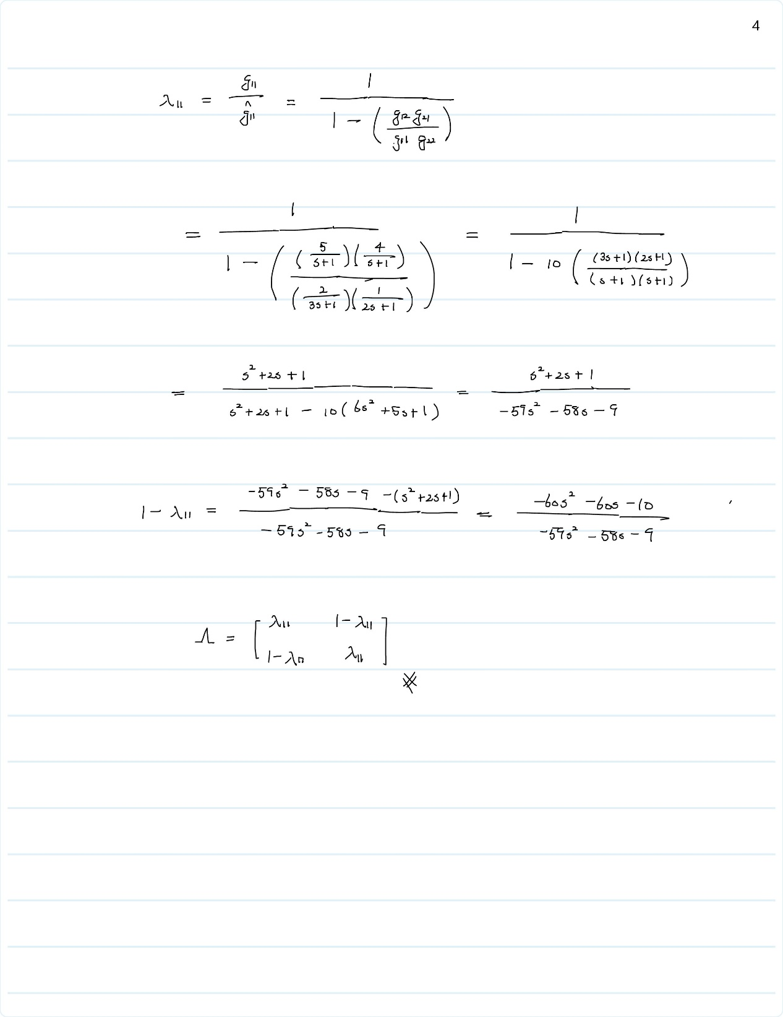

# Q03

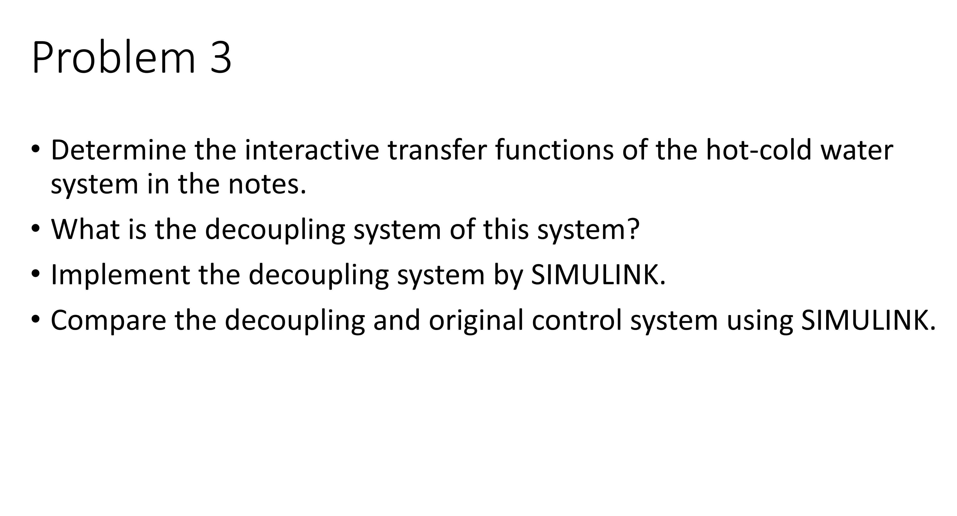

## Ans03-01

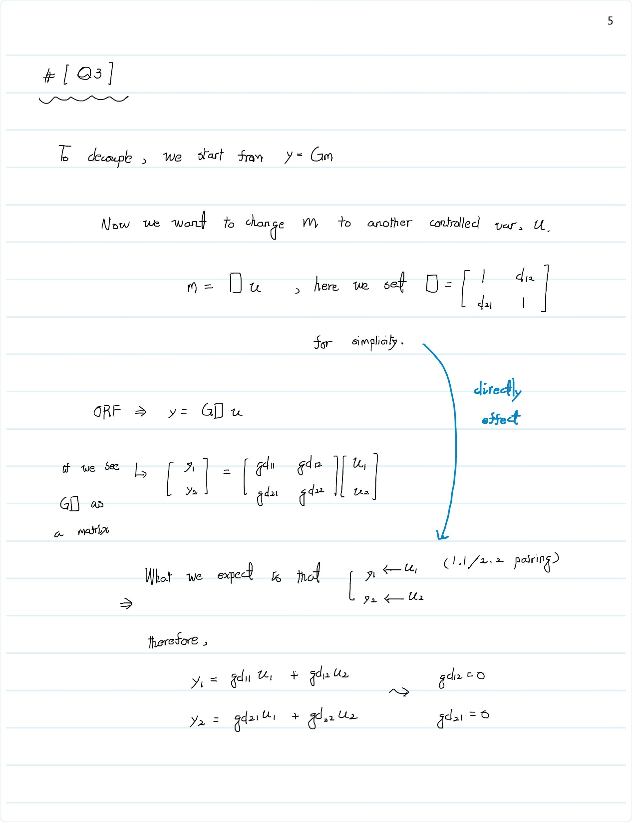

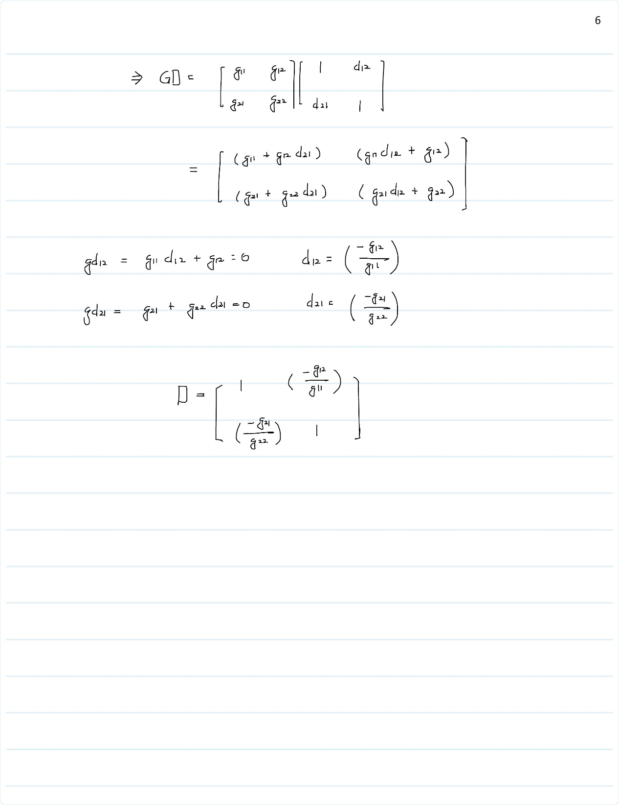

## Ans03-02

### Original control

* First we see the original PID control to the process with no decoupling.
* Org Control to variable (y1)

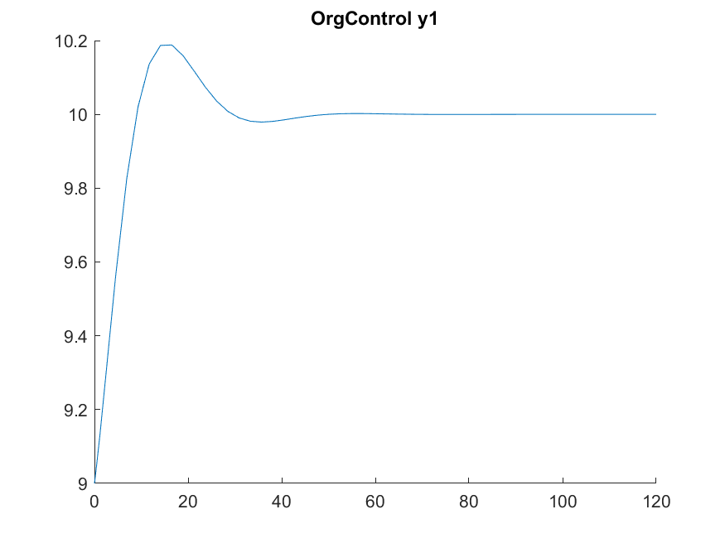

* Org Control to variable (y2)

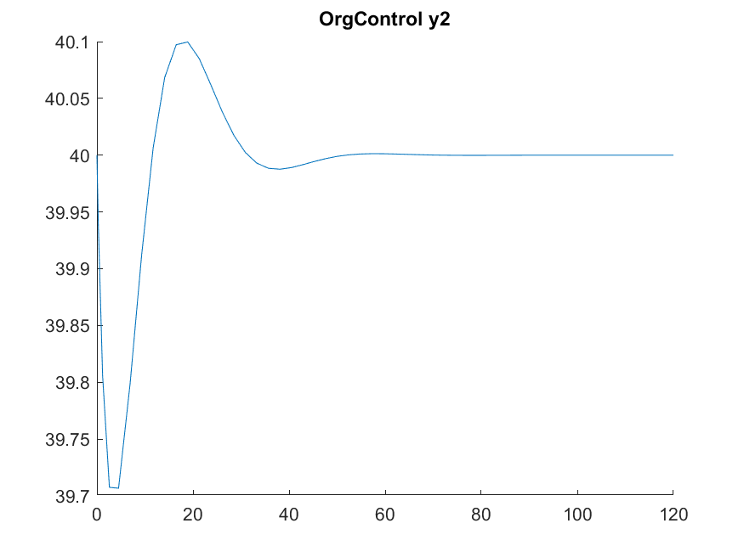

### Approximate ODE process with transfer function

* We could approximate ethe ODE process to transfer function with FOPDT method.

According to the formula:

Where

|  |  |
| --- | --- |
|  | Change of CV divide by change of MV |
|  | Time constant |
|  | Process time delay |

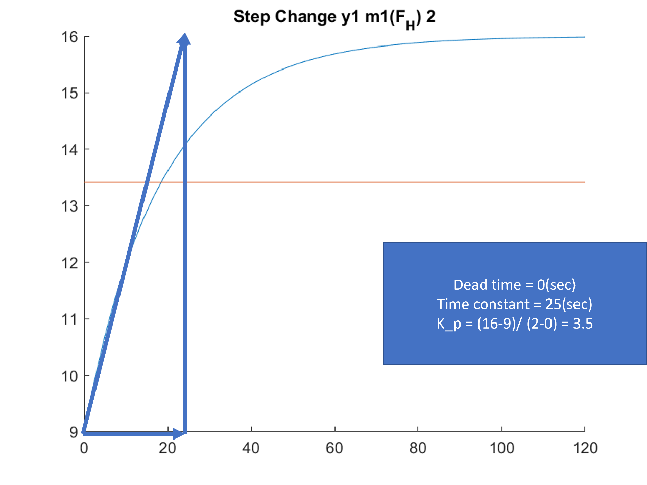

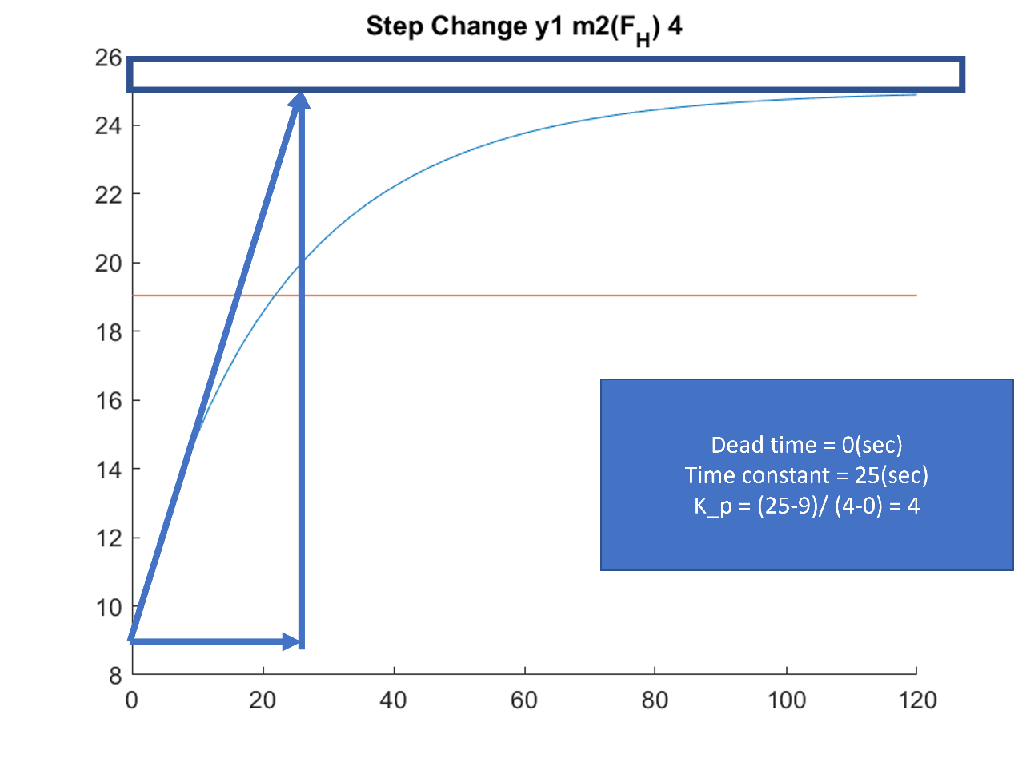

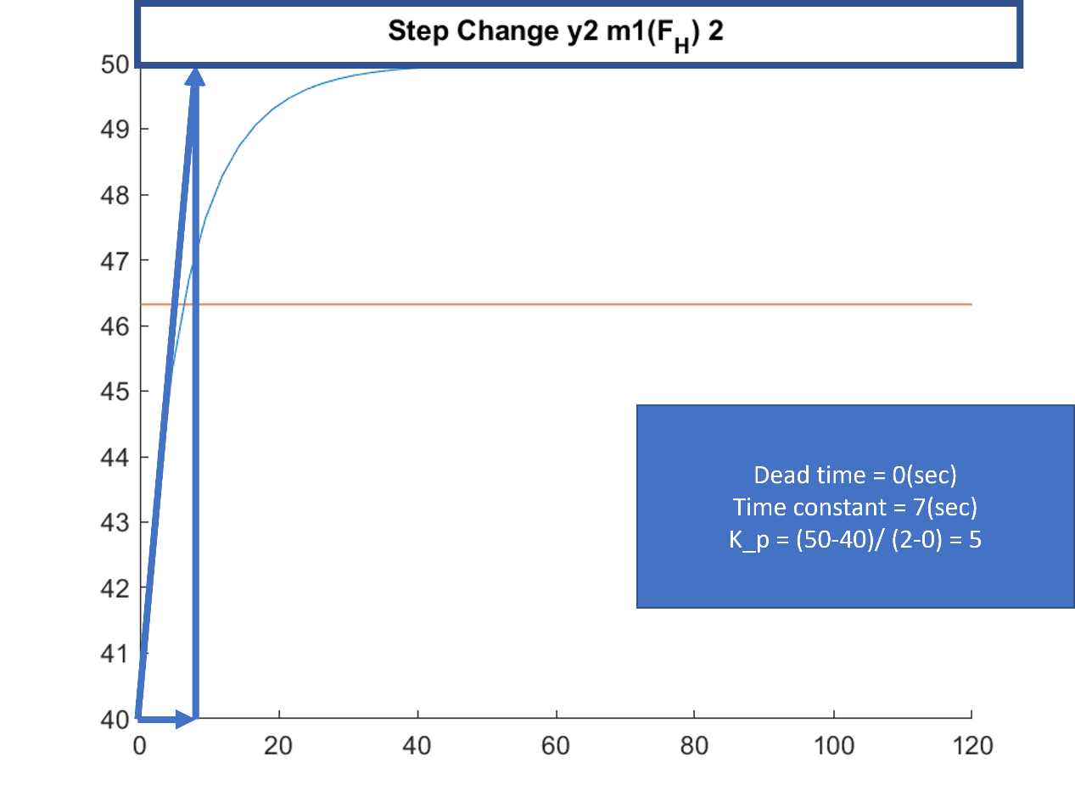

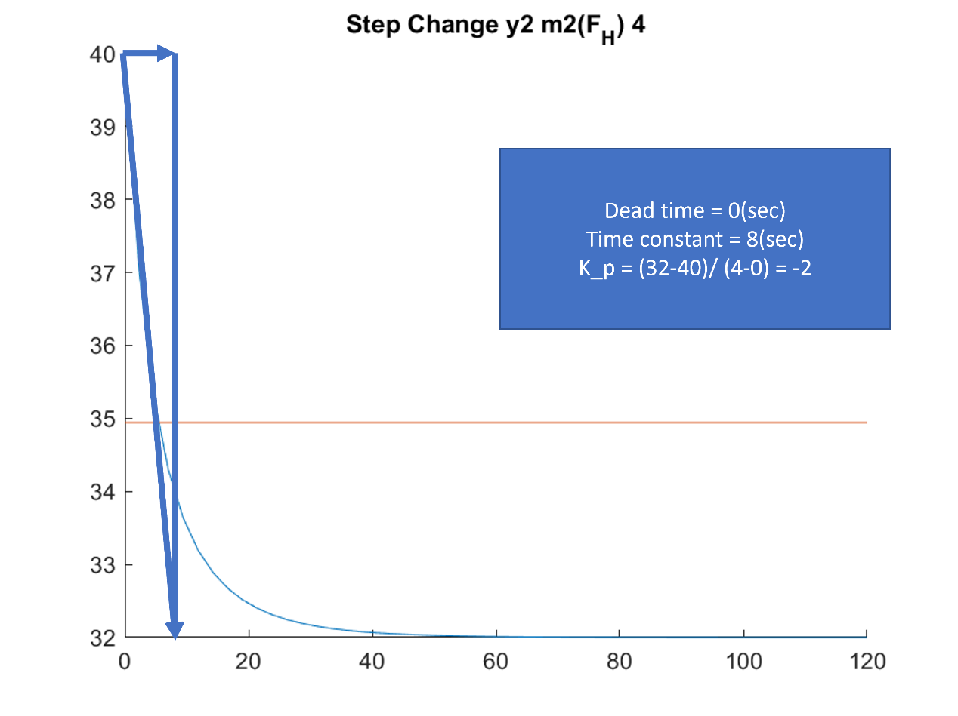

* Therefore, with a little bit adjustment, we can get the transfer function which can almost describe the original ODE process.
* Transfer function: (may different from different people)

|  |  |
| --- | --- |
|  |  |
|  |  |
|  |  |
|  |  |

* Now we have the transfer function for each controlled variable, and manipulated variable. Decoupling can be done by the above formula. In this case, we assume that the decoupling matrix, , is
* Therefore, we can draw the reaction curve for each decoupling manipulated variable, , and determine the coefficient of PID controller.
* Use Decouple variable, , to control y1, .

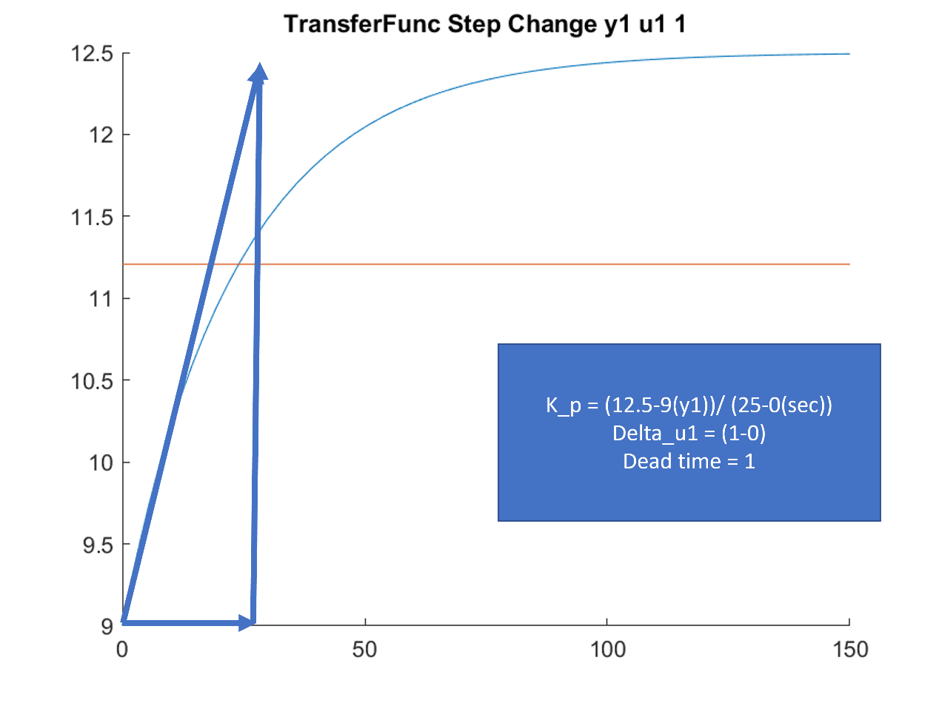

* Use Decouple variable, , to control y2, .

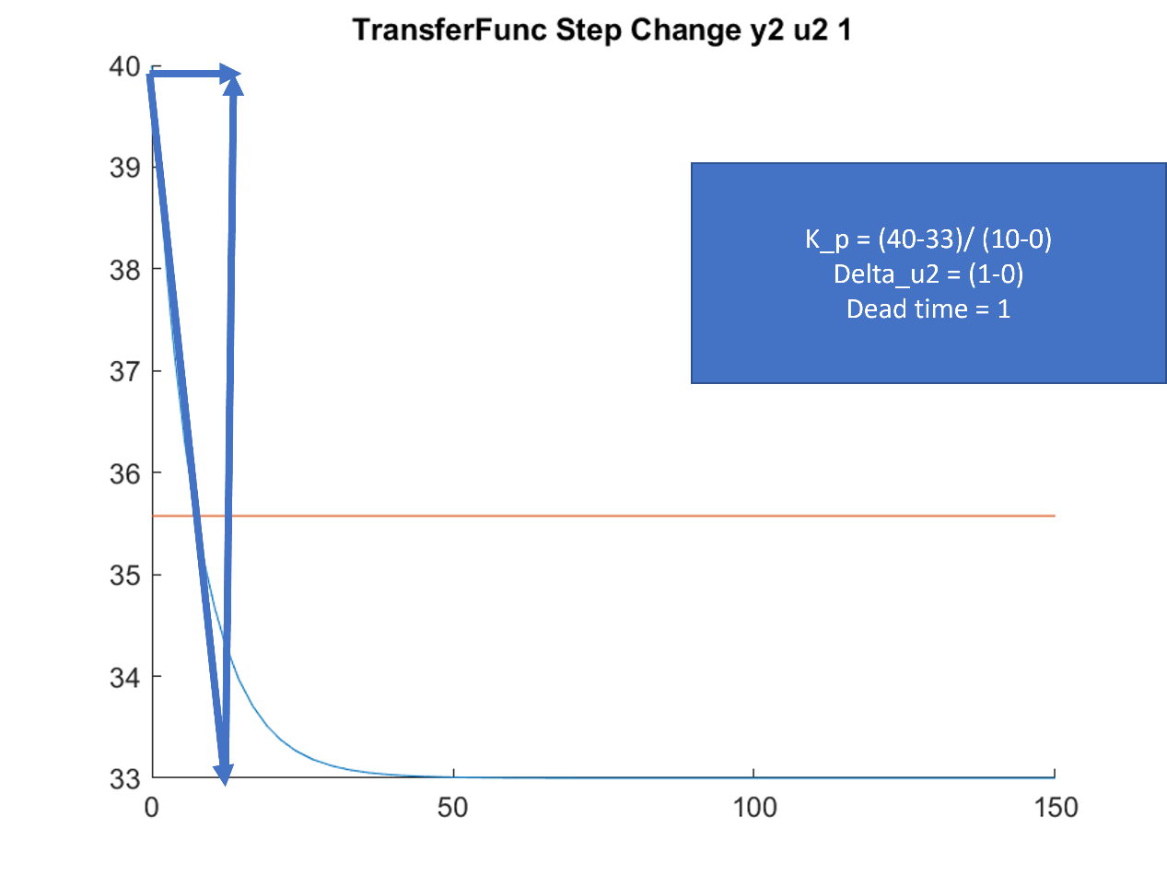

* Finally, we can implement the control system with decouple.
* We can see the control system is obvious better than the original control system.

