# HW05

112032533 黃柏勳

## Question

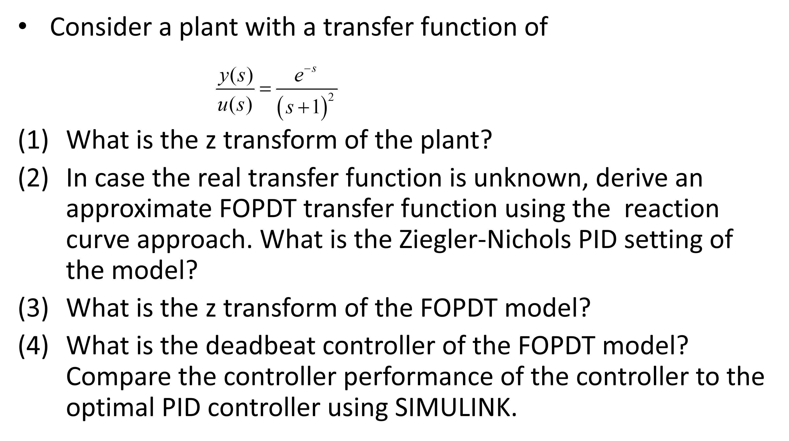

### Q01 :

* Q : What is the z transform of the plant?

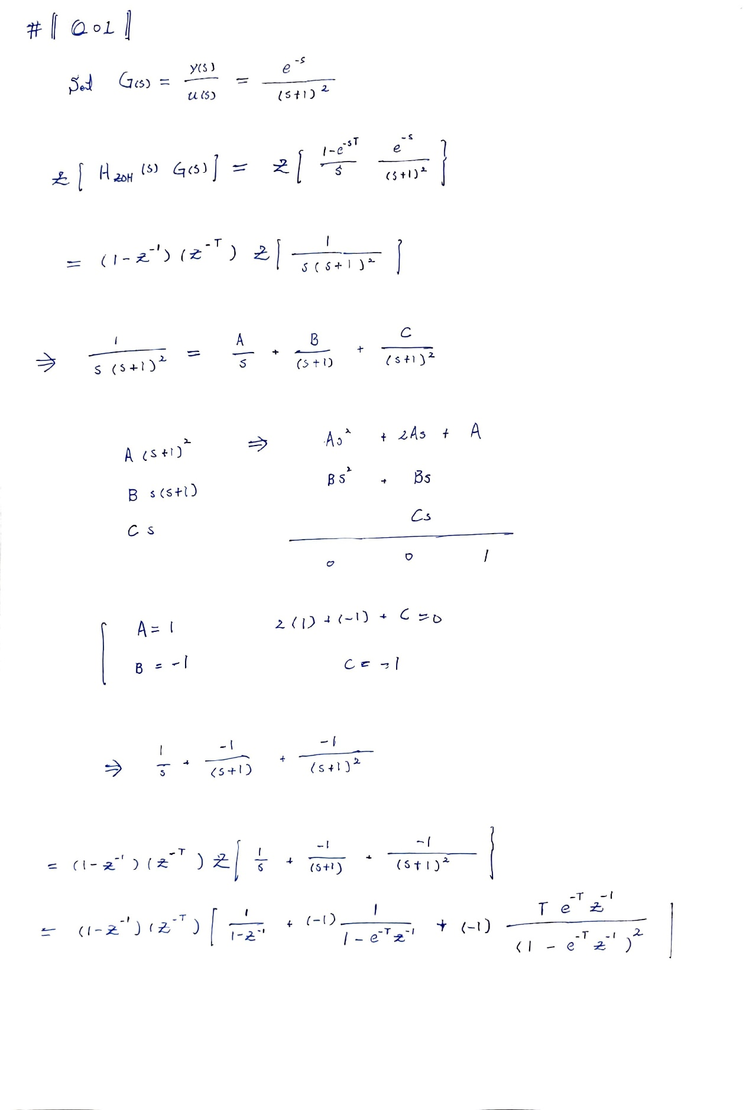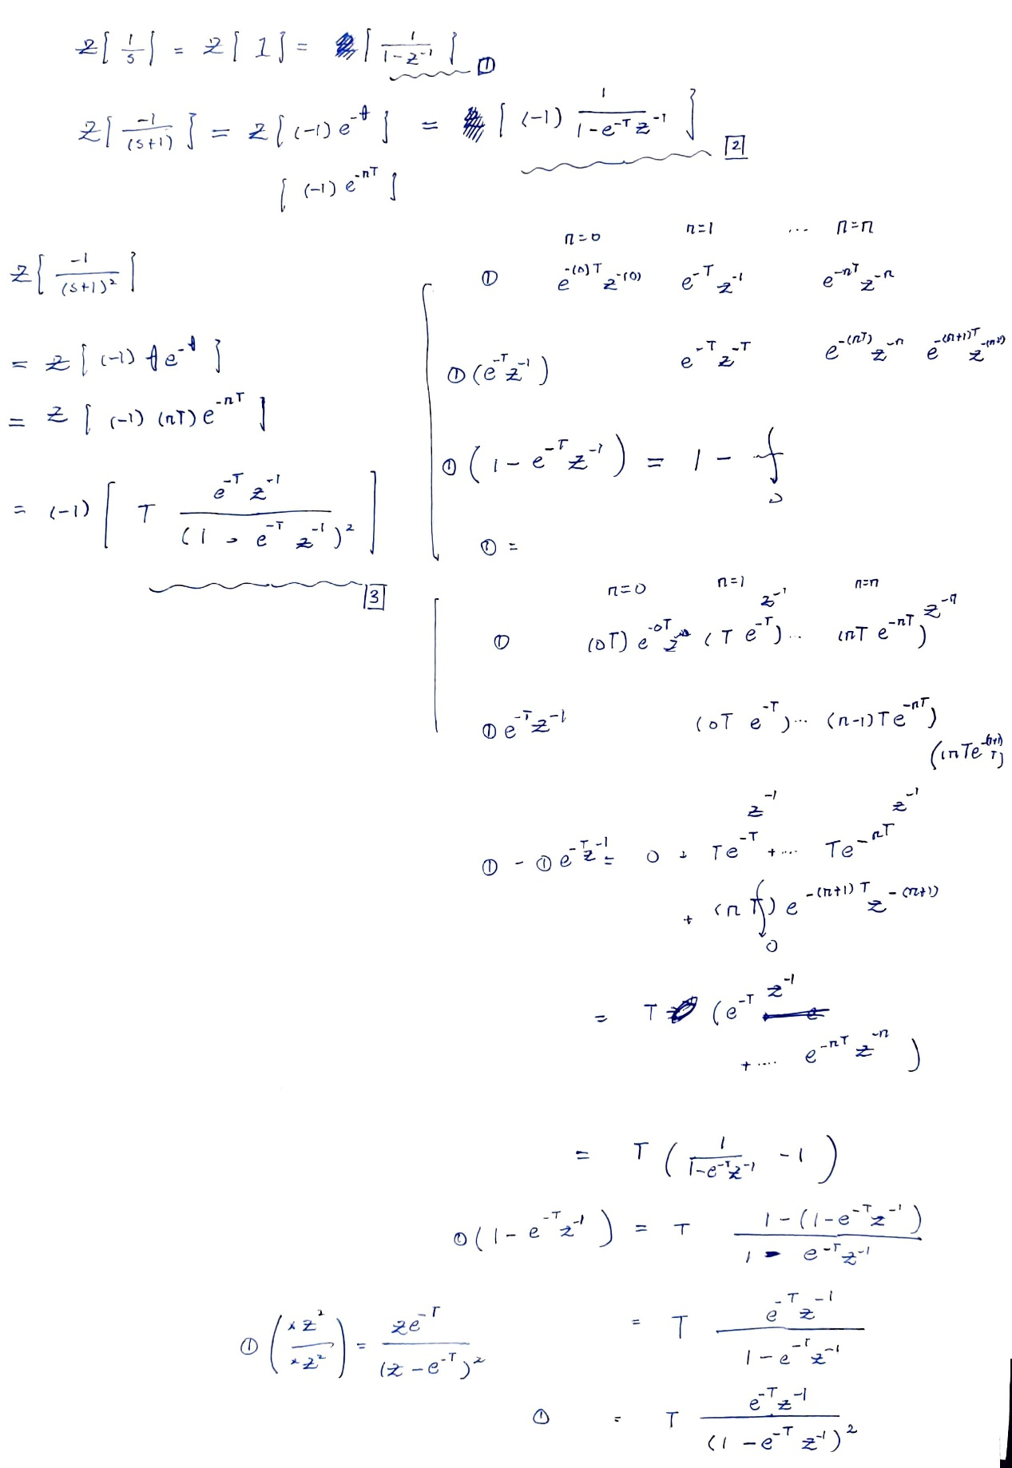

### Q02

* Q : In case the real transfer function is unknown, derive an approximate FOPDT transfer function using the reaction curve approach. What is the Ziegler-Nichols PID setting of the model?
* Ans :

By the method of FOPDT, we can find the coefficient for the simplified transfer function, $G_{FOPDT}\left(s\right)$.

Through the following picture, we can find out that the curve can be mostly described by $G_{FOPDT}\left(s\right)=\frac{\left(1\right)e^{-(1)s}}{2s+1}$.

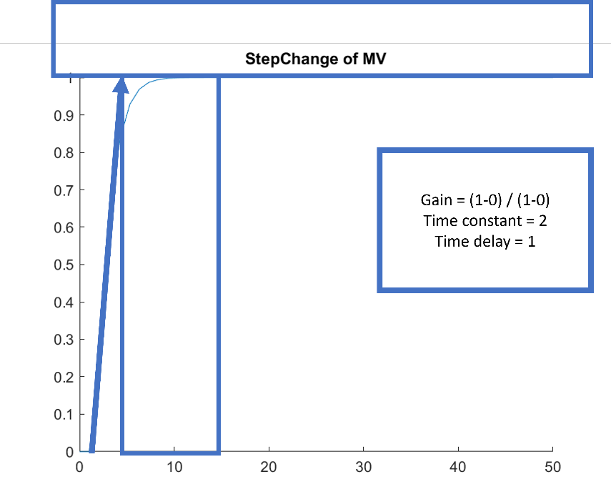

* Indeed, in comparison, the two pictures are very similar.

|  |  |
| --- | --- |
|  |  |
| Original Transfer function: $G(s)$ | FOPDT Transfer function: $G_{FOPDT}(s)$ |

* And we can control the continuous system with PID, whose coefficients are as follows:

For mv PID controller====================

Kc: 2.4000

Tau_I: 2.0000

Tau_D: 0.5000

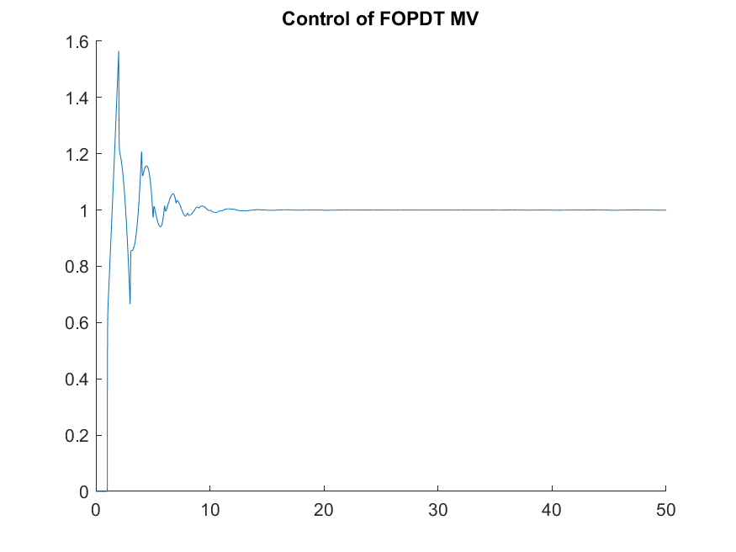

### Q03:

* Q: What is the z transform of the FOPDT model?
* Ans:

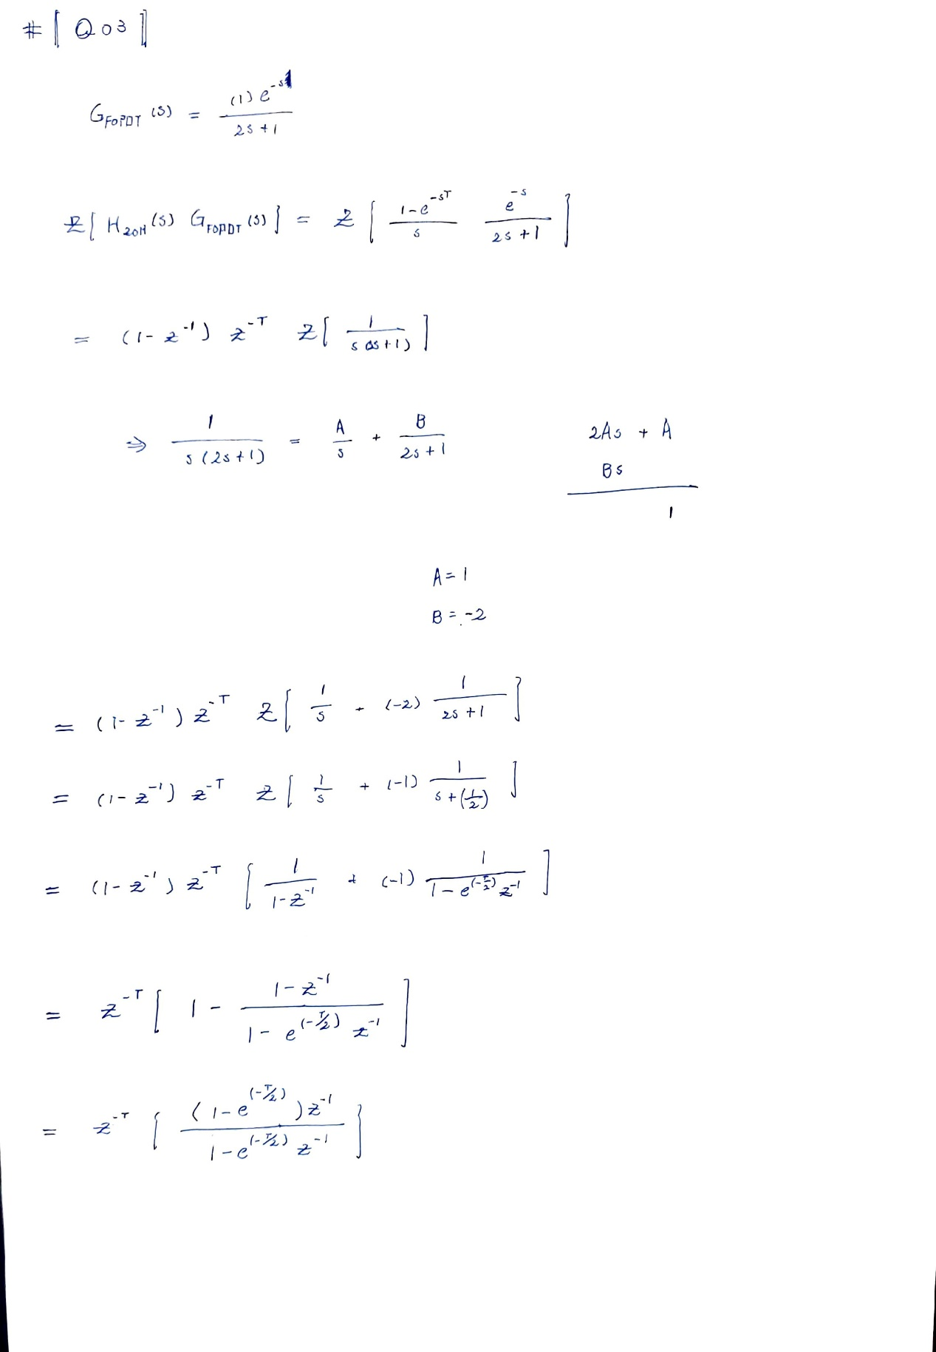

### Q04:

* Q: What is the deadbeat controller of the FOPDT model? Compare the controller performance of the controller to the optimal PID controller using SIMULINK.
* Ans:

To calculate the deadbeat control, $D(s)$, we need to know the sampling time, $T$, first. Here we set $T=1$.

Therefore, the deadbeat controller is

$$D\left(s\right)=\frac{z^{-1}}{1-z^{-1}}\left(\frac{1}{HG\left(z\right)}\right)=\frac{z-e^{\frac{-1}{2}(1)}}{\left(1-e^{\frac{-1}{2}\left(1\right)}\right)z-\left(1-e^{\frac{-1}{2}\left(1\right)}\right)}$$

And the PID controller coefficient here, we use the matlab tuning tool to tune the discrete PID controller.

The following is the comparison between two different controllers.

Obviously, the deadbeat control has better performance.

|  |  |
| --- | --- |
|  |  |
| PID control | Deadbeat control |