HW_FinalExam_takehome

112032533 黃柏勳

# Problem06

* Consider the above hot-cold water system with the following parameters:

|  |  |  |
| --- | --- | --- |
|  |  | unit |
| \bar{F}_H | 3 | m^3/min |
| \bar{F}_C | 0.5 | m^3/min |
| \bar{h} | 4 | m |
| \bar{T} | 62.8571 | oC |
| \bar{T}_H | 70 | oC |
| \bar{T}_C | 20 | oC |
| Area | 1 | m^2 |
| \rho | 1000 | kg/m^3 |
| C_p | 1 | kcal/(kg*oC) |

## Q01

* Derive the energy and material balances equations.

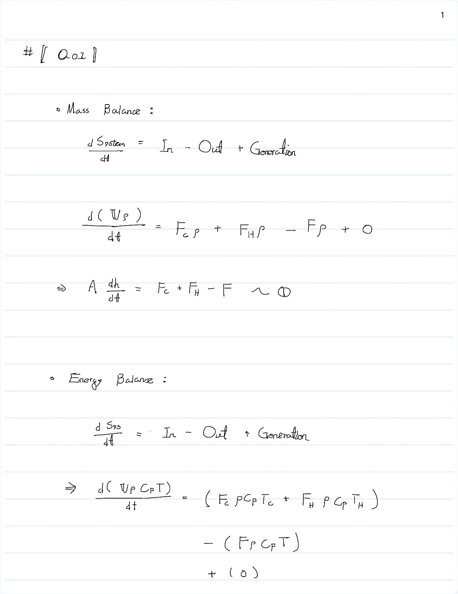

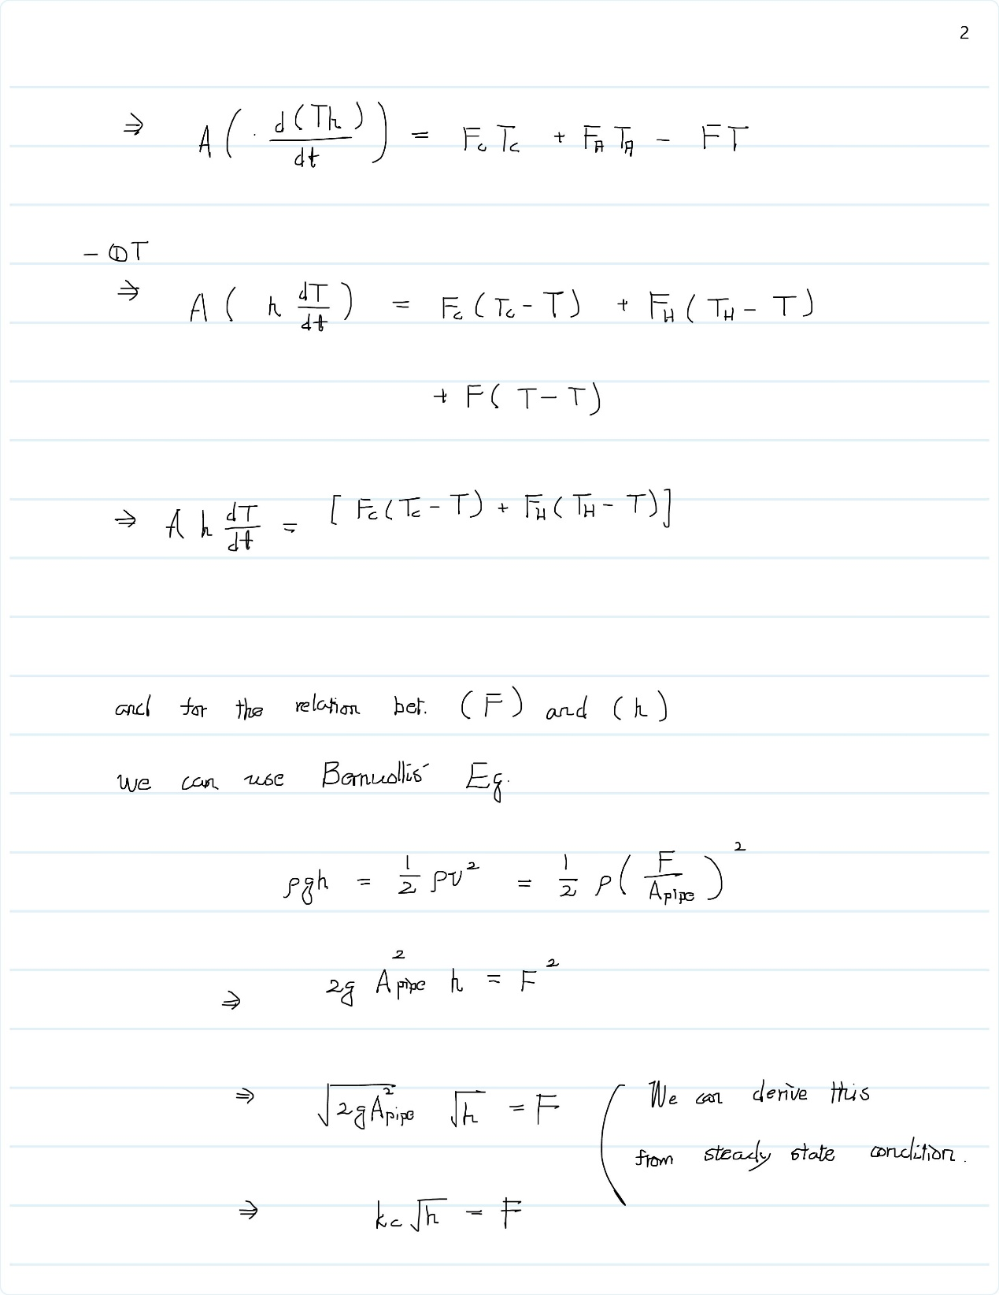

## Q02

* Write a SIMULINK to simulate the dynamic system with sampling time of 1 minute.

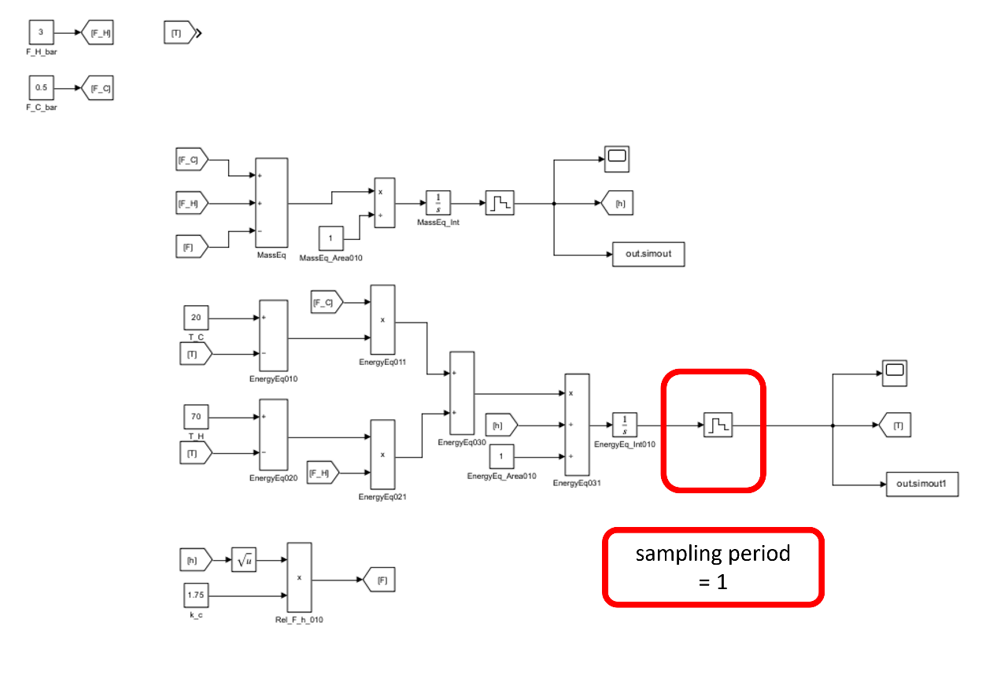

## Q03

* Perform dynamic simulation of process control of the multivariable system by assuming a step change of level set point by increasing to 5m with two individual controllers all with $K_{c}=1, τ_{I}=1(min)$
* Ans.

We can define the Relative Gain Array, RGA, first, and then determine which controller could have better control performance.

We start with FOPDT method.

By the following Simulink layout, we can draw the step change plot and find out their transfer functions.

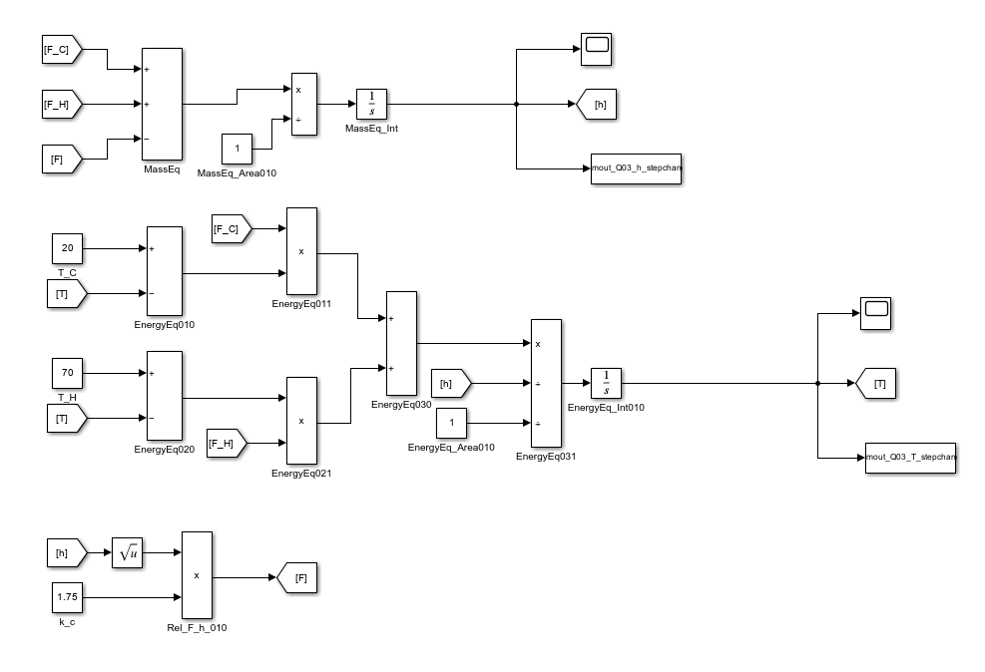

* Step change of F_C

|  |  |
| --- | --- |
|  |  |
| Height (h) | Temperature (T) |

* Step change of F_H

|  |  |
| --- | --- |
|  |  |
| Height (h) | Temperature (T) |

And therefore, we can calculate the relative gain array.

We found out that the cold water, $F_{c}$, should control temperature, $T$; and the hot water, $F_{H}$, should control height, $h$.

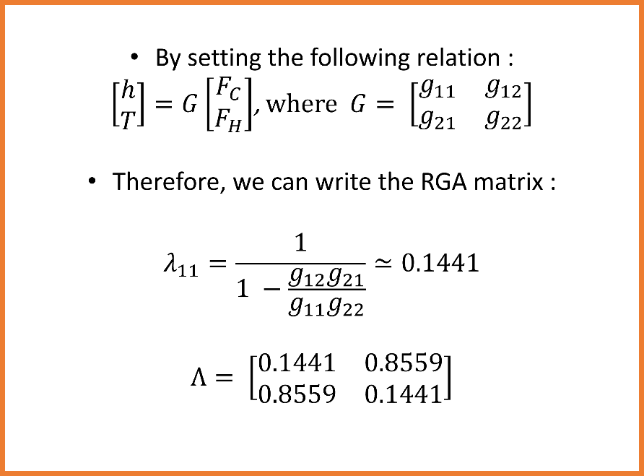

## Q04

* Derive all transfer functions using step response approximation and draw the the plant block functions. Also derive the decoupling system for the plant.
* Ans.:

By the same procedure, we can derive the transfer functions for controllers and outputs.

* Step change of F_C

|  |  |
| --- | --- |
|  |  |
| Height (h) | Temperature (T) |

* Step change of F_H

|  |  |
| --- | --- |
|  |  |
| Height (h) | Temperature (T) |

* By the following formula : 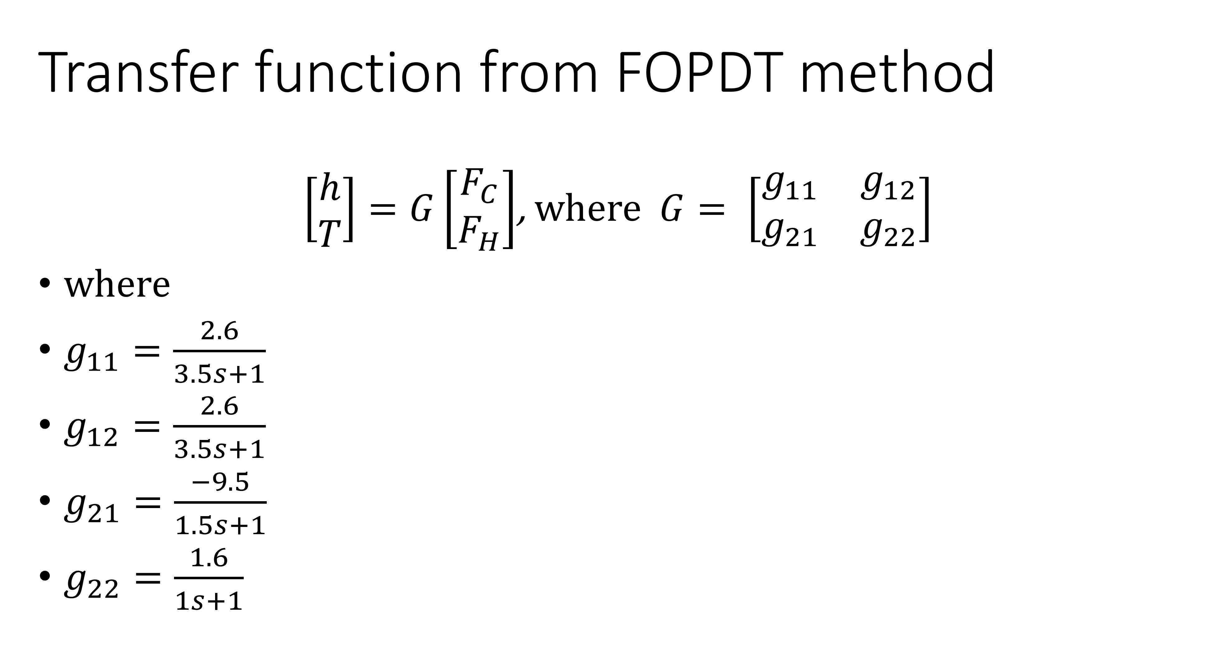
* FOPDT Layout:

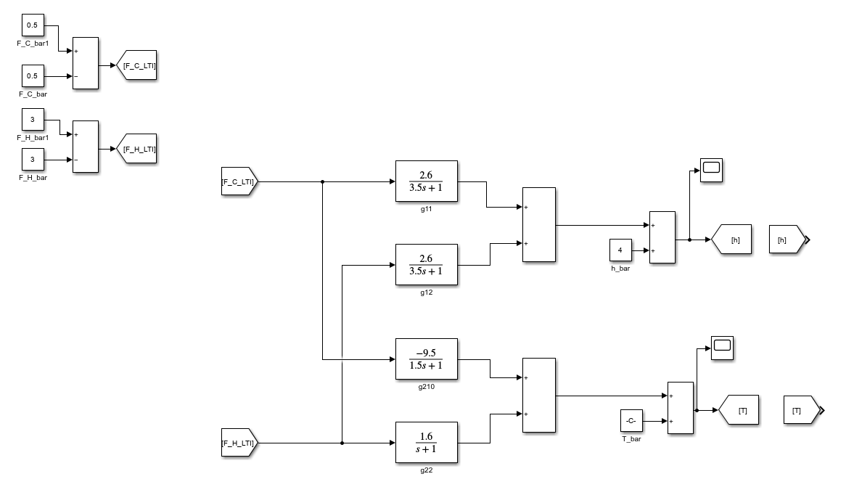

* And therefore, we can calculate the decouple matrix:

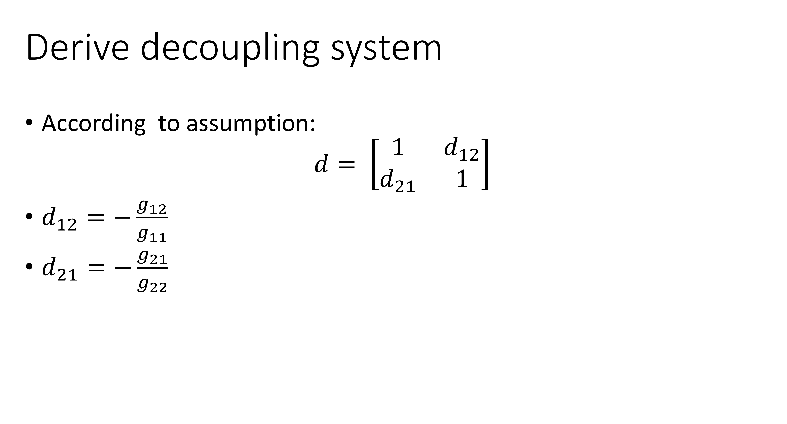

* FOPDT decoupling Layout:

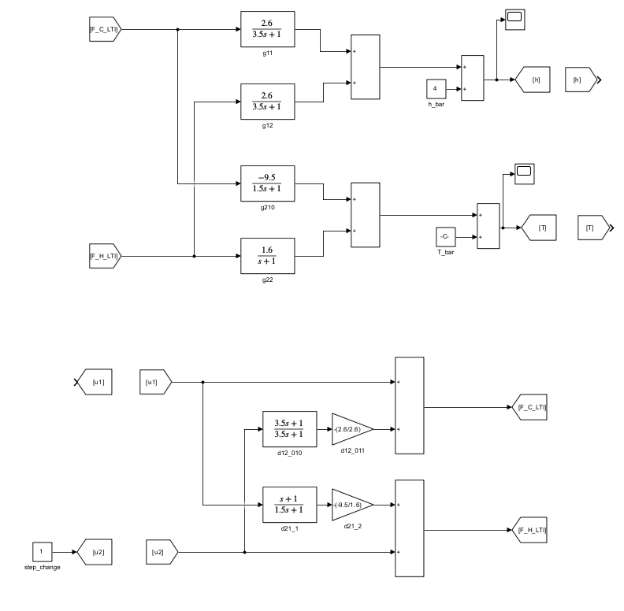

## Q05

* Ans.

By setting such PID controller, we set the set point of height to $5m$, the results are as follows.

* Decouple: PID control

|  |  |
| --- | --- |
|  |  |
| Height (h) | Temperature (T) |

## Q06

* Compare the results in Q03 and Q05.
* Ans.

We can simply compare the results by superposition.

|  |  |
| --- | --- |
|  |  |
| Height (h) | Temperature (T) |

We can see that the result from decoupling system is way better than the couple system.